Software Requirement Specification

QLVLXD-SRS-001

Version 1.0

**Revision History**

|  |  |  |  |  |
| --- | --- | --- | --- | --- |
| **Date** | **Version** | **Description** | **Author** | **Revised by** |
| 10/4/2023 | 1.0 | First version | Group 5 | Group 5 |
| 15/4/2023 | 1.0 | Build Basic method | Group 5 | Group 5 |
| 23/4/2023 | 1.0 | Creates pages that link together | Group 5 | Group 5 |
| 28/4/2023 | 1.0 |  | Group 5 | Group 5 |
| 05/5/2023 | 1.0 |  | Group 5 | Group 5 |
|  |  |  |  |  |

**Mục Lục**

1.Introduction 4

1.1.Overview 4

1.2.Scope 4

2.Functional Requirements 4

2.1.Feature/Component #1: Login Screen 4

2.1.1 : User interface 4

2.1.2 Functional Requirements 5

2.2. Feature/Component #2: Register Screen 6

2.2.1.Register Screen 6

2.2.2 Functional Requirements 7

2.3: Feature/Component #3: Main Screen 7

2.3.1:Main Screen 7

2.3.2 Functional Requirements 7

2.4: Feature/Component #4: Customer management 8

2.4.1 : Customer management: 8

2.4.2Functional Requirements 9

2.5 Feature/Component #5: Supplier management 10

2.5.1 : Supplier management 10

2.5.2.Functional Requirements : 10

2.6 : Feature/Component #6: Supplier management 11

2.6.1: Material List 11

2.6.2Functional Requirements : 12

2.7 : Feature/Component #7: Material Creation Screen 13

2.7.1 : Material Creation Screen 13

2.7.2.Functional Requirements : 13

2.8 : Feature/Component #7: Bill 14

2.8.1 : Bill 14

2.8.2Functional Requirements : 14

2.9 : Feature/Component #7: Bill list 15

2.9.1 : Bill list 15

# 1.Introduction

## 1.1.Overview

The application allows management of imported and exported building materials

## 1.2.Scope

* Demo version
* Demo version for display purpose only , not linked to Database
* IOS : IOS 10.4 to 14.6
* IOS test devices : Iphone Xr , Iphone 11 Pro
* Only supports screen orientation in portrait mode

# 2.Functional Requirements

## 2.1.Feature/Component #1: Login Screen

### 2.1.1 : User interface

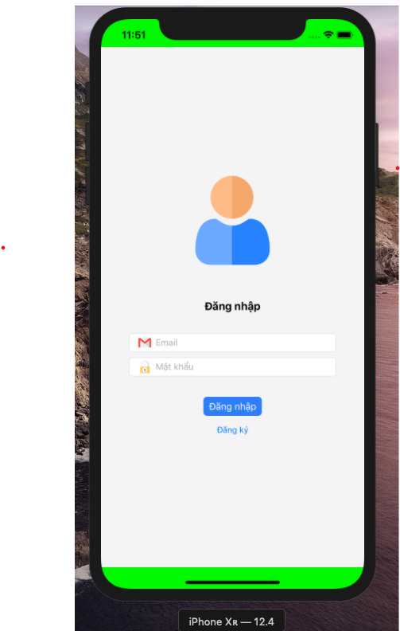

Images 1: Registration

### 2.1.2 Functional Requirements

|  |  |  |  |
| --- | --- | --- | --- |
| Item | Description | Action | Respone |
| My System Registration screen | My System Registration screen has 2 buttons :   * Login * Register | N/A | N/A |
| Register | Click the Rigister button to register | when we click on the register button  ,we are taken to the registration screen | The successful registration screen is displayed |
| Login | There are 2 text boxes to enter data:   * Email * Password | enter required data | Successfully logged in to the main screen |

## 2.2. Feature/Component #2: Register Screen

### 2.2.1.Register Screen

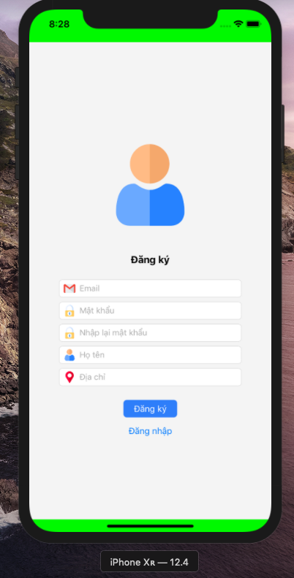

|  |  |  |  |
| --- | --- | --- | --- |
| Item | Description | Action | Respone |
| Register Screen | Has 2 buttons and 5 text box:   * Email * Password * Enter Password * Full name * Address | N/A | N/A |
| Register Screen | Insert information:   * Email * Password * Enter Password * Full name * Address | Display successful login message | The screen displays a successful registration message |

### 2.2.2 Functional Requirements

## 2.3: Feature/Component #3: Main Screen

### 2.3.1:Main Screen

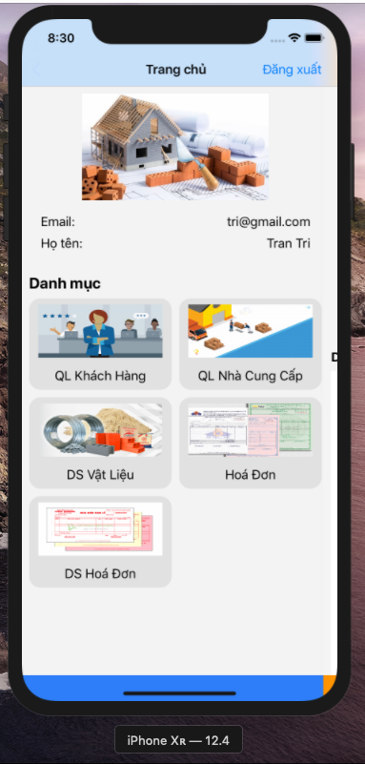

### 2.3.2 Functional Requirements

|  |  |  |  |
| --- | --- | --- | --- |
| Item | Description | Action | Respone |
| Main Screen | There are 6 buttons with 6 functions :   * Logout * Customer management * Supplier management * Material List * Bill * Bill list | N/A | N/A |
| Logout | Click log out when user want to return to the login page | Click on logout | Return to the login screen |
| 5 Functions | With the remaining 5 functions:   * Customer management * Supplier management * Material List * Bill * Bill list | Click 1/5 to go to the function user want to perform | Bring to the interface that needs to be manipulated successfully |

## 2.4: Feature/Component #4: Customer management

### 2.4.1 : Customer management:

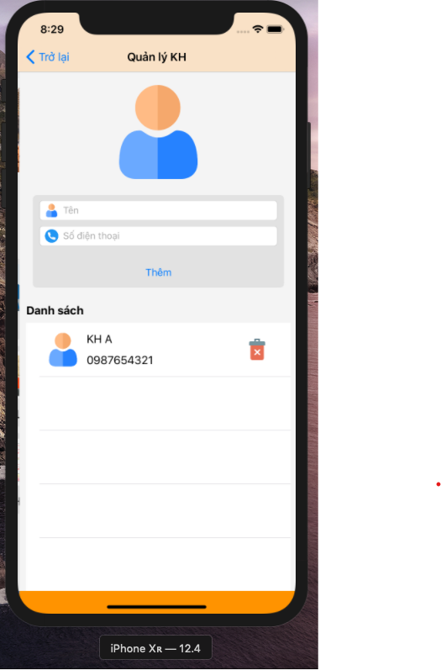

### 2.4.2Functional Requirements

|  |  |  |  |
| --- | --- | --- | --- |
| Item | Description | Action | Respone |
| Customer Screen | Has 3 buttons :   * Back * Add * Deletes | N/A | N/A |
| Buttons “ Back” | when the user presses back, it returns to the main screen | Click on Back | Return to main screen successfully |
| Buttons “ Add” | If the user does not enter the information, an error message will be displayed | Click on Add | Display a message asking for information |
| Buttons “Add” | Enter all required information | Click on Add | More successful customer information |
| Buttons “Delete” | When user want to delete a customer | Click on Delete | Display a message whether you want to delete or not |

## 2.5 Feature/Component #5: Supplier management

### 2.5.1 : Supplier management

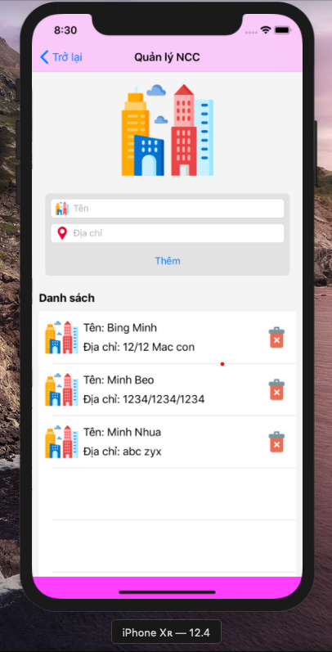

### 2.5.2.Functional Requirements :

|  |  |  |  |
| --- | --- | --- | --- |
| Item | Description | Action | Respone |
| **Functional Requirements** | Has 3 buttons :   * Back * Add * Deletes | N/A | N/A |
| Buttons “ Back” | when the user presses back, it returns to the main screen | Click on Back | Return to main screen successfully |
| Buttons “ Add” | If the user does not enter the information, an error message will be displayed | Click on Add | Display a message asking for information |
| Buttons “Add” | Enter all required information | Click on Add | More successful customer information |
| Buttons “Delete” | When user want to delete a customer | Click on Delete | Display a message whether you want to delete or not |

## 2.6 : Feature/Component #6: Building materials management

### 2.6.1: Material List

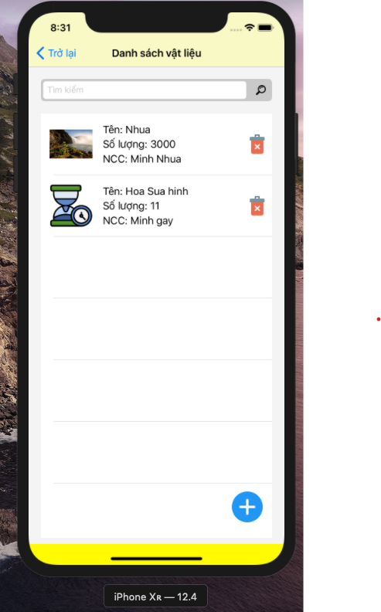

### 2.6.2Functional Requirements :

|  |  |  |  |
| --- | --- | --- | --- |
| Item | Description | Action | Respone |
| **Material list** | Has 3 buttons :   * Back * Add * Deletes * Search | N/A | N/A |
| Buttons “ Back” | when the user presses back, it returns to the main screen | Click on Back | Return to main screen successfully |
| Buttons “ Search” | If the user does not enter the information, an error message will be displayed | Click on Add | Display a message asking for information |
| Buttons “Search” | Enter the information you are looking for | Click on Add | Display the information you need to search successfully |
| Buttons “+” | There is a function to bring to the material creation page | Click on + | Take to the successful ingredient creation page |
| Buttons “Delete” | When user want to delete a customer | Click on Delete | Display a message whether you want to delete or not |

## 2.7 : Feature/Component #7: Material Creation Screen

### 2.7.1 : Material Creation Screen

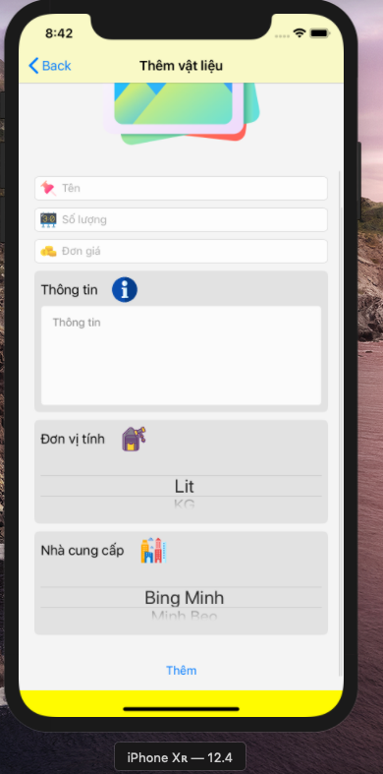

### 2.7.2.Functional Requirements :

|  |  |  |  |
| --- | --- | --- | --- |
| Item | Description | Action | Respone |
| **Material Creation** | Has 3 buttons :   * Back * Add Images * Add | N/A | N/A |
| Buttons “ Back” | when the user presses back, it returns to the main screen | Click on Back | Return to main screen successfully |
| Buttons “ Add ” | If the user does not enter the information, an error message will be displayed | Click on Add | Display a message asking for information |
| Buttons “Images” | Can chose a picture in the system file | Click on Images | Display image input panel |
| Buttons “+” | There is a function to bring to the material creation page | Click on + | Take to the successful ingredient creation page |

## 2.8 : Feature/Component #7: Bill

### 2.8.1 : Bill

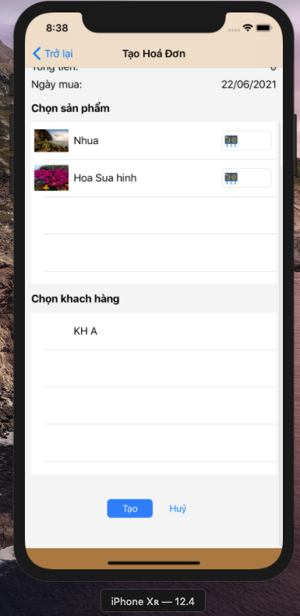

### 2.8.2Functional Requirements :

|  |  |  |  |
| --- | --- | --- | --- |
| Item | Description | Action | Respone |
| **Bill** | Has 3 buttons :   * Back * Add * Cancel | N/A | N/A |
| Buttons “ Back” | when the user presses back, it returns to the main screen | Click on Back | Return to main screen successfully |
| Buttons “ Add ” | If the user does not enter the information, an error message will be displayed | Click on Add | Display a message asking for information |
| Buttons “Add” | Enter quantity and select customer | Click on Add | Successfully added bill |
| Buttons “Cancel” | click to cancel order | Click on Cancel | display a message that the order has been successfully canceled |

## 2**.9 : Feature/Component #7**: **Bill list**

### 2.9.1 : Bill list

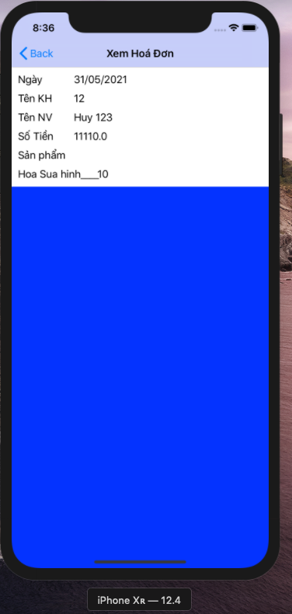

**2.9.2 :**

|  |  |  |  |
| --- | --- | --- | --- |
| Item | Description | Action | Respone |
| **Bill List** | Has buttons :   * Back | N/A | N/A |
| Buttons “ Back” | when the user presses back, it returns to the main screen | Click on Back | Return to main screen successfully |
| Bill list | User can see the bill add before | N/A | N/A |