Analysis Document

for

EduManager

Version 1.0 approved

Prepared by Group
Le Nguyen Thao Quynh – 22200226
Tran Nguyen Duy Phuc – 22206070

Huynh Vinh Sang- 22206390

Hoa Sen University
November 13, 2024

Table of Contents
Table of Contents ii
Revision History ii
1. Introduction 1
1.1 Purpose 1
1.2 Document Conventions 1
1.3 References 1
2. Overall Description 1
2.1 Product Perspective 1
2.2 User Classes and Characteristics 2
3. Use Case Approach 3
3.1 Use Case Identification 3
3.2 Use Case Diagram 4
3.3 Use Case Description 5
4. Analysis Models 21

Revision History
Name | Date | Reason For Changes | Version
Le Nguyen Thao Quynh | 11/13/24 | initial draft | 1.0 draft 1
Le Nguyen Thao Quynh | 11/20/24 | baseline following changes after inspection | 1.0 approved

Introduction

Purpose
This Analysis Document describes the various analysis models including the context diagram, the user classes identified the following primary actors and use cases for the EduManger System, and the system transition diagram.

Document Conventions
No special typographical conventions are used in this document.

References
- sblptr. (2022, December 15). Use Case Diagram Student information management system. Retrieved November 25, 2024, from GenMyModel: https://app.genmymodel.com/api/repository/sblptr7/Use%20Case%20Diagram%20Student%20information%20management%20system
- Wiegers, K. (2013). Cafeteria Ordering System Vision and Scope Document. Retrieved from www.processimpact.com/projects/COS/COS Vision and Scope.docx

Overall Description

Product Perspective
The EduManager system is an educational management application, supporting the learning management of students, lecturers, and managers in the educational environment. The context diagram in Figure 1 illustrates the external entities and the system interface for the 1.0 release. This system is expected to evolve over multiple versions.
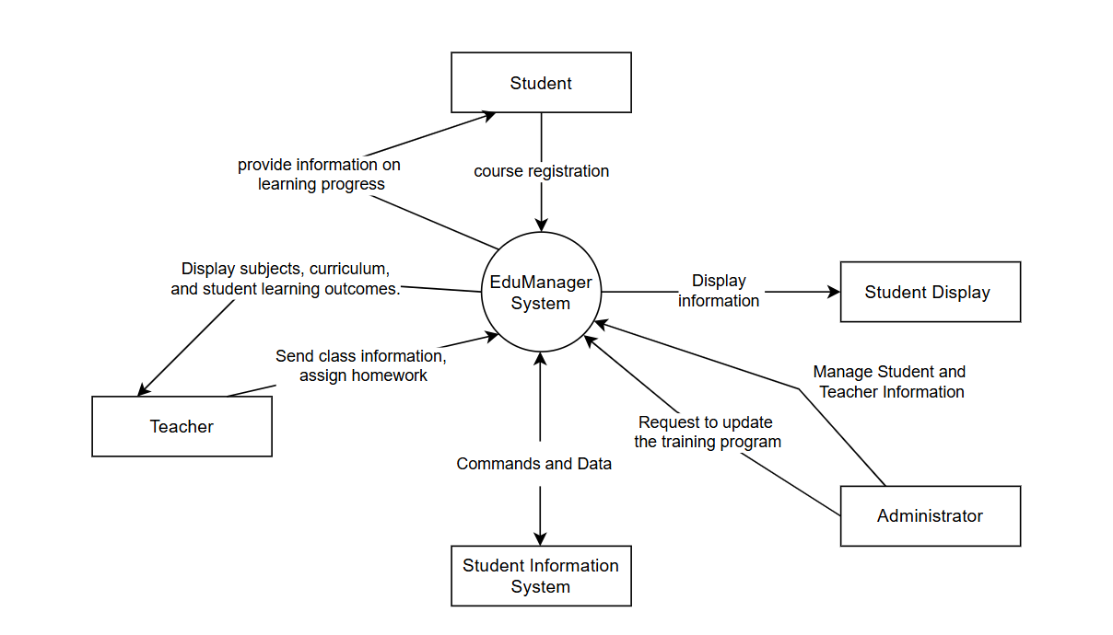
Figure 1. Context Diagram for release 1.0 of the EduManager

User Classes and Characteristics
Student:
- Be the primary user of the system.
- There is a need to manage personal information, register subjects, and monitor learning progress.
- Participate in submitting assignments and paying tuition fees online.
- The system can be accessed from multiple devices (computers, mobile phones).

Teacher:
- Manage classes and assign assignments to students.
- Track student learning and progress.
- Access to information about students and curriculum is required.
- Use the system to send notifications, check student attendance.

School Administrator:
- Track the learning and outcomes of the entire student.
- Manage learning programs and the account of teachers and students.

Student Information System:
- Not a direct user, but an interactive system with EduManager.
- Provide and receive information about students, grades, and learning data.
- Integrate with EduManager to update and synchronize information.

Use Case Approach

Use Case Identification
Primary Actor | Use Cases
Student | - Login  - Logout  - Register for courses  - Create study plan  - View course  - Submit assigments  - View study material  - View scores  - View academy progress  - View schedule  - Take attendance  - Make payment tuition  - Contact
Teacher | - Login  - Logout  - Assign assignment  - Track student scores  - Send notification  - Upload study material  - Check attendance  - Contact
School Administrator | - Login  - Logout  - Manage user account  - Manage courses (Add couse, Delete course, Assign teacher, Set schedule)  - Contact

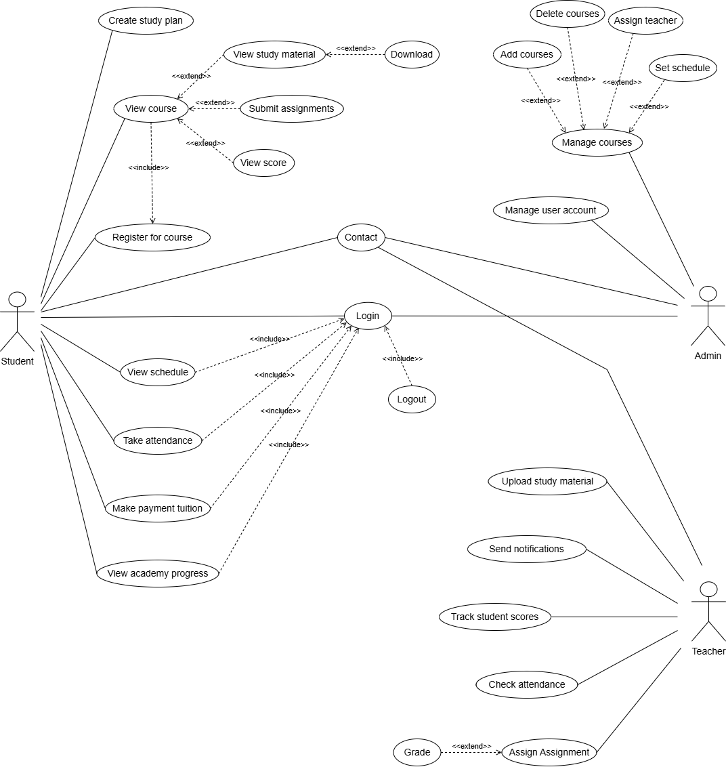
Use Case Diagram
Figure 2. Use case of EduManager

Use Case Description
UC ID and Name: | UC-1 Login
Created By: | Thao Quynh | Date Created: | 19/11/24
Primary Actor: | Student/Teacher/School Administrator | Secondary Actors: | None
Trigger: | The actor requests to login to the system.
Description: | The primary actor login to the system to access their profile and system functionalities. The login requires valid credentials (username and password).
Preconditions: | PRE-1. The actor must have an existing account.
Postconditions: | POST-1. The actor is logged into the system, with access granted to their relevant features.
Normal Flow: | - Actor navigates to the login page.  - Actor enters their credentials (username and password).  - System validates credentials. (see 1.1)  - If the credentials are valid, the system grants access to the actor and redirects to the dashboard or homepage. (see 1.0.E1)
Alternative Flows: | 1.1 Invalid login credentials:  - Actor enters incorrect credentials.  - System displays an error message and prompts the actor to try again.  - Return to step 2
Exceptions: | 1.0.E1 Account not found:  - If the actor enters invalid credentials and no account exists, the system notifies the actor and asks to register or retry.  2. Return to step 2.
Priority: | High
Frequency of Use: | Every time the actor accesses the system, multiple times per day.
Business Rules: | BR-1: Credentials must be encrypted and stored securely.
Other Information: | The login system should allow for password recovery if the actor forgets their credentials.
Assumptions: | None

UC ID and Name: | UC-2 Logout
Created By: | Thao Quynh | Date Created: | 19/11/24
Primary Actor: | Student/Teacher/School Administrator | Secondary Actors: | None
Trigger: | The actor wants to end their session after completing tasks.
Description: | Actor logs out of the system to end the session. This ensures the account is secure and no one else can access the actor's information.
Preconditions: | PRE-1. The actor is already logged into the system.
Postconditions: | POST-1. The actor is logged out, and access is terminated.
Normal Flow: | - The actor selects the "Logout" button from the system.  - The system ends the session and takes the actor to the login page.  - The actor is logged out, and no further action can be performed until they log in again.
Alternative Flows: | None
Exceptions: | None
Priority: | High
Frequency of Use: | Every time the actor finishes using the system.
Business Rules: | BR-2: The system should securely log out the actor and clear personal data after logout.
Other Information: | The system should automatically log out the actor after a set period of inactivity (e.g., 30 minutes) to improve security.
Assumptions: | None

UC ID and Name: | UC-3 Register for courses
Created By: | Thao Quynh | Date Created: | 19/11/24
Primary Actor: | Student | Secondary Actors: | None
Trigger: | The student register for courses in each semester
Description: | The student selects courses they wish to enroll in for the upcoming semester and submits their course registration.
Preconditions: | PRE-1. Student is logged in.
Postconditions: | POST-1. Student register successfull.
Normal Flow: | - Student navigates to the course registration page  - Student selects courses to enroll in for the upcoming semester. (see 3.1)  - Student confirms their course selection and assigns study hours for each course (if applicable).  - Student submits the registration request. (see 3.2)  - System processes the course registration and updates schedule.  - System confirms successful registration, and the student receives a notification.
Alternative Flows: | 3.1 Invalid course selection:  - Student is not eligible to register for the selected course (see 3.0.E1, 3.0)  - System informs the student.  - System ask student to choose another course from the available options.  - Student choose another course from the available options.  - Return to step 3.
Exceptions: | 3.0.E1 Schedule Conflict:  - If the selected courses have overlapping schedules, the system alerts the student of the conflict.  - System prompt to resolve the conflict by modifying their selections (e.g., dropping one course or changing the time of one course).  - Return to step 3 of the 3.1.  3.0.E2 Course Limit Reached:  - If the student exceeds the maximum credit limit allowed for the semester, the system informs the student.  - The student is asked to adjust their selections to comply with the credit limit.  - The system lists the course students can choose.  - Return to step 4 of the 3.1
Priority: | High
Frequency of Use: | Limit time per semester, typically before course registration.
Business Rules: | BR-1: Student must fulfill course prerequisites to be eligible for enrollment in certain courses.  BR-2: System should ensure no duplicate courses are selected.  BR-3: Student can only register for courses during the designated registration period.  BR-4: The student must confirm their course selections before final submission.
Other Information: | The course registration system should be updated with real-time course availability.  Students should be able to view course details (e.g., syllabus, schedule, instructor) before finalizing their course selection.
Assumptions: | None

UC ID and Name: | UC-4 Create Study Plan
Created By: | Thao Quynh | Date Created: | 19/11/24
Primary Actor: | Student | Secondary Actors: | None
Trigger: | The student decides to organize their courses academic schedule.
Description: | Student creates a personalized study plan outlining the courses and the schedule for the new semester.
Preconditions: | PRE-1. Student is logged in.  PRE-2. Student has access to course options and schedule.
Postconditions: | POST-1. Study plan is saved and ready for course registration.
Normal Flow: | - Student accesses the study plan page.  - Student views available courses and schedules.  - Student selects courses and assigns study hours for each. (see 4.0.E1)  - Student saves the study plan.  - Study plan is updated in the system and ready for course registration.
Alternative Flows: | None
Exceptions: | 4.0.E1 Conflict in schedule:  - If selected courses have overlapping schedules, the system alerts student and asks them to resolve the conflict.  - Student modifies the schedule by changing or removing conflicting courses.  - Return to step 4.
Priority: | High
Frequency of Use: | Limit time per semester, typically before course registration.
Business Rules: | BR-1. Study plan must include all registered courses for the semester.  BR-2. Student can modify their study plan before the registration period ends.
Other Information: | The study plan helps student manage time and ensures they are ready for the upcoming semester.
Assumptions: | None

UC ID and Name: | UC-5 View Course
Created By: | Thao Quynh | Date Created: | 19/11/24
Primary Actor: | Student | Secondary Actors: | None
Trigger: | Student wants to review a specific course before registration.
Description: | Student views detailed information about a course, including the syllabus, schedule, assignments, and teacher details.
Preconditions: | PRE-1. Student is logged in.  PRE-2. Student has access to course list.
Postconditions: | POST-1. Student views the course details.
Normal Flow: | - Student navigates to the course list.  - Student selects a course they are interested in.  - System displays the course details, schedule, assignments, and instructor information.  - Student reviews the course details.
Alternative Flows: | None
Exceptions: | None
Priority: | High
Frequency of Use: | Regularly, especially before login.
Business Rules: | BR-1. Course information should be updated by the teacher.
Other Information: | None
Assumptions: | None

UC ID and Name: | UC-6 Submit Assignments
Created By: | Thao Quynh | Date Created: | 19/11/24
Primary Actor: | Student | Secondary Actors: | None
Trigger: | Student finishes an assignment and wants to submit it.
Description: | Student submits assignments through the system. The system confirms the submission and records the time.
Preconditions: | PRE-1. Student is logged in.  PRE-2. Assignment is open for submission.
Postconditions: | POST-1. Assignment is submitted and recorded in the system.
Normal Flow: | - Student selects the assignment they want to submit.  - Student uploads the completed work. (see 6.0, 6.1)  - Student confirms the submission.  - System records the timestamp and confirms the submission.
Alternative Flows: | 6.0 Multiple submissions:  - If the assignment allows multiple submissions, the system asks student if they want to submit a new version.  - Student submits a new version, or selects the previous submission.  6.1 Submission Error:  - Student uploads the wrong file or encounters an error during submission (see 6.1.E1, 6.1.E2)  - Return to step 3.
Exceptions: | 6.1.E1 Late submission: Allow submit (1a), Not allow submit (2a)  1a. If the teacher does not allow submissions after the deadline, the system will prevent the student from uploading the assignment.  1b. The system will display a message informing the student.  2a. If the teacher allows late submissions, the student is still able to upload the assignment after the deadline.  2b. When the student submits the assignment, the system will notify the student about the late submission.  2c. The system calculates the time past the deadline and displays it to the student.  6.1.E2 File upload error:  - If the file cannot be uploaded (e.g., due to format or size), the system informs student and asks them to try again or upload a different file.  - Student uploads the file again in the correct format.  - Return to step 3.
Priority: | High
Frequency of Use: | Regularly, depending on assignment deadlines.
Business Rules: | BR-1. Late submission will not be graded.
Other Information: | Student can track all submissions and see past assignments.
Assumptions: | None

UC ID and Name: | UC-7 View study material
Created By: | Thao Quynh | Date Created: | 19/11/24
Primary Actor: | Student | Secondary Actors: | None
Trigger: | Student wants to view study materials for a course.
Description: | The student views materials like lecture notes, reading materials, and other resources uploaded by the teacher.
Preconditions: | PRE-1: Student is logged in.  PRE-2: Study material is uploaded by the teacher.
Postconditions: | POST-1. The student views or downloads the study material.
Normal Flow: | - Student navigates to the "Study Material" section for the course.  - System displays the list of available materials.  - Student selects the desired material.  - System displays or downloads the selected material.
Alternative Flows: | None
Exceptions: | None
Priority: | High
Frequency of Use: | Regularly
Business Rules: | BR-1: Study materials should be uploaded in accessible formats like PDF or DOCX
Other Information: | None
Assumptions: | None

UC ID and Name: | UC-8 View Scores
Created By: | Thao Quynh | Date Created: | 19/11/24
Primary Actor: | Student | Secondary Actors: | None
Trigger: | Student wants to view their academic scores.
Description: | The student checks their academic performance, including grades from assignments and exams.
Preconditions: | PRE-1: Student is logged in.  PRE-2: Grades for the student are recorded by the teacher.
Postconditions: | POST-1: The student views their grades.
Normal Flow: | - Student navigates to the "Scores" section.  - System displays a list of grades for assignments, exams, and final scores.  - Student reviews the grades.
Alternative Flows: | None
Exceptions: | None
Priority: | High
Frequency of Use: | Regularly
Business Rules: | BR-1: Scores must be updated by the teacher after the grading process.
Other Information: | None
Assumptions: | None

UC ID and Name: | UC-9 View academy progress
Created By: | Thao Quynh | Date Created: | 19/11/24
Primary Actor: | Student | Secondary Actors: | None
Trigger: | Student wants to review their overall academic progress.
Description: | The student views a summary of their academic performance, including completed courses and grades.
Preconditions: | PRE-1: Student is logged in.  PRE-2: Academic progress data is recorded.
Postconditions: | POST-1: The student views their academic progress report.
Normal Flow: | - Student navigates to the "Academic Progress" section.  - System displays a summary of the student's completed courses, grades, and GPA.  - Student reviews their academic progress.
Alternative Flows: | None
Exceptions: | None
Priority: | High
Frequency of Use: | Regularly
Business Rules: | BR-1: Progress report must include all completed courses and their grades
Other Information: | None
Assumptions: | None

UC ID and Name: | UC-10 View Schedule
Created By: | Thao Quynh | Date Created: | 19/11/24
Primary Actor: | Student | Secondary Actors: | None
Trigger: | Student wants to check their schedule.
Description: | Student views their schedule for the current semester, including classes, assignments, and exams.
Preconditions: | PRE-1. Student is logged in.  PRE-2. Student is enrolled in courses.
Postconditions: | POST-1. Student views their detailed schedule.
Normal Flow: | - Student navigates to the "Schedule" section.  - System displays all registered courses, class times, and important dates (e.g., exams).  - Student reviews their schedule.
Alternative Flows: | None
Exceptions: | None
Priority: | High
Frequency of Use: | Regularly
Business Rules: | BR-9. Schedule should be updated if any changes occur.
Other Information: | None
Assumptions: | None

UC ID and Name: | UC-11 Take Attendance
Created By: | Thao Quynh | Date Created: | 19/11/24
Primary Actor: | Student | Secondary Actors: | None
Trigger: | Student wants to check their schedule.
Description: | Student marks their attendance for a class or lecture. The system tracks their attendance for each course they are enrolled in and statistic it to the teacher
Preconditions: | PRE-1. Student is logged in.  PRE-2. The attendance system is set up to record attendance.
Postconditions: | POST-1. Student’s attendance is recorded for the class session.
Normal Flow: | - Student choose the option "Attendance" in the home page.  - System confirms the student's attendance for the class session. (see 11.0.E1)  - Attendance is recorded and saved.
Alternative Flows: | None
Exceptions: | 11.0.E1 Attendance not allowed:  - If the class has already started or attendance is closed for that session, the system informs the student and prevents attendance marking.  - Student may need to contact the instructor for exceptions.
Priority: | Medium
Frequency of Use: | Daily or per session.
Business Rules: | BR-9. Attendance can only be recorded during the designated period for the class.
Other Information: | Attendance can be tracked and reported for course requirements.
Assumptions: | None

UC ID and Name: | UC-12 Make Payment for Tuition
Created By: | Thao Quynh | Date Created: | 19/11/24
Primary Actor: | Student | Secondary Actors: | None
Trigger: | Student wants to pay tuition for the semester.
Description: | Student makes a payment for tuition or other fees through the system.
Preconditions: | PRE-1. Student is logged in.  PRE-2. Student has outstanding tuition or fees.
Postconditions: | POST-1. Payment is processed and recorded in the system.
Normal Flow: | - Student navigates to the "Tuition Payment" section.  - Student selects the amount and payment method.  - Student confirms the payment.  - Payment is processed, and the system confirms the transaction (see 12.0.E1)
Alternative Flows: | None
Exceptions: | 12.0.E1 Payment failure:  - If the payment transaction fails, the system informs the student and requests them to try again or contact support.  - Student retries the payment or chooses a different method.  - Return to step 3.
Priority: | High
Frequency of Use: | Semester-wise, typically at the beginning of the semester.
Business Rules: | BR-1. Payment must be completed before the registration period ends.
Other Information: | Payment confirmation will be sent to the student’s email or phone.
Assumptions: | None

UC ID and Name: | UC-13 Contact
Created By: | Thao Quynh | Date Created: | 22/11/24
Primary Actor: | Student, Teacher, School Administrator | Secondary Actors: | None
Trigger: | Actor encounters an issue or has a question.
Description: | Student, School administrator and the teacher contact with each other for any academic-related or technical issues.
Preconditions: | PRE-1. Actors is logged in.  PRE-2. Actors has a question or issue to address.
Postconditions: | POST-1. The system stores the contact request and sends it to the appropriate recipient.  POST-2. The recipient receives the contact request and can reply back to resolve the issue.
Normal Flow: | - Actors goes to the "Contact Support" section in the system.  - Actors selects the type of issue.  - Actors writes a message or describes the issue.  - Actors sends the contact request.  - The system forwards the request to the appropriate recipient.  - The recipient reads the message and responds to resolve the issue or provide information
Alternative Flows: | None
Exceptions: | None
Priority: | Medium
Frequency of Use: | Regularly
Business Rules: | BR-1: Response time for course-related questions should be within 48 hours.  BR-2: Technical support issues should be resolved within 24 hours.
Other Information: | None
Assumptions: | None

UC ID and Name: | UC-16 Assign Assignment
Created By: | Thao Quynh | Date Created: | 22/11/24
Primary Actor: | Teacher | Secondary Actors: | None
Trigger: | Teacher wants to assign the assignment to their student
Description: | The teacher creates and assigns an assignment for students to complete. The assignment may include instructions, due dates, and file uploads for students to access and work on.
Preconditions: | PRE-1. Teacher is logged in.  PRE-2. Teacher has entered the course.
Postconditions: | POST-1. Assignment is successfully created and assigned to students. Students can view the assignment in their course materials.
Normal Flow: | - Teacher selects the course for which they want to assign the assignment.  - Teacher enters the assignment title and description, including instructions for the students.  - Teacher sets the due date and any other required details (e.g., maximum file size, submission format).  - Teacher uploads any supporting materials or files related to the assignment (e.g., instructions, templates). (see 16.0)  - Teacher clicks on the “Assign” button to finalize the assignment.  - The system confirms the assignment has been successfully created and made available to students.
Alternative Flows: | 16.0 Invalid file format:  - If the file format is not supported (e.g., not PDF or DOCX), the system prompts the Teacher to upload a valid file.  - Teacher selects a valid file and retries the upload.
Exceptions: | None
Priority: | High
Frequency of Use: | Frequently, especially at the start of a new course or semester.
Business Rules: | BR-1: Uploaded study material must be accessible to all enrolled students within 5 minutes of upload.
Other Information: | None
Assumptions: | None

UC ID and Name: | UC-17 Track Student Score
Created By: | Thao Quynh | Date Created: | 20/12/24
Primary Actor: | Teacher | Secondary Actors: | None
Trigger: | The teacher wants to track and update students' scores for quizzes, assignments, exams, and final grades.
Description: | Teacher uploads study materials, such as lecture notes, presentations, or additional resources, for students to access.
Preconditions: | PRE-1. Teacher is logged in.  PRE-2: Teacher has entered the course and the course has students enrolled.  PRE-3: Teacher has assigned or graded quizzes, assignments, exams, or other assessments.
Postconditions: | POST-1: Teacher can view and update student scores for quizzes, assignments, exams, and final grades.  POST-2: Student’s score is updated and visible in the system.
Normal Flow: | - Teacher navigates to the course dashboard.  - Teacher selects the course to view student performance.  - System displays a list of enrolled students and their respective scores.  - Teacher selects a student or group of students to track their scores.  - Teacher reviews the detailed scores for quizzes, assignments, exams, or final grades. (see 17.0)
Alternative Flows: | 17.0 Teacher enter the scores:  - Teacher enter detailed scores for quizzes, assignments, exams, or final grades. (see 17.0.E1)  - System confirms that the scores have been updated successfully.  - Teacher can provide feedback to the student alongside the score.
Exceptions: | 17.0.E1 Invalid score entry:  1. If Teacher tries to input a score in an incorrect format (e.g., text instead of numbers), system alerts Teacher to correct the input.  2. Teacher corrects the score and proceeds.
Priority: | High
Frequency of Use: | Frequently
Business Rules: | BR-1: Scores must be entered within a specific timeframe (e.g., within 1 week of an assignment or exam).  BR-2: Scores must correspond to the assessments (e.g., quizzes, assignments) based on the syllabus.  BR-3: Only authorized teachers or instructors can modify student scores.  BR-4: Students should receive feedback alongside their scores, if applicable.
Other Information: | None
Assumptions: | None

UC ID and Name: | UC-18 Send Notification
Created By: | Thao Quynh | Date Created: | 20/12/24
Primary Actor: | Teacher | Secondary Actors: | None
Trigger: | Teacher wants to send a notification to students (e.g., for updates, reminders, or announcements).
Description: | Teacher sends notifications to students about course-related events, deadlines, or important updates.
Preconditions: | PRE-1. Teacher is logged in.  PRE-2: Teacher has access to the course or group of students they want to send notifications to.
Postconditions: | POST-1: The notification is successfully sent to the selected students
Normal Flow: | - Teach selects the course or student group for the notification.  - Teacher types the content of the notification (e.g., an announcement, reminder, or update).  - Teacher selects the students or group of students who should receive the notification.  - Teacher reviews the notification content and recipients.  - Teacher clicks the "Send" button to dispatch the notification.  - System sends the notification to the selected recipients.  - System confirms that the notification was sent successfully.
Alternative Flows: | None
Exceptions: | None
Priority: | High
Frequency of Use: | Frequently
Business Rules: | BR-1: Notifications should be clear and concise, without excessive information.  BR-2: Notifications must be sent to enrolled students or the intended audience.
Other Information: | None
Assumptions: | None

UC ID and Name: | UC-19 Upload Study Material
Created By: | Thao Quynh | Date Created: | 20/12/24
Primary Actor: | Teacher | Secondary Actors: | None
Trigger: | Teacher wants to share new study material with students.
Description: | Teacher uploads study materials, such as lecture notes, presentations, or additional resources, for students to access.
Preconditions: | PRE-1. Teacher is logged in.  PRE-2. Teacher has entered the course.
Postconditions: | POST-1. Study material is uploaded and available for students to download or view.
Normal Flow: | - Teacher selects the course to upload the material.  - Teacher choose file to upload. (19.0)  - Teacher enters the description or title for the study material.  - Teacher clicks on the "Upload" confirm. (see 19.0.E1)  - The system confirms that the material has been successfully uploaded and is available to students.
Alternative Flows: | 19.0 Invalid file format:  - If the file format is not supported (e.g., not PDF or DOCX), the system prompts the Teacher to upload a valid file.  - Teacher selects a valid file and retries the upload.
Exceptions: | 19.0.E1 Upload failure:  - If the upload fails (e.g., due to connectivity issues), the system notifies the Teacher and prompts to try again.  - Teacher may retry the upload or contact support if the issue persists.
Priority: | High
Frequency of Use: | Frequently, especially at the start of a new course or semester.
Business Rules: | BR-1: Uploaded study material must be accessible to all enrolled students within 5 minutes of upload.
Other Information: | None
Assumptions: | None

UC ID and Name: | UC-20 Check attendance
Created By: | Thao Quynh | Date Created: | 20/12/24
Primary Actor: | Teacher | Secondary Actors: | None
Trigger: | Teacher wants to check the attendance of students for a particular class or session
Description: | Teacher checks the attendance of students to monitor their participation in the course.
Preconditions: | PRE-1: Teacher is logged into the system.  PRE-2: Teacher has already marked attendance for the class or session.
Postconditions: | POST-1: Teacher can view the list of students who attended or missed a session
Normal Flow: | - Teacher navigates to the course's attendance section.  - Teacher selects the class or session for which attendance needs to be checked.  - System displays the attendance list, showing students who attended and those who were absent.  - Teacher reviews the attendance or take actions if necessary (e.g., mark a student as present).  - System updates the attendance record based on Teacher’s changes
Alternative Flows: | None
Exceptions: | None
Priority: | High
Frequency of Use: | Frequently
Business Rules: | BR-1: Attendance records must be updated immediately after each session.  BR-2: Only authorized teachers can mark or modify attendance.
Other Information: | Teachers can export attendance reports for record-keeping purposes.
Assumptions: | None

UC ID and Name: | UC-24 Manage User Account
Created By: | Thao Quynh | Date Created: | 22/11/24
Primary Actor: | School Administrator (Admin) | Secondary Actors: | None
Trigger: | Administrator needs to manage user accounts.
Description: | The School Administrator manages user accounts, including adding, deleting, and modifying accounts for teachers, students, and other staff.
Preconditions: | PRE-1. Admin is logged into the system.  PRE-2. Admin has appropriate permissions to manage accounts.
Postconditions: | POST-1. User account is added, deleted, or modified as requested.
Normal Flow: | - Admin navigates to the "User Management" section.  - Admin selects the action (add, delete, modify) for a user.  - Admin submits the action.  - The system processes the request and updates the user account accordingly.
Alternative Flows: | 24.1 Add user account:  - Admin selects "Add User" from the available actions.  - Admin enters the new user details (e.g., email, password, name,role, contact information, etc.).  - Admin submits the details for creation. (see 24.1.E1)  - The system processes the request and successfully adds the user account.  24.2 Modify user account:  - Admin selects "Modify User" and chooses the user to be modified.  - Admin updates the user details (e.g., role, contact information, etc.).  - Admin submits the changes for the user account. (see 24.1.E1)  - The system processes the changes and successfully modifies the user account.  24.3 Delete user account:  - Admin selects "Delete User" and chooses the user to delete.  - Admin confirms the deletion of the user account.  - The system processes the changes and successfully modifies the user account.
Exceptions: | 24.1.E1 Invalid User Details:  - If the system fails to process the account modification, it informs the Administrator of the issue.  - The system prompts the Administrator to correct the information.  - Administrator revises and submits the information again.  - Return to step 3 in 24.1 or 24.2.  24.3.E1 User Account Deletion Blocked by Dependencies:  - The system identifies that the user account is linked to ongoing activities or data (e.g., courses or assignments).  - The system prompt Admin to resolve these dependencies before proceeding with the deletion.  - The system processes the deletion request and successfully deletes the user account.  - Return to step 2 in normal flow.
Priority: | High
Frequency of Use: | Frequently
Business Rules: | BR-1: All account modifications should be logged for security purposes.
Other Information: | None
Assumptions: | None

UC ID and Name: | UC-25 Manage Courses
Created By: | Thao Quynh | Date Created: | 22/11/24
Primary Actor: | School Administrator (Admin) | Secondary Actors: | None
Trigger: | School Administrator needs to add, remove, or modify a course or its details.
Description: | The School Administrator manages courses by adding or deleting courses, assigning teachers to courses, and setting schedules for courses. This allows the system to keep course information up-to-date and ensures that students can register for the correct courses based on their availability.
Preconditions: | PRE-1. Admin is logged into the system.  PRE-2. Admin has appropriate permissions to manage courses.
Postconditions: | POST-1. Course is added, deleted, or modified (teacher assigned, schedule set) as requested.  POST-2. The course information is updated in the system, and students can view and register for the course (if added).
Normal Flow: | - School Administrator navigates to the "Manage Courses" section.  - School Administrator selects an action (Add course, Delete course, Assign teacher, Set schedule). (see 25.1, 25.2, 25.3)  - For setting a schedule:  - School Administrator sets the time, days, and location for the course.  - System updates the course schedule and makes it available to students.  - The system confirms that the course has been added, deleted, teacher assigned, or schedule set successfully.
Alternative Flows: | 25.1 Add a course:  - School Administrator enters course details (name, description, credits, etc.). (see 25.1.E1)  - Admin assign the Teacher who will teach the course. (see 25.1.E2)  - Admin setting a schedule.  - System stores the new course and makes it available for student registration.  - Return to step 4.  25.2 Delete a course:  - School Administrator selects the course to delete. (see 25.1.E1)  - System removes the course and updates the course catalog.  - Return to step 4.
Exceptions: | 25.1.E1 Course already exists:  - If a course with the same name already exists, the system notifies the  - School Administrator enter another course detaill (3a) or cancel the action (4a).  3a. Admin enter another course detail.  3b. Return to step 2 of 25.1.  4a. Admin cancel the action.  4b. System move to home page.  25.1.E2 No Teacher available:  - If the teacher cannot be assigned due to scheduling conflicts or other issues, the system notifies the Administrator.  - School Administrator can select a different teacher or resolve the issue  25.0.E1 Course deletion failure:  - If the system encounters an error while deleting the course (e.g., technical issues), it informs the Administrator.  - School Administrator may retry or contact support.
Priority: | High
Frequency of Use: | Frequently
Business Rules: | BR-1: Courses must be scheduled at least two weeks before the semester starts to allow students enough time to register.  BR-2: Each course must have at least one teacher assigned before it can be listed for student registration.  BR-3: Deleting a course that has students enrolled requires confirmation to prevent accidental deletions.
Other Information: | - Courses can be updated or deleted at any time, but changes may affect student registration.  - School Administrators must ensure that courses have valid schedules and assigned teachers before students can register.
Assumptions: | None

Analysis Models
