Software Requirements Specification

for

EduManager
Version 1.0 approved
Prepared by Group
Hoa Sen University
December 12, 2024

Table of Contents
Table of Contents ii
Revision History iii
1. Introduction 1
1.1 Purpose 1
1.2 Document Conventions 1
1.3 Project Scope 1
1.4 References 1
2. Overall Description 2
2.1 Product Perspective 2
2.2 User Classes and Characteristics 2
2.3 Operating Environment 3
2.4 Design and Implementation Constraints 3
2.5 Assumptions and Dependencies 3
3. System Features 3
3.1 Course Registration 3
3.1.1 Description 3
3.1.2 Functional Requirements 3
3.2 Submit Assignments Online 4
3.2.1 Description 4
3.2.2 Functional Requirements 4
3.3 View Grades and Attendance 4
3.3.1 Description 4
3.3.2 Functional Requirements 4
3.4 Manage Course Content (for Teachers) 4
3.4.1 Description 4
3.4.2 Functional Requirements 4
3.5 Tuiton Payment Management 5
3.5.1 Description 5
3.5.2 Functional Requirements 5
3.6 Personal Study Plan Management 5
3.6.1 Description 5
3.6.2 Functional Requirements 5
3.7 Account Management 5
3.7.1 Description 5
3.7.2 Functional Requirements 6
3.8 Course Management 6
3.8.1 Description 6
3.8.2 Functional Requirements 6
4. Data Requirements 6
4.1 Logical Data Model 6
4.2 Data Dictionary 7
4.3 Reports 8
4.4 Data Acquisition, Integrity, Retention, and Disposal 8
5. External Interface Requirements 8
5.1 User Interfaces 8
5.2 Software Interfaces 9
5.3 Hardware Interfaces 9
5.4 Communications Interfaces 9
6. Quality Attributes 9
6.1 Usability 9
6.2 Performance 10
6.3 Security 10
6.4 Safety 10
6.5 Availability Requirements 10
6.6 Robustness Requirements 11
7. Internationalization and Localization Requirements 11
8. Other Requirements 11
Appendix B: Analysis Models 12

Revision History
Name | Date | Reason For Changes | Version
Le Nguyen Thao Quynh | 12/12/24 | initial draft | 1.0 draft 1
Le Nguyen Thao Quynh | 12/13/24 | baseline following changes after inspection | 1.0 approved

Introduction

Purpose
This Software Requirements Specification (SRS) document describes the functional and non-functional requirements for the EduManager System, an platform designed to support students, teachers, and administrators in managing educational activities. This document is intended for project team members involved in the development and validation of the system. All requirements specified herein are committed for the initial release of EduManager.

Document Conventions
No special typographical conventions are used in this SRS.

Project Scope
EduManager is a comprehensive school system that facilitates online course registration, personal study planning, assignment submissions, access to course materials, grade review, attendance tracking, and fee payments for students. Teachers can manage their class lists, upload relevant course materials, and monitor attendance. Administrators can manage course, assign courses to teachers, manage fee payments, and control user accounts for both students and teachers.

References
- GreekforGreeks. (2023, September 22). Explain about Internationalization and Localization. Retrieved December 3, 2024, from GreeksForGeeks: https://www.geeksforgeeks.org/explain-about-internationalization-and-localization/
- Jevsikova, T. (2010). Localization and Internationalization of Web-Based Learning Environment. Retrieved from ResearchGate: https://www.researchgate.net/publication/221437660_Localization_and_Internationalization_of_Web-Based_Learning_Environment
- Tamara Kuprina, A. M. (2020). The method of educational programs localization under internationalization of academic environment. Journal of Language and Cultural Education. Retrieved 12 3, 2024, from https://www.researchgate.net/publication/352511962_The_method_of_educational_programs_localization_under_internationalization_of_academic_environment

Overall Description

Product Perspective
The EduManager system is an educational management application, supporting the learning management of students, lecturers, and managers in the educational environment. The context diagram in Figure 1 illustrates the external entities and the system interface for the 1.0 release. This system is expected to evolve over multiple versions.
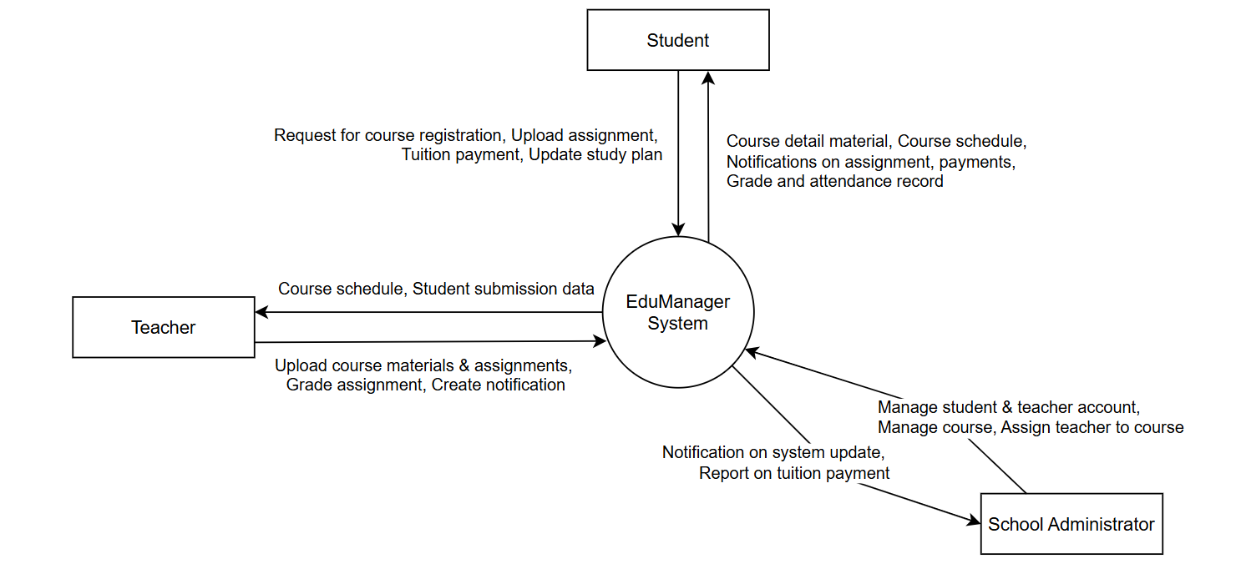
Figure 1. Context Diagram for release 1.0 of the EduManager

User Classes and Characteristics
Student | A student is someone who enrolled at the school. They will use the system to register for courses, plan their studies, submit assignments online, view grades, track attendance, and pay tuition fees. Around 5,000 students are expected to use the system regularly.
Teacher | A teacher is an instructor who uses the system to manage courses, upload study materials, track student progress, and grade assignments. There will be about 200 teachers using the system.
School Administrator | The admin is the school management, responsible for overseeing the system, including assigning courses to teachers, managing student accounts, and handling tuition payments. There will be around 5 to 7 admins in charge of managing the system.

Operating Environment
OE-1: The EduManager system will work on popular web browsers such as Google Chrome, Firefox, Safari, and Microsoft Edge.
OE-2: The system will run on servers with Windows and Apache HTTP Server.
OE-3: The system will be accessible from the school’s network, a VPN, and mobile devices like smartphones and tablets.

Design and Implementation Constraints
CO-1: The system must follow the school's software development guidelines.
CO-2: The system will use a standard database to store information.
CO-3: All web content will meet the HTML5 standard.

Assumptions and Dependencies
AS-1: The school operates on a regular academic schedule, with classes and assignments due during weekdays.
DE-1: The system depends on the school’s payment system to handle tuition fees.
DE-2: The system also depends on the school’s course scheduling system for managing classes and deadlines.

System Features

Course Registration

Description
Students can use the system to register for courses at the beginning of each semester. They can select courses, check if they are available, and complete their registration. They can also change or cancel their course choices before the deadline.

Functional Requirements
Course Selection: The system will show available courses.
Registration Confirmation: After selecting courses, the system will confirm the registration and notify the student.
Late Registration: If the deadline has passed, the system will notify the student and allow them to request late registration if allowed.

Submit Assignments Online

Description
Students can submit their assignments online. They can upload files, check submission status, and receive feedback from teachers. The system will notify students about assignment deadlines.

Functional Requirements
Upload assignment: Students shall be able to upload assignments in supported formats.
Reminder deadline: The system shall send reminders for upcoming deadlines.
Notification feedback: After grading, students shall be notified and can view teacher feedback.

View Grades and Attendance

Description
Students can view their grades and attendance records for each course. Teachers will update grades and attendance, and this information will be displayed in the system for students to access.

Functional Requirements
View grades: Students shall be able to see their grades for assignments, exams, and courses.
Track attendance: The system shall show attendance and missed classes.
Generate reports: Students and teachers shall be able to generate academic performance reports.

Manage Course Content (for Teachers)

Description
Teachers can upload and manage course materials, such as lecture notes, assignments, and other resources. Teachers can also track attendance and grade assignments.

Functional Requirements
Upload study material: Teachers shall be able to upload files, documents, and media to the system.
Grade assignment: Teachers can enter grades for assignments and exams
Manage attendance: Teachers can view student attendance.

Tuiton Payment Management

Description
The EduManager system allows students to pay tuition fees directly through the platform. Students can view their tuition fee status, make payments, and receive confirmation of their payment. The system will also notify students of any outstanding payments and deadlines. Admins will have access to view, manage, and track payment status for all students.

Functional Requirements
View Tuition Fees: Students can view the total tuition fees and payment due dates.
Make Payment: Students can securely pay their tuition fees using available payment methods.
Payment Confirmation: After a payment is made, the system will notify the student of successful payment and update the status.
Late Payment Notifications: The system will send reminders to students with overdue payments.
Admin Access: Admins can view and manage payment records, including dates, amounts, and payment methods for each student.

Personal Study Plan Management

Description
Students can create a personal study plan for the upcoming semester. This plan will include the courses they intend to take, along with schedules and study goals. Students can modify their study plans at any time before the start of the semester.

Functional Requirements
Create Study Plan: Students can choose courses, set study goals, and define a timetable.
View Study Plan: Students can view their current study plan and make updates if necessary.
Modify Plan: Students can modify their plans before the semester begins, such as adding or dropping courses.

Account Management

Description
Admins are responsible for managing user accounts within the EduManager system. This includes adding, deleting, and modifying accounts for both students and teachers. Admins will also manage course assignments for teachers, course schedules, and tuition payment tracking.

Functional Requirements
User Account Creation: Admins can create accounts for new students and teachers, providing them with login credentials.
User Account Deletion/Modification: Admins can delete or modify user accounts as needed.
Tuition Payment Management: Admins can view and manage tuition payments for all students, ensuring payments are tracked accurately.

Course Management

Description
Admins will manage all aspects of course offerings within the EduManager system. This includes creating new courses, setting course schedules, and assigning teachers to specific courses.

Functional Requirements
Create New Courses: Admins can create new courses, including course names, descriptions, and schedules.
Assign Teachers to Courses: Admins will assign teachers to specific courses and ensure that each course has an appropriate instructor.
Update Course Information: Admins can modify course details, such as update course schedules.
Monitor Course Enrollment: Admins can view the number of students enrolled in each course and take necessary actions if there are too many or too few students.

Data Requirements

Logical Data Model
The logical data model for EduManager includes the following key entities:
- Student: Stores personal details, enrolled courses, grades, attendance, and payment history.
- Teacher: Stores personal details, assigned courses, uploaded teaching materials, and notifications sent.
- Admin: Stores credentials, managed courses, and user accounts including teachers and students.
- Course: Contains information about course schedules, teaching materials, and teacher assignments.
- Payment: Tracks fees, payment dates, and payment methods.

Data Dictionary
Key attributes for the data entities are described below:
- Student:
- StudentID (Primary Key): Unique identifier for a student.
- Name: The student’s full name.
- Email: Contact email address.
- Password: Password to enter the system.
- CoursesEnrolled: List of course IDs the student is enrolled in.
- AttendanceRecords: Attendance information.

- Teacher:
- TeacherID (Primary Key): Unique identifier for a teacher.
- Name: The teacher’s name.
- Password: Password to enter the system.
- AssignedCourses: List of courses taught by the teacher.

- School Administrator:
- AdminID (Primary Key): Unique identifier for an administrator.
- Name: The Admin’s name.
- Password: Password to enter the system.

- Course:
- CourseID (Primary Key): Unique identifier for a course
- Name: Course name.
- Description: Description about the course information
- Schedule: Timetable for the course.

- Payment:
- PaymentID (Primary Key): Unique identifier for each payment.
- Amount: Amount paid.
- StudentID (Foreign Key): References the “StudentID” who made the payment.
- Date: Date of payment.
- Status: Payment’s status
- PaymentMethod: Method of payment (e.g., credit card, bank transfer, etc.).

Reports
System-generated reports include:
- Student Progress Reports: Detailing grades, completed courses, and progress status.
- Payment Reports: Summarizing tuition fee payments by students, including details like payment date, amount, and method.

Data Acquisition, Integrity, Retention, and Disposal
EduManager ensures data integrity through input validation and transaction management. Data retention policies comply with educational standards, academic records and student records are stored on the MongoDB database and are backed up periodically for a certain period of time before being securely deleted, and obsolete or redundant data is securely deleted after being stored on the database for at least 5 years.

Tuition payment history is stored securely and securely, ensuring payments are tracked for the entire period required by the institution. After the retention period, payment records are securely archived or deleted.

External Interface Requirements

User Interfaces
The application written in Flutter programming language will provide a user-friendly interface for students, teachers and administrators.

- Students:
- Log in and access personal information panel.
- Register for courses, create study plans, view class schedules and access teaching materials.
- Submit assignments and view grades.
- View tuition payment status and make payments.

- Teachers:
- Manage course content and upload teaching materials.
- Track student progress and attendance.
- Send notifications to students.

- Admin:
- Manage user accounts (add/delete students and teachers).
- Manage detailed information about courses, class schedules and teacher assignments.
- View and manage tuition payments for students.

Software Interfaces
EduManager integrates with the following:
MongoDB Database: To store data.
Payment Gateway API: To enable tuition payment.
Node.js Back-end: To handle business logic and API requests.

Hardware Interfaces
The application will be supported on the following devices:
- Smartphones and tablets (Android/iOS).
- Laptops and desktops for administrative tasks.

Communications Interfaces
EduManager communicates over the entire HTTP protocol. Data transmission uses HTTPS with an additional SSL (Secure Sockets Layer) certificate to encrypt subsequent message protocols for increased security, ensuring user information remains confidential and secure. Payment transactions are processed securely via the payment API gateway with subsequent data encrypted.

This updated model consolidates the tuition payment tracking system within the EduManager application, ensuring that students can manage their core finances while providing administrators with administrative tools to track payment status.

Quality Attributes

Usability
USE-1: New users (students, teachers) shall be able to successfully login with their accounts on their first try.
USE-2: After logging in, students can see their class schedule, grades and personal information, while teachers see their teaching assignments and student lists.
USE-3: Student can creates a personalized study plan outlining the courses and the schedule for the new semester. While teacher can uploads study materials, such as lecture notes or additional resources, for students to access.
USE-4: The School Administrator manages user accounts, including adding, deleting, and modifying accounts for teachers, students, and other staff.

Performance
PER-1: The amount of users of the system is unlimited but however, only a maximum of 10000 concurrent users at a time to avoid performance degradation and the peak usage time window is 16:00 P.M. to 22:30 P.M. local time, with an estimated average session duration of 1 hour and 35 minutes.
PER-2: Loading time of EduManager application can be finished within 3 seconds from the time the user requests to load each page over a 35Mbps or faster Internet connection.
PER-3: When a student submits an assignment, the system can confirm submission immediately without significant delay.
PER-4: The application shall display confirmation messages to users within an average of 30 minutes and a maximum of 50 minutes after the user (students, teachers) submits their information to the School Administrator.
PER-5: When teacher accessing student records through an API, the time of response is only 1.5 seconds to load and show the records of a specific student.

Security
SEC-1: All network transactions that involve financial information or personally identifiable information shall be encrypted and the School Administrators will manage details of all the confidential database.
SEC-2: Only School Administrator can create new courses and makes it available for student registration.
SEC-3: Students are required to log on to the application to view their class schedule, grades and personal information.
SEC-4: Only authorized EduManager teacher can upload student’s scores for a specific semester.

Safety
SAF-1: The application must provide School Administrator with clear options to consent to data collection and inform them about every data of all the branches of Hoa Sen University.
SAF-2: The EduManager application can provide online tutorials that educate new students and new teachers about recognizing phishing attempts and securing their accounts.
SAF-3: The system will do a weekly checkup to make sure the application doesn’t contain any bugs or viruses that can potentially harm student and teacher personal information. Also, recovery drills are conducted bi-annually to ensure readiness.

Availability Requirements
AVL-1: The EduManager app will be available and operational for 24/7 of every weeks, excluding scheduled maintenance windows.

Robustness Requirements
ROB-1: If the connection between students, teachers with the application is broken due to bad connection, weak Wi-Fi or sudden degradation, the application will immediately support users (students, teachers) to reload the app’s page or recover page during taking an exam and continue to do it.
ROB-2: If the system fails to retrieve grades due to a temporary database issue, it should still allow students to access other features, like class schedules.
ROB-3: If the system fails to load and retrieve data that teachers needed to fix or update, they can immediately contact School Administrator to resolve the issues.

Internationalization and Localization Requirements
- Geographical Location: The EduManager can be accessed in every countries regarding geographical location and if the location have internet connection then the application can be freely accessed by users (students, teachers and School Administrator).
- Multi-Language Support: In the settings menu, users can switch their preferred language from "English" to "Tieng Viet" immediately, and the application will reload in Vietnamese, applying the new settings instantly.
- Date and Time Format: The application can display dates in formats suitable for the user’s locale to help user can identify the local time in foreign country and also display the time in home country to keep watch for the right time that each tests will be opened based on the time in home country while the user is in a foreign country with different schedule.
- Accessibility Compliance: Application can support audio, video tutorials include subtitles in many supported languages, ensuring that users who are hearing impaired can follow along.
- Currency Formatting: The application will only show monetary values in the user's local currency based on their country and if the users wish to pay the course’s fee with a different currency, they need to contact School Administrator for further support.

Other Requirements
- Installation: The EduManager application can directly accessed using web browser like Web browser: IE 10 or later, Mozilla FF 31 or later, Google Chrome, Firefox, Cốc Cốc , Safari version 11.1 or later.
- Accessibility: Users can access the application using the account that is provided to them by School Administrator. Users can log in and log out whenever they want.
- Monitoring and Logging: Automated alerts are generated for unusual login attempts, such as multiple failed attempts from the same IP address.

Appendix B: Analysis Models
Figure 2 is an Entity-relationship diagrams of EduManager system. The diagram outlines the core entities and their relationships within the EduManager system, showcase how students, teachers, school administrators, courses, and related data interact to support key functionalities.
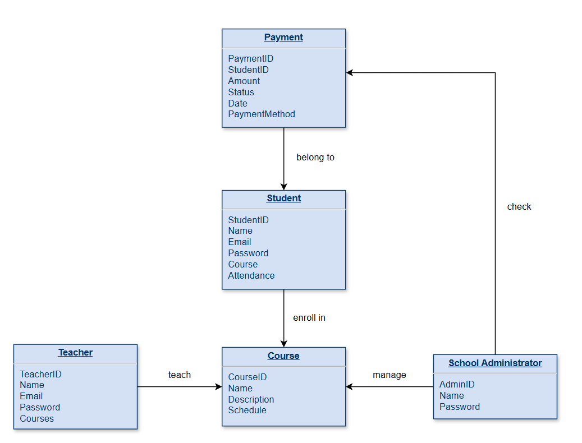

Figure 2. Entity-relationship diagrams for release 1.0 of the EduManager

