VIETNAM GENERAL CONFEDERATION OF LABOR
TON DUC THANG UNIVERSITY
FACULTY OF INFORMATION TECHNOLOGY



Le Nhat Huy– 523H0138
Ta Duong – 523H0131

ENDTERM REPORT

Deep Learning

HO CHI MINH CITY, 2026
VIETNAM GENERAL CONFEDERATION OF LABOR
TON DUC THANG UNIVERSITY
FACULTY OF INFORMATION TECHNOLOGY



Le Nhat Huy– 523H0138
Ta Duong – 523H0131

ENDTERM REPORT

Deep Learning

Advised by
Associate Professor Dr. Le Anh Cuong

HO CHI MINH CITY, 2026
ACKNOWLEDGEMENT
We are grateful for the opportunity to study Deep Learning at Ton Duc Thang University. This course has provided us with valuable knowledge and practical experience in developing multimodal models, particularly for Visual Question Answering (VQA) and image captioning tasks.
We would like to express our sincere thanks to Assoc. Prof. Dr. Le Anh Cuong for his dedicated guidance and support throughout this course. His instruction has greatly contributed to our understanding of both theoretical concepts and practical implementation in deep learning.
Although we have made our best efforts to complete this project, there may still be some shortcomings due to limited experience and time constraints. We sincerely welcome your feedback and suggestions for further improvement.
Finally, we wish you good health and continued success in your work.

Best regards.
Best regards. Ho Chi Minh city, 25th April 2026.
Author
(Signature and full name)

Nguyen Minh Hoang Vu

Le Nhat Huy

Tran Van Qui

DECLARATION OF AUTHORSHIP
We hereby declare that this project is our own work, conducted under the guidance of Assoc. Prof. Dr. Le Anh Cuong. The research content and results presented in this report are original and have not been published in any form prior to this submission.
All data used for analysis, evaluation, and discussion are collected from various sources and are clearly cited in the reference section. In addition, any materials, comments, or data from other authors or organizations have been properly acknowledged and referenced.
We take full responsibility for the content of this project. Ton Duc Thang University is not responsible for any copyright or intellectual property violations that may arise during the implementation of this work (if any).
Ho Chi Minh city, 25th April 2026.
Author
(Signature and full name)

Nguyen Minh Hoang Vu

Le Nhat Huy

Tran Van Qui

LIST OF FIGURES
Figure 1 Question Type Distribution 2
Figure 2 Q&A Length Distribution 3

LIST OF TABLES
Table 1 Configuration Description Table 4

TABLE OF CONTENT

ABBREVIATIONS
DL | Deep Learning
VQA | Visual Question Answering
QA | Question – Answer
EDA | Exploratory Data Analysis
BLIP | Bootstrapped Language-Image Pretraining
CNN | Convolutional Neural Network
RNN | Recurrent Neural Network
ROUGE | Recall-Oriented Understudy for Gisting Evaluation
BERTScore | Semantic similarity metric based on BERT
METEOR | Metric for Evaluation of Translation with Explicit ORdering
BLEU | Bilingual Evaluation Understudy

Theoretical Background

Deep Learing
Deep Learning (DL) is a subfield of Machine Learning that focuses on training neural networks with multiple layers to learn complex patterns from data. Unlike traditional machine learning methods, deep learning models automatically extract hierarchical features from raw inputs such as images and text.
In recent years, deep learning has achieved significant success in various domains, particularly in computer vision and natural language processing. Its ability to model non-linear relationships makes it highly suitable for multimodal tasks such as Visual Question Answering (VQA) and image captioning.

Convolutional Neural Networks (CNN)
Convolutional Neural Networks (CNNs) are widely used for image processing tasks. A CNN consists of convolutional layers, pooling layers, and fully connected layers.
The convolution operation allows the model to extract spatial features such as edges, textures, and object structures. Pooling layers reduce spatial dimensions while preserving important information.
Popular CNN architectures such as ResNet50 and DenseNet121 are commonly used as image encoders due to their strong feature extraction capabilities.

Recurrent Neural Networks and LSTM
Recurrent Neural Networks (RNNs) are designed to process sequential data such as text. However, standard RNNs suffer from the vanishing gradient problem, making it difficult to learn long-term dependencies.
To address this issue, Long Short-Term Memory (LSTM) networks are introduced. LSTM uses gating mechanisms (input gate, forget gate, and output gate) to control the flow of information, allowing the model to retain relevant context over long sequences.
LSTM is widely used in sequence generation tasks, including text generation and image captioning.

Transformer Architecture
The Transformer architecture has become the dominant approach in modern deep learning, especially for language and multimodal tasks. Unlike RNNs, Transformers rely entirely on the self-attention mechanism to model relationships between tokens.
Self-attention allows the model to focus on different parts of the input sequence dynamically. Multi-head attention further enhances this capability by learning multiple representation subspaces.
Transformer-based models provide better parallelization and capture long-range dependencies more effectively than traditional sequential models.

Multimodal Learning
Multimodal learning refers to the integration of multiple data modalities, such as images and text, into a unified model.
In tasks like Visual Question Answering, the model must understand both visual content and natural language. This requires effective fusion strategies, including:
- Early fusion: combining features at input level
- Late fusion: combining features at decision level
Multimodal learning enables richer representations and improves performance in complex reasoning tasks.

Vision Language Models
Vision-language models are designed to jointly process images and text. One prominent model is BLIP.
BLIP consists of a vision encoder and a text decoder connected through cross-attention mechanisms. The model is pretrained on large-scale image-text datasets, enabling strong generalization across multiple tasks such as VQA and image captioning.
By leveraging multimodal pretraining, BLIP can learn meaningful alignments between visual and textual representations.

Evaluation Metrics
To evaluate the performance of generated text, several metrics are commonly used.
BLEU measures n-gram overlap between generated and reference text, while ROUGE-L focuses on sequence similarity using the longest common subsequence. METEOR considers synonym matching and linguistic variations.
Additionally, BERTScore evaluates semantic similarity using contextual embeddings, providing a more robust assessment beyond surface-level matching.
Exact Match Accuracy is also used in tasks like VQA to measure strict correctness of predictions.

Visual Question Answering

Problem Definition
Visual Question Answering (VQA) is a multimodal task that requires a model to answer natural language questions based on visual content. In this project, we focus on building a Vietnamese VQA system in the domain of Vietnamese food.
The system takes two inputs:
- An image of a Vietnamese dish
- A question in Vietnamese
and generates a short answer (≤ 10 words).
This task is challenging because it requires the integration of visual understanding and language reasoning. The model must extract meaningful features from the image, understand the semantics of the question, and generate a correct answer conditioned on both modalities.
The system is designed to handle multiple types of questions, including recognition, yes/no, attribute, counting, and spatial reasoning.

Dataset Construction
The dataset is constructed from a Vietnamese food image collection, consisting of 30 classes with 100 images per class, resulting in a total of 3000 images.
For each image, multiple question–answer (QA) pairs are generated using a large language model, ensuring diversity across five question types: recognition, yes/no, attribute, counting, and spatial.
The final dataset contains approximately 18,000 QA pairs. The data is split at the image level into training, validation, and test sets with a ratio of 80/10/10 to prevent data leakage.
To improve data quality, additional preprocessing steps are applied, including balancing yes/no answers and ensuring uniform distribution across classes.

Data Analysis (EDA)
Exploratory Data Analysis (EDA) is conducted to better understand the dataset.
The dataset is well-balanced across all 30 classes, with each class containing exactly 100 images. The distribution of question types is uniform, as each image is associated with five QA pairs of different types.
Answer lengths are generally short, with most answers containing fewer than 10 words, satisfying the task constraint. The vocabulary size is moderate, allowing efficient training without excessive sparsity.
An initial bias toward affirmative answers in yes/no questions is identified and corrected using hard-negative sampling, resulting in a balanced distribution between "Có" and "Không".
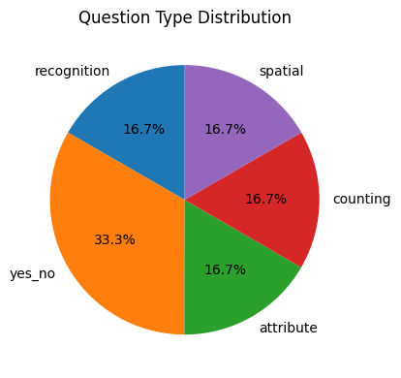
Figure 1 Question Type Distribution
Figure above illustrates the distribution of question types in the dataset. The dataset is designed to include five categories: recognition, yes/no, attribute, counting, and spatial.
Among them, yes/no questions account for approximately 33.3%, while the remaining categories are evenly distributed at around 16.7% each. This slight imbalance is intentional, as yes/no questions are common in real-world VQA tasks and help the model learn binary reasoning.
Overall, the distribution remains relatively balanced, ensuring that the model is exposed to diverse reasoning types.
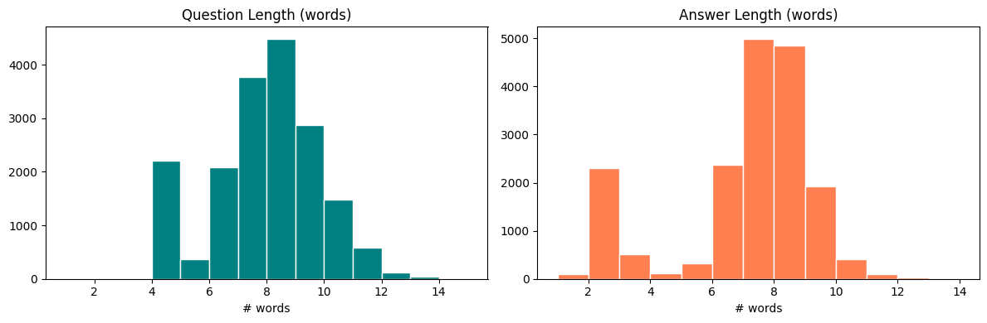
Figure 2 Q&A Length Distribution
The distribution of question and answer lengths is shown in the figure above.
Most questions contain between 6 and 10 words, with an average length of approximately 8 words. This indicates that the questions are sufficiently descriptive without being overly complex.
Similarly, answers are generally short, typically ranging from 6 to 9 words. This satisfies the constraint of keeping answers concise (≤ 10 words), while still providing enough information for meaningful responses.
The relatively narrow distribution of lengths helps stabilize model training, as it reduces variability in sequence length and improves convergence.

Preprocessing
Data preprocessing is applied to both image and text modalities to ensure compatibility with the model architecture.
For images, all inputs are resized to 224×224 pixels and normalized using ImageNet statistics. Data augmentation techniques such as random horizontal flipping and color jitter are applied during training to improve generalization.
For text, Vietnamese sentences are segmented using underthesea and tokenized using the PhoBERT tokenizer. Both questions and answers are padded or truncated to fixed lengths.
An answer vocabulary is constructed using only the training set to avoid data leakage. Special tokens such as <PAD>, <BOS>, <EOS>, and <UNK> are included to support sequence generation.

Model Architecture
Two main approaches are implemented in this project.
Approach A (Custom Architecture) uses separate encoders for image and text. A pretrained ResNet50 extracts visual features, while PhoBERT encodes the input question. The two feature vectors are fused via concatenation and passed to a decoder.
Two decoder variants are explored:
- A1: LSTM-based decoder for sequential generation
- A2: Transformer-based decoder using self-attention and cross-attention
Approach B (Multimodal Pretrained) uses the BLIP model. Two configurations are evaluated:
- B1: Zero-shot (no fine-tuning)
- B2: Fine-tuned on the dataset
For Vietnamese handling, B1 uses a translation pipeline, while B2 directly learns Vietnamese through fine-tuning.
Configuration | Description
A1 | Direction A with LSTM decoder
A2 | Direction A with Transformer decoder
B1 | Direction B no training required
B2 | Direction B fine-tuned
Table 1 Configuration Description Table

Multimodal Pretrained Approach
In addition to the custom architecture, a pretrained multimodal model is incorporated to evaluate the effectiveness of vision-language representations.
In this project, the BLIP (Bootstrapping Language-Image Pretraining) model is selected due to its strong performance in visual question answering tasks. BLIP is designed to jointly encode visual and textual information, enabling efficient multimodal reasoning.
Two configurations are considered. In the first configuration (B1), the model is used in a zero-shot setting without any fine-tuning. Since BLIP is primarily trained on English data, a translation pipeline is applied to convert Vietnamese questions into English before inference, and the predicted answers are translated back into Vietnamese.
In the second configuration (B2), the model is fine-tuned on the constructed Vietnamese dataset. To improve training efficiency and prevent overfitting, most encoder parameters are frozen, while only selected decoder layers are updated using parameter-efficient techniques such as LoRA or PEFT.
This setup allows a direct comparison between zero-shot generalization and fine-tuned performance in a domain-specific Vietnamese VQA task.

Evaluation Methods
To rigorously assess model performance, a combination of exact matching, n-gram-based, and semantic similarity metrics is employed.
Exact Match Accuracy is used as the primary evaluation metric, reflecting strict correctness by measuring whether the predicted answer exactly matches the ground truth. To address the inherent ambiguity of natural language, Soft Accuracy (as defined in VQA v2) is additionally considered.
To evaluate textual quality, BLEU, ROUGE-L, and METEOR are utilized. BLEU measures n-gram overlap, ROUGE-L captures sequence-level similarity via longest common subsequence, and METEOR incorporates synonym matching and linguistic variations.
Furthermore, BERTScore is adopted to measure semantic similarity by comparing contextual embeddings, thereby providing a more robust evaluation beyond surface-level matching.
Finally, an LLM-as-a-judge framework is considered for qualitative assessment, where a large language model evaluates answer correctness given both visual and textual inputs.
Due to ongoing experiments, detailed quantitative results will be reported in the final version.

Training Strategy
The training and implementation strategies differ significantly between the four configurations to evaluate the impact of supervised learning versus zero-shot inference.

For Custom Architectures (A1 & A2)
The training for ResNet50-PhoBERT models focuses on bridging the gap between frozen pre-trained encoders and task-specific decoders:
- Initialization and Freezing: In the initial stage (first 3 epochs), the ResNet50 and PhoBERT encoders are completely frozen to allow the randomly initialized LSTM or Transformer decoder to adapt to the extracted features without distorting the pre-trained weights.
- Gradual Unfreezing: After the 3rd epoch, the high-level layers of the encoders are unfrozen, and the model is trained with a lower learning rate $\left({10}^{-5}\right)$ to fine-tune the entire pipeline.
- Decoding Strategies:
- A1 (LSTM): Trained using Teacher Forcing to accelerate convergence by feeding ground-truth tokens into the next time step.
- A2 (Transformer): Utilizes Scheduled Sampling and is evaluated using Beam Search (size=3) to improve sequence coherence.

Configuration B1: Zero-shot Inference Strategy
Unlike the other configurations, B1 does not undergo any training or fine-tuning on the local dataset:
- Zero-shot Nature: The model uses the original Salesforce/blip-vqa-base weights without updating any parameters.
- Translation Pipeline: To handle the language barrier, a three-step inference strategy is used: translating the Vietnamese question to English, performing VQA inference, and translating the English result back to Vietnamese.
- Baseline Purpose: This serves as a control group to measure the foundational vision-language alignment of BLIP before domain-specific adaptation.

For Fine-tuned BLIP (B2)
The strategy for B2 focuses on direct domain adaptation through supervised learning:
- Two-Phase Fine-Tuning: Initial epochs focus on adapting the text decoder to Vietnamese food terminology while freezing the vision encoder, followed by a second phase where the entire model is unfrozen at a very low learning rate.
- Optimization: AdamW is paired with Mixed Precision (fp16) and Gradient Accumulation to manage the large parameter count and memory constraints.

Reinforcement Learning (DPO)
As a final refinement, the B2 model undergoes Direct Preference Optimization (DPO) using a dataset of 150 pairs to align predictions with human preferences and reduce common hallucinations

Evaluation Methods
To rigorously assess the performance of the VQA system, a combination of strict and semantic metrics is employed:
- Exact Match (EM): The primary metric for VQA, requiring the predicted answer to match the ground truth exactly (string-to-string).
- Text Similarity Metrics:
- BLEU-4 & ROUGE-L: Used to evaluate the quality of word overlap and longest common subsequence, particularly for descriptive answers.
- METEOR: Provides a more robust evaluation by considering synonyms and stemming.
- Semantic Similarity (BERTScore): Leverages contextual embeddings from PhoBERT to measure the semantic alignment between the prediction and the ground truth, acknowledging correct answers that use different wording.
- Qualitative Evaluation (LLM-as-a-Judge): A subset of the test results was evaluated by Gemini-1.5-Flash to provide a "Human-like" score (on a scale of 0 to 1), assessing the logical reasoning behind the answers.

CHEST X-RAY REPORT GENERATION

Problem Definition
Medical Report Generation is a specialized variant of the image captioning problem in computer vision, where the objective is to generate clinically meaningful textual descriptions from medical images.
In this work, the task focuses on chest X-ray report generation. Given a chest X-ray image as input, the model is required to produce a textual report describing radiological findings, mimicking the workflow of radiologists in clinical practice.
Unlike standard image classification tasks, this problem is inherently multimodal (vision-to-language) and significantly more challenging. The output is a variable-length sequence, requiring the model to both identify abnormal regions in the image and generate coherent domain-specific medical language. Furthermore, medical reports follow a structured style, often containing specialized terminology and frequent negation patterns such as “no acute findings” or “unremarkable”.

Dataset
The dataset used in this study is the Indiana University Chest X-ray dataset, which consists of paired chest X-ray images and corresponding radiology reports. The preprocessing pipeline includes filtering out samples with missing or empty findings, mapping images to reports via unique identifiers, and selecting a single representative image per study. After preprocessing, approximately 3,337 image–report pairs are obtained.
The dataset is divided into training, validation, and test sets with a ratio of 80/10/10 to ensure reproducibility and fair evaluation. Additionally, report length analysis is conducted to determine an appropriate maximum sequence length. For the BLIP model, MAX_LEN is set to 128 to accommodate WordPiece tokenization. A crucial data cleaning step involves removing the HIPAA-anonymized "XXXX" placeholders using Regular Expressions to prevent artificially inflated evaluation metrics.

Text & Image Preprocessing
For the baseline model (DenseNet + LSTM), images are resized to 224×224 and normalized using ImageNet statistics. Text is tokenized using spaCy, and a custom vocabulary of 839 words is built with a minimum frequency threshold of 3.
In contrast, the BLIP model utilizes a unified BlipProcessor. Images are resized to a higher resolution of 384×384 to preserve fine-grained pathological details. Text processing employs a BertTokenizer with approximately 30,000 WordPiece tokens. This subword tokenization effectively handles rare medical terminology, eliminating the out-of-vocabulary (<unk>) problem encountered in the baseline approach.

Model Architecture

Baseline Model: DenseNet + LSTM
The baseline model follows a classical encoder–decoder architecture inspired by the “Show, Attend and Tell” framework.
The image encoder is based on DenseNet (DenseNet121), pretrained on ImageNet. It extracts spatial visual features from the input image, which are then reshaped into a sequence of feature vectors.
The decoder is implemented using an LSTM with Bahdanau attention. At each time step, the decoder attends to different spatial regions of the image and generates one token sequentially.
However, this approach has several limitations:
- The encoder is pretrained only on natural images, not medical data
- The decoder relies on a small vocabulary (~839 words)
- No multimodal pretraining between image and text
- LSTM struggles with long-range dependencies

Proposed Approach: BLIP Fine-tuned
The proposed model is based on the BLIP architecture, a unified vision-language model pretrained on large-scale image–text pairs.
The model consists of two main components:
Vision Encoder:
- A Vision Transformer (ViT-B/16) is used to extract visual features. The image is divided into patches and processed using self-attention, allowing the model to capture global context effectively.
Text Decoder:
- A Transformer-based decoder inspired by BERT is used to generate the report. It incorporates masked self-attention for autoregressive generation and cross-attention to integrate visual features.
This architecture enables strong multimodal reasoning and significantly improves performance compared to traditional methods.

Training and Optimization Strategies
The baseline model is trained for 30 epochs using Teacher Forcing and the Adam optimizer. The DenseNet121 encoder remains completely frozen throughout the training process to prevent overfitting on the small dataset.
For the BLIP model, a two-phase fine-tuning strategy is implemented over 8 epochs to prevent catastrophic forgetting. In Phase 1 (Epochs 1-2), the ViT encoder is frozen, allowing the text decoder to adapt to the medical domain. In Phase 2 (Epochs 3-8), the vision encoder is unfrozen and trained with a learning rate ten times smaller than that of the decoder [cite: 220-222]. [cite_start]To manage memory constraints, mixed precision (fp16) and gradient accumulation are utilized.

Experimental Results and Training Dynamics
To comprehensively evaluate the performance of the proposed architecture against the baseline, both quantitative metrics and training dynamics are analyzed. The quantitative evaluation is conducted using standard n-gram overlap metrics, including BLEU, ROUGE-L, and METEOR, alongside the semantic similarity metric BERTScore. All metrics are calculated after a rigorous data cleaning step to remove anonymized placeholders, ensuring a perfectly fair comparison.
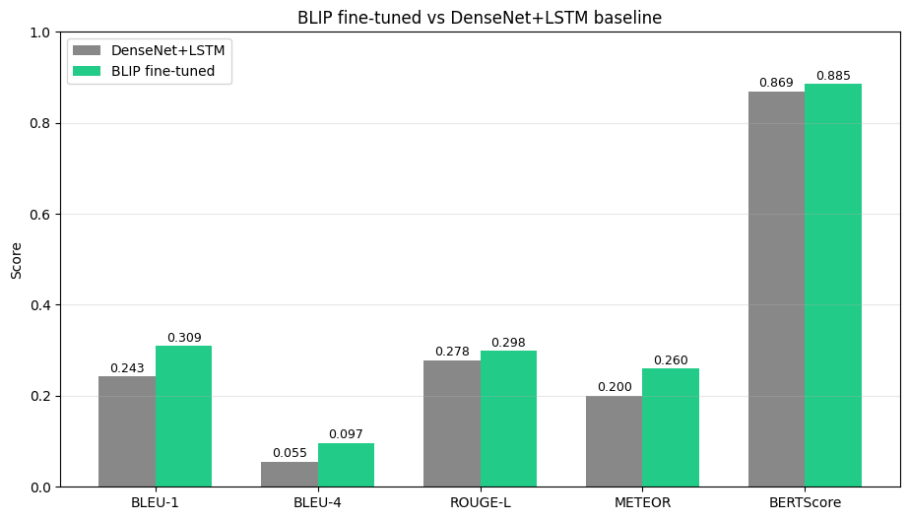
Figure 3 BLIP fine-tuned vs DenseNet+LSTM baseline
- Conclusion
As illustrated in the performance comparison chart above, the fine-tuned BLIP model demonstrates a consistent and substantial superiority over the DenseNet and LSTM baseline across all measured criteria. Specifically, the baseline model achieved a BLEU-1 score of 0.243, a BLEU-4 score of 0.055, a ROUGE-L score of 0.278, a METEOR score of 0.200, and a BERTScore of 0.869. In stark contrast, the proposed BLIP architecture yielded significantly higher results, achieving a BLEU-1 score of 0.309, a BLEU-4 score of 0.097, a ROUGE-L score of 0.298, a METEOR score of 0.260, and a BERTScore of 0.885. The most notable improvement is observed in the strict BLEU-4 metric, which nearly doubled compared to the baseline. This significant enhancement indicates that the foundational vision-language pre-training and the advanced contextual modeling capabilities of the Transformer decoder allow the model to generate medical phrasing that is both grammatically accurate and structurally coherent, effectively overcoming the sequential limitations of the traditional RNN approach.
Furthermore, the high BERTScore confirms that the generated reports are highly aligned with the ground truth in terms of clinical semantics.
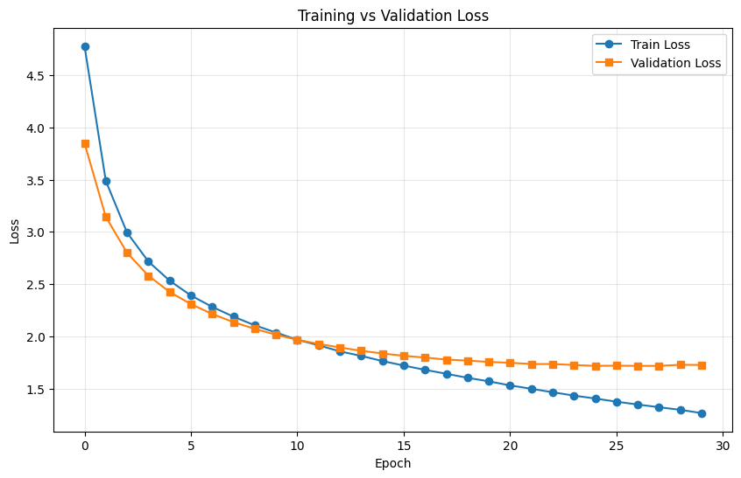 | 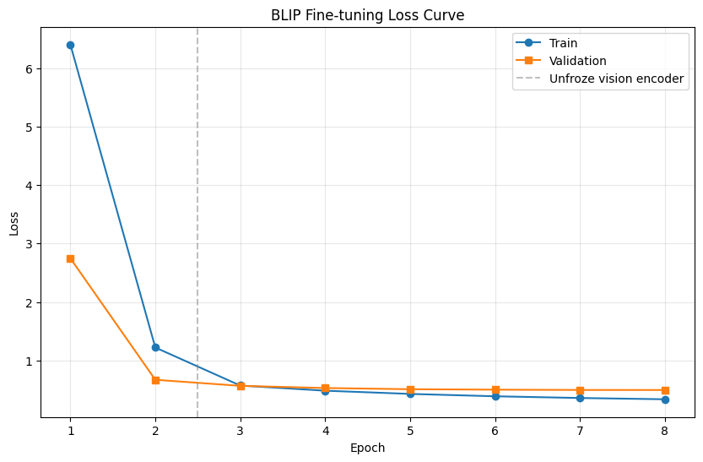
Figure 4 Training vs Validation Loss and BLIP Fine-tuning Loss Curve
- Conclusion
Analyzing the loss curves highlights the distinct learning efficiency of both architectures. The baseline DenseNet and LSTM model shows a gradual decline over 30 epochs, with validation loss steadily converging from approximately 3.8 to 1.7. This indicates stable but inherently slow learning, as the model trains entirely from scratch.
Conversely, the pre-trained BLIP model achieves remarkably rapid convergence within just 8 epochs. Training loss drops sharply from over 6.0 to roughly 1.2 immediately after the first epoch. Unfreezing the vision encoder after epoch 2 (indicated by the vertical dashed line) allows the validation loss to rapidly stabilize at a very low value of approximately 0.5. This confirms that the two-phase fine-tuning strategy efficiently adapts the model to the specialized X-ray domain while successfully preventing catastrophic forgetting.

Limitations and Future Work
Despite the significant improvements achieved by the BLIP model, the absolute BLEU-4 score remains relatively low compared to general image captioning tasks. This is primarily due to the highly subjective nature of medical reporting, where different radiologists may use entirely different phrasing for the same clinical findings. Furthermore, the dataset utilized is relatively small (approximately 2.6k training samples) compared to the 247 million parameters of the BLIP model, which inevitably leads to early overfitting.
To further enhance the system, future work should focus on scaling up the training process using larger datasets such as MIMIC-CXR. Additionally, initializing the architecture with domain-specific checkpoints, such as BiomedCLIP or MedCLIP, could provide a stronger foundational understanding of medical imagery. Incorporating the patient's clinical history and the "impression" section of the report would also provide valuable context. Most importantly, future evaluations must incorporate Clinical Efficacy metrics, such as CheXbert F1, as standard n-gram metrics like BLEU do not fully capture the clinical accuracy of the generated medical findings. Exploring Reinforcement Learning with Human Feedback (RLHF) using clinical rewards represents a highly promising direction to align the generated text with actual diagnostic accuracy.

Conclusion
This project presented two deep learning applications in multimodal learning: a Vietnamese Visual Question Answering system for Vietnamese food images and a chest X-ray report generation system. Both tasks combine computer vision and natural language processing, requiring the models to understand visual information and generate meaningful textual outputs.
For the VQA task, the system was built on a Vietnamese food dataset with image–question–answer pairs covering different question types such as recognition, yes/no, attribute, counting, and spatial questions. Several model configurations were compared, including a custom architecture with LSTM decoder, a custom architecture with Transformer decoder, zero-shot BLIP, and fine-tuned BLIP. The results showed that the Transformer decoder performed better than the LSTM decoder, while fine-tuned BLIP achieved the best overall performance. This demonstrates the advantage of pretrained multimodal models when they are adapted to a specific domain and language.
For the chest X-ray report generation task, a DenseNet121 + LSTM model was used as the baseline, while a fine-tuned BLIP model was used as the main approach. Experimental results showed that BLIP outperformed the baseline across evaluation metrics such as BLEU, ROUGE-L, METEOR, and BERTScore. This improvement comes from BLIP’s vision-language pretraining, Transformer-based architecture, and stronger ability to generate coherent medical descriptions.
Overall, the project shows that pretrained multimodal models are more effective than traditional encoder–decoder architectures for complex vision-language tasks. However, some limitations remain. The VQA model still has difficulty with counting and spatial reasoning, while the chest X-ray model is limited by the small dataset size and the complexity of medical language. In future work, larger datasets, stronger vision-language models, and more human-based evaluation methods could be used to improve accuracy and reliability.
In conclusion, this project successfully demonstrates how deep learning can be applied to practical multimodal problems. The experimental results confirm the importance of Transformer architectures, fine-tuning strategies, and proper evaluation methods in building effective vision-language systems.

REFERENCES
[1] K. He, X. Zhang, S. Ren, and J. Sun, “Deep Residual Learning for Image Recognition,” in Proceedings of the IEEE Conference on Computer Vision and Pattern Recognition (CVPR), 2016, pp. 770–778.
[2] G. Huang, Z. Liu, L. van der Maaten, and K. Q. Weinberger, “Densely Connected Convolutional Networks,” in Proceedings of the IEEE Conference on Computer Vision and Pattern Recognition (CVPR), 2017, pp. 4700–4708.
[3] K. Xu, J. Ba, R. Kiros, K. Cho, A. Courville, R. Salakhudinov, R. Zemel, and Y. Bengio, “Show, Attend and Tell: Neural Image Caption Generation with Visual Attention,” in Proceedings of the 32nd International Conference on Machine Learning (ICML), 2015, pp. 2048–2057.
[4] A. Vaswani, N. Shazeer, N. Parmar, J. Uszkoreit, L. Jones, A. N. Gomez, Ł. Kaiser, and I. Polosukhin, “Attention Is All You Need,” in Advances in Neural Information Processing Systems (NeurIPS), vol. 30, 2017.
[5] J. Li, D. Li, C. Xiong, and S. C. H. Hoi, “BLIP: Bootstrapping Language-Image Pre-training for Unified Vision-Language Understanding and Generation,” in Proceedings of the 39th International Conference on Machine Learning (ICML), 2022, pp. 12888–12900.
[6] D. Q. Nguyen and A. T. Nguyen, “PhoBERT: Pre-trained Language Models for Vietnamese,” in Findings of the Association for Computational Linguistics: EMNLP 2020, 2020, pp. 1037–1042.
[7] Y. Goyal, T. Khot, D. Summers-Stay, D. Batra, and D. Parikh, “Making the V in VQA Matter: Elevating the Role of Image Understanding in Visual Question Answering,” in Proceedings of the IEEE Conference on Computer Vision and Pattern Recognition (CVPR), 2017, pp. 6904–6913.
[8] K. Papineni, S. Roukos, T. Ward, and W.-J. Zhu, “BLEU: A Method for Automatic Evaluation of Machine Translation,” in Proceedings of the 40th Annual Meeting of the Association for Computational Linguistics (ACL), 2002, pp. 311–318.
[9] C.-Y. Lin, “ROUGE: A Package for Automatic Evaluation of Summaries,” in Text Summarization Branches Out, 2004, pp. 74–81.
[10] S. Banerjee and A. Lavie, “METEOR: An Automatic Metric for MT Evaluation with Improved Correlation with Human Judgments,” in Proceedings of the ACL Workshop on Intrinsic and Extrinsic Evaluation Measures for Machine Translation and/or Summarization, 2005, pp. 65–72.
[11] T. Zhang, V. Kishore, F. Wu, K. Q. Weinberger, and Y. Artzi, “BERTScore: Evaluating Text Generation with BERT,” in International Conference on Learning Representations (ICLR), 2020.
[12] R. Rafailov, A. Sharma, E. Mitchell, S. Ermon, C. D. Manning, and C. Finn, “Direct Preference Optimization: Your Language Model is Secretly a Reward Model,” in Advances in Neural Information Processing Systems (NeurIPS), 2023.
[13] Open-i, “Indiana University Chest X-ray Collection,” National Library of Medicine. [Online]. Available: Open-i Indiana University Chest X-ray Collection. Accessed: May 5, 2026.
[14] raddar, “Chest X-rays Indiana University,” Kaggle Dataset. [Online]. Available: Kaggle Chest X-rays Indiana University Dataset. Accessed: May 5, 2026.

