Open beta 1
known issues:
- workprofile app tab is not implemented in NeoLauncher
- overlapping widgets is not implemented in NeoLauncher
- icon picture change with own picture is not implemented in NeoLauncher

- the Leos-Launcher widgets don’t work, but all others.
- when activating Launcher Settings / Home Widget / Schow Smartspace an warning appears, that G**gle app is missing. It’s only a onetime warning and you can go ahead
- if you activating the ‚not available‘ Gesture and using it, the Launcher will crash
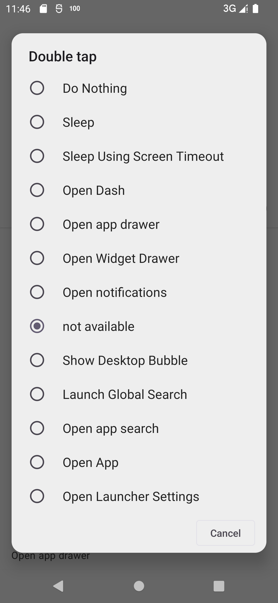

Restore of ‚old‘ backup won’t work, because of complete new sources !!!!!

If you find any bug, pls document it with screeshot or record in a document and share the document in group.

PLEASE SHARE NO BUG / SCREENSHOT ETC DIRECT IN GROUP. ONLY DOCUMENTS !!!!!!!!!!!!!!!!!!

