**AI Ops Team Run Book**

# Table of Contents

Contents

Table of Contents 2

1. 📘 Overview 4

2. 🔧 Infrastructure Components Covered 4

3. 📊 Architecture Diagram 4

4. 🕒 Daily Operations Checklist 6

5. 🚨 Incident Management 6

6. 🛠️ Standard Operating Procedures (SOPs) 6

6.1 Server Reboot Procedure 6

6.2 Disk Space Management 6

6.3 Patch Management 7

7. 📈 Monitoring & Reporting 7

8. 📞Escalation Contacts 7

9. 🧯Disaster Recovery (DR) Details - Applications 7

9.1 Core Banking 8

9.2 Internet Banking 8

9.3 Mobile Banking 8

9.4 Payment Gateway 8

9.5 Loan Origination 8

9.6 CRM System 9

9.7 Email System 9

9.8 Document Management 9

9.9 ATM Switch 9

9.10 Reporting System 9

10.🧯Disaster Recovery (DR) Details - Infrastructure 9

10.1 Web Server Recovery 9

10.3 App Server Recovery 9

10.4 Recovery Steps (UNIX): 9

10.6 Database Recovery 10

10.7 Firewall Recovery 10

10.8 Load Balancer Recovery 10

10. 9 Monitoring System Recovery 11

10.10 Storage System Recovery 11

10.11 Network Switch Recovery 11

10.12 VPN Gateway Recovery 12

10.13 Cloud Service Recovery 12

11. Change Management Process 12

12. Capacity Planning Guidelines 12

13. Security Monitoring & Compliance Checks 13

14. Automation Scripts or Tools Used 13

15. Audit & Compliance Reporting Templates 13

16. Integration with CI/CD Pipelines 13

17. Visual Timeline for DR Drills or Maintenance Windows 13

18. Change Category Timelines 14

19. Capacity Planning Breach Steps (UNIX) 14

Appendix: 14

Useful Commands & Troubleshooting Tips 14

🏦 Bank IT Production Management Runbook – Infrastructure Support

# 1. 📘 Overview

This runbook provides standardized procedures for monitoring, maintaining, and supporting the bank’s IT infrastructure in production environments. It ensures high availability, performance, and security of systems critical to banking operations.

# 2. 🔧 Infrastructure Components Covered

* **Servers**: Physical and virtual (Windows/Linux)
* **Storage Systems**: SAN/NAS
* **Network Devices**: Routers, switches, firewalls
* **Databases**: Oracle, SQL Server, PostgreSQL
* **Monitoring Tools**: Nagios, SolarWinds, Splunk
* **Backup Systems**: Veeam, Commvault
* **Cloud Services**: AWS, Azure (if applicable)

# 3. 📊 Architecture Diagram

Below is the updated architecture diagram with dummy IPs labeled for each component.

# 4. 🕒 Daily Operations Checklist

|  |  |  |
| --- | --- | --- |
| **Time** | **Task** | **Owner** |
| 06:00 | Check system health dashboards | Infra Ops |
| 07:00 | Review overnight alerts and logs | Infra Ops |
| 08:00 | Verify backups completed successfully | Backup Admin |
| 09:00 | Confirm network connectivity and latency | Network Admin |
| 10:00 | Patch compliance check (weekly) | Sys Admin |

# 5. 🚨 Incident Management

**Severity Levels**:

* P1 (Critical): Major outage affecting banking operations
* P2 (High): Partial outage or degraded performance
* P3 (Medium): Non-critical issue with workaround
* P4 (Low): Minor issue or cosmetic bug

**Response Matrix:**

|  |  |  |  |
| --- | --- | --- | --- |
| **Severity** | **Response Time** | **Resolution Time** | **Escalation** |
| P1 | 15 mins | 2 hours | Infra Head, IT Director |
| P2 | 30 mins | 4 hours | Team Lead |
| P3 | 1 hour | 24 hours | Assigned Engineer |
| P4 | 4 hours | 3 days | Assigned Engineer |

# 6. 🛠️ Standard Operating Procedures (SOPs)

## 6.1 Server Reboot Procedure

1. Notify stakeholders via email.
2. Validate backup status.
3. Reboot during approved window.
4. Post-reboot health check.

## 6.2 Disk Space Management

1. Monitor thresholds via alerts.
2. Clean temp/log files.
3. Extend volume if needed.
4. Document changes in ticketing system.

## 6.3 Patch Management

1. Review patch advisories.
2. Test in staging.
3. Schedule deployment.
4. Validate post-deployment.

# 7. 📈 Monitoring & Reporting

* Daily Health Reports: Sent by 10 AM
* Weekly Infra Summary: Includes uptime, incidents, changes
* Monthly Capacity Planning Report

# 8. 📞Escalation Contacts

|  |  |  |
| --- | --- | --- |
| **Role** | **Name** | **Contact** |
| Infra Head | Ravi Kumar | +91-XXXXXXXXXX |
| Network Lead | Priya Sharma | +91-XXXXXXXXXX |
| DB Admin | Arjun Mehta | +91-XXXXXXXXXX |
| Backup Admin | Sneha Rao | +91-XXXXXXXXXX |

# 9. 🧯Disaster Recovery (DR) Details - Applications

|  |  |  |
| --- | --- | --- |
| **Application** | **Production IP** | **DR IP** |
| Web Server | 192.168.9.10 | 10.10.10.10 |
| App Server | 192.168.9.20 | 10.10.10.20 |
| Payment Gateway | 192.168.9.30 | 10.10.10.30 |
| Core Banking | 192.168.9.40 | 10.10.10.40 |
| CRM | 192.168.9.50 | 10.10.10.50 |
| HRMS | 192.168.9.60 | 10.10.10.60 |
| Email Server | 192.168.9.70 | 10.10.10.70 |
| File Server | 192.168.9.80 | 10.10.10.80 |
| Monitoring System | 192.168.9.90 | 10.10.10.90 |
| Backup System | 192.168.9.100 | 10.10.10.100 |
| Firewall | 192.168.9.110 | 10.10.10.110 |

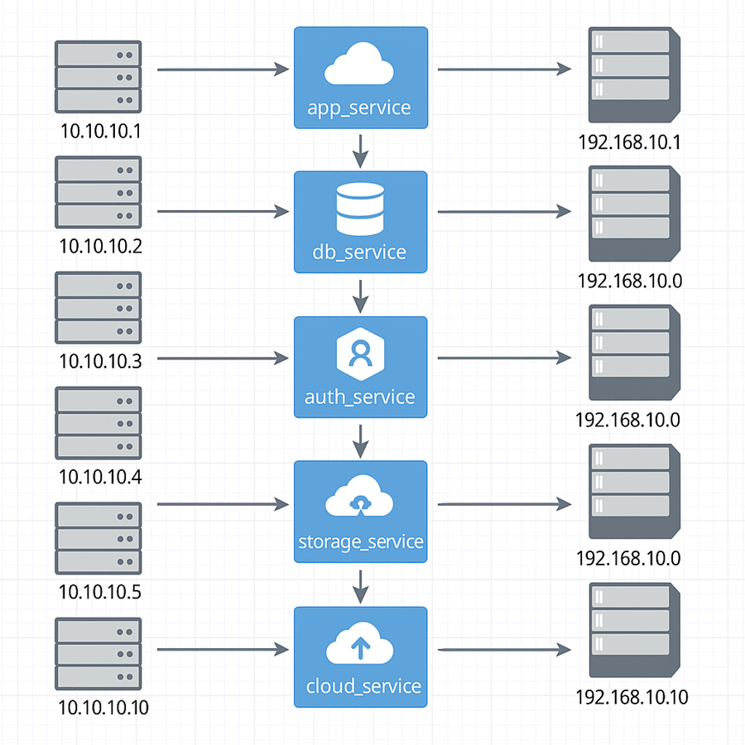

## 9.1 Core Banking

Active-Passive setup across DC1 and DC2. DR fallback via DNS switch.

## 9.2 Internet Banking

Cloud-based DR with auto-scaling. Manual failover via load balancer.

## 9.3 Mobile Banking

Hybrid DR with container replication. Fallback via Kubernetes redeploy.

## 9.4 Payment Gateway

Real-time replication to DR site. Failover via routing switch.

## 9.5 Loan Origination

Scheduled sync to DR. Manual activation via DR script.

## 9.6 CRM System

Cloud DR with snapshot restore. Fallback via cloud console.

## 9.7 Email System

DR via secondary MX records. Failover automatic.

## 9.8 Document Management

DR via replicated storage. Manual mount and service restart.

## 9.9 ATM Switch

DR via redundant hardware. Failover via hardware switch.

## 9.10 Reporting System

DR via nightly ETL to DR DB. Manual report engine activation.

# 10.🧯Disaster Recovery (DR) Details - Infrastructure

## 10.1 Web Server Recovery

Production IP: 192.168.1.1

DR IP: 10.10.10.1

**Recovery Steps (UNIX):**

* 1. Identify the impacted server using monitoring tools.
* 2. SSH into the server using credentials: ssh admin@192.168.1.1
* 3. Check system logs: tail -n 100 /var/log/syslog
* 4. Restart affected services: sudo systemctl restart <service>
* 5. Validate service status: sudo systemctl status <service>
* 6. Notify stakeholders and update incident ticket.

## 10.3 App Server Recovery

Production IP: 192.168.1.2

DR IP: 10.10.10.2

## 10.4 Recovery Steps (UNIX):

* 1. Identify the impacted server using monitoring tools.
* 2. SSH into the server using credentials: ssh admin@192.168.1.2
* 3. Check system logs: tail -n 100 /var/log/syslog
* 4. Restart affected services: sudo systemctl restart <service>
* 5. Validate service status: sudo systemctl status <service>
* 6. Notify stakeholders and update incident ticket.

## 10.6 Database Recovery

Production IP: 192.168.1.3

DR IP: 10.10.10.3

**Recovery Steps (UNIX):**

* 1. Identify the impacted server using monitoring tools.
* 2. SSH into the server using credentials: ssh admin@192.168.1.3
* 3. Check system logs: tail -n 100 /var/log/syslog
* 4. Restart affected services: sudo systemctl restart <service>
* 5. Validate service status: sudo systemctl status <service>
* 6. Notify stakeholders and update incident ticket.

**Oracle DB Recovery Steps:**

* 1. Connect to Oracle DB server: ssh oracle@192.168.1.103
* 2. Check DB status: sqlplus / as sysdba -> SELECT status FROM v$instance;
* 3. Restart DB if needed: shutdown immediate; startup;
* 4. Validate application connectivity.
* 5. Notify DB admin and update ticket.

## 10.7 Firewall Recovery

Production IP: 192.168.1.4

DR IP: 10.10.10.4

**Recovery Steps (UNIX):**

* 1. Identify the impacted server using monitoring tools.
* 2. SSH into the server using credentials: ssh admin@192.168.1.4
* 3. Check system logs: tail -n 100 /var/log/syslog
* 4. Restart affected services: sudo systemctl restart <service>
* 5. Validate service status: sudo systemctl status <service>
* 6. Notify stakeholders and update incident ticket.

## 10.8 Load Balancer Recovery

Production IP: 192.168.1.5

DR IP: 10.10.10.5

**Recovery Steps (UNIX):**

* 1. Identify the impacted server using monitoring tools.
* 2. SSH into the server using credentials: ssh admin@192.168.1.5
* 3. Check system logs: tail -n 100 /var/log/syslog
* 4. Restart affected services: sudo systemctl restart <service>
* 5. Validate service status: sudo systemctl status <service>
* 6. Notify stakeholders and update incident ticket.

## 10. 9 Monitoring System Recovery

Production IP: 192.168.1.6

DR IP: 10.10.10.6

**Recovery Steps (UNIX):**

* 1. Identify the impacted server using monitoring tools.
* 2. SSH into the server using credentials: ssh admin@192.168.1.6
* 3. Check system logs: tail -n 100 /var/log/syslog
* 4. Restart affected services: sudo systemctl restart <service>
* 5. Validate service status: sudo systemctl status <service>
* 6. Notify stakeholders and update incident ticket.

## 10.10 Storage System Recovery

Production IP: 192.168.1.7

DR IP: 10.10.10.7

**Recovery Steps (UNIX):**

* 1. Identify the impacted server using monitoring tools.
* 2. SSH into the server using credentials: ssh admin@192.168.1.7
* 3. Check system logs: tail -n 100 /var/log/syslog
* 4. Restart affected services: sudo systemctl restart <service>
* 5. Validate service status: sudo systemctl status <service>
* 6. Notify stakeholders and update incident ticket.
* 5. Notify DB admin and update ticket.

## 10.11 Network Switch Recovery

Production IP: 192.168.1.8

DR IP: 10.10.10.8

**Recovery Steps (UNIX):**

* 1. Identify the impacted server using monitoring tools.
* 2. SSH into the server using credentials: ssh admin@192.168.1.8
* 3. Check system logs: tail -n 100 /var/log/syslog
* 4. Restart affected services: sudo systemctl restart <service>
* 5. Validate service status: sudo systemctl status <service>
* 6. Notify stakeholders and update incident ticket.

## 10.12 VPN Gateway Recovery

Production IP: 192.168.1.9

DR IP: 10.10.10.9

**Recovery Steps (UNIX):**

* 1. Identify the impacted server using monitoring tools.
* 2. SSH into the server using credentials: ssh admin@192.168.1.9
* 3. Check system logs: tail -n 100 /var/log/syslog
* 4. Restart affected services: sudo systemctl restart <service>
* 5. Validate service status: sudo systemctl status <service>
* 6. Notify stakeholders and update incident ticket.

## 10.13 Cloud Service Recovery

Production IP: 192.168.1.10

DR IP: 10.10.10.10

**Recovery Steps (UNIX):**

* 1. Identify the impacted server using monitoring tools.
* 2. SSH into the server using credentials: ssh admin@192.168.1.10
* 3. Check system logs: tail -n 100 /var/log/syslog
* 4. Restart affected services: sudo systemctl restart <service>
* 5. Validate service status: sudo systemctl status <service>
* 6. Notify stakeholders and update incident ticket.

# 11. Change Management Process

CAB Workflow: Request → Review → Approval → Implementation → Validation

|  |  |
| --- | --- |
| **Step** | **Description** |
| 1 | Submit change request in ServiceNow |
| 2 | CAB reviews impact and risk |
| 3 | Approval from stakeholders |
| 4 | Implement during change window |
| 5 | Post-change validation and closure |

# 12. Capacity Planning Guidelines

Monthly review of CPU, Memory, Disk usage across servers. Threshold: 80% utilization.

|  |  |  |
| --- | --- | --- |
| **Resource** | **Threshold** | **Action** |
| CPU | 80% | Upgrade or load balance |
| Memory | 75% | Add RAM or optimize apps |
| Disk | 85% | Extend volume or archive data |

# 13. Security Monitoring & Compliance Checks

Tools: Splunk, Qualys, Nessus. Daily scans and monthly compliance reports.

|  |  |  |
| --- | --- | --- |
| **Check** | **Frequency** | **Tool** |
| Vulnerability Scan | Daily | Nessus |
| Log Review | Daily | Splunk |
| Patch Compliance | Weekly | Qualys |

# 14. Automation Scripts or Tools Used

Tools: Ansible, PowerShell, Bash scripts.

|  |  |
| --- | --- |
| **Tool** | **Purpose** |
| Ansible | Server provisioning |
| PowerShell | Windows patching |
| Bash | Unix health checks |

# 15. Audit & Compliance Reporting Templates

Monthly audit reports include access logs, change history, and patch status.

|  |  |  |
| --- | --- | --- |
| **Report** | **Frequency** | **Owner** |
| Access Logs | Monthly | Security Team |
| Change History | Monthly | Infra Ops |
| Patch Status | Monthly | Sys Admin |

# 16. Integration with CI/CD Pipelines

CI/CD tools: Jenkins, GitLab. Infra scripts versioned and deployed via pipelines.

|  |  |
| --- | --- |
| **Tool** | **Function** |
| Jenkins | Automated deployment |
| GitLab | Version control |
| Terraform | Infra provisioning |

# 17. Visual Timeline for DR Drills or Maintenance Windows

DR Drill Timeline:

|  |  |
| --- | --- |
| **Time** | **Activity** |
| 08:00 | Initiate DR drill |
| 08:30 | Failover DB to DR site |
| 09:00 | Validate application connectivity |
| 10:00 | Rollback to primary site |

# 18. Change Category Timelines

|  |  |  |
| --- | --- | --- |
| Change Type | Timeline | Approval Required |
| Emergency | Within 1 hour | Infra Head |
| Standard | 2 business days | CAB |
| Major | 5 business days | CAB + IT Director |

# 19. Capacity Planning Breach Steps (UNIX)

1. Monitor disk usage: df -h
2. Identify large files: du -sh * | sort -h
3. Clean up temp/log files: sudo rm -rf /var/log/*.gz
4. Extend volume if needed: lvextend -L +10G /dev/mapper/root
5. Resize filesystem: resize2fs /dev/mapper/root
6. Update capacity planning dashboard and notify stakeholders.

# Appendix:

# Useful Commands & Troubleshooting Tips

**Common commands**:

Unix: df -h, top, ps aux, netstat -tulnp

Windows: ipconfig, tasklist, netstat -an