INTE2580/77 – Security Testing Assignment 2

Prepared by: Le Phuc Thinh
Student ID: s3893964

Table of Contents
Contents
Table of Contents 2
Section 1: Intrusion Detection 3
Q1.1 3
Q1.2 3
Q1.3 3
Q1.4 3
Q1.5 3
Q1.6 3
Q1.7 3
Q1.8 5
Q1.9 6
Section 2: Firewalls 6
Q2.1 6
Q2.2 8
Fig8: Q2.2 output 9
Q2.3 9
Q2.4 11
Q2.5 13
Section 3: Symmetric Encryption 16
Q3.1 16
Q3.2 17
Q3.3 19
Section 4: Appendix 20

Section 1: Intrusion Detection

Q1.1
- NIDS is the better intrusion detection method here because we can place it at a gateway to filter out packets with malicious characters. However, since the packets or encrypted because of HTTPS we need to have TLS interception so the NIDS can read the packets. This will provide real time alert compared to HIDS/logging because those 2 methods only alert after the packets reached the host.

Q1.2
- Logging is the better method here because we want low latency with many users online for the website. So, logging will keep logs of all the requests and analyze them offline later.

Q1.3
- NIDS should be used here because the packets on port 25 are unencrypted so a NIDS could scan it for phishing attacks.

Q1.4
- For script kiddies the signature-based technique is good since these attackers used known tools so we could detect common patterns from these attacks easily.

Q1.5
- Specification-based detection techniques are good here because we can set legal actions for the IDS so any abnormal behavior outside these rules like unauthorized employee accessing the protected /etc/passwd file is flag.

Q1.6
- Anomaly-based is the best here because it is good against unseen attacks and we can set normal system behavior so anything that is different from the baseline is flag.

Q1.7
First you want to open your VM, install Snort and set it up. Then go into terminal and type “sudo nano /etc/snort/rules/local.rules” to open snort rules file and edit.
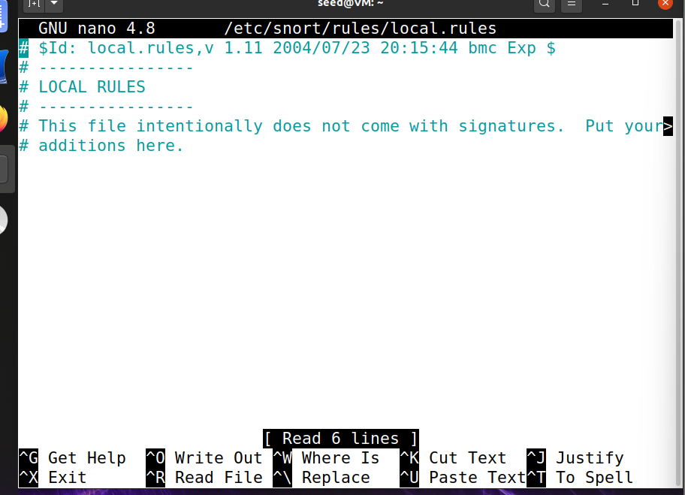
Fig1:Snort rule file
From here add your snort rule with these lines:
# Detect ICMP echo requests (pings) to subnet 10.0.2.0/24
alert icmp any any -> 10.0.2.0/24 any (itype:8; msg:"Le Phuc Thinh external ICMP test detected against the subnet"; sid:389396401; rev:1;)

# Detect ICMP echo requests to your IP_1 (3.9.6.4)
alert icmp any any -> 3.9.6.4 any (itype:8; msg:"Le Phuc Thinh external ICMP test detected against the subnet"; sid:389396402; rev:1;)
Then type this command to validate the Snort rules: sudo snort -T -c /etc/snort/snort.conf -i enp0s3.

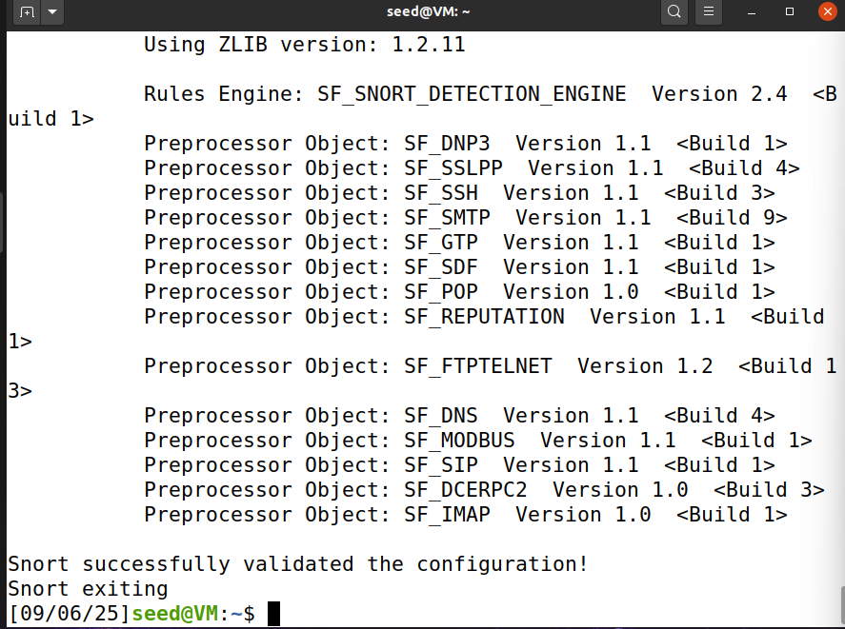
Fig 2: Snort successfully validated
Then launch it with this command: sudo snort -A console -q -u snort -g snort -c /etc/snort/snort.conf -i enp0s3

Q1.8
When snort is running, we can open a new terminal to type this command to ping: sudo ping -b -c 4 10.0.2.0
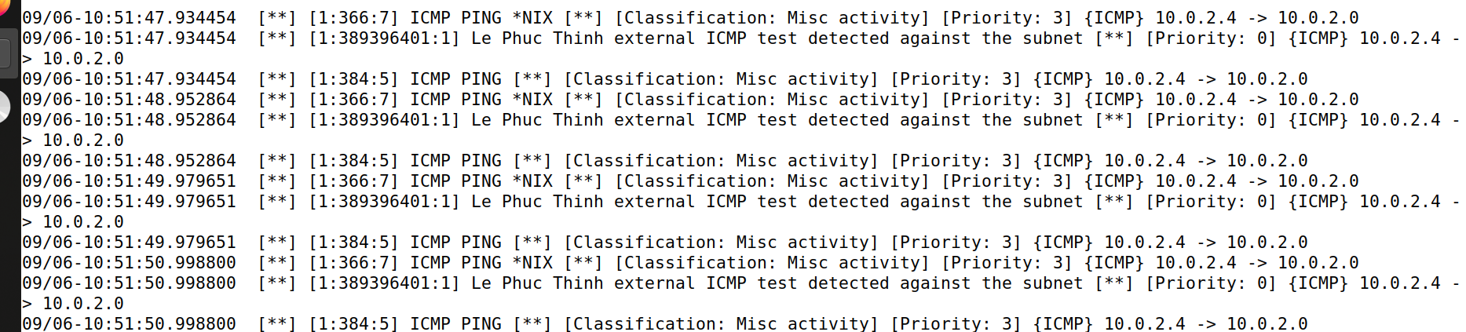
Fig3: Alert message 1

Q1.9
To test if snort is working when we ping IP1 we can type this command in a new window: ping -c 4 3.9.6.4
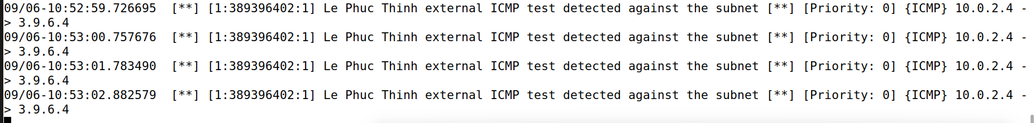
Fig4: Alert message 2

Section 2: Firewalls

Q2.1
First to set up this lab you want to download the Labsetup-firewall.zip. Then open a terminal and unzip it. Type these commands in the terminal:
cp /media/sf_Downloads/Labsetup-firewall.zip ~/
cd ~
unzip Labsetup-firewall.zip -d Labsetup-firewall
cd Labsetup-firewall
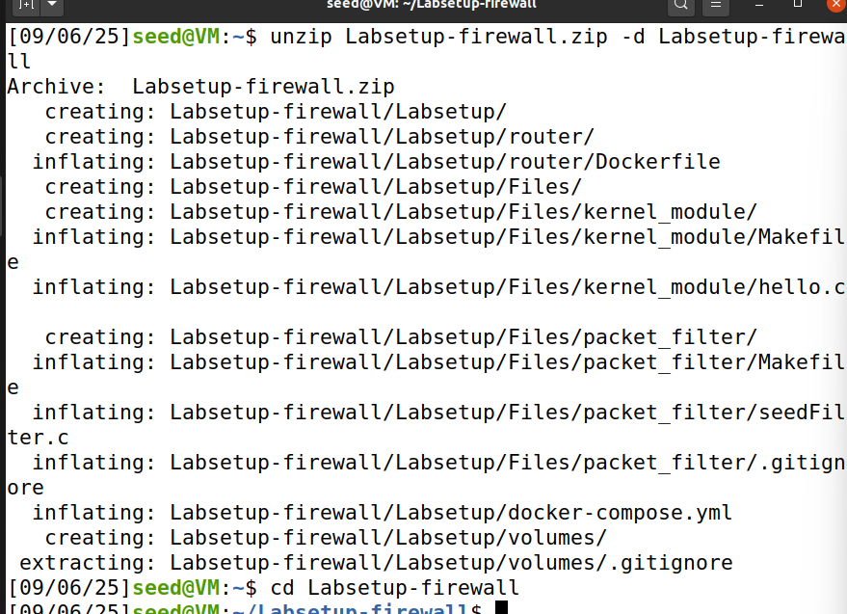
Fig5: Lab setup
Then to run the docker container type these commands:
docker-compose build
docker-compose up -d
docker ps
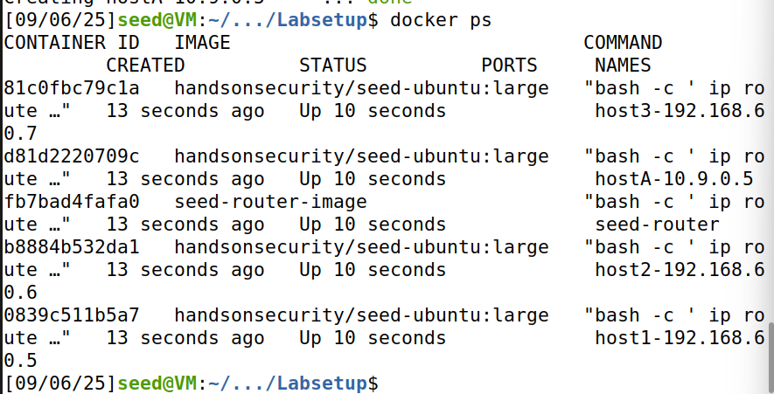
Fig6: Output of all the containers running
Next get inside the router shell with command: docker exec -it seed-router bash
Add this rule to the firewall: iptables -A OUTPUT -p icmp -d 3.9.6.4 --icmp-type echo-request -j DROP
Next try to send 4 packets ping to IP1 with: ping -c 4 3.9.6.4
You can also verify rule is active with this command: iptables -L OUTPUT -v --line-numbers
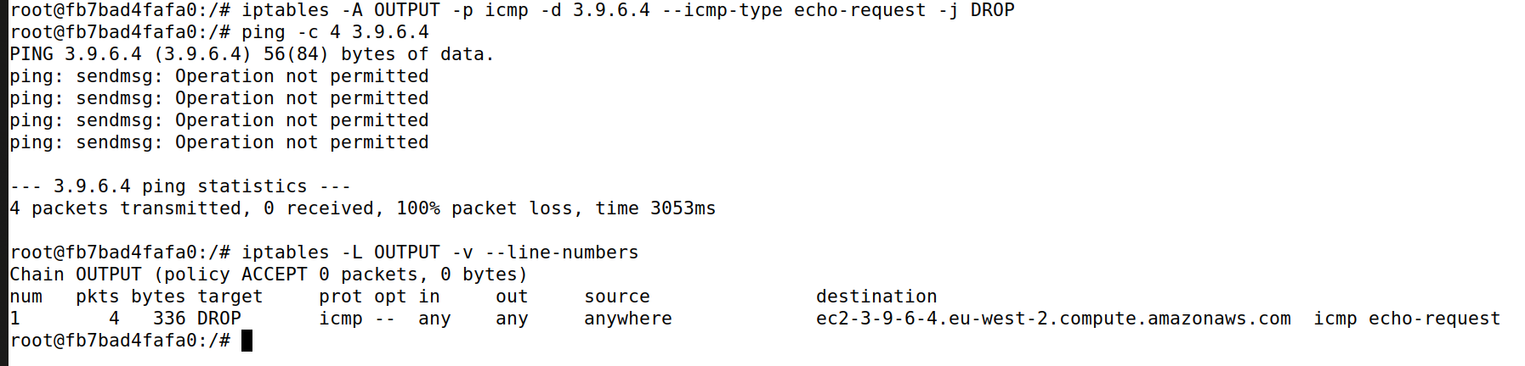
Fig7: Q2.1 output with 4 packets dropped

Q2.2
Inside the router shell type this command to add a drop rule to drop all echo replies from 8.8.8.8: iptables -A INPUT -p icmp -s 8.8.8.8 --icmp-type echo-reply -j DROP
Try to test the firewall by pinging 4 packets to 8.8.8.8: ping -c 4 8.8.8.8
Verify rules and counter: iptables -L INPUT -v --line-numbers
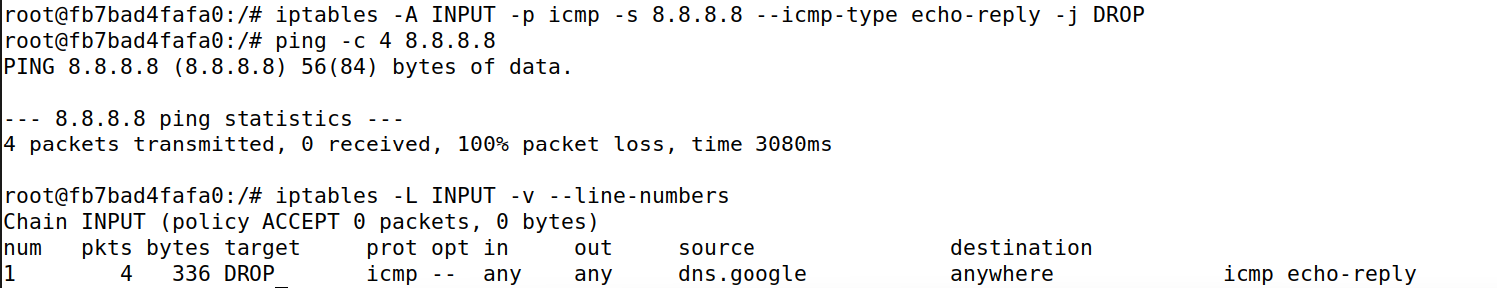

Fig8: Q2.2 output

From figure 8 we can see that the iptables show that after we ping dns.google (8.8.8.8) the icmp echo-reply were dropped and there are 4 packets dropped.

Q2.3
First, we want to add rules to the stateless iptables. This command below provides the rules that satisfy the question requirements:
iptables -A FORWARD -s 192.168.60.0/24 -p tcp --dport 23 -j ACCEPT (allow internal host to telnet)
iptables -A FORWARD -d 192.168.60.5 -p tcp --dport 23 -j ACCEPT (allow outsider to only telnet to host 192.168.60.5)
iptables -A FORWARD -j DROP (block all other packets)
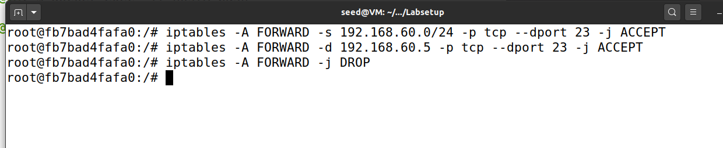
Fig 9: stateless firewall rule

To test this, we want to open 2 new terminals to access host from outside and inside our home network. I will access from the outside host first (host A terminal) with:
docker exec -it hostA-10.9.0.5 bash
From here I will telnet from the outside (Host A) to the allowed 192.168.60.5 host and the not allowed host 192.168.60.6 with these commands:
telnet 192.168.60.5 23
telnet 192.168.60.6 23
We can also test that other packets rather than these get block by pinging: ping -c 4 192.168.60.6
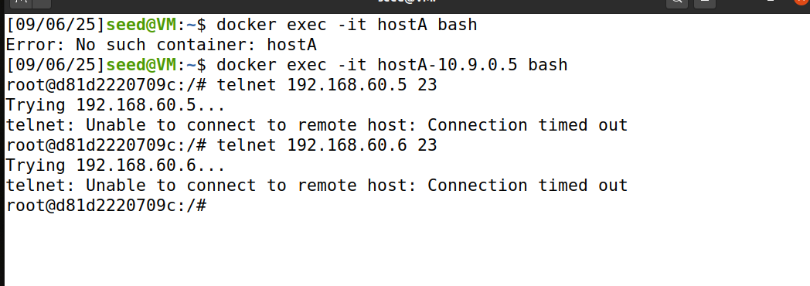
Fig 10: Outside host telnet to inside hosts
Next to demonstrate that inside host (host1-192.168.60.5) can telnet everywhere by accessing host1 terminal:
docker exec -it host1-192.168.60.5 bash
telnet 192.168.60.6 23 (host 1 telnet to another host)
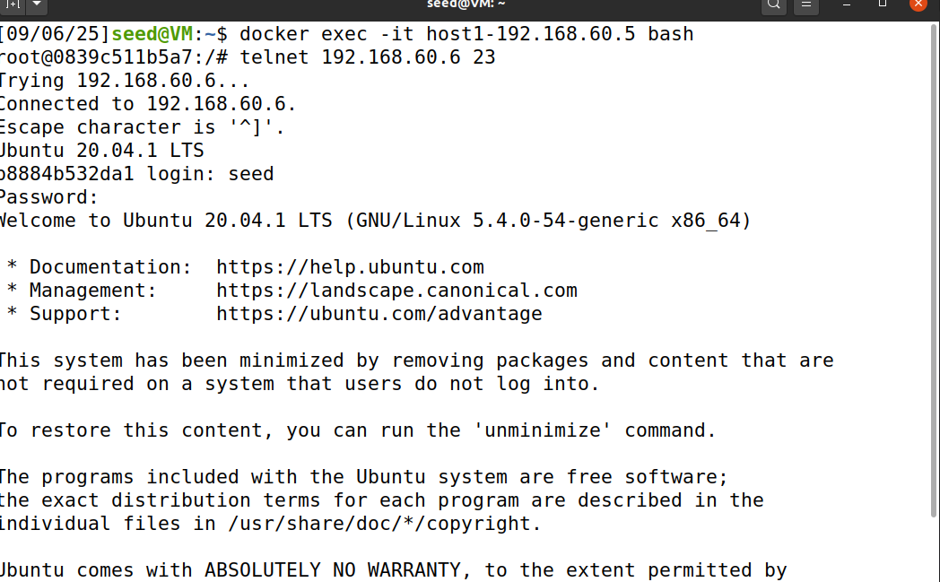
Fig 11: Inside host successfully telnet to another host

Use iptables -L FORWARD -v --line-numbers to verify.
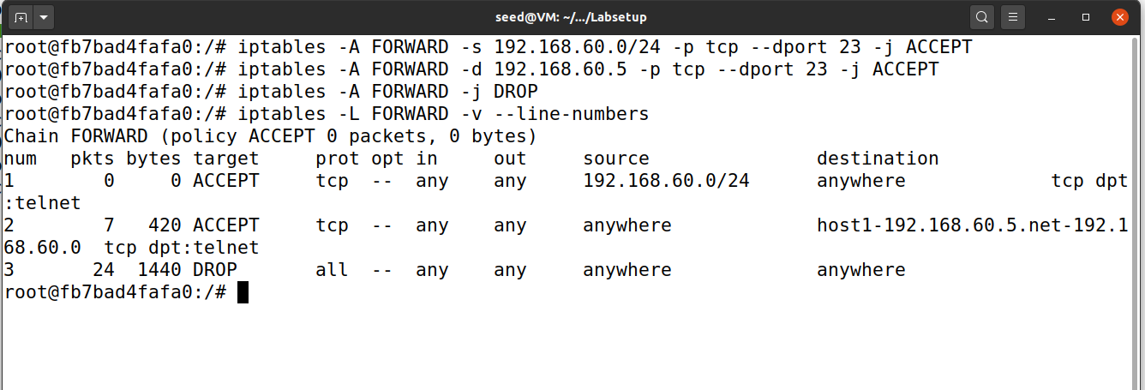
Fig12: Rule table output with counter increased

As you can see from the table since the output of outside host terminal does not show us clearly. From the seed router we can see that our stateless firewall rule were applied.

Q2.4
Before we move on to this question first, we need to clear the iptables rules from the previous question. Then we will add the rules and check the rule table to see if our rules are properly implemented. After that we will test the rules and check the counter again. Type these commands in router terminal:
iptables -F FORWARD (remove previous rules)
iptables -A FORWARD -m state --state ESTABLISHED,RELATED -j ACCEPT (allow reply for allowed connection)
iptables -A FORWARD -s 192.168.60.0/24 -d 10.9.0.0/24 -p tcp --dport 23 -m state --state NEW -j DROP (block internal host to telnet connection to outside host)
iptables -A FORWARD -d 192.168.60.5 -p tcp --dport 23 -m state --state NEW -j ACCEPT (allow outside host to telnet to ip 60.5 only)
iptables -A FORWARD -j DROP (drop everything else)
iptables -L FORWARD -v --line-numbers (show rules with counter)
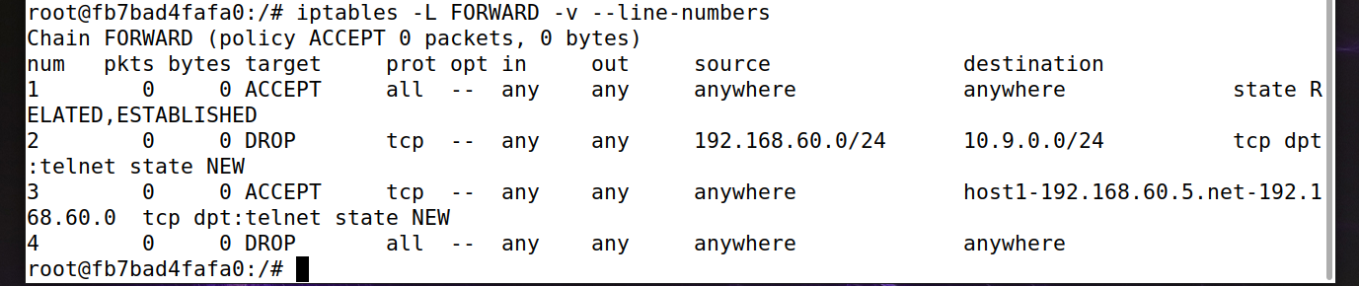
Fig13: Rule tables with all the rules

Next, we need to open a few terminals to test these rules by accessing different containers. First we access host1 and place a listener.
docker exec -it host1-192.168.60.5 bash
nc -l -p 23
Then from an inside host we try to telnet to outside host. So we open a terminal and access host 2 for this:
docker exec -it host2-192.168.60.6 bash
telnet 10.9.0.5 23
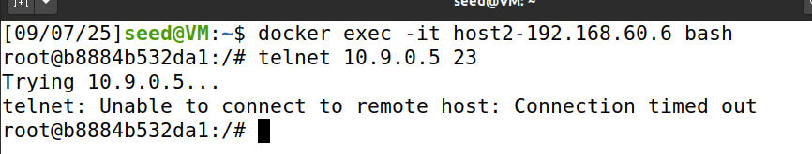
Fig14: inside host can’t telnet outside

Then to test an outside host telnet to inside hosts (allowed and not). Open another new terminal to access hostA:
docker exec -it hostA-10.9.0.5 bash
telnet 192.168.60.5 23 (allow)
telnet 192.168.60.6 23 (should be not allow)
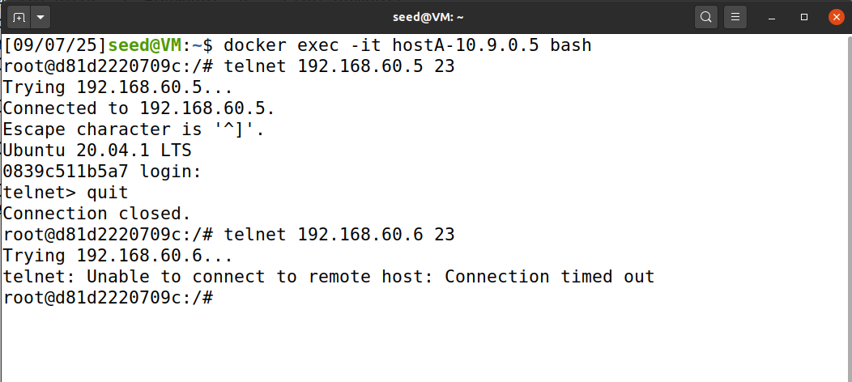
Fig15: Only the allowed 192.168.60.5 23 host can telnet, others can not

Then to check if the counter increase in our rule table we do this in seed router terminal:
iptables -L FORWARD -v --line-numbers
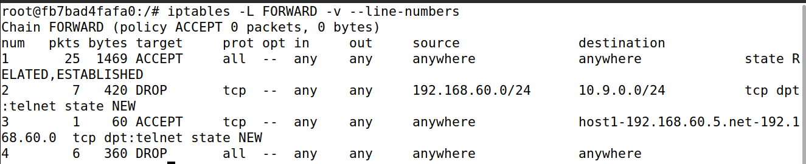
Fig16: Rule table with counter increase for the rules that applied

Q2.5
Same thing previous exercise, you want to first flush all the old rules, make it stateful then add the stateful firewall rules. Commands below are for the seed router terminal:
iptables -F FORWARD
iptables -A FORWARD -m state --state ESTABLISHED,RELATED -j ACCEPT (allow replies of established connection making it stateful)
iptables -A FORWARD -s 192.168.60.0/24 -p tcp --dport 23 -m state --state NEW -j ACCEPT (allow internal host to telnet everywhere)
iptables -A FORWARD -d 192.168.60.5 -p tcp --dport 23 -m state --state NEW -j ACCEPT (allow outside to telnet to ip ending with 60.5 only)
iptables -A FORWARD -j DROP (drop everything else)
iptables -L FORWARD -v --line-numbers (rule table with counter)
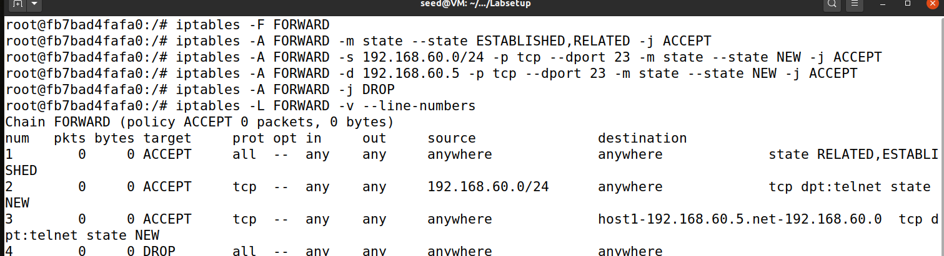
Fig16: rules output with 0 counter

To test internal can telnet to outside in a new terminal:
docker exec -it host2-192.168.60.6 bash
telnet 10.9.0.5 23
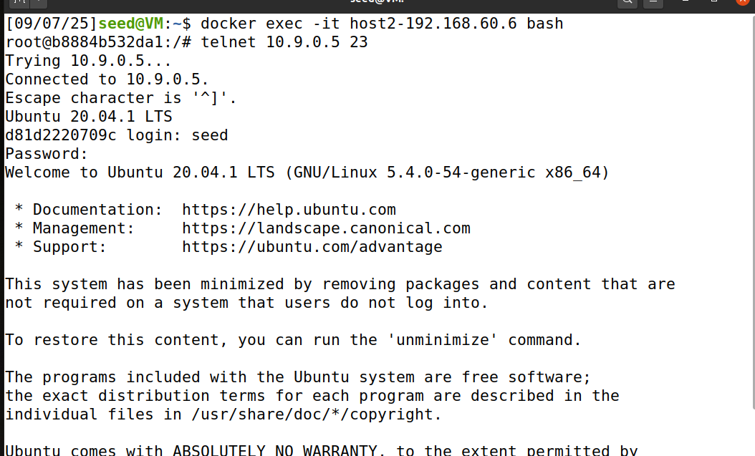
Fig17: Successful telnet connection
Test the outside host (hostA) can telnet to the allowed/not allowed inside host in a new terminal:
docker exec -it hostA-10.9.0.5 bash
telnet 192.168.60.5 23 (allow)
telnet 192.168.60.6 23 (not)
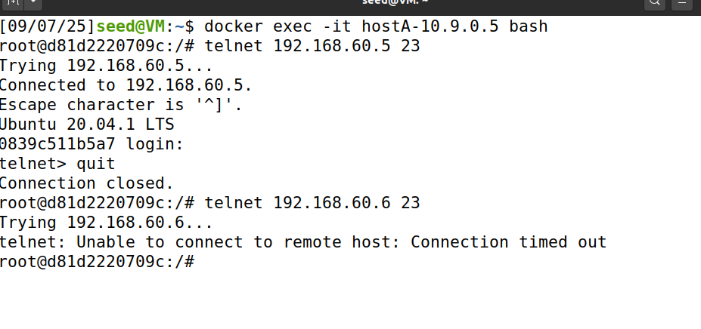Fig18: Allow and not allow telnet connections

Verify on router terminal:
iptables -L FORWARD -v --line-numbers
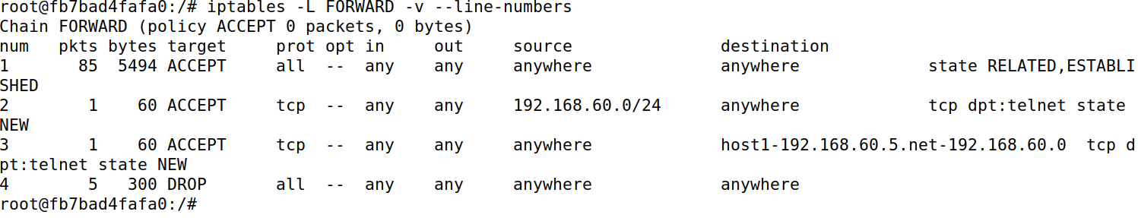
Fig19: Counter increased

Section 3: Symmetric Encryption

Q3.1
KEY_1 = aa33889933996644aa33889933996644
IV_1 = 0a03080903090604
Make sure you are in the folder which contains the image.

AES-128-ECB — Encrypt & Decrypt:
openssl enc -aes-128-ecb -e -in pic_original.bmp -out pic_ecb.enc \
-K aa33889933996644aa33889933996644 -nopad

openssl enc -aes-128-ecb -d -in pic_ecb.enc -out pic_ecb.dec.bmp \
-K aa33889933996644aa33889933996644 -nopad

AES-128-CBC — Encrypt & Decrypt:
openssl enc -aes-128-cbc -e -in pic_original.bmp -out pic_cbc.enc \
-K aa33889933996644aa33889933996644 -iv 0a03080903090604 -nopad
openssl enc -aes-128-cbc -d -in pic_cbc.enc -out pic_cbc.dec.bmp \
-K aa33889933996644aa33889933996644 -iv 0a03080903090604 -nopad

Finally, to view the 2 encrypted and 2 decrypted files:
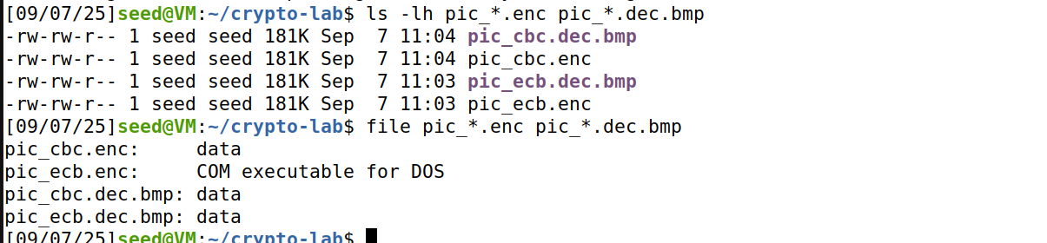Fig20: Output files

Q3.2
First install ghex
sudo apt-get update
sudo apt-get install -y ghex
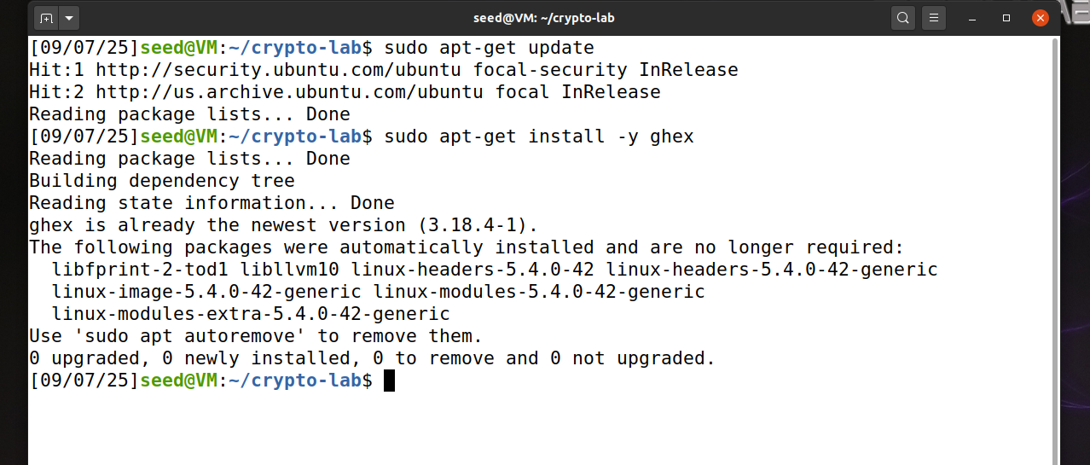
Fig21: ghex installed

Then open the original pic in ghex:
ghex pic_original.bmp
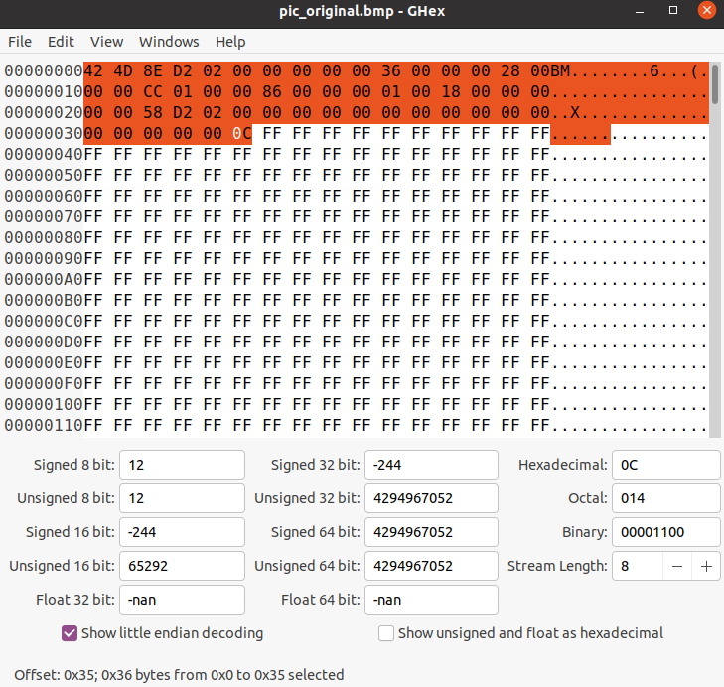
Fig22: pic in ghex

Then copy the first 54 bytes and paste them into encrypted ECB file and save it as pic_ecb_ header.bmp. You can open up ghex file of pic_ecb.en by going to the UI through file > open > select it.

Repeat for CBC and save as pic_cbc_header.bmp:
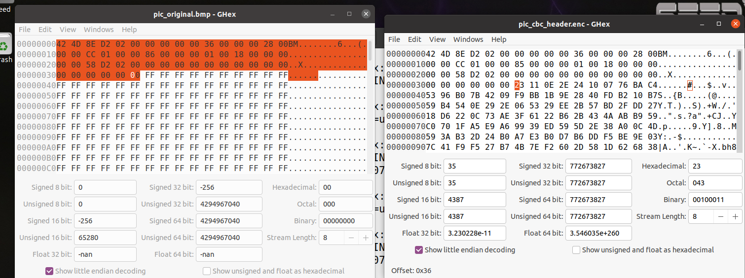
Fig23: Header of pic_ebc.en edited like original pic

Q3.3
To view the images, you can go into its folder and open them:
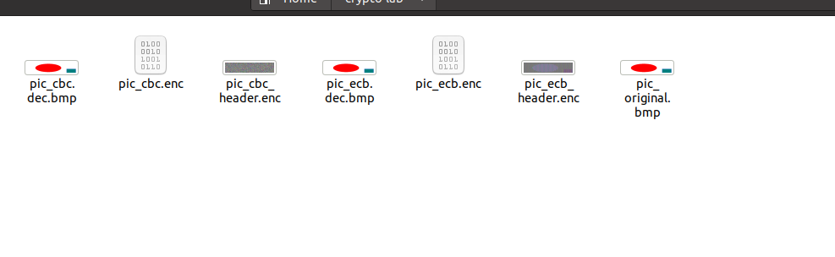
Fig24: Folder with images

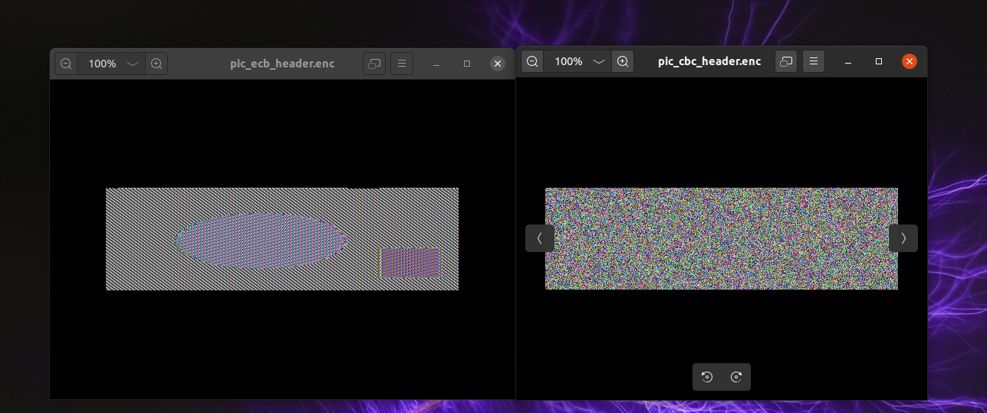Fig25: ECB (left) vs CBC (right)

From my observations I can clearly see that ECB encryption did a bad job because the background color is changed, however the shapes remained with their color swapped between the two. This makes it so easy to decipher the original image hence bad encryption. On the contrary, the CBC encryption did a good job mixing up everything into a messy TV static like image that is impossible to decipher the original.

Section 4: Appendix
AI Declaration: This assignment was created with the help of ChatGPT version 5.0 to help to create Linux commands, generate ideas and solutions. Prompt used where the assignment pdf file with some small follow up questions.

