**SWINBURNE VIETNAM**

**HO CHI MINH CAMPUS**



**Class: COS40006**

**Deployment Portfolio Task 2**

**Instructor: Dr. Thomas Hang**

**Student names: Le Quang Hai**

# Task 2.1

## Create an SSH key pair



## Create an EC2 instance

**Initiate instance creation**



**Select VPC, located subnet, configure security group**

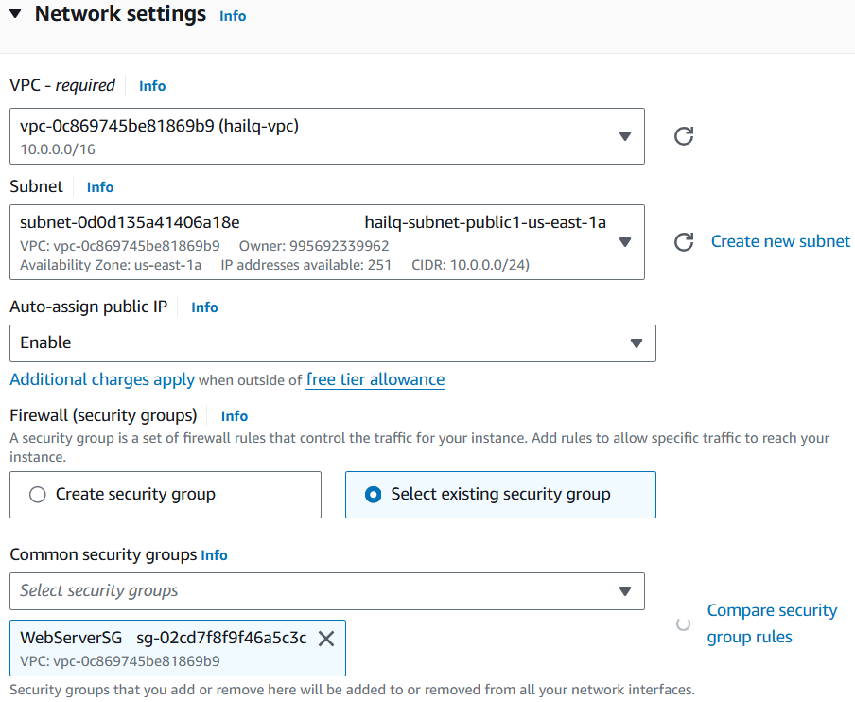



**For other settings, use default setting, then launch instance**

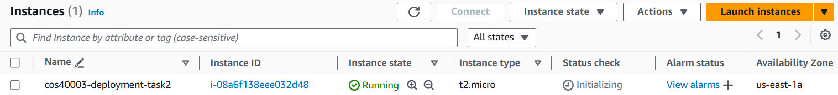



# Deploy a WordPress instance

**Load the source code to the EC2 instance**



**Create scripts to run the application**



**Create an S3 bucket for storing source code**



**Set public policy for S3 bucket**



**Bundle the application's files into a single archive file and push the archive file**



**Create a deployment group**



**Successfully deploy the app**



**Access the application via http**



**Notes: the given script on Amazon website is compatible with Amazon Linux 2 EC2 instance; since we use the newest version Amazon Linux 2023, some script must be re-written.**

* For installing PHP use: sudo dnf install php php-cli php-common php-mysqlnd php-json php-xml -y
* For installing MariaDB use: sudo dnf install mariadb105-server -y

## Update the WordPress application

**Set up the site**



**Install WordPress**

**Successfully deploy**

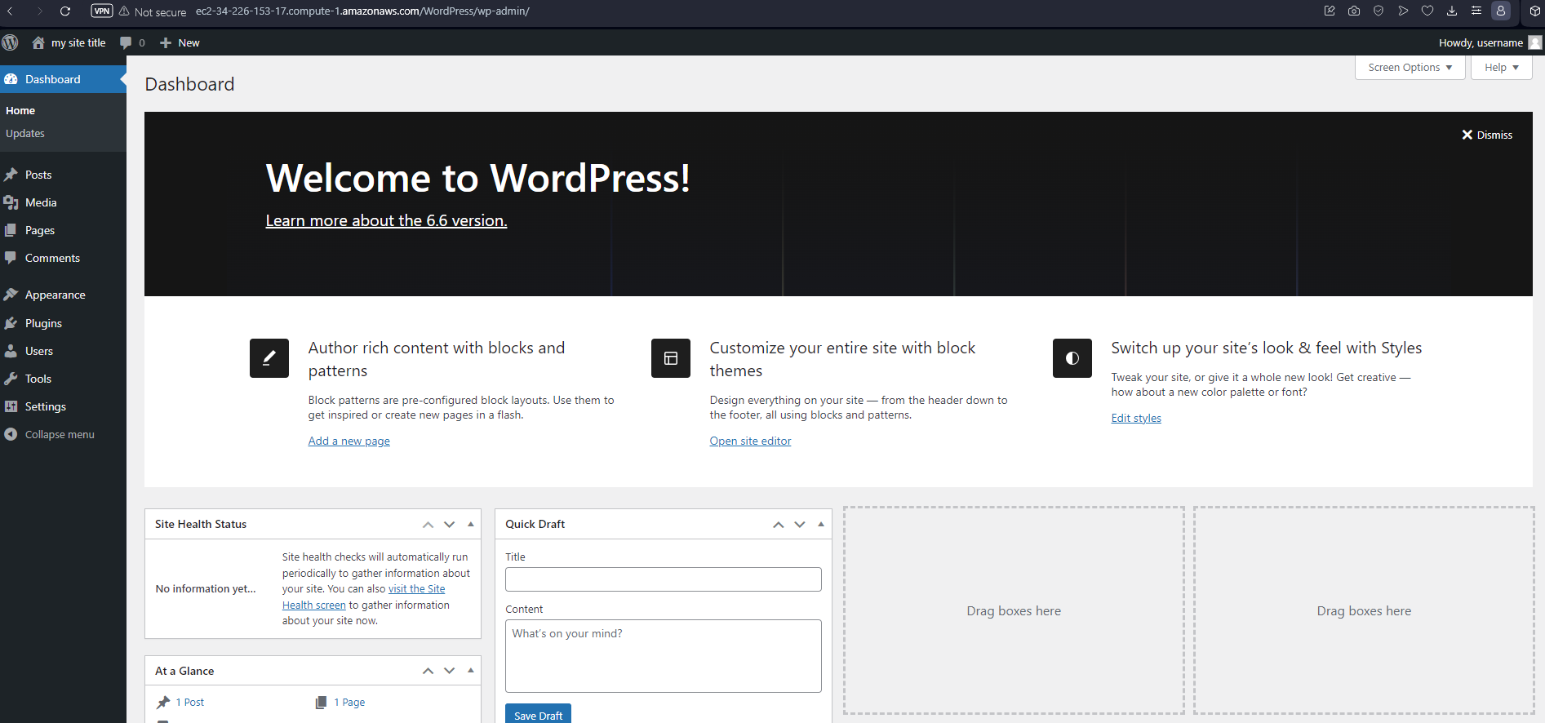

# Task 2.2

## Create an ELB

**Create a target group, prepare for ELB creation**



**Create security group for ELB**



**Create an application ELB with the prepared resources**



## Re-install WordPress using an external database

**Create an AWS RDS database instance**



**Modify the settings in the wp-config.php file corresponding to the RDS database instance**



**Modify the scripts/install_dependencies.sh file to install mysql-client instead of mariadb-server**



**Modify the scripts/create_test_db.sh correspondingly to the RDS instance**

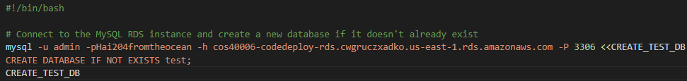

**Modify the scripts/start_server.sh to no longer start a local database service**



**Deploy similarly to Task 2.1**



**-----------------------------------------------------------------------------------------------------------------------------**

## Backup instance to S3

**To back up the instance, AWS provides the EBS snapshot creation. The snapshot is then stored in S3.**



**We create a schedule, specifically:**

* **A snapshot is taken every day at 12 am**
* **The snapshot remains in S3 for 24 hours**



**Now we ensure the backup is always the most up-to-date. For testing purposes, we create a snapshot manually**

## Create an instance from S3 backup

**From the snapshot taken above, create an AWS AMI out of it**



**From the AMI create we can create an EC2 instance with an exact copy of the files in the CodeDeployDemo instance**



**In order to listen on http request, the newly created instance must start httpd and php-frm service, add these commands to the data executed on boot up**

**Now the WordPress site should be available for http request**

# Task 2.3

## **Create a Launch Template (formerly Launch Configuration* now deprecated)**



## Create an ASG

**Create an elastic application load balancer at layer 7 to prepare for ASG creation**



## Configure ASG to launch instance



**After creating ASG, 2 instances is initialized as specified in settings**



## Test scaling

**On the instances, install “stress” with**

**Then overload CPU usage of the instances by**



**Now a new instance is automatically created**

# Task 2.4

## **Connecting to instances via SSH**

## **All the tasks above can be automated completely via AWS CLI**

Before starting, to avoid error, delete the existing resources (perhaps from last deployment, etc.)

Create a AWS CodeDeploy Application via CLI



Push the current directory to S3 and attach it with the Application created via CLI



Create a deployment group for the application

Deploy the application from the using that deployment group

Create a launch template via CLI

Launch an EC2 instance from the created launch template



Create an application elastic load balancer

Finally create an auto scaling group via CLI

