**SWINBURNE VIETNAM**

**HO CHI MINH CAMPUS**



**Class: COS40006**

**Deployment Portfolio Task 3**

**Instructor: Dr. Thomas Hang**

**Student names: Le Quang Hai**

# Task 3.1 Pass:

## Create Azure account

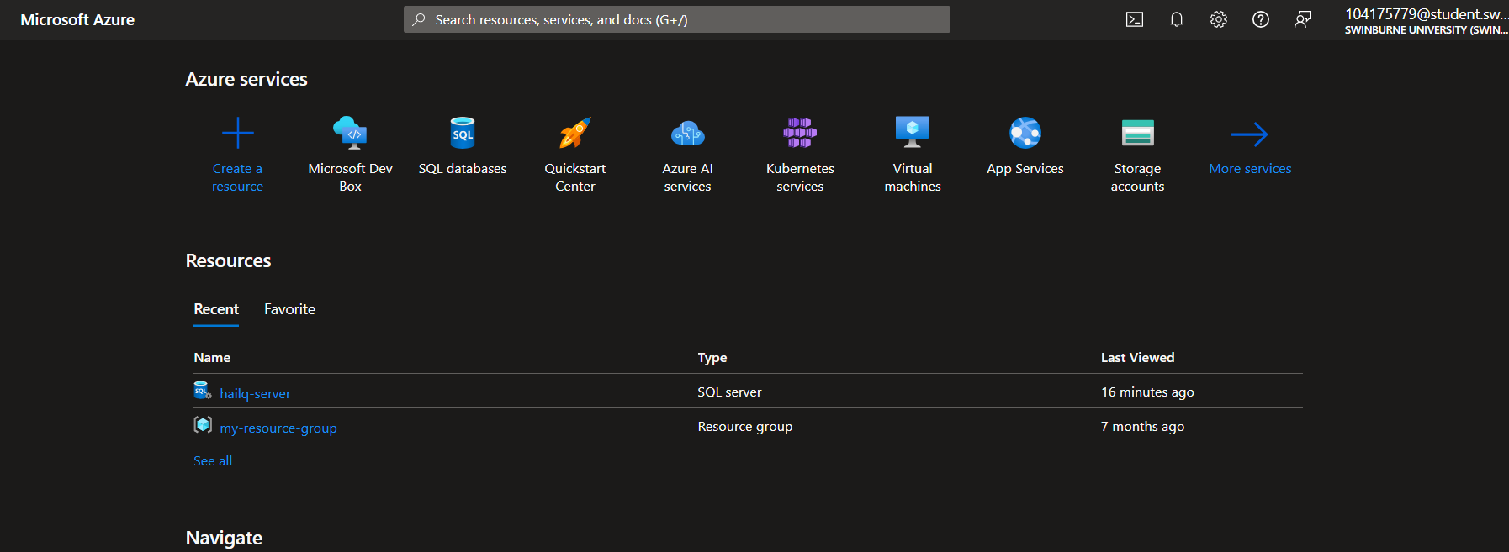

## Install visual Studio

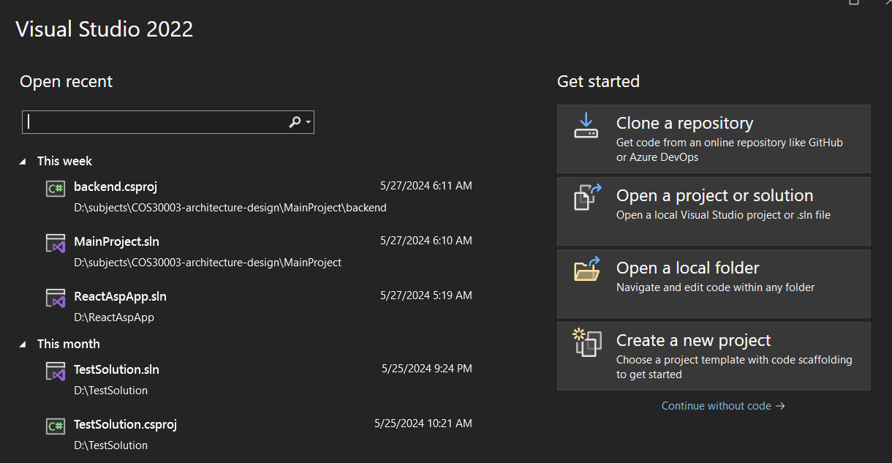

## Deploy any existing app to cloud via Azure

For simplicity we will test on a static web app

### Create a resource group

Enter subscription, name, region

Review and create

Create successfully

### Create a new app service plan to be used in the new web app

Select the subscription, group resource, operation system, machine type, region and tier

Review and create

Create successfully

### Create the new web app

Select subscription, resource group (created from above screenshots), name, and source code location

Open a new tab, go to GitHub and create a DemoCode repository containing an index.html file with contain as below

Back to web app creation, select the repository to deploy

Select region

Review configuration before creation

Web application deployed successfully

Go to resource

Visit the website that we deployed

# Task 3.2 Credit

From Visual Studio, create an ASP.NET Core Web App Project

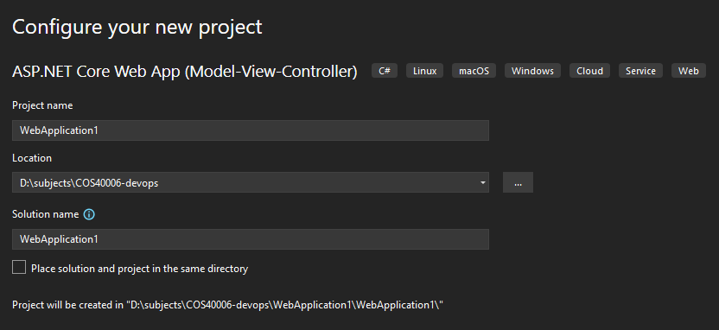

Verify the ASP.NET Core Web App created successfully

Right click the project and select “publish”

In the select window, select "Azure App Service for Windows”

Log in with your Azure account

Create a hosting plan from within the publish

Now we have configured to create a Windows App Service in a new resource group named COS40006-ResourceGroup and with COS40006-HostingPlan hosting plan

Click create, waiting … After finishing, we can go to Azure portal console web platform to verify the success creation of the resources

We verify from Visual Studio and click ‘Finish’

Done publishing app

By default the app service deploy a default page by Microsoft, to make the app deploy my own app, click “publish” and wait

We successfully deployed the ASP.NET Core Web App to Azure App Service using Visual Studio

We **deactivate** the service (we cannot achieve similar result by interacting with the Azure console)

Verify that the app has been deactivated

Get back to the same domain url

# Task 3.2: HD

## Install PHP on Visual Studio

Open Visual Studio, instead of opening an existing project or creating new one, click on “Continue without code”

Go to “Extension” 🡪 “Manage extension”

Search for PHP Tools for Visual Studio and install it

Close Visual Studio window so that the installer can run automatically

Verify success installation

Now we can create a PHP web application in Visual Studio

## Develop a web application

We create another GitHub repository with a Hello World code in the index.php file

## Transfer files to visual studio

We use git clone command to obtain the code from the GitHub repository created above to our local folder

Open Visual Studio, click “Create new project” 🡪 “PHP project from existing code”

We specify location of the code we have just cloned from remote

We have successfully created a PHP from the pre-created PHP project

## Deploy app to cloud via Azure

Go to Azure console and create another new Web App, this time select PHP 8.3 for run-time environment

Select the deployment GitHub settings

Review setup before creation

Waiting for the auto-deployment

Deployment succeeds

Navigate to the domain to enter the PHP page

