- Your company has serval departments. Each department has a number of virtual machines (VMs).
The company has an Azure subscription that contains a resource group named RG1.
All VMs are located in RG1.
You want to associate each VM with its respective department.
What should you do?
- ☐ Create Azure Management Groups for each department.
- ☐ Create a resource group for each department.
- ☐ Assign tags to the virtual machines.
- ☐ Modify the settings of the virtual machines.
Answer: C
Note: Tags are metadata elements (name-value pairs) used to logically organize resources. Since all VMs are already in RG1, applying tags like Department: IT or Department: HR is the most efficient way to categorize them for billing and management without moving them.
Why other options are incorrect?
A . Management Groups: These are used for managing multiple subscriptions and applying governance at scale. They cannot be used to categorize individual VMs within a single Resource Group.
B. Create a resource group for each department: While possible, the question states VMs are already in RG1. Moving them to new Resource Groups is more complex and time-consuming than simply tagging.
D. Modify the settings of the virtual machines: VM settings (size, disk, networking) do not provide a built-in "Department" field or categorization feature.
Key Takeaway
- English: Tags are not inherited. If you apply a tag to a Resource Group, the resources inside (like VMs) do not automatically inherit that tag. You must apply tags individually or use Azure Policy to enforce tagging.
- Note: The question is included in a number of questions that depicts the identical set-up. However, every question has a distinctive result. Establish if the solution satisfies the requirements.
Your company has an Azure Active Directory (Azure AD) subscription. You want to implement an Azure AD conditional access policy. The policy must be configured to require members of the Global Administrators group to use Multi-Factor Authentication and an Azure AD-joined device when they connect to Azure AD from untrusted locations. Solution: You access the Azure portal to alter the session control of the Azure AD conditional access policy. Does the solution meet the goal?
- ☐ Yes
- ☐ No
Answer: B. No
Note: The requirements "Require Multi-Factor Authentication" and "Require Azure AD-joined device" are Grant Controls, not Session Controls. Session controls are used to limit user experience within a session (e.g., preventing downloads or using Conditional Access App Control), whereas Grant controls determine whether a user is allowed to access the resource at all based on specific conditions
Azure Active Directory (Azure AD) is a old name of Entra ID
- You need to recommend a solution to automate the configuration for the finance department users. The solution must meet the technical requirements.
What should you include in the recommendation?
- ☐ Azure AD B2C
- ☐ Dynamic groups and conditional access policies
- ☐ Azure AD Identity Protection
- ☐ an Azure logic app and the Microsoft Identity Management (MIM) client
Answer: B. Dynamic groups and conditional access policies.
Note: Dynamic Groups: Use attributes (like department == "Finance") to automatically add or remove users from a group. This automates the "membership" part.
Conditional Access Policies: Use these groups as a "Scope" to automatically apply security configurations (like MFA or device compliance) to those specific users.
Why other options are incorrect
- A. Azure AD B2C: Used for customer-facing applications (Business-to-Consumer), not for managing internal employees or automating their configurations.
- C. Azure AD Identity Protection: Focused on detecting and remediating identity-based risks (like leaked credentials), not on automating general department-based configurations.
- D. Azure Logic App and MIM client: Too complex and usually unnecessary for simple department-based automation. Microsoft Identity Management (MIM) is mostly for on-premises/hybrid legacy environments.
Key Takeaway:
- Whenever you see "Automate configuration based on department" in AZ-104, your mind should immediately go to Dynamic Groups. It is the foundation for "Attribute-based Access Control" (ABAC)
- You have an Azure subscription that contains an Azure Active Directory (Azure AD) (Entra ID) tenant named contoso.com and an Azure Kubernetes Service (AKS) cluster named AKS1.
An administrator reports that she is unable to grant access to AKS1 to the users in contoso.com.
You need to ensure that access to AKS1 can be granted to the contoso.com users.
What should you do first?
- ☐ From contoso.com, modify the Organization relationships settings.
- ☐ From contoso.com, create an OAuth 2.0 authorization endpoint.
- ☐ Recreate AKS1.
- ☐ From AKS1, create a namespace.
Answer: C. Recreate AKS1.
Note: To integrate Azure AD with AKS, the integration must be enabled during the cluster creation process. If an existing AKS cluster was created without Azure AD integration enabled, you cannot simply "turn it on" in the settings later. You must recreate the cluster with the integration feature enabled.
Why other options are incorrect:
- A. Modify Organization relationships
This is used for B2B collaboration (external users), not for granting internal tenant users access to a cluster.
- B. Create an OAuth 2.0 authorization endpoint:
Azure AD already provides these endpoints; you don't manually create them for this purpose.
- D. Create a namespace
Namespaces are for logical isolation inside Kubernetes, but they don't solve the "Identity" problem if the cluster doesn't recognize Azure AD users yet
- Your company has an Azure Active Directory (Azure AD) subscription.
You want to implement an Azure AD conditional access policy.
The policy must be configured to require members of the Global Administrators group to use Multi-Factor Authentication and an Azure AD-joined device when they connect to Azure AD from untrusted locations.
Solution: You access the Azure portal to alter the grant control of the Azure AD conditional access policy.
Does the solution meet the goal?
- ☐ Yes
- ☐ No
Answer: A. Yes
Note: In a Conditional Access policy, the "Grant" section is exactly where you define the security requirements that must be met before access is allowed. This includes "Require multi-factor authentication" and "Require Azure AD joined device". Since the solution points to the correct configuration area, it meets the goal.
Why this is correct:
- Assignments: Defines Who (Global Admins), What (Cloud Apps), and Where (Untrusted locations).
- Grant Controls: Defines How to access. This is where you toggle the checkboxes for MFA and Device Compliance.
- You are planning to deploy an Ubuntu Server virtual machine to your company's Azure subscription.
You are required to implement a custom deployment that includes adding a particular trusted root certification authority (CA).
Which of the following should you use to create the virtual machine?
- ☐ The New-AzureRmVm cmdlet.
- ☐ The New-AzVM cmdlet.
- ☐ The Create-AzVM cmdlet.
- ☐ The az vm create command.
#cloud-config
ca-certs:
trusted:
- |
-----BEGIN CERTIFICATE-----
MIIDdTCCAl2gAwIBAgILBAAAAAABFUtaw5QwDQYJKoZIhvcNAQELBQAwVzELMAkG
A1UEBhMCVVMxGTAXNVBAoMEEdvb2dsZSBJbmMxJzAlBgNVBAMMHkdvb2dsZSBJ
bnRlcm5ldCBBdXRob3JpdHkgRzIwHhcNMTcwNjIyMTEwNDAwWhcNMTcwOTI0MTEw
... (Nội dung chứng chỉ CA của bạn tại đây) ...
-----END CERTIFICATE-----

runcmd:
- [ update-ca-certificates ]
- [ echo, "Custom CA has been installed successfully", ">", "/var/log/custom-ca.log" ]
Answer: D. The az vm create command
Note: The az vm create command (part of Azure CLI) is the best choice for Linux deployments because it natively supports the --custom-data parameter. For Ubuntu/Linux, this parameter allows you to pass a cloud-init script, which is the industry standard for automating tasks like installing packages, creating users, or adding trusted CA certificates during the first boot.

Why other options are incorrect:
- A. The New-AzureRmVm cmdlet
This belongs to the old AzureRM PowerShell module, which is deprecated (replaced by the Az module).
- B. The New-AzVM cmdlet:
While this is the current PowerShell cmdlet, using az vm create with cloud-init is generally more straightforward and standard for complex Linux customizations like CA injection
- C. The Create-AzVM cmdlet:
This command does not exist in Azure PowerShell. The correct verb is New.
- You have Azure subscription that includes data in following locations:
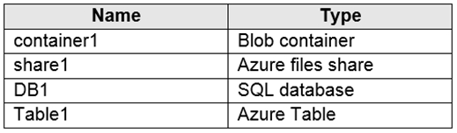
You plan to export data by using Azure import/export job named Export1.
You need to identify the data that can be exported by using Export1.
Which data should you identify?
- ☐ DB1
- ☐ container1
- ☐ share1
- ☐ Table1
Answer: B. container1 (Azure Blob Storage)
Note: The Azure Import/Export service supports Exporting data only from Azure Blob Storage. Specifically, you can export Block Blobs, Append Blobs, and Page Blobs.
Why other options are incorrect:
- A. DB1 (Azure SQL Database)
To export a SQL Database, you should use BACPAC files or Azure Data Factory, not the physical drive-based Import/Export service
- C. share1 (Azure File Share)
While Import/Export service supports Importing into Azure Files, it does not support Exporting from Azure Files. This is a very common "trap" in the AZ-104 exam
- D. Table1 (Azure Table Storage)
NoSQL Table storage is not supported by the Import/Export service
- Note: This question is part of a series of questions that present the same scenario. Each question in the series contains a unique solution that might meet the stated goals. Some question sets might have more than one correct solution, while others might not have a correct solution.
After you answer a question in this section, you will NOT be able to return to it. As a result, these questions will not appear in the review screen.
You have an Azure virtual machine named VM1 that runs Windows Server 2016.
You need to create an alert in Azure when more than two error events are logged to the System event log on VM1 within an hour.
Solution: You create an Azure storage account and configure shared access signatures (SASs). You install the Microsoft Monitoring Agent on VM1. You create an alert in Azure Monitor and specify the storage account as the source.
Does that meet the goal?
- ☐ Yes
- ☐ No
Answer: B. No
Note: Azure Monitor Alerts for Event Logs do not use Storage Accounts as a direct source for real-time alerting. Instead, the logs should be sent to a Log Analytics Workspace. From there, you use a Kusto Query (KQL) to count the error events and trigger an alert. Using a Storage Account with SAS is more suitable for long-term archiving or manual diagnostic exports, not for active monitoring alerts.
Why other options are incorrect:
- Storage Account Source: Azure Monitor Alerts cannot "poll" a storage account effectively to detect specific log events in real-time
- Microsoft Monitoring Agent (MMA): While MMA (now migrating to Azure Monitor Agent - AMA) is used to collect logs, it needs to point to a Log Analytics Workspace to make the data "queryable" for alerts.
- Note: This question is part of a series of questions that present the same scenario. Each question in the series contains a unique solution that might meet the stated goals. Some question sets might have more than one correct solution, while others might not have a correct solution.
After you answer a question in this section, you will NOT be able to return to it. As a result, these questions will not appear in the review screen.
You have an Azure virtual machine named VM1 that runs Windows Server 2016.
You need to create an alert in Azure when more than two error events are logged to the System event log on VM1 within an hour.
Solution: You create an Azure Log Analytics workspace and configure the data settings. You add the Microsoft Monitoring Agent VM extension to VM1. You create an alert in Azure Monitor and specify the Log Analytics workspace as the source.
Does this meet the goal?
- ☐ Yes
- ☐ No
Answer: A. Yes
Note: This solution follows the correct architecture for log-based alerting. First, the Microsoft Monitoring Agent (or Azure Monitor Agent) collects logs from the OS. Second, those logs are sent to a Log Analytics Workspace (the data store). Finally, Azure Monitor can query that workspace to identify the "Error" events and trigger an alert based on the threshold (more than 2 errors in 1 hour).
- You have Azure virtual machines that run Windows Server 2019 and are configured as shown in the following table.
You create a private Azure DNS zone named adatum.com. You configure the adatum.com zone to allow auto registration from VNET1.
Which A records will be added to the adatum.com zone for each virtual machine? To answer, select the appropriate options in the answer area.
NOTE: Each correct selection is worth one point.
Hot Area:
Show Suggested Answer
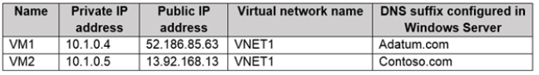
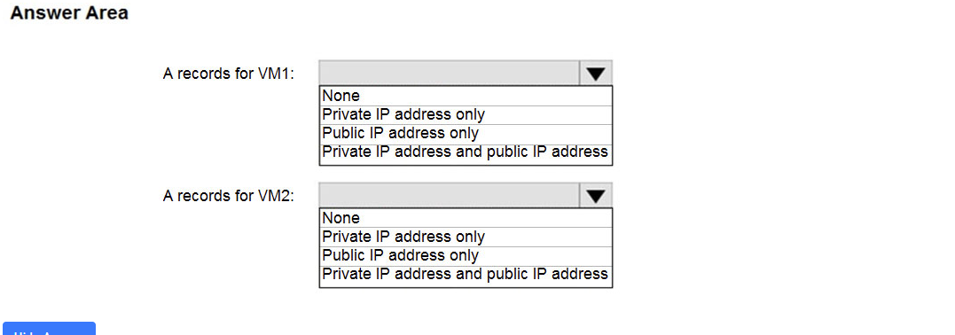
Answer: VM1 Private IP address only
VM2 Private IP address only
Note:
- You have an Azure virtual machine named VM1 and a Recovery Services vault named Vault1.
You create a backup policy named Policy1 as shown in the exhibit. (Click the Exhibit tab.)
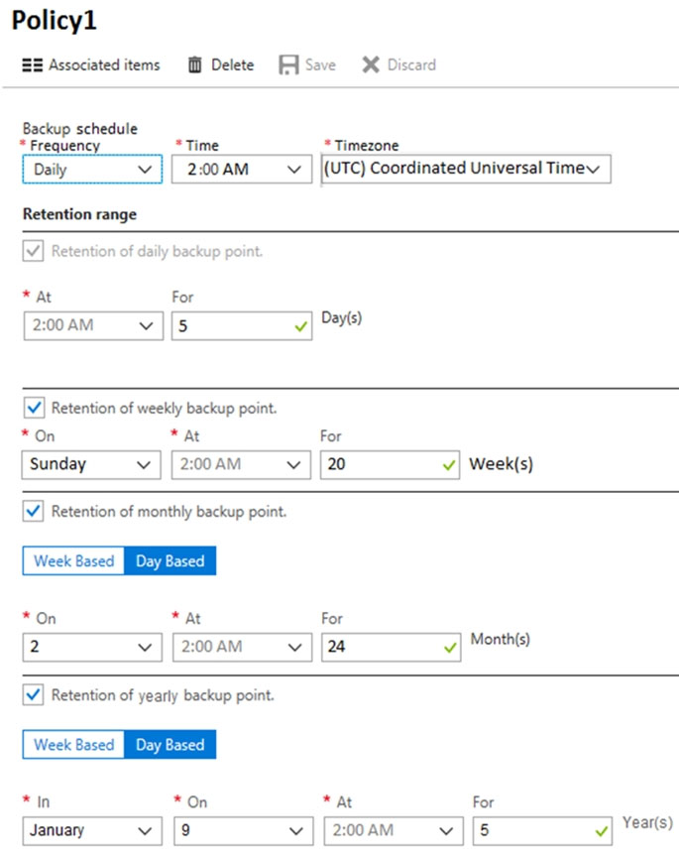
You configure the backup of VM1 to use Policy1 on Thursday, January 1 at 1:00 AM.
You need to identify the number of available recovery points for VM1.
How many recovery points are available on January 8 and January 15? To answer, select the appropriate options in the answer area.
NOTE: Each correct selection is worth one point.
Hot Area:
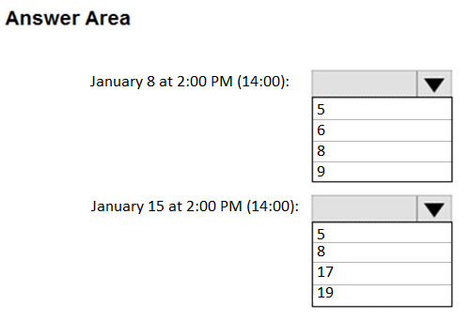
- ☐ A
- ☐ B
- ☐ C
- ☐ C
Answer:
Note:

