ACTION

Action return button:

**class** ActionHelloWorld(Action):  
  
 **def** name(self) -> Text:  
 **return "action_return_button"  
  
 def** run(self, dispatcher: CollectingDispatcher,  
 tracker: Tracker,  
 domain: Dict[Text, Any]) -> List[Dict[Text, Any]]:  
  
 dispatcher.utter_message(buttons=[  
 {**"payload"**: **"/affirm"**, **"title"**: **"Yes"**},  
 {**"payload"**: **"/deny"**, **"title"**: **"No"**},  
 ])  
 **return** []

Action trả lời theo tên

**class** ActionGreetName(Action):  
 **def** name(self) -> Text:  
 **return "action_greet_name"  
  
 def** run(  
 self,  
 dispatcher: **"CollectingDispatcher"**,  
 tracker: Tracker,  
 domain: **"DomainDict"**,  
 ) -> List[Dict[Text, Any]]:  
  
 dispatcher.utter_message(response=**"utter_greet_name"**, name = **"Thọ"**)  
  
 **return** []

Tương tự ta sẽ có

* Trả về ảnh

dispatcher.utter_message(image = "https://i.imgur.com/nGF1K8f.jpg")

* Trả về attachment (URL || File)

dispatcher.utter_message(attachment = "")

Biểu thức chính quy

- **regex**: phone_number  
 **examples**: |  
 - \d{10,12}  
  
- **intent**: test_phone_number  
 **examples**: |  
 - sdt [1234567891]{"entity":"phone_number"}

Config tiếng Việt

<https://viblo.asia/p/rasa-chatbot-tang-kha-nang-chatbot-voi-custom-component-va-custom-tokenizationtieng-viet-tieng-nhat-Qbq5QN4mKD8>

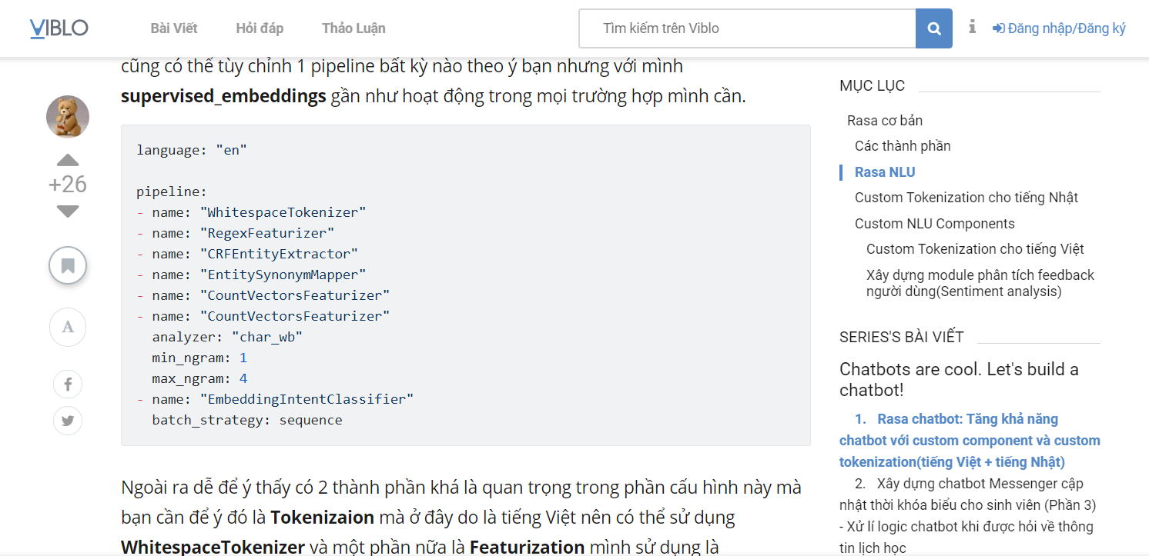

Form Adrress

validate_address.rar

Form Name_Phone_Amount

RasaRequestNamePhoneAmount.rar

Validate Input Form