**PROJECT TOOL GENERATE**

**BY:** [**tuanbao97@gmail.com**](mailto:tuanbao97@gmail.com)

# I/ Configure project using Eclipse

## *1/ Import project using maven*

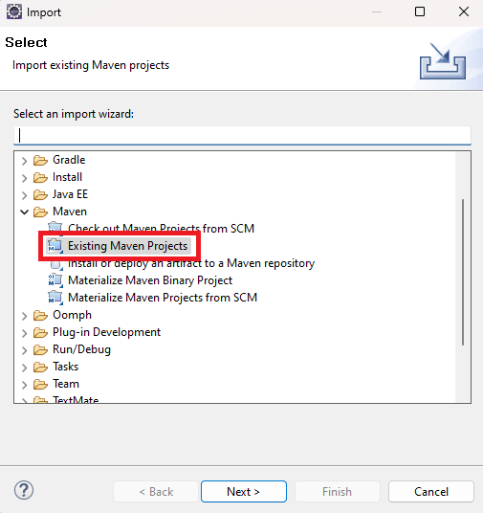

## 

## ***2/ Configure datasouce information***

* This project has 2 data sources: one for the generating tool itself and one for fetching project customer data.

### ***2.1/* Configure *Datasouce* in Eclipse**

* You will see an .env file in the source folder project, this is the eviroment variable configuration information.
* 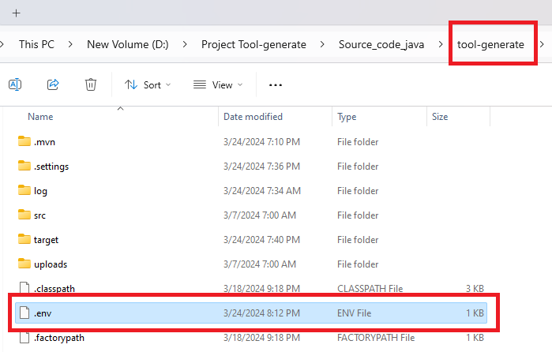
* You will define your datasource information. With driver name, url, username, password.

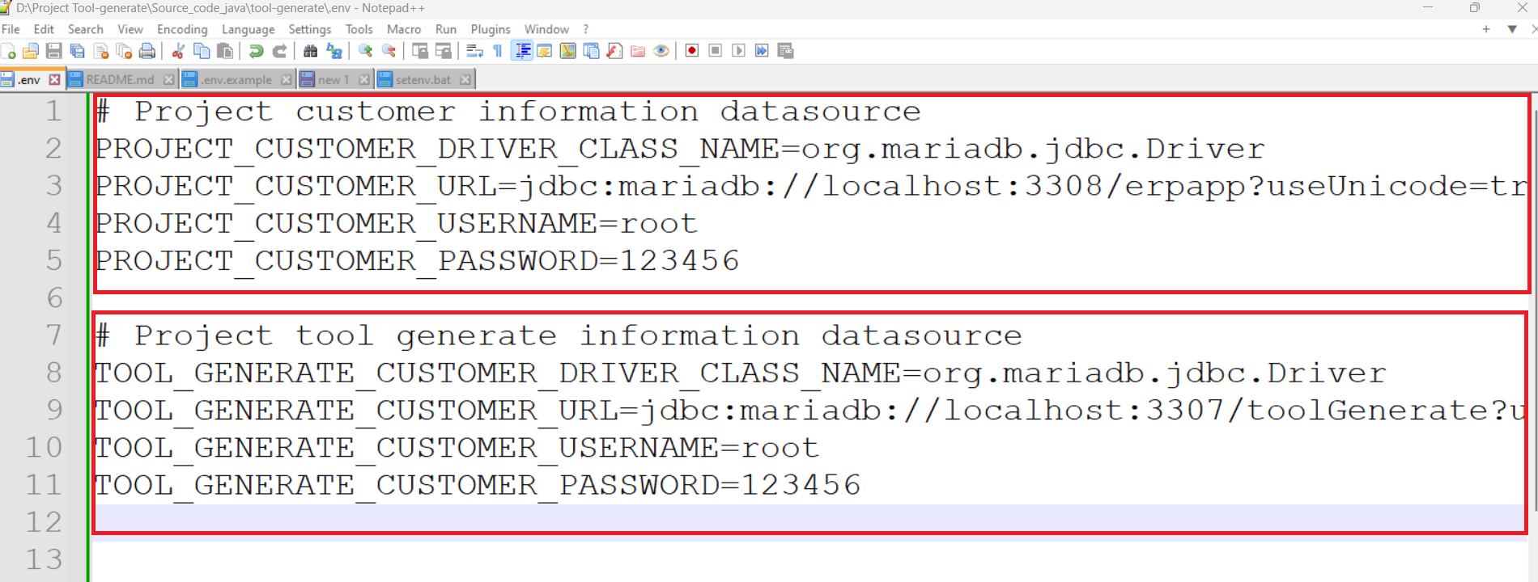

* Proceed to configure these env variables in the project.
* Step 1 right-click and select project -> Step 2 select Run AS -> Step 3 select Run Configurations .

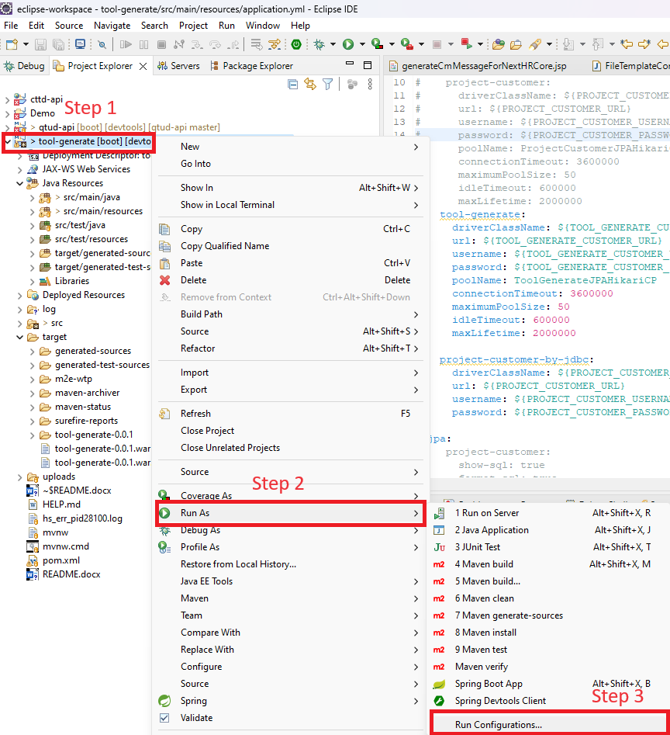

* Step 1 select project -> Step 2 select Environment tab -> Step 3 click Add button to add env variable like the .env file you defined above.

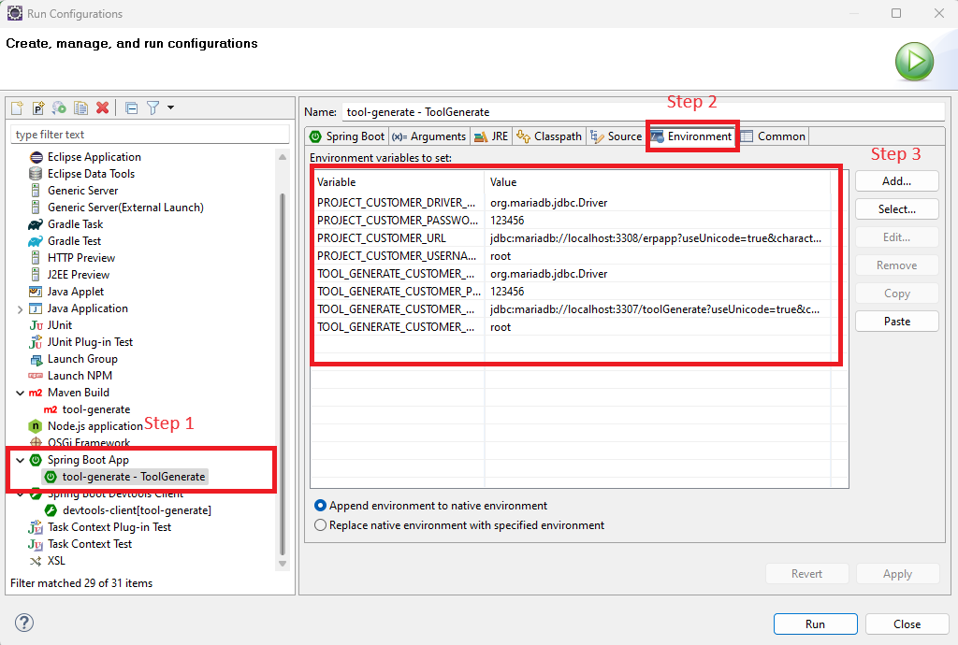

* Run project to testing

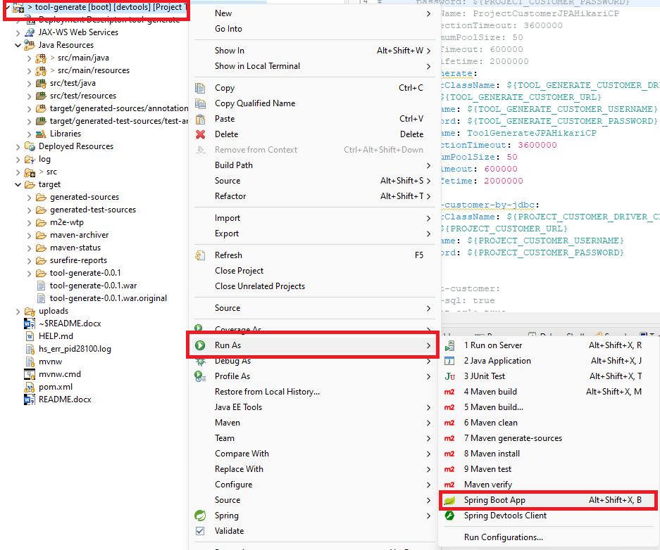

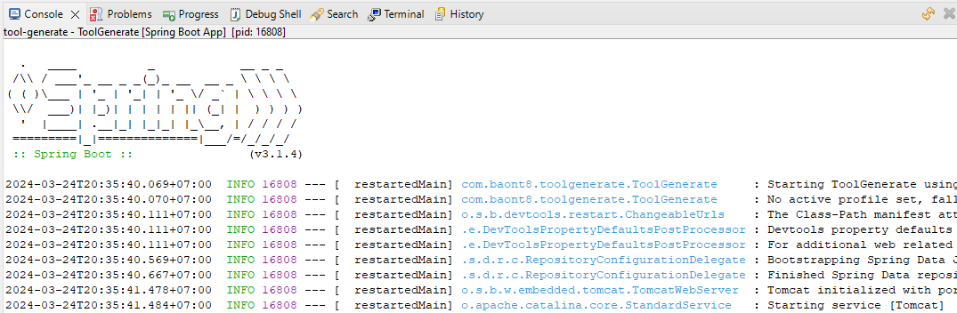

### **2.2/ Configure Datasouce when you run command maven**

* When running mvn clean install, mvn package, mvn spring-boot:run, it is required to include evironment variables as in the .env file above.
* Syntax:

| -D{ENV_NAME}={ENV_VALUE} |
| --- |

* Example:

| mvn spring-boot:run -Dspring-boot.run.jvmArguments="-DPROJECT_CUSTOMER_DRIVER_CLASS_NAME=org.mariadb.jdbc.Driver -DPROJECT_CUSTOMER_URL='jdbc:mariadb://localhost:3308/erpapp?useUnicode=true&characterEncoding=UTF-8' -DPROJECT_CUSTOMER_USERNAME=root -DPROJECT_CUSTOMER_PASSWORD=123456 -DTOOL_GENERATE_DRIVER_CLASS_NAME=org.mariadb.jdbc.Driver -DTOOL_GENERATE_URL='jdbc:mariadb://localhost:3307/toolGenerate?useUnicode=true&characterEncoding=UTF-8&createDatabaseIfNotExist=true' -DTOOL_GENERATE_USERNAME=root -DTOOL_GENERATE_PASSWORD=123456" |
| --- |

| mvn clean install -DPROJECT_CUSTOMER_DRIVER_CLASS_NAME=org.mariadb.jdbc.Driver -DPROJECT_CUSTOMER_URL='jdbc:mariadb://localhost:3308/erpapp?useUnicode=true&characterEncoding=UTF-8' -DPROJECT_CUSTOMER_USERNAME=root -DPROJECT_CUSTOMER_PASSWORD=123456 -DTOOL_GENERATE_DRIVER_CLASS_NAME=org.mariadb.jdbc.Driver -DTOOL_GENERATE_URL='jdbc:mariadb://localhost:3307/toolGenerate?useUnicode=true&characterEncoding=UTF-8&createDatabaseIfNotExist=true' -DTOOL_GENERATE_USERNAME=root -DTOOL_GENERATE_PASSWORD=123456 |
| --- |

| mvn package -DPROJECT_CUSTOMER_DRIVER_CLASS_NAME=org.mariadb.jdbc.Driver -DPROJECT_CUSTOMER_URL='jdbc:mariadb://localhost:3308/erpapp?useUnicode=true&characterEncoding=UTF-8' -DPROJECT_CUSTOMER_USERNAME=root -DPROJECT_CUSTOMER_PASSWORD=123456 -DTOOL_GENERATE_DRIVER_CLASS_NAME=org.mariadb.jdbc.Driver -DTOOL_GENERATE_URL='jdbc:mariadb://localhost:3307/toolGenerate?useUnicode=true&characterEncoding=UTF-8&createDatabaseIfNotExist=true' -DTOOL_GENERATE_USERNAME=root -DTOOL_GENERATE_PASSWORD=123456 |
| --- |

### 

### ***2.3/ Configure Datasouce when you* deploy tomcat**

* Step 1 Go to folder apache-tomcat -> bin folder
* Step 2 Create setenv.bat if not exists. Open the file and edit follow .env file above

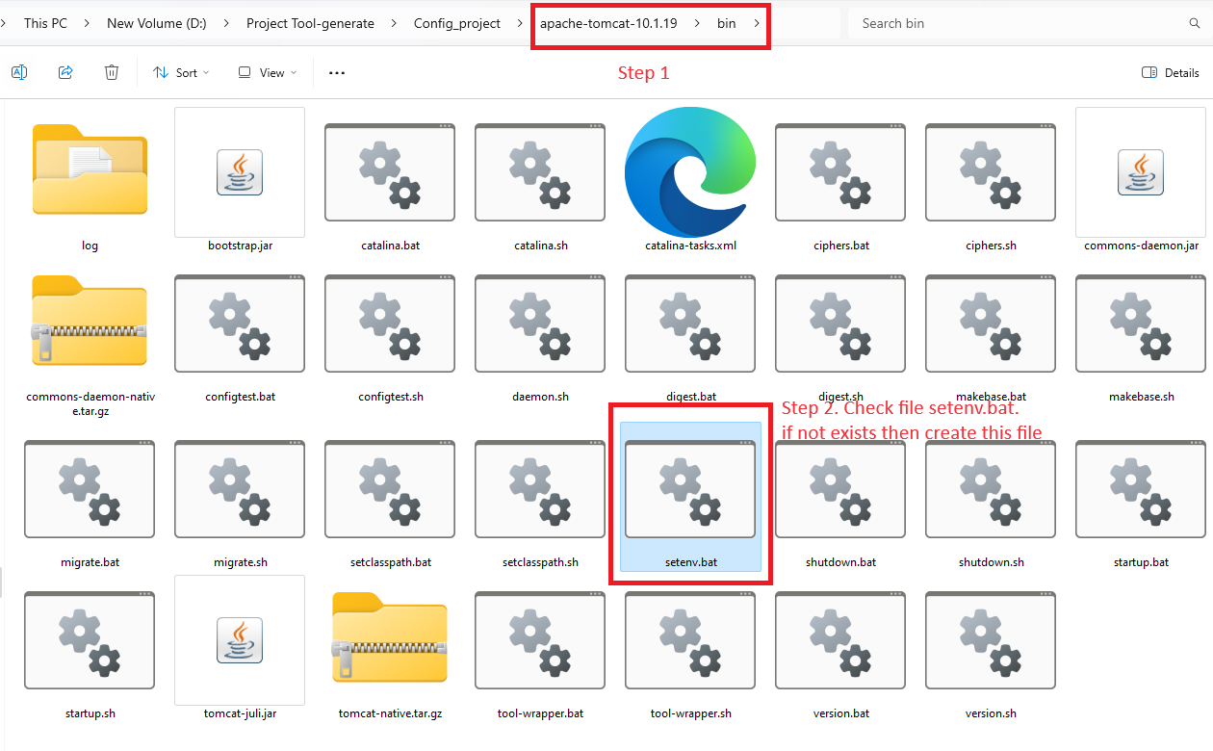

* Edit setenv.bat . Note that it is different from the .env file in that it must have the SET keyword at the beginning (required).

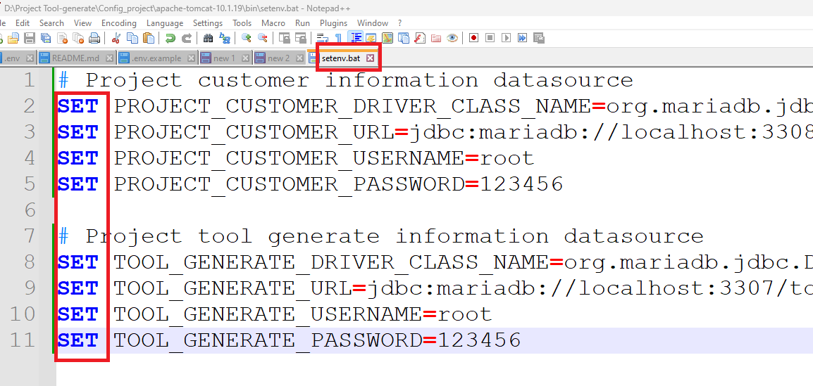

* Save and run setenv.bat. You have successfully configured env for tomcat