Vectors:
If w == 1, then vector is a pos in space
If w == 0, the vector is a direction

dot = "alignement intensity"

CrossProd:
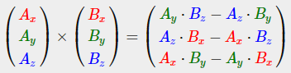

Matrices:
Indexed as (i, j) ((row, col))

Matrix addition/substraction (only available on same-sized matrices)
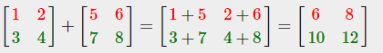

Matrix-matrix multiplication follows 2 rules:
1. Can only be done if LeftMat.colAmnt = RightMat.rowAmnt
2. It's not commutative (A*B != B*A)
Same with vectors: MxN matrix can be multiplied by Nx1 vector
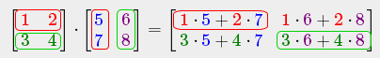

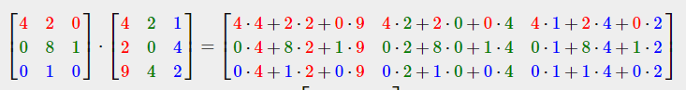
Matrix-scalar product
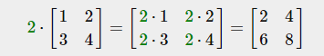

Matrix x Vertex (in this order) = TransformedVertex
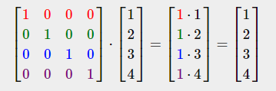

↑
Identity matrix: only 0s except on its diagonal (usually a starting point for generating other transformation matrices)

Scaling:
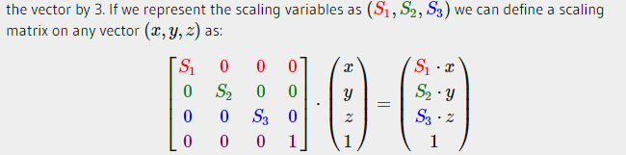

Translation: top-3 values of 4th column (so if w == 0, can't translate (would always returns 0))

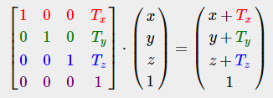

Rotation: circle is 360 degrees or 2PI radians. Most rotation functions require angle in radians (but can be converted)

angle in degrees = angle in radians * (180 / PI)
angle in radians = angle in degrees * (PI / 180)
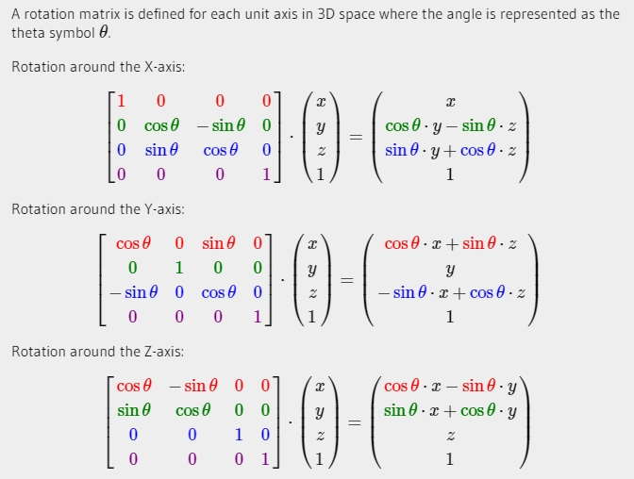
Combining matrices:
True power from using matrices for transformation is that they can be combined to obtain a single transformation matrix.
E.g: we have a vector (x,y,z) and want to scale it by 2 and then translate it by (1,2,3). We need a translation and a scaling matrix.
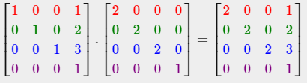
/!\ Notice that we first do a translation THEN a scale transformation. Remember that matrix multiplication is not commutative so order matters. /!\

When multiplying matrices the right-most matrix is first multiplied with the vector, so it should be readen from right to left.
It is advised to first do scaling operations, the rotations and lastly translations.

