Coordinate Systems
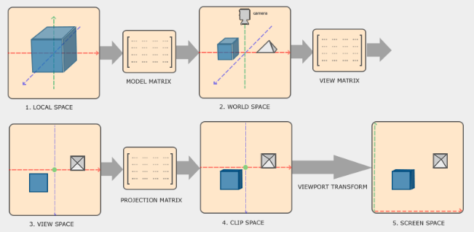
GL expects all the vertices that we want to become visible to be in normalized device coordinates after each vertex shader run. That is, the xyz coordinates of each vertex should be between -1.0 and 1.0.
What we usually do, is:
- Specify the coordinates in a range (or space) we determine ourselves;
- In the vertex shader, transform these coordinates to normalized device coordinates (NDC).
These NDC are then given to the rasterizer to transform them to 2D coordinates/pixels on screen.

Local space:
Coordinate space that is local to the object

World space:
Coordinates of all vertices relative to a world. Objects’ coordinates are transformed from local to world with the model matrix.

View space:
Usually refered as Camera/Camera space/eye space). Transforms world-space coordinates to coordinates that are in front of user’s view. It is the space as seen from the camera’s POV. It is accomplished with a combination of translations and rotations to translate/rotate the scene so that certain items are transformed to the front of the camera. These combined transformations are generally stored inside a view matrix.

Clip space:
At the end of each vertex run, GL expects coordinates to be within a specific tange and any coordinates out of that range is clipped (aka discarded).
Because specifying all the visible coordinates to be within the range -1-1 is not intuitive, we specify our own coordinate set to work in and convert those back to NDC as GL expects them.
To do so, we define a projection matrix that specifies a range of coords (e.g. -1000 and 1000 in each dimension). The projection matrix then converts coords within this range to NDC.
This “viewing box” is called a frustrum. All this conversion process is called projection.
Once all the vertices are transformed to clip space, a final operation called perspective division is performed. It divides the xyz components of position vectors by the vector’s homogeneous w component. This operation is what transforms the 4D clip space coords to 3D NDC. It is performed automatically at the end of vertex shader step.
The projection matrix usually takes two different froms, each one defining its own unique frustrum. It can be either an orthographic projmat or a perspective projmat.

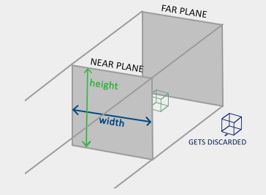
Orthographic projection:
An orthographic projection matrix directly maps coordinates to the 2D plane that is your screen, but in reality a direct projection produces unrealistic results since the projection doesn't take perspective into account. That is something the perspective projection matrix fixes for us.
In orthographic projection, w component is not manipulated (stays 1), so farther objects don’t seem smaller. This method is used for 2D rendering and some architectural/engineering applications.

Perspective projection:
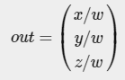
The projection matrix maps a given frustrum range to clip space, but also manipulates the w value of each vertex coord in such a way that the further away a vertex coordinate is from the viewer, the higher this w component becomes. Once the coords are transformed to clip space they are in the range -w to w (anything outside is clipped). GL requires that the visible coordinates fall between the range -1 to 1 as the final vertex shader output. Once the coords are in clip space, perspective division is applied to the clip space coords:

Each component of the vertex coord is divided by its w component giving smaller vertex coords the further away a vertex is from the viewer. The resulting coords are then in normalized device space.
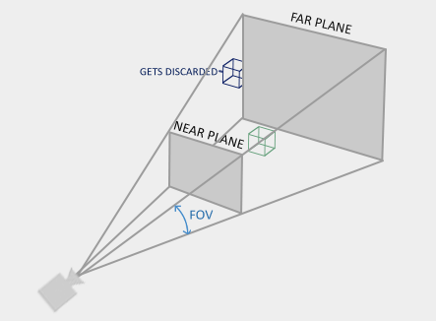

We create a transformation matrix for each of the aforementioned steps: model, view and projection matrix. A vertex coordinate is then transformed to clip coordinates as follows:

The resulting vertex should then be assigned to gl_Position (in vertexShader), GL will then automatically perform perspective division and clipping.

The output of the vertex shader requires the coords to be in clip-space (what the transformation matrices did).
GL then performs perspective division on the clip-space coords to transform them into NDC and then uses the parmas from glViewPort() to map the NDC to screen coords. This process is called viewport transform.

