Math Cheatsheet

Cosinus & Sinus
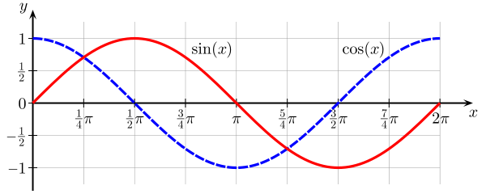

Unit circle
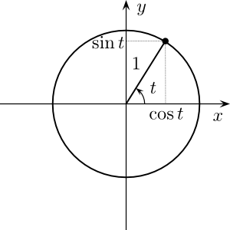
t is an angle in radians.
0 radians = 0 degrees
180 degrees = Pi radians
360 degrees ( full circle ) = 2*Pi radians
90 degrees = Pi/2 radians
Vectors
ALWAYS know in which coordinates your vector is.
A 3D vector is (x,y,z), but a homogeneous 3D vector is (x,y,z,w).
- w=0 : it’s a direction
- w=1 : it’s a position
- else : it may still be correct, but you’d better know what you’re doing.
You can only multiply a 4x4 matrix with a homogeneous vector.

Length
Just like cartesian distance : sqrt( x² + y² + z² ). w doesn’t count.

Cross product
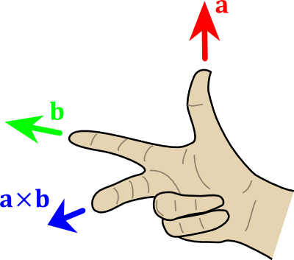
The X is the notation for the cross product. length( a x b ) == length(a) * length(b) * sin(θ), so you may want to normalize() the result.

Dot product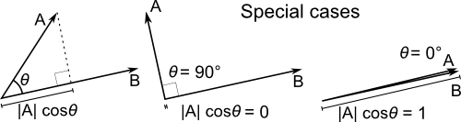
A.B = length(A)cos(Theta) , but most likely computed as A.xB.x +A.yB.y +A.zB.z

Addition and substraction
component-wise :
res.x = A.x + B.x
res.y = A.y + B.y
...

Multiplication
component-wise :
res.x = A.x * B.x
res.y = A.y * B.y
...

Normalization
Divide the vector by its length :
normalizedVector = vec * ( 1.0f / vec.length() )

Matrices

Matrix-Matrix multiplication
example for a translation matrix :
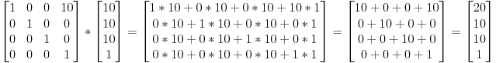

Matrix-Vector multiplication
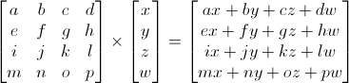

Usual Transformations
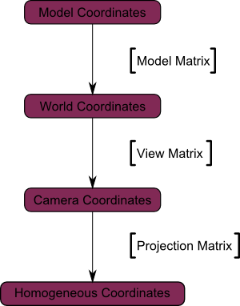
… but in your shaders, you can also represent your vectors in tangent space. And in image-space when you do post-effects.
res.x = A.x + B.x

