**Cytoscape Basic Usage**

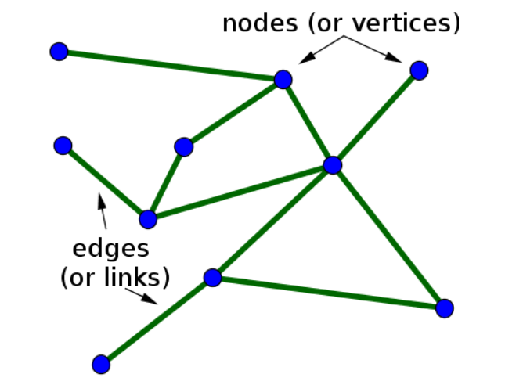

Image source: <https://mathinsight.org/>

**Group Selectors**: a dictionary of 2 possible keys: ‘selector’ and ‘style’.

The value of ‘selector’ can be ‘node’ or ‘edge’.

The value of ‘style’ is a new dictionary where the key is ‘label’, whose value represents what is displayed right above or next to the element (node or edge) on the screen.

{  
 **'selector'**: **'edge'**,  
 **'style'**: {  
 **'label'**: **'data(weight)'** }  
},

{  
 **'selector'**: **'node'**,  
 **'style'**: {  
 **'label'**: **'data(label)'** }  
},

**Class Selectors**: a dictionary of 2 possible keys: ‘selector’ and ‘style’.

The value of ‘selector’ can be any class that was assigned to the elements’ classes.

Element example (Node):

{**'data'**: {**'id'**: **'ed'**, **'label'**: **'Executive Director (Harriet)'**},  
 **'classes'**: **'purple'** *# One class* },

Element example (Edge):

{'data': {'source': 'ed', 'target': 'vp1', 'weight': 1}, 'classes': 'purple'},

Class selector example:

{  
 **'selector'**: **'.purple'**,  
 **'style'**: {  
 **'background-color'**: **'purple'**,  
 **'line-color'**: **'purple'** }  
},

The value of ‘style’ is a new dictionary that defines the element’s class.

For more defining parameters pertaining to NODES:

[*https://js.cytoscape.org/#style/node-body*](https://js.cytoscape.org/#style/node-body)

For more defining parameters pertaining to EDGE lines:[*https://js.cytoscape.org/#style/edge-line*](https://js.cytoscape.org/#style/edge-line)

**If this was helpful…**

I’m asking my viewers to support my Dash Plotly educational channel. A growing number of viewers are looking for high quality, professional content on Dash, which is hard to find. I am trying to fill that gap.

I believe that anyone working with data can benefit from knowing Dash Plotly, which is why I take the complex parts of Dash and break them down into bite-size tutorials for everyone to have.

My goal is to help people build careers in data visualization, so if you appreciate my channel and are able to support its existence, I would be grateful to you.

Become my supporter at either of these:

<https://www.patreon.com/charmingdata>

<https://github.com/sponsors/Coding-with-Adam>

By joining my community, you can get access to members' only posts, my private GitLab repository, and a one-on-one consultation.

Thank you,  
Adam