Lê Thị Bảo Uyên
22632501
1, docker –version
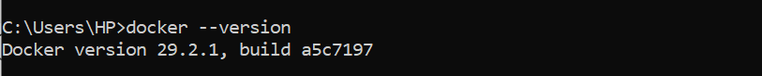
2, docker run hello-world
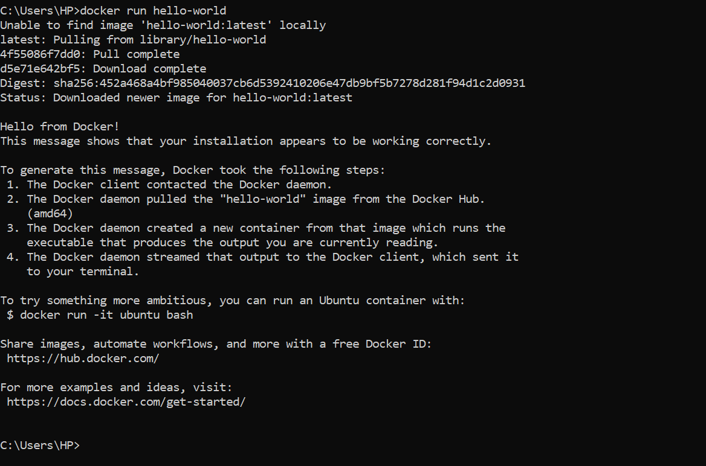
3, docker pull nginx
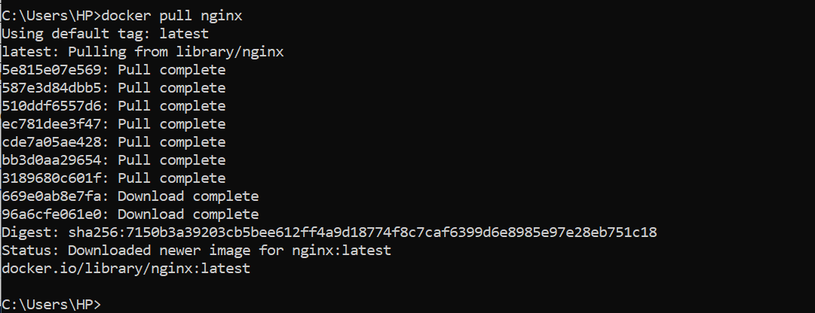
4, docker images
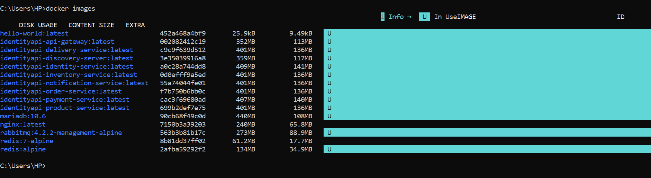
5, docker run -d nginx
6, docker ps
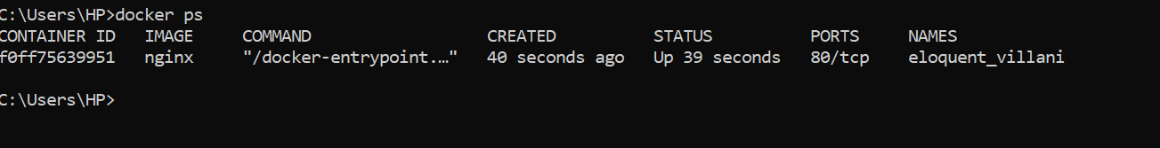
7, docker ps -a
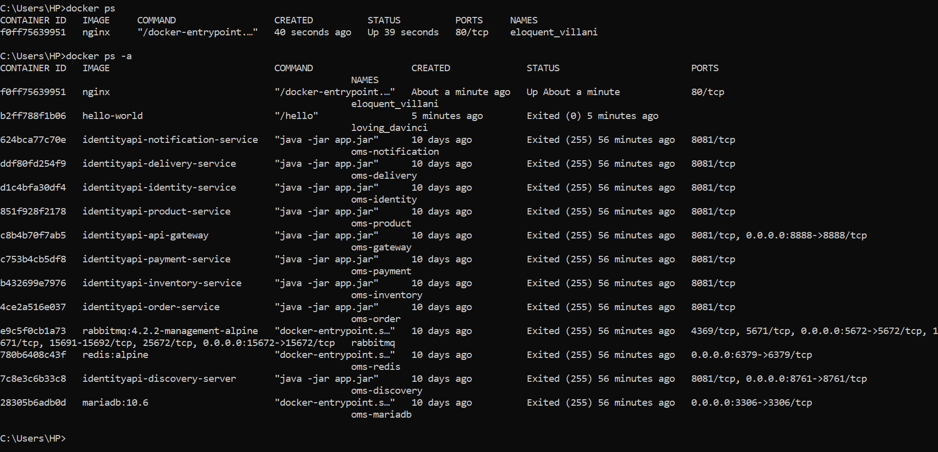
8, docker logs <container_id>
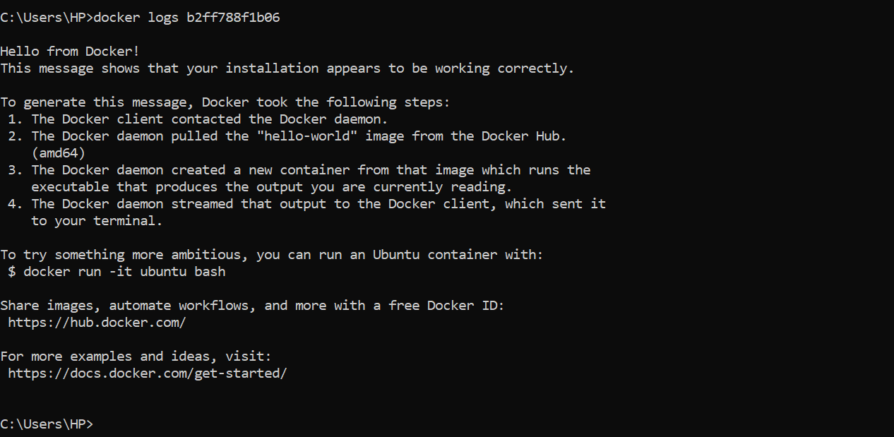
9, docker exec -it <container_id> /bin/sh
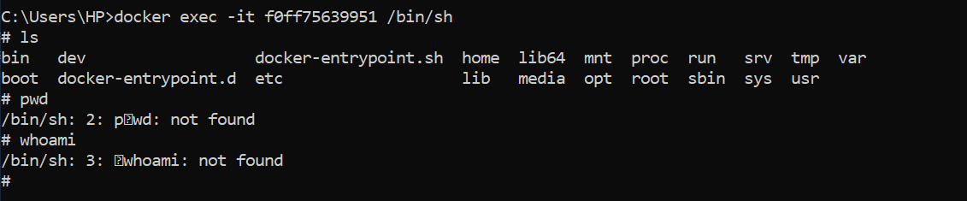
10, docker stop <container_id>
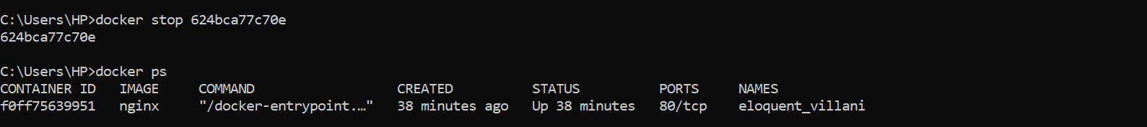
11, docker restart <container_id>
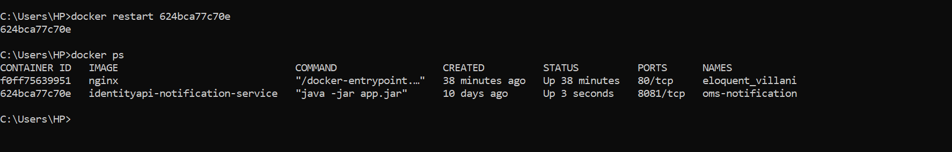
12, docker rm <container_id>
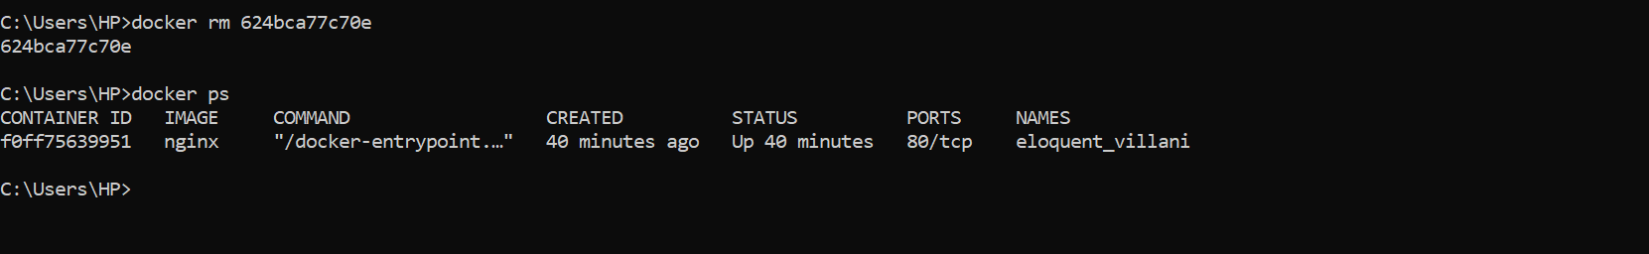
13, docker container prune
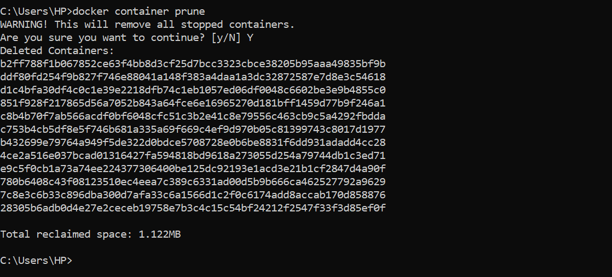
14, docker rmi <image_id>
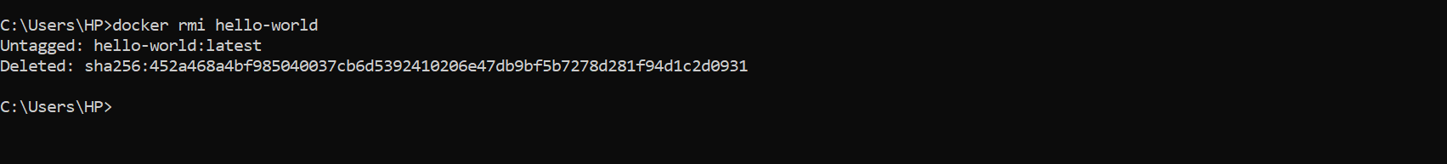
15, docker image prune -a
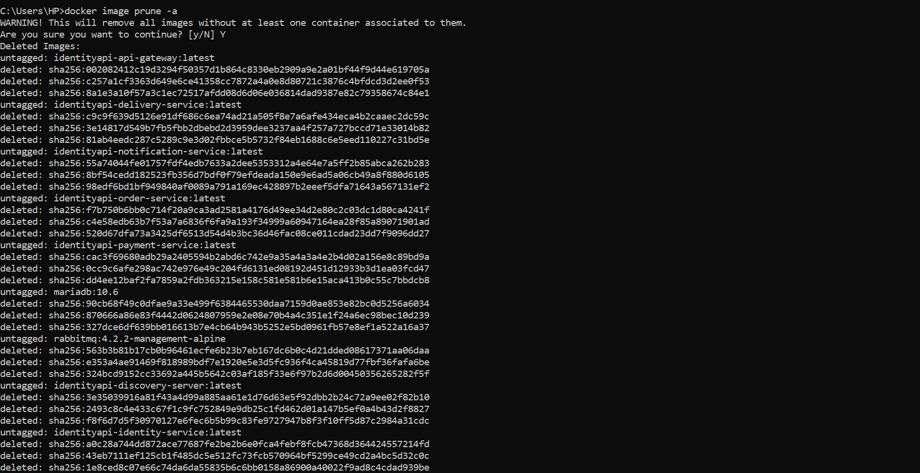
16, docker run -d -p 8080:80 nginx
17, docker inspect <container_id>
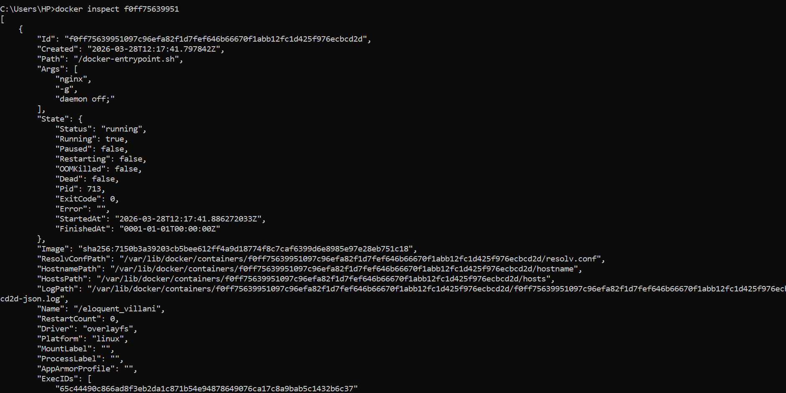
18, docker run -d -v mydata:/data nginx
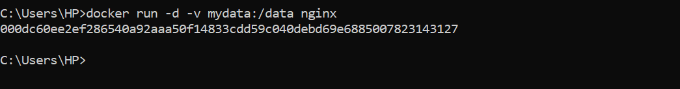
19, docker volume ls
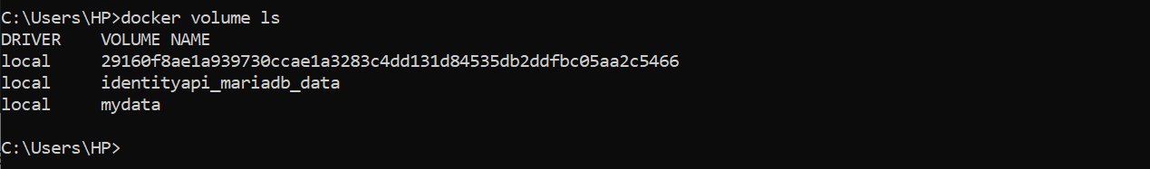
20, docker volume prune
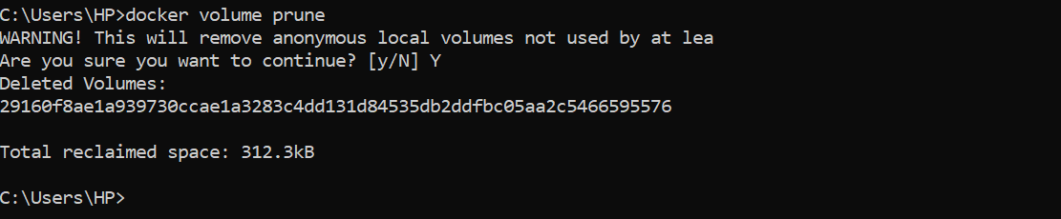
21, docker run -d --name my_nginx nginx
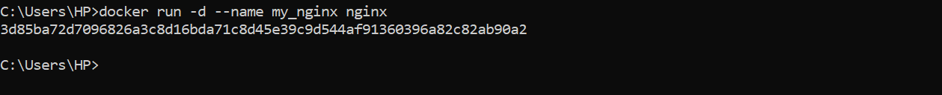
22, docker stats
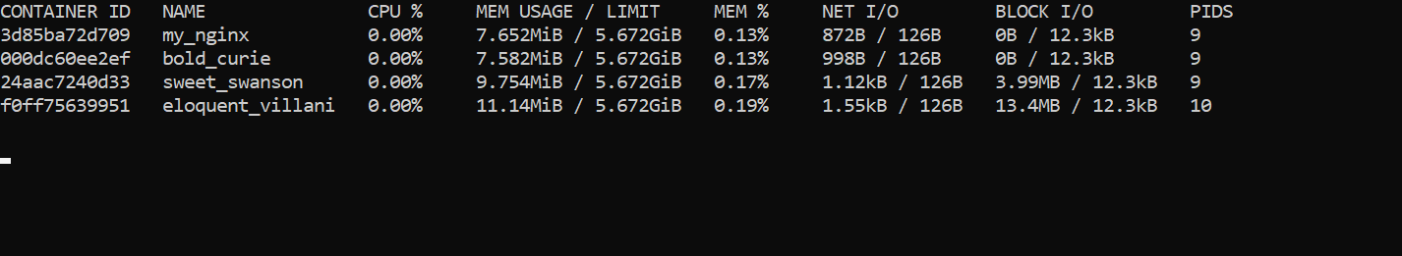
23, docker network ls
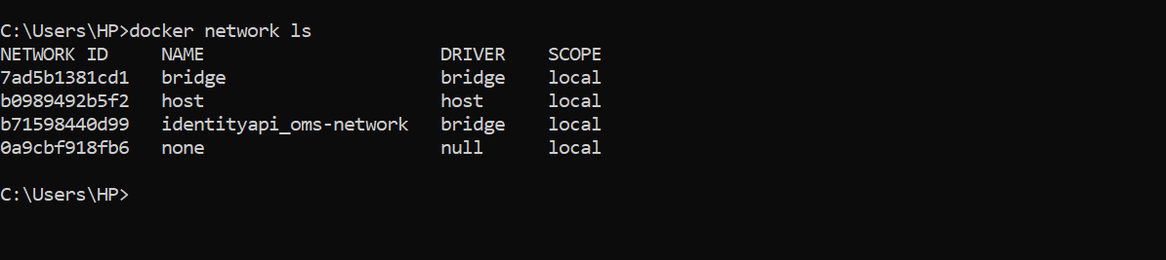
24, docker network create my_network
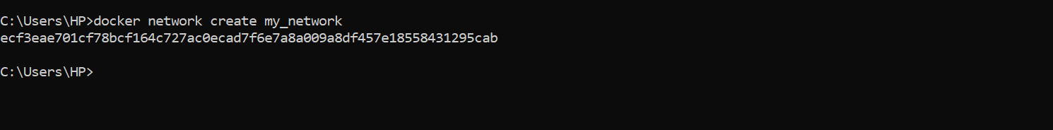
25, docker run -d --network my_network --name my_container nginx
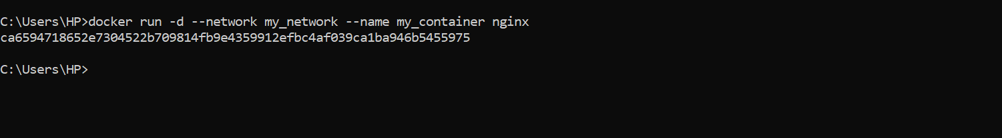
26, docker network connect my_network my_nginx
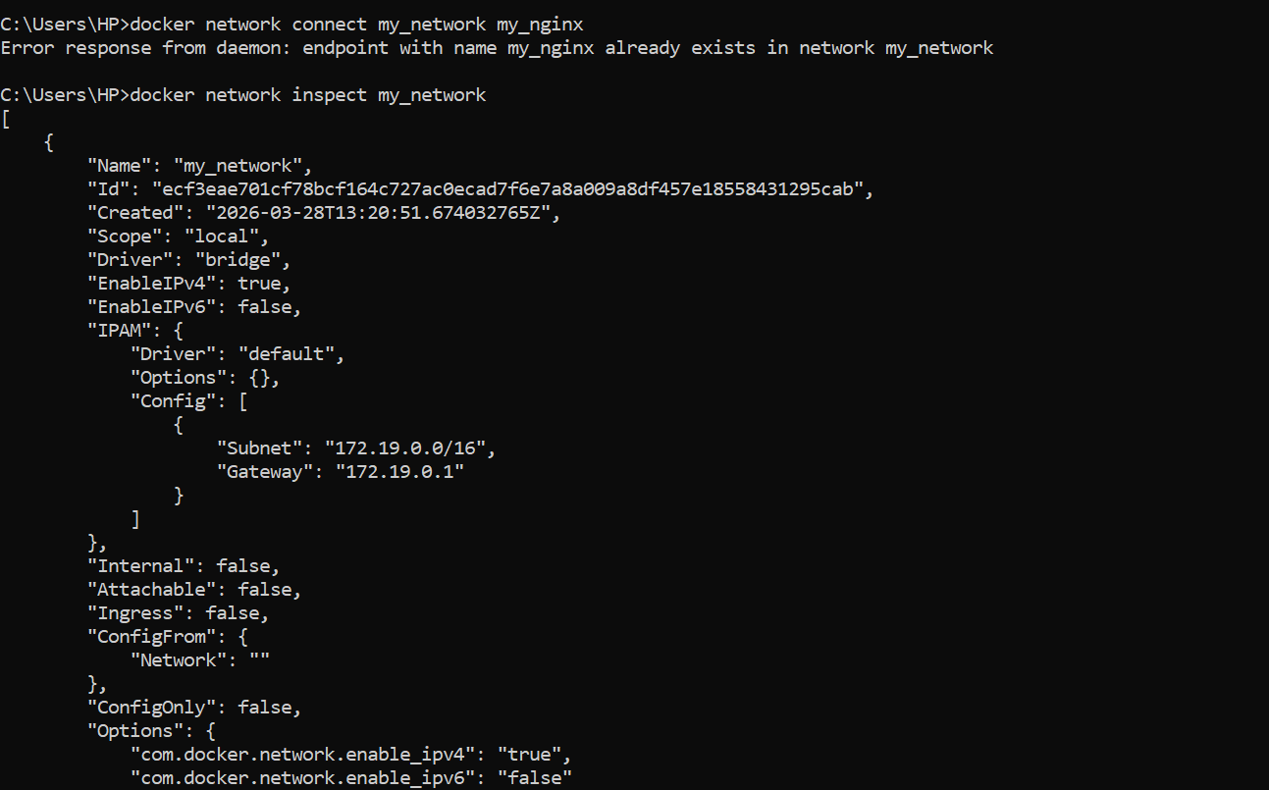
27, docker run -d -e MY_ENV=hello_world nginx
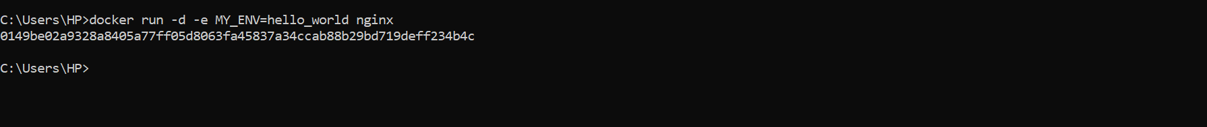
28, docker logs -f my_nginx
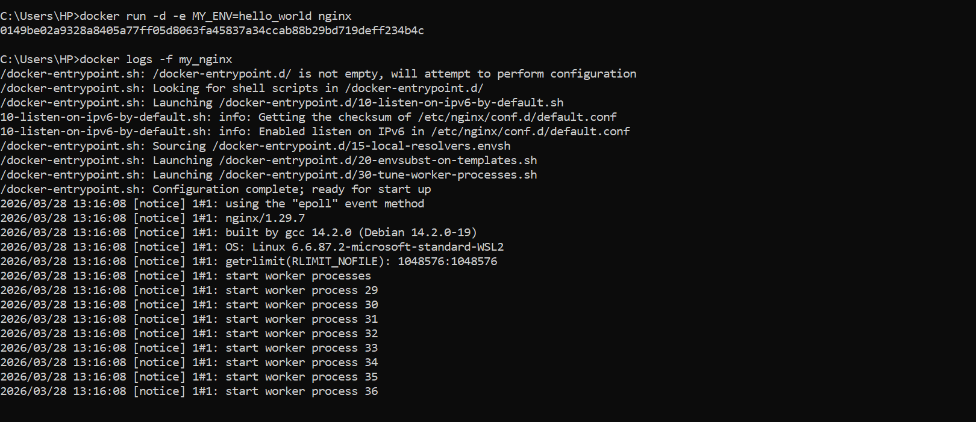
29, FROM nginx
COPY index.html /usr/share/nginx/html/index.html
• FROM nginx: dùng image nginx làm base
• COPY: copy file web vào container
30, docker build -t my_nginx_image .
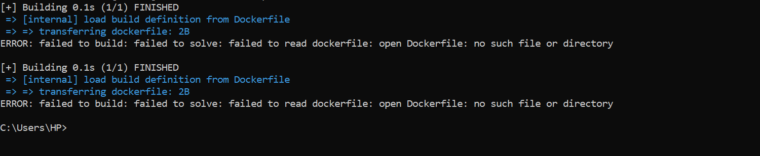
31, docker run -d -p 8080:80 my_nginx_image
