**Tên: Lê Thị Mỹ Hằng**

**Lớp: 11_ĐH_TMĐT**

**BÀI TẬP LÝ THUYẾT 4**

**Bài 4**: *Activity* và *Intent*

**Bước 1** - Tạo project và chuẩn bị

Mở Android Studio → New Project → chọn Empty Activity → đặt tên ví dụ TeofirstAppBai2 → Finish.

**Bước 2** - Thiết kế giao diện activity_main.xml

Ví dụ :

<?xml version="1.0" encoding="utf-8"?>

<androidx.constraintlayout.widget.ConstraintLayout

xmlns:android="http://schemas.android.com/apk/res/android"

xmlns:app="http://schemas.android.com/apk/res-auto"

android:layout_width="match_parent"

android:layout_height="match_parent">

<Button

android:id="@+id/btnHelloWorld"

android:layout_width="wrap_content"

android:layout_height="wrap_content"

android:onClick="onBtnHelloClick"

android:text="HelloWorld"

app:layout_constraintTop_toTopOf="parent"

app:layout_constraintStart_toStartOf="parent"

app:layout_constraintEnd_toEndOf="parent"/>

<Button

android:id="@+id/btnRegister"

android:layout_width="wrap_content"

android:layout_height="wrap_content"

android:onClick="onBtnRegisterClick"

android:text="Register"

app:layout_constraintTop_toBottomOf="@id/btnHelloWorld"

app:layout_constraintStart_toStartOf="parent"

app:layout_constraintEnd_toEndOf="parent"/>

</androidx.constraintlayout.widget.ConstraintLayout>

**Bước 3** - Thêm 2 Activity mới (HelloActivity, RegisterActivity)

Android Studio: Project (app) → right-click package java → New → Activity → Empty Activity → đặt tên HelloActivity.

Làm tương tự cho RegisterActivity.

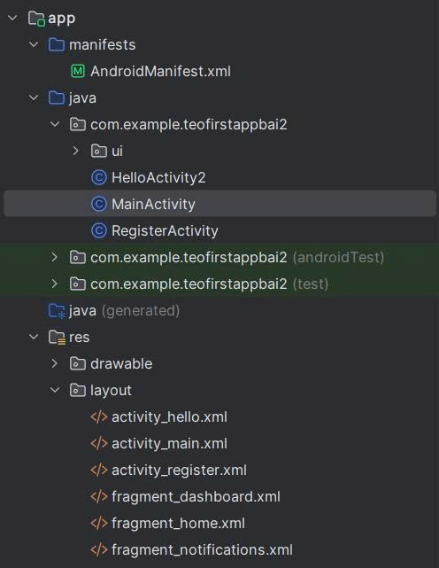

**Bước 4** - Code MainActivity.java

package com.example.TeofirstAppBai2;

import android.content.Intent;

import android.os.Bundle;

import android.view.View;

import androidx.appcompat.app.AppCompatActivity;

public class MainActivity extends AppCompatActivity {

@Override

protected void onCreate(Bundle savedInstanceState) {

super.onCreate(savedInstanceState);

setContentView(R.layout.activity_main);

}

// Gọi HelloActivity

public void onBtnHelloClick(View view) {

Intent intent = new Intent(this, HelloActivity.class);

startActivity(intent);

}

// Gọi RegisterActivity

public void onBtnRegisterClick(View view) {

Intent intent = new Intent(this, RegisterActivity.class);

startActivity(intent);

}

}

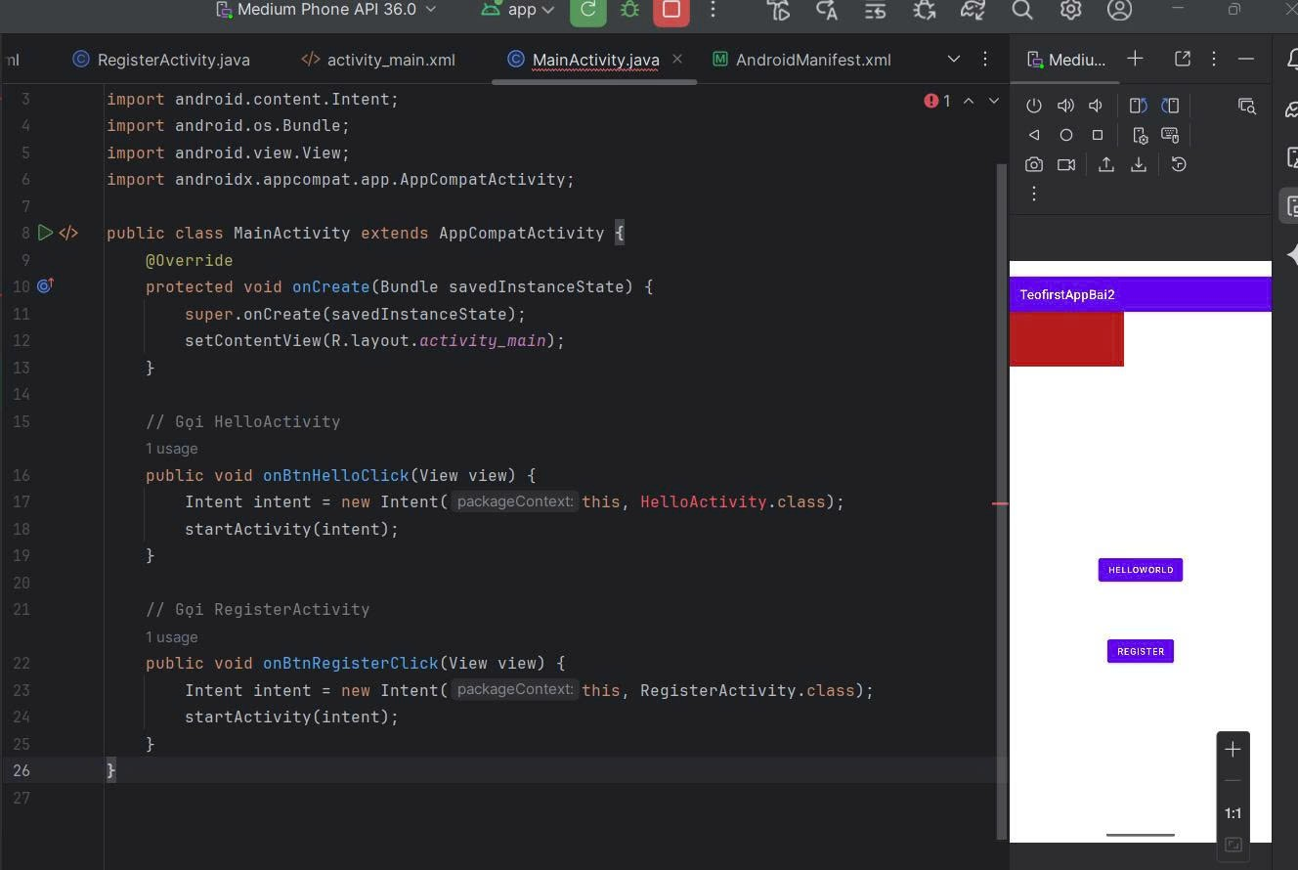

**Bước 5** - Implement HelloActivity và RegisterActivity

**HelloActivity.java**

public class HelloActivity extends AppCompatActivity {

@Override protected void onCreate(Bundle savedInstanceState) {

super.onCreate(savedInstanceState);

setContentView(R.layout.activity_hello);

// Nếu Main/Register gửi data:

String name = getIntent().getStringExtra("name");

TextView tv = findViewById(R.id.tvHello);

if (name != null) tv.setText("Hello, " + name + "!");

}

}

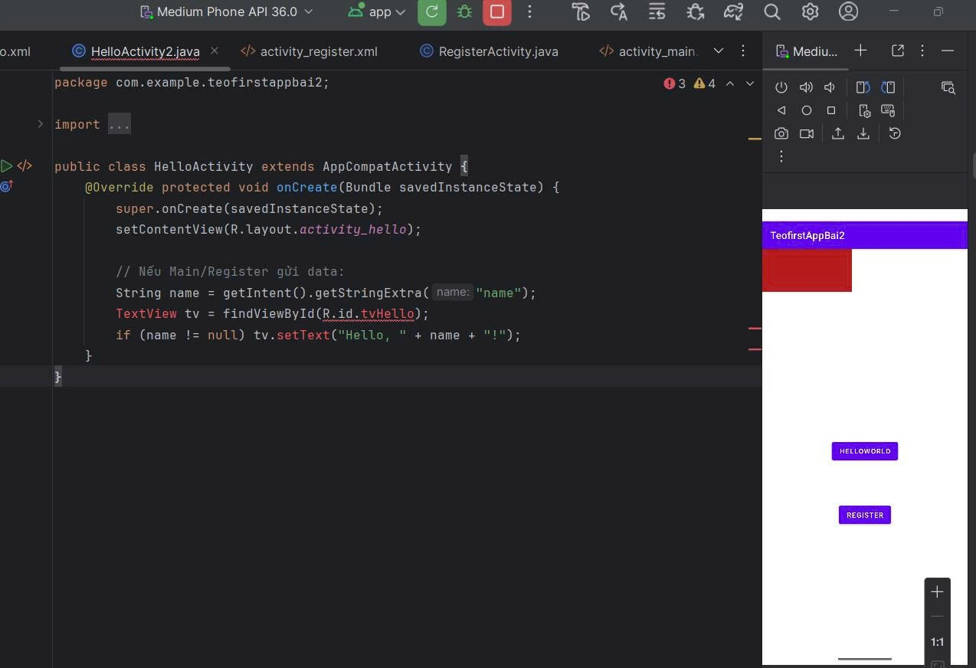

**RegisterActivity.java**

public class RegisterActivity extends AppCompatActivity {

EditText etName, etEmail;

@Override protected void onCreate(Bundle s) {

super.onCreate(s);

setContentView(R.layout.activity_register);

etName = findViewById(R.id.etName);

etEmail = findViewById(R.id.etEmail);

findViewById(R.id.btnSubmit).setOnClickListener(v -> {

String name = etName.getText().toString().trim();

if (name.isEmpty()) { etName.setError("Nhập tên"); return; }

Intent i = new Intent(this, HelloActivity.class);

i.putExtra("name", name);

startActivity(i);

});

}

}

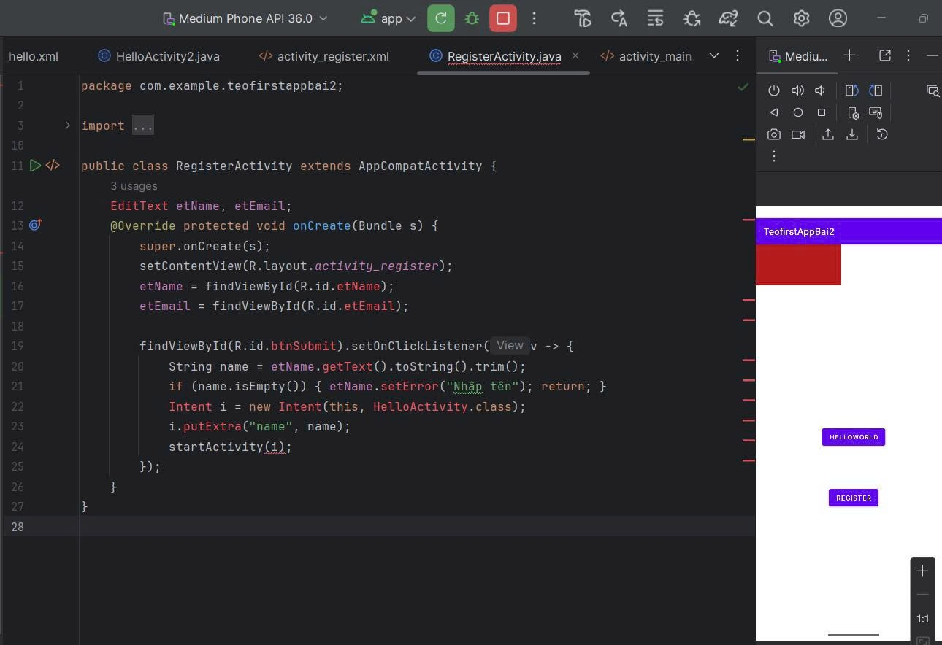

**Bước 6** - Kiểm tra AndroidManifest.xml

Kiểm tra xem có các entry như:

<application ...>

<activity android:name=".RegisterActivity" android:exported="false" />

<activity android:name=".HelloActivity" android:exported="false" />

<activity android:name=".MainActivity">

<intent-filter>

<action android:name="android.intent.action.MAIN"/>

<category android:name="android.intent.category.LAUNCHER"/>

</intent-filter>

</activity>

</application>

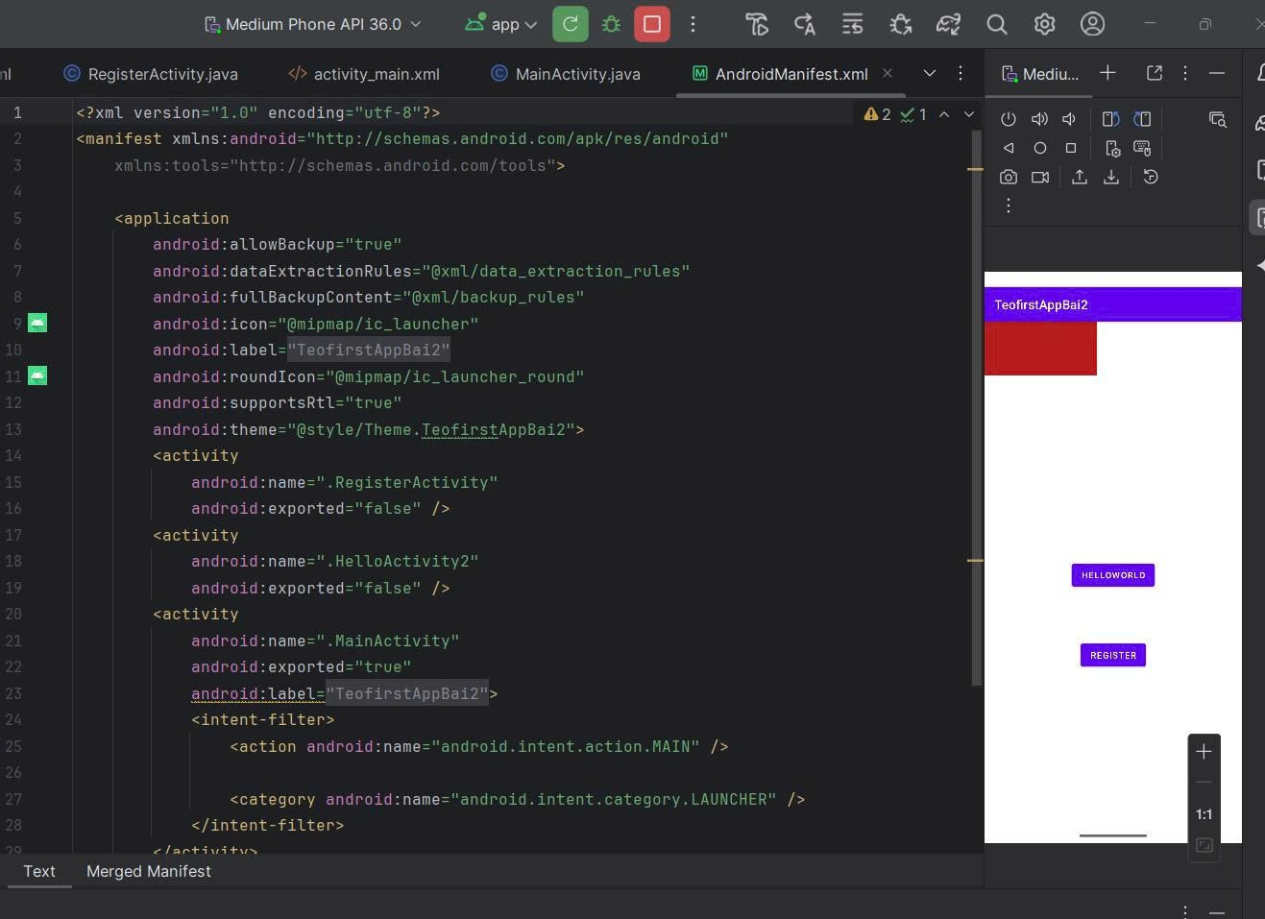

**Kết quả:**

