**Step 0: Install git and create a GitHub account**

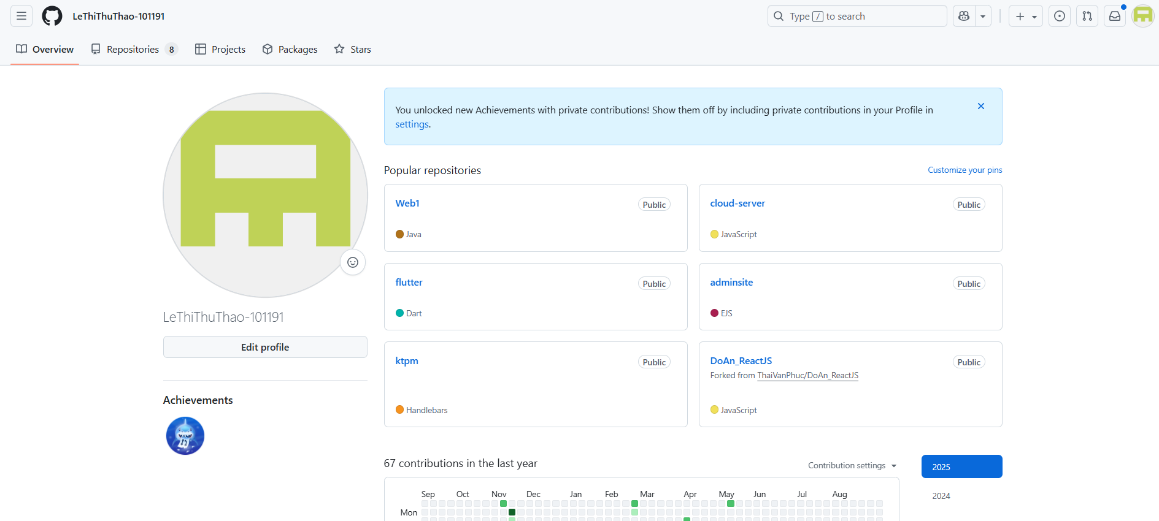

**Step 1: Create a local git repository**

**Step 2: Add a new file to the repo**

**Step 3: Add a file to the staging environment**

**Step 4: Create a commit**

**Step 5: Create a new branch**

**Step 6: Create a new repository on GitHub**

**Step 7: Push a branch to GitHub**

