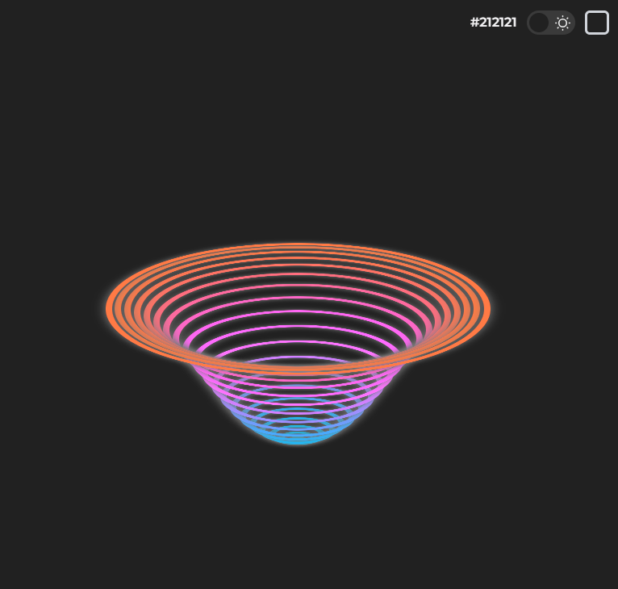

|  |  |
| --- | --- |
| <div class="container">  <div class="item" style="--i:0;"></div>  <div class="item" style="--i:1;"></div>  <div class="item" style="--i:2;"></div>  <div class="item" style="--i:3;"></div>  <div class="item" style="--i:4;"></div>  <div class="item" style="--i:5;"></div>  <div class="item" style="--i:6;"></div>  <div class="item" style="--i:7;"></div>  <div class="item" style="--i:8;"></div>  <div class="item" style="--i:9;"></div>  <div class="item" style="--i:10;"></div>  <div class="item" style="--i:11;"></div>  <div class="item" style="--i:12;"></div>  <div class="item" style="--i:13;"></div>  <div class="item" style="--i:14;"></div>  <div class="item" style="--i:15;"></div>  <div class="item" style="--i:16;"></div>  <div class="item" style="--i:17;"></div>  <div class="item" style="--i:18;"></div>  <div class="item" style="--i:19;"></div>  <div class="item" style="--i:20;"></div>  </div> | .container {  position: absolute;  top: 40%;  height: 90%;  display: flex;  justify-content: center;  align-items: center;  }  .item {  position: absolute;  background-color: transparent;  width: calc(var(--i) * 2.5vmin);  aspect-ratio: 1;  border-radius: 50%;  border: .9vmin solid rgb(0, 200, 255);  transform-style: preserve-3d;  transform: rotateX(70deg) translateZ(50px);  animation: my-move 3s ease-in-out calc(var(--i) * 0.08s) infinite;  box-shadow: 0px 0px 15px rgb(124, 124, 124),  inset 0px 0px 15px rgb(124, 124, 124);  }  @keyframes my-move {  0%,  100% {  transform: rotateX(70deg) translateZ(50px) translateY(0px);  filter: hue-rotate(0deg);  }  50% {  transform: rotateX(70deg) translateZ(50px) translateY(-50vmin);  filter: hue-rotate(180deg);  }  } |

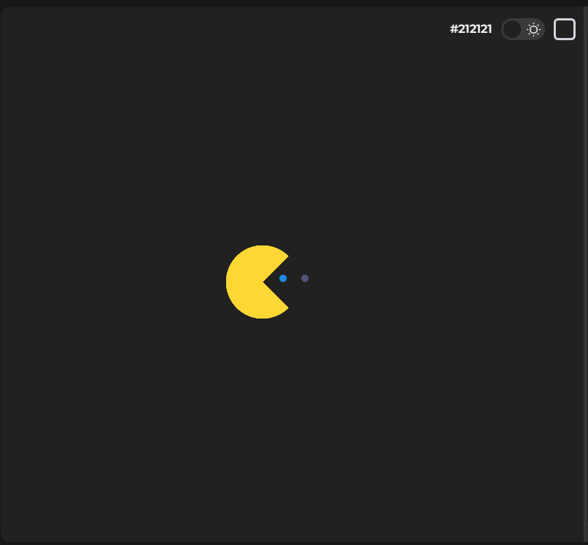

|  |  |
| --- | --- |
| <main id="container">    <div class="dots">  <div class="dot"></div>  <div class="dot"></div>  <div class="dot"></div>  <div class="dot"></div>  <div class="dot"></div>  <div class="dot"></div>  <div class="dot"></div>  <div class="dot"></div>  <div class="dot"></div>  <div class="dot"></div>  </div>  <div class="dots2">  <div class="dot2"></div>  <div class="dot2"></div>  <div class="dot2"></div>  <div class="dot2"></div>  <div class="dot2"></div>  <div class="dot2"></div>  <div class="dot2"></div>  <div class="dot2"></div>  <div class="dot2"></div>  <div class="dot2"></div>  </div>  <div class="circle"></div>  </main> | .circle {  position: relative;  left: -100px;  width: 0;  height: 0;  border: 50px solid #FDD835;  border-radius: 50%;  border-right-color: transparent;  animation: move 5s linear 0s infinite normal forwards;  }  .circle:before {  content: "";  position: absolute;  top: -50px;  left: -50px;  width: 0;  height: 0;  border: 50px solid #FDD835;  border-radius: 50%;  border-right-color: transparent;  animation: chomp1 .25s ease-in-out 0s infinite normal forwards;  }  .circle:after {  content: "";  position: absolute;  top: -50px;  left: -50px;  width: 0;  height: 0;  border: 50px solid #FDD835;  border-radius: 50%;  border-right-color: transparent;  animation: chomp2 .25s ease-in-out 0s infinite normal forwards;  }  .loader {  position: relative;  top: 50px;  width: 300px;  height: 0px;  border-top: 10px dotted black;  animation: loader_4013 5s ease-in-out 0s infinite normal forwards;  }  .dots {  position: relative;  top: 60px;  display: flex;  justify-content: center;  align-items: center;  }  .dot {  position: relative;  width: 10px;  height: 10px;  margin: 0 10px;  border-radius: 50%;  background: #1E88E5;  animation: dot1 5s linear 0s infinite none normal;  }  .dot:nth-child(1) {  animation-delay: 0s  }  .dot:nth-child(2) {  animation-delay: 0.25s  }  .dot:nth-child(3) {  animation-delay: 0.5s  }  .dot:nth-child(4) {  animation-delay: 0.75s  }  .dot:nth-child(5) {  animation-delay: 1s  }  .dot:nth-child(6) {  animation-delay: 1.25s  }  .dot:nth-child(7) {  animation-delay: 1.5s  }  .dot:nth-child(8) {  animation-delay: 1.75s  }  .dot:nth-child(9) {  animation-delay: 1.9s  }  .dot:nth-child(10) {  animation-delay: 2.1s  }  .dots2 {  position: relative;  top: 50px;  left: 10px;  display: flex;  justify-content: center;  align-items: center;  }  .dot2 {  position: relative;  left: -10px;  width: 10px;  height: 10px;  margin: 0 10px;  border-radius: 50%;  background: #F44336;  opacity: 0;  animation: dot2 5s linear 0s infinite none normal;  }  .dot2:nth-child(10) {  animation-delay: 2.5s  }  .dot2:nth-child(9) {  animation-delay: 2.75s  }  .dot2:nth-child(8) {  animation-delay: 3.0s  }  .dot2:nth-child(7) {  animation-delay: 3.25s  }  .dot2:nth-child(6) {  animation-delay: 3.5s  }  .dot2:nth-child(5) {  animation-delay: 3.75s  }  .dot2:nth-child(4) {  animation-delay: 4.0s  }  .dot2:nth-child(3) {  animation-delay: 4.25s  }  .dot2:nth-child(2) {  animation-delay: 4.5s  }  .dot2:nth-child(1) {  animation-delay: 4.6s  }  /* #F44336;, #1E88E5, #FDD835; */  @keyframes chomp1 {  0% {  transform: rotate(0deg);  }  50% {  transform: rotate(45deg);  }  100% {  transform: rotate(0deg);  }  }  @keyframes chomp2 {  0% {  transform: rotate(0deg);  }  50% {  transform: rotate(-45deg);  }  100% {  transform: rotate(0deg);  }  }  @keyframes move {  0%, 100% {  left: -100px;  }  0%, 48% {  transform: rotateY(0deg);  }  50%, 100% {  transform: rotateY(180deg);  }  50% {  left: 100%;  }  }  @keyframes loader_4013 {  0%, 100% {  border-top: 10px dotted #1E88E5;  }  0%, 48% {  border-top: 10px dotted #1E88E5;  }  50%, 100% {  border-top: 10px dotted #F44336;  }  50% {  border-top: 10px dotted #F44336;  }  }  @keyframes dot1 {  0%,4% {  background: #1E88E5;  opacity: 1;  }  5%,94% {  background: #F44336;  opacity: 0;  }  95%,100% {  background: #1E88E5;  opacity: 1;  }  }  @keyframes dot2 {  0%,4% {  background: #F44336;  opacity: 1;  }  5%,94% {  opacity: 0;  }  95%,100% {  background: #F44336;  opacity: 1;  }  } |

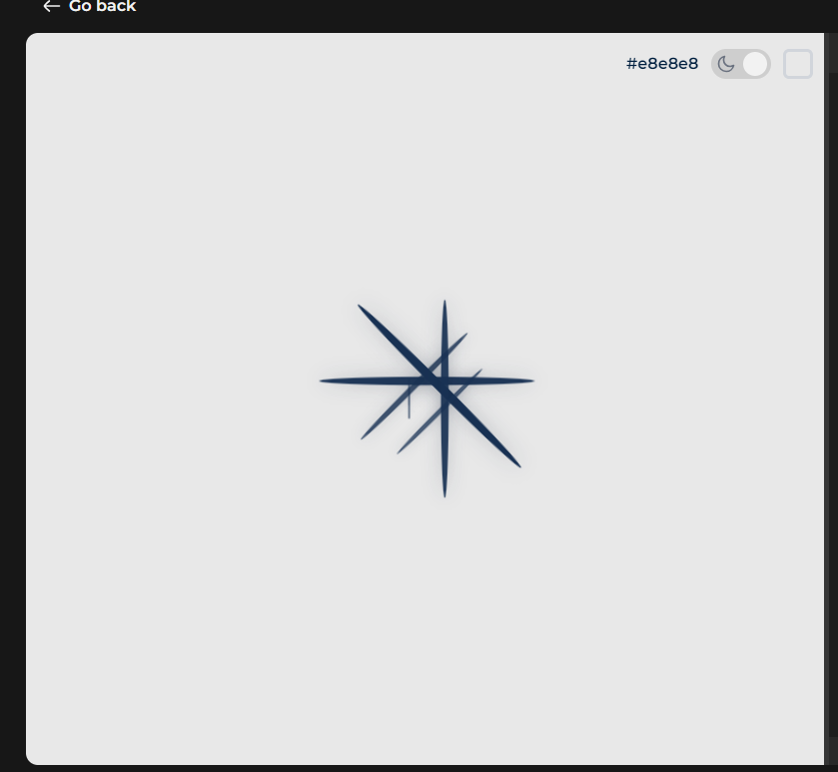

|  |  |
| --- | --- |
| <div class="loader">  <div class="loaders"></div>  <div class="loaders"></div>  <div class="loaders"></div>  <div class="loaders"></div>  <div class="loaders"></div>  <div class="loaders"></div>  <div class="loaders"></div>  <div class="loaders"></div>  </div> | .loader {  --uib-size: 2.8rem;  --uib-speed: .9s;  --uib-color: #183153;  position: relative;  display: flex;  align-items: center;  justify-content: flex-start;  height: var(--uib-size);  width: var(--uib-size);  }  .loaders {  position: absolute;  top: 0;  left: 0;  display: flex;  align-items: center;  justify-content: flex-start;  height: 100%;  width: 100%;  }  .loaders::before {  content: '';  height: 20%;  width: 20%;  border-radius: 50%;  background-color: var(--uib-color);  transform: scale(0);  opacity: 0.5;  animation: pulse0112 calc(var(--uib-speed) * 1.111) ease-in-out infinite;  box-shadow: 0 0 20px rgba(18, 31, 53, 0.3);  padding-bottom: 222px;  }  .loaders:nth-child(2) {  transform: rotate(45deg);  }  .loaders:nth-child(2)::before {  animation-delay: calc(var(--uib-speed) * -0.875);  }  .loaders:nth-child(3) {  transform: rotate(90deg);  }  .loaders:nth-child(3)::before {  animation-delay: calc(var(--uib-speed) * -0.75);  }  .loaders:nth-child(4) {  transform: rotate(135deg);  }  .loaders:nth-child(4)::before {  animation-delay: calc(var(--uib-speed) * -0.625);  }  .loaders:nth-child(5) {  transform: rotate(180deg);  }  .loaders:nth-child(5)::before {  animation-delay: calc(var(--uib-speed) * -0.5);  }  .loaders:nth-child(6) {  transform: rotate(225deg);  }  .loaders:nth-child(6)::before {  animation-delay: calc(var(--uib-speed) * -0.375);  }  .dot-spinner__dot:nth-child(7) {  transform: rotate(270deg);  }  .loaders:nth-child(7)::before {  animation-delay: calc(var(--uib-speed) * -0.25);  }  .loaders:nth-child(8) {  transform: rotate(315deg);  }  .loaders:nth-child(8)::before {  animation-delay: calc(var(--uib-speed) * -0.125);  }  @keyframes pulse0112 {  0%,  100% {  transform: scale(0);  opacity: 0.5;  }  50% {  transform: scale(1);  opacity: 1;  }  } |



|  |  |
| --- | --- |
| <div class="bulb">  <svg width="60pt" height="60pt" version="1.1" viewBox="0 0 1200 1200" xmlns="http://www.w3.org/2000/svg">  <g>  <path d="m930 552.86h-660c-6.9297 0-13.191-4.168-15.836-10.582-2.6602-6.4102-1.1875-13.777 3.7148-18.684l289.72-289.7c4.1367-4.1367 10.078-5.875 15.836-4.6211 5.707 1.2734 10.379 5.375 12.387 10.883 3.7031 10.164 13.43 16.996 24.176 16.996s20.473-6.832 24.191-17.008c2.0078-5.5078 6.6797-9.5938 12.406-10.863 5.6602-1.2539 11.668 0.48437 15.82 4.6211l289.7 289.7c4.9062 4.9062 6.3789 12.27 3.7148 18.684-2.6445 6.4062-8.9062 10.574-15.836 10.574zm-618.62-34.285h577.23l-245.5-245.51c-11.102 11.469-26.586 18.367-43.109 18.367-16.539 0-32.008-6.8984-43.109-18.348z"></path>  <path d="m986.48 1028.6h-772.97c-23.203 0-42.086-18.883-42.086-42.086v-425.82c0-23.203 18.883-42.09 42.086-42.09h772.97c23.203 0 42.086 18.887 42.086 42.09v425.82c0 23.203-18.883 42.086-42.086 42.086zm-772.97-475.71c-4.3008 0-7.8008 3.5-7.8008 7.8047v425.82c0 4.3008 3.5 7.8008 7.8008 7.8008h772.97c4.3008 0 7.8008-3.5 7.8008-7.8008v-425.82c0-4.3047-3.5-7.8047-7.8008-7.8047z"></path>  <path d="m599.92 935.74c-89.332 0-162-72.758-162-162.17 0-89.414 72.672-162.17 162-162.17 89.414 0 162.17 72.758 162.17 162.17-0.003906 89.414-72.758 162.17-162.17 162.17zm0-290.05c-70.43 0-127.72 57.371-127.72 127.89 0 70.512 57.289 127.89 127.72 127.89 70.512 0 127.89-57.371 127.89-127.89-0.003907-70.516-57.375-127.89-127.89-127.89z"></path>  <path d="m576.71 838.07c-4.5547 0-8.9062-1.8086-12.121-5.0234l-48.113-48.129c-6.6953-6.6953-6.6953-17.543 0-24.242 6.6953-6.6953 17.543-6.6953 24.242 0l35.992 36.012 82.582-82.582c6.6953-6.6953 17.543-6.6953 24.242 0 6.6953 6.6953 6.6953 17.543 0 24.242l-94.703 94.703c-3.2148 3.2109-7.5703 5.0195-12.121 5.0195z"></path>  <path d="m600 291.43c-25.113 0-47.777-15.887-56.383-39.559-2.3633-6.1445-3.6172-13.125-3.6172-20.441 0-33.082 26.918-60 60-60s60 26.918 60 60c0 7.3477-1.2383 14.312-3.6992 20.727-8.5391 23.387-31.207 39.273-56.301 39.273zm0-85.715c-14.18 0-25.715 11.535-25.715 25.715 0 3.0625 0.50391 5.9766 1.4414 8.4375 3.8008 10.445 13.527 17.277 24.273 17.277s20.473-6.832 24.191-17.008c1.0391-2.6992 1.5234-5.6094 1.5234-8.707 0-14.18-11.535-25.715-25.715-25.715z"></path>  </g>  </svg>  </div> | .bulb svg {  display: block;  height: 90px;  transform-origin: center top;  animation: swing_31 1.3s ease-in-out infinite alternate;  }  @keyframes swing_31 {  0% {  transform: rotate(18deg);  }  100% {  transform: rotate(-18deg);  }  } |

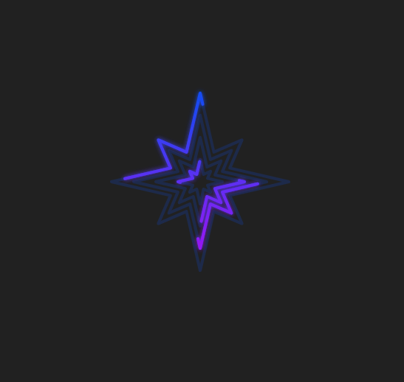

|  |  |
| --- | --- |
| .star {  margin: auto;  width: 16em;  height: 16em;  }  .star__stroke {  --dur: 2s;  animation: stroke1 var(--dur) linear infinite;  }  .star__stroke--2 {  animation-name: stroke2;  animation-delay: calc(var(--dur) / -2);  }  .star__stroke--3 {  animation-name: stroke3;  animation-direction: reverse;  }  .star__stroke--4 {  animation-name: stroke4;  animation-delay: calc(var(--dur) / -2);  animation-direction: reverse;  }  @keyframes stroke1 {  from {  stroke-dashoffset: 0;  }  to {  stroke-dashoffset: 124;  }  }  @keyframes stroke2 {  from {  stroke-dashoffset: 0;  }  to {  stroke-dashoffset: 248;  }  }  @keyframes stroke3 {  from {  stroke-dashoffset: 0;  }  to {  stroke-dashoffset: 372;  }  }  @keyframes stroke4 {  from {  stroke-dashoffset: 0;  }  to {  stroke-dashoffset: 496;  }  } | .star {  margin: auto;  width: 16em;  height: 16em;  }  .star__stroke {  --dur: 2s;  animation: stroke1 var(--dur) linear infinite;  }  .star__stroke--2 {  animation-name: stroke2;  animation-delay: calc(var(--dur) / -2);  }  .star__stroke--3 {  animation-name: stroke3;  animation-direction: reverse;  }  .star__stroke--4 {  animation-name: stroke4;  animation-delay: calc(var(--dur) / -2);  animation-direction: reverse;  }  @keyframes stroke1 {  from {  stroke-dashoffset: 0;  }  to {  stroke-dashoffset: 124;  }  }  @keyframes stroke2 {  from {  stroke-dashoffset: 0;  }  to {  stroke-dashoffset: 248;  }  }  @keyframes stroke3 {  from {  stroke-dashoffset: 0;  }  to {  stroke-dashoffset: 372;  }  }  @keyframes stroke4 {  from {  stroke-dashoffset: 0;  }  to {  stroke-dashoffset: 496;  }  } |

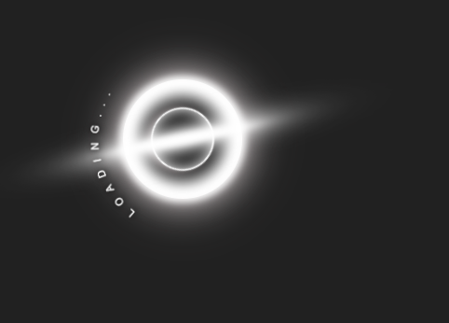

|  |  |
| --- | --- |
| <div class="loader">  <div class="blackhole">  <div class="blackhole-circle"></div>  <div class="blackhole-disc"></div>  </div>  <div class="curve">  <svg viewBox="0 0 500 500">  <path id="loading" d="M73.2,148.6c4-6.1,65.5-96.8,178.6-95.6c111.3,1.2,170.8,90.3,175.1,97"></path>  <text width="500">  <textPath xlink:href="#loading">  loading...  </textPath>  </text>  </svg>  </div>  </div> | .loader {  display: flex;  width: 8rem;  height: 8rem;  justify-content: center;  align-items: center;  position: relative;  flex-direction: column;  }  .curve {  width: 180%;  height: 180%;  position: absolute;  animation: rotate 8s linear infinite;  fill: transparent;  }  .curve text {  letter-spacing: 20px;  text-transform: uppercase;  font: 1.5em "Fira Sans", sans-serif;  fill: white;  filter: drop-shadow(0 2px 8px black);  }  .blackhole {  z-index: -1;  display: flex;  position: absolute;  width: 8rem;  height: 8rem;  align-items: center;  justify-content: center;  }  .blackhole-circle {  z-index: 0;  display: flex;  width: 100%;  height: 100%;  border-radius: 50%;  background: radial-gradient(circle at center, black 25%, white 35%, white 100%);  box-shadow: 0px 0px 2rem #c2babb;  align-items: center;  justify-content: center;  }  .blackhole-circle::after {  z-index: 0;  position: absolute;  content: "";  display: flex;  width: 100%;  height: 100%;  border-radius: 50%;  border: 4px solid white;  background: radial-gradient(circle at center, black 35%, white 60%, white 100%);  box-shadow: 0px 0px 5rem #c2babb;  align-items: center;  justify-content: center;  filter: blur(4px);  animation: pulseAnimation linear infinite 2s alternate-reverse;  }  .blackhole-circle::before {  z-index: 1;  content: "";  display: flex;  width: 4rem;  height: 4rem;  border: 2px solid #ffffff;  box-shadow: 3px 3px 10px #c2babb, inset 0 0 1rem #ffffff;  border-radius: 50%;  top: 5rem;  filter: blur(0.5px);  animation: rotate linear infinite 3s;  }  .blackhole-disc {  position: absolute;  z-index: 0;  display: flex;  width: 5rem;  height: 10rem;  border-radius: 50%;  background: radial-gradient(circle at center, #ffffff 80%, #353535 90%, white 100%);  filter: blur(1rem) brightness(130%);  border: 1rem solid white;  box-shadow: 0px 0px 3rem #d7c4be;  transform: rotate3d(1, 1, 1, 220deg);  animation: pulseAnimation2 linear infinite 2s alternate-reverse;  justify-content: center;  align-items: center;  }  .blackhole-disc::before {  content: "";  position: absolute;  z-index: 0;  display: flex;  width: 5rem;  height: 10rem;  border-radius: 50%;  background: radial-gradient(circle at center, #ffffff 80%, #353535 90%, white 100%);  filter: blur(3rem);  border: 1rem solid white;  box-shadow: 0px 0px 6rem #d7c4be;  animation: pulseAnimation linear infinite 2s alternate-reverse;  }  @keyframes rotate {  0% {  transform: rotate(0deg);  }  100% {  transform: rotate(360deg);  }  }  @keyframes pulseAnimation {  0% {  box-shadow: 0px 0px 3rem #c2babb;  transform: scale(1);  }  100% {  box-shadow: 0px 0px 5rem #c2babb;  transform: scale(1.09);  }  }  @keyframes pulseAnimation2 {  0% {  box-shadow: 0px 0px 3rem #c2babb;  transform: rotate3d(1, 1, 1, 220deg) scale(1);  }  100% {  box-shadow: 0px 0px 5rem #c2babb;  transform: rotate3d(1, 1, 1, 220deg) scale(.95);  }  } |

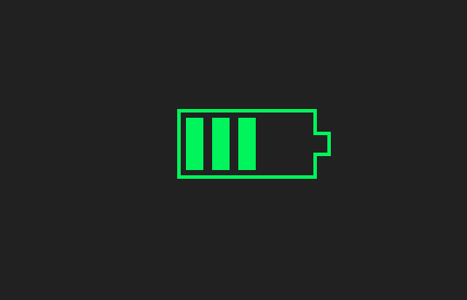

|  |  |
| --- | --- |
| <div class="loader"></div> | .loader {  width: 160px;  height: 80px;  border: 4px solid #00F45B;  border-right-color: transparent;  padding: 6px;  background: repeating-linear-gradient(90deg,#00F45B 0 20px,#0000 0 30px)  left/0% 100% no-repeat content-box content-box;  position: relative;  animation: p5 2s infinite steps(6);  }  .loader::before {  content: "";  position: absolute;  top: -4px;  bottom: -4px;  left: 100%;  width: 20px;  background: linear-gradient(  #0000 calc(50% - 14px),#00F45B 0 calc(50% - 10px),  #0000 0 calc(50% + 10px),#00F45B 0 calc(50% + 14px),#0000 0) left /100% 100%,  linear-gradient(#00F45B calc(50% - 10px),#0000 0 calc(50% + 10px),#00F45B 0) left /4px 100%,  linear-gradient(#0000 calc(50% - 10px),#00F45B 0 calc(50% + 10px),#0000 0) right/4px 100%;  background-repeat: no-repeat;  }  @keyframes p5 {  100% {  background-size: 120% 100%  }  } |

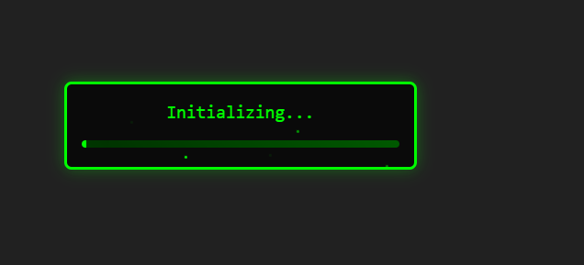

|  |  |
| --- | --- |
| <div class="hacker-loader">  <div class="loader-text">  <span data-text="Initializing..." class="text-glitch">Initializing...</span>  </div>  <div class="loader-bar">  <div class="bar-fill"></div>  <div class="bar-glitch"></div>  </div>  <div class="particles">  <div class="particle"></div>  <div class="particle"></div>  <div class="particle"></div>  <div class="particle"></div>  <div class="particle"></div>  </div>  </div> | .hacker-loader {  position: relative;  width: 24em;  height: 6em;  background-color: #0a0a0a;  border: 0.2em solid #00ff00;  border-radius: 0.5em;  padding: 1em;  overflow: hidden;  box-shadow: 0 0 1em rgba(0, 255, 0, 0.3);  }  .loader-text {  text-align: center;  margin-bottom: 1em;  }  .text-glitch {  color: #00ff00;  font-family: monospace;  font-size: 1.5em;  position: relative;  display: inline-block;  }  .text-glitch::before,  .text-glitch::after {  content: attr(data-text);  position: absolute;  top: 0;  left: 0;  width: 100%;  height: 100%;  background-color: #0a0a0a;  clip: rect(0, 0, 0, 0);  }  .text-glitch::before {  left: -0.1em;  text-shadow: 0.1em 0 #ff00ff;  animation: glitch-effect 3s infinite linear alternate-reverse;  }  .text-glitch::after {  left: 0.1em;  text-shadow: -0.1em 0 #00ffff;  animation: glitch-effect 2s infinite linear alternate-reverse;  }  .loader-bar {  width: 100%;  height: 0.5em;  background-color: #003300;  border-radius: 0.25em;  position: relative;  overflow: hidden;  }  .bar-fill {  position: absolute;  top: 0;  left: 0;  width: 0;  height: 100%;  background-color: #00ff00;  animation: bar-fill-animation 2s infinite ease-in-out;  }  .bar-glitch {  position: absolute;  top: 0;  left: 0;  width: 100%;  height: 100%;  background: linear-gradient(  45deg,  transparent,  rgba(0, 255, 0, 0.2),  transparent  );  background-size: 200% 200%;  animation: bar-glitch-animation 2s infinite linear;  }  .particles {  position: absolute;  top: 0;  left: 0;  width: 100%;  height: 100%;  pointer-events: none;  }  .particle {  position: absolute;  width: 0.2em;  height: 0.2em;  background-color: #00ff00;  border-radius: 50%;  opacity: 0;  animation: particle-animation 2s infinite linear;  }  .particle:nth-child(1) {  top: 10%;  left: 10%;  animation-delay: 0s;  }  .particle:nth-child(2) {  top: 30%;  left: 60%;  animation-delay: 0.5s;  }  .particle:nth-child(3) {  top: 70%;  left: 30%;  animation-delay: 1s;  }  .particle:nth-child(4) {  top: 90%;  left: 90%;  animation-delay: 1.5s;  }  .particle:nth-child(5) {  top: 50%;  left: 50%;  animation-delay: 2s;  }  @keyframes glitch-effect {  0% {  clip: rect(42px, 9999px, 44px, 0);  }  5% {  clip: rect(12px, 9999px, 59px, 0);  }  10% {  clip: rect(48px, 9999px, 29px, 0);  }  15.0% {  clip: rect(42px, 9999px, 73px, 0);  }  20% {  clip: rect(63px, 9999px, 27px, 0);  }  25% {  clip: rect(34px, 9999px, 55px, 0);  }  30.0% {  clip: rect(86px, 9999px, 73px, 0);  }  35% {  clip: rect(20px, 9999px, 20px, 0);  }  40% {  clip: rect(26px, 9999px, 60px, 0);  }  45% {  clip: rect(25px, 9999px, 66px, 0);  }  50% {  clip: rect(57px, 9999px, 98px, 0);  }  55.0% {  clip: rect(5px, 9999px, 46px, 0);  }  60.0% {  clip: rect(82px, 9999px, 31px, 0);  }  65% {  clip: rect(54px, 9999px, 27px, 0);  }  70% {  clip: rect(28px, 9999px, 99px, 0);  }  75% {  clip: rect(45px, 9999px, 69px, 0);  }  80% {  clip: rect(23px, 9999px, 85px, 0);  }  85.0% {  clip: rect(54px, 9999px, 84px, 0);  }  90% {  clip: rect(45px, 9999px, 47px, 0);  }  95% {  clip: rect(37px, 9999px, 20px, 0);  }  100% {  clip: rect(4px, 9999px, 91px, 0);  }  }  @keyframes bar-fill-animation {  0%,  100% {  width: 0;  }  50% {  width: 100%;  }  }  @keyframes bar-glitch-animation {  0% {  background-position: 0 0;  }  100% {  background-position: 200% 0;  }  }  @keyframes particle-animation {  0% {  opacity: 0;  transform: translate(0, 0);  }  50% {  opacity: 1;  }  100% {  opacity: 0;  transform: translate(2em, 2em);  }  } |

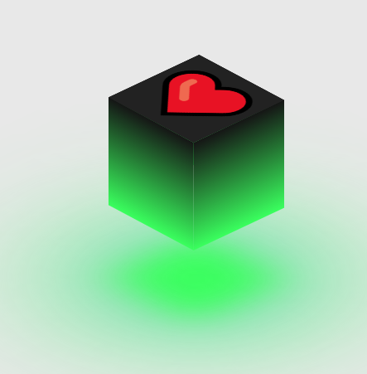

|  |  |
| --- | --- |
| <div class="glowing-cube">  <div class="top">❤</div>  <div>  <span style="--i:0;"></span>  <span style="--i:1;"></span>  <span style="--i:2;"></span>  <span style="--i:3;"></span>  </div>  </div> | .glowing-cube {  position: relative;  width: 150px;  height: 150px;  transform-style: preserve-3d;  animation: cube-rotate 4s linear infinite;  }  @keyframes cube-rotate {  0% {  transform: rotatex(-30deg) rotatey(0deg);  }  100% {  transform: rotatex(-30deg) rotatey(360deg);  }  }  .glowing-cube div {  position: absolute;  inset: 0;  transform-style: preserve-3d;  }  .glowing-cube div span {  position: absolute;  inset: 0;  background: linear-gradient(#151515, #3aff5e);  transform: rotatey(calc(90deg * var(--i))) translatez(calc(150px / 2));  }  .glowing-cube .top {  position: absolute;  inset: 0;  background: #222;  transform: rotatex(90deg) translatez(calc(150px / 2));  display: flex;  justify-content: center;  align-items: center;  color: var(--top-font-color);  font-size: 7rem;  }  .glowing-cube .top::before {  content: '';  position: absolute;  background: #3aff5e;  inset: 0;  transform: translatez(calc(0px - calc(150px + 100px)));  filter: blur(30px);  box-shadow: 0 0 120px rgba(58, 134, 255, 0.2),  0 0 200px rgba(58, 134, 255, 0.4),  0 0 300px #00ff2f,  0 0 400px #51fd71,  0 0 500px #3aff5e;  } |

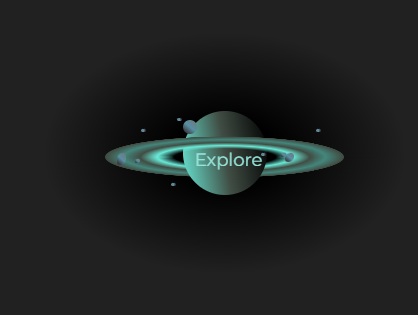

|  |  |
| --- | --- |
| <button>  <div class="main">  <div class="rings" id="ring1"></div>  <div class="rings" id="ring2"></div>  <div class="asteriods-large" id="asteriod1"></div>  <div class="asteriods-large" id="asteriod2"></div>  <div class="asteriods-large" id="asteriod3"></div>  <div class="asteriods-large" id="asteriod4"></div>  <div class="asteriods-large" id="asteriod5"></div>  <div class="asteriods-small" id="asteriod6"></div>  <div class="asteriods-small" id="asteriod7"></div>  <div class="asteriods-small" id="asteriod8"></div>  <div class="asteriods-small" id="asteriod9"></div>  <div class="asteriods-small" id="asteriod10"></div>  <div id="saturn"></div>  <div id="explore">Explore</div>  </div>  </button> | button {  border: 0;  background: radial-gradient(ellipse at 50% 50%,black 20%,transparent 72%);  font-size: 17px;  height: 200px;  width: 300px;  zoom: 1.2;  }  .main {  width: 70px;  margin: auto;  position: relative;  transform: rotateZ(0deg);  isolation: isolate;  scale: 1;  transition: all 1.5s;  }  .main:hover {  transform: rotateZ(240deg);  scale: 2;  /* filter: drop-shadow(10px,10px,10px,white); */  filter: drop-shadow(-1px -1px 5px #69e9d6);  }  .rings {  position: absolute;  width: 200px;  height: 100px;  /* background-color: #000000; */  border-radius: 150px 150px 0 0;  background: radial-gradient(circle at 50% 100%,transparent 30%, #69e9d6 40%,#404D44 50%,#44867c 60%,#404D44 70%,transparent);  }  #saturn {  width: 70px;  height: 70px;  border-radius: 50%;  background: linear-gradient(80deg,#69e9d6,#404D44,#000000);  }  #ring1 {  transform: rotateX(80deg);  top: -20px;  left: -65px;  }  #ring2 {  transform: rotateX(-100deg);  left: -65px;  z-index: -1;  top: -3px;  }  .asteriods-large {  position: absolute;  width: 8px;  height: 10px;  border-radius: 15px 8px;  background: linear-gradient(220deg,#6f7776,#598ea3,#311515);  transform: rotateZ(0deg);  transition: all 3s;  }  #asteriod1 {  top: 8px;  height: 12px;  width: 12px;  border-radius: 50%;  }  #asteriod2 {  top: 35px;  height: 10px;  left: -55px;  }  #asteriod3 {  top: 35px;  height: 8px;  left: 85px;  }  #asteriod4 {  top: 40px;  height: 4px;  width: 4px;  left: -40px;  }  #asteriod5 {  top: 35px;  height: 4px;  width: 4px;  left: 82px;  }  .asteriods-small {  position: absolute;  width: 4px;  height: 3px;  border-radius: 15px 8px;  background: linear-gradient(80deg,#6f7776,#598ea3,#311515);  transform-origin: 50px 50px;  transform: rotateZ(0deg);  transition: all 3s;  }  #asteriod6 {  top: 6px;  left: -5px;  border-radius: 50%;  }  #asteriod7 {  top: 15px;  left: -35px;  }  #asteriod8 {  top: 35px;  left: 65px;  }  #asteriod9 {  top: 60px;  left: -10px;  }  #asteriod10 {  top: 15px;  left: 112px;  }  #explore {  position: absolute;  top: 32px;  font-size: 15px;  color: hsl(171, 59%, 74%);  left: 10px;  transition: all 3s;  }  .main:hover > .asteriods-large,.main:hover > .asteriods-small {  transform: translateX(28px);  }  .main:hover > #explore {  translate: -10px 20px;  transform: rotateZ(120deg);  }  .main:not(hover) > #explore {  translate: 0px;  transform: rotateZ(0deg);  }  .main:not(hover) > .asteriods-large,.main:not(hover) > .asteriods-small {  transform: translateX(0px);  }  .main:is(:active) > #explore {  translate: -100px 200px;  }  .main:is(:active) {  translate: -200px;  } |

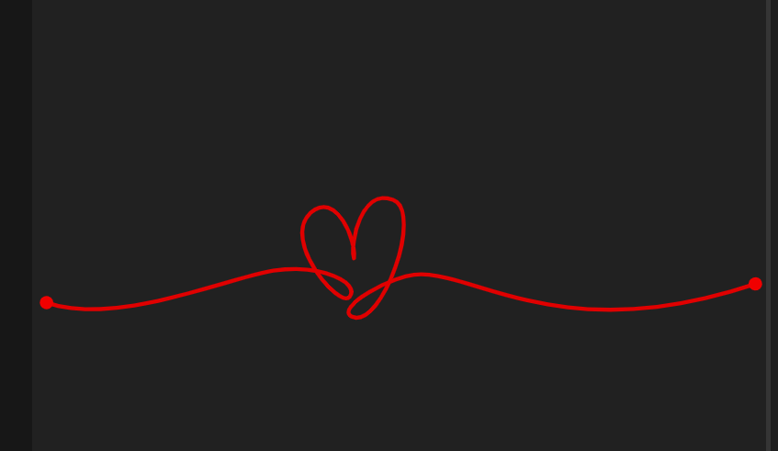

|  |  |
| --- | --- |
| <svg  class="heart"  viewBox="-5 -5 278 56"  version="1.1"  id="svg5"  xmlns="http://www.w3.org/2000/svg"  >  <filter>  <feGaussianBlur stdDeviation="1.6"></feGaussianBlur>  </filter>  <g transform="translate(29.1 -127.42)" id="layer1">  <path  pathLength="1"  d="M-28.73 167.2c26.43 9.21 68.46-9.46 85.45-12.03 18.45-2.78 32.82 4.86 28.75 9.83-3.82 4.66-25.77-21.18-14.81-31.5 9.54-8.98 17.64 10.64 16.42 17.06-1.51-6.2 2.95-26.6 14.74-22.11 11.7 4.46-4.33 49.03-15.44 44.08-6.97-3.1 15.44-16.26 26.1-16 23.03.56 55.6 27.51 126.63 3.36"  id="line"  ></path>  </g>  <g transform="translate(29.1 -127.42)" id="layer2">  <path  pathLength="1"  d="M-28.73 167.2c26.43 9.21 68.46-9.46 85.45-12.03 18.45-2.78 32.82 4.86 28.75 9.83-3.82 4.66-25.77-21.18-14.81-31.5 9.54-8.98 17.64 10.64 16.42 17.06-1.51-6.2 2.95-26.6 14.74-22.11 11.7 4.46-4.33 49.03-15.44 44.08-6.97-3.1 15.44-16.26 26.1-16 23.03.56 55.6 27.51 126.63 3.36"  id="point"  filter="url(#blur)"  ></path>  </g>  </svg> | .heart #line {  fill: none;  stroke: #e00000;  stroke-width: 1.5;  stroke-linecap: butt;  stroke-linejoin: round;  stroke-miterlimit: 4;  stroke-opacity: 1;  stroke-dasharray: 1;  stroke-dashoffset: 1;  animation: dash 3s linear infinite;  }  .heart #point {  fill: none;  stroke: #f00000;  stroke-width: 5;  stroke-linecap: round;  stroke-linejoin: round;  stroke-miterlimit: 0.1;  stroke-opacity: 1;  stroke-dasharray: 0.0001, 0.9999;  stroke-dashoffset: 1;  animation: dash 3s linear infinite;  }  @keyframes dash {  0% {  stroke-dashoffset: 1;  }  80% {  stroke-dashoffset: 0;  }  100% {  stroke-dashoffset: 0;  }  } |

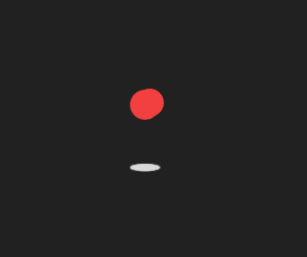

|  |  |
| --- | --- |
| <div class="container">  <div class="preloader">  <span></span>  <span></span>  <span></span>  </div>  <div class="shadow"></div>  </div> | .container {  position: absolute;  top: 50%;  left: 50%;  transform: translate(-50%, -50%);  }  .container .preloader {  animation: rotate 2.3s cubic-bezier(0.75, 0, 0.5, 1) infinite;  }  @keyframes rotate {  50% {  transform: rotate(360deg);  }  100% {  transform: rotate(720deg);  }  }  .preloader span {  --c: #f23f3f;  position: absolute;  display: block;  height: 64px;  width: 64px;  background: var(--c);  border: 1px solid var(--c);  border-radius: 100%;  }  .preloader span:nth-child(1) {  transform: translate(-28px, -28px);  animation: shape_1 2.3s cubic-bezier(0.75, 0, 0.5, 1) infinite;  }  @keyframes shape_1 {  60% {  transform: scale(0.4);  }  }  .preloader span:nth-child(2) {  transform: translate(28px, -28px);  animation: shape_2 2.3s cubic-bezier(0.75, 0, 0.5, 1) infinite;  }  @keyframes shape_2 {  40% {  transform: scale(0.4);  }  }  .preloader span:nth-child(3) {  position: relative;  border-radius: 0px;  transform: scale(0.98) rotate(-45deg);  animation: shape_3 2.3s cubic-bezier(0.75, 0, 0.5, 1) infinite;  }  @keyframes shape_3 {  50% {  border-radius: 100%;  transform: scale(0.5) rotate(-45deg);  }  100% {  transform: scale(0.98) rotate(-45deg);  }  }  .shadow {  position: relative;  top: 30px;  left: 50%;  transform: translateX(-50%);  display: block;  height: 16px;  width: 64px;  border-radius: 50%;  background-color: #d9d9d9;  border: 1px solid #d9d9d9;  animation: shadow 2.3s cubic-bezier(0.75, 0, 0.5, 1) infinite;  }  @keyframes shadow {  50% {  transform: translateX(-50%) scale(0.5);  border-color: #f2f2f2;  }  } |

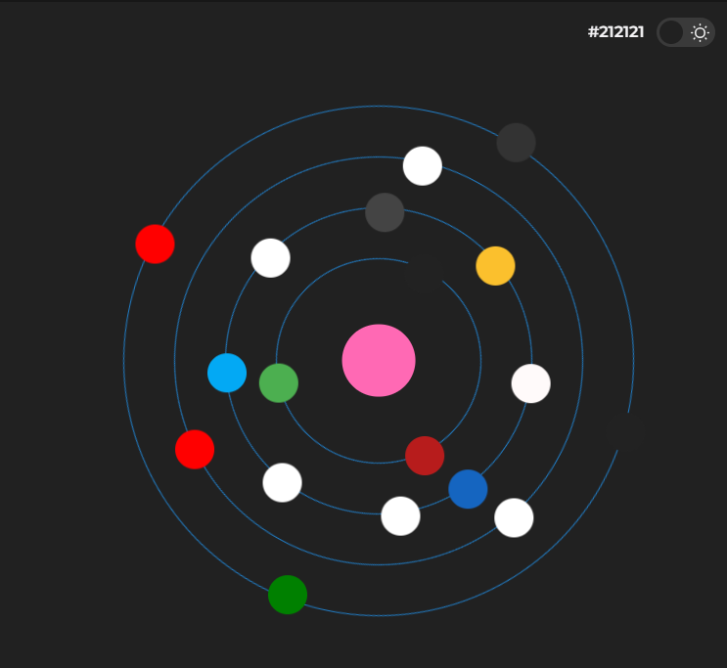

|  |  |
| --- | --- |
| <div class="orbit">    <ul class="orbit-wrap">    <li class="orbit-center">  <i class="orbit-center__icon fa fa-code"></i>  </li>  <li>  <ul class="ring-0">  <li><i class="orbit-icon fa fa-git"></i></li>  <li><i class="orbit-icon fa fa-free-code-camp"></i></li>  <li><i class="orbit-icon fa fa-meetup"></i></li>  <li><i class="orbit-icon fa fa-codepen"></i></li>  </ul>  </li>  <li>  <ul class="ring-1">  <li><i class="orbit-icon fa fa-podcast"></i></li>  <li><i class="orbit-icon fa fa-css3"></i></li>  <li><i class="orbit-icon fa fa-html5"></i></li>  </ul>  </li>  <li>  <ul class="ring-2">  <li><i class="orbit-icon fa fa-windows"></i></li>  <li><i class="orbit-icon fa fa-safari"></i></li>  <li><i class="orbit-icon fa fa-edge"></i></li>  <li><i class="orbit-icon fa fa-linux"></i></li>  <li><i class="orbit-icon fa fa-apple"></i></li>  <li><i class="orbit-icon fa fa-chrome"></i></li>  <li><i class="orbit-icon fa fa-android"></i></li>  <li><i class="orbit-icon fa fa-firefox"></i></li>  </ul>  </li>  <li>  <ul class="ring-3">  <li><i class="orbit-icon fa fa-coffee"></i></li>  <li><i class="orbit-icon fa fa-terminal"></i></li>  <li><i class="orbit-icon fa fa-heart-o"></i></li>  </ul>  </li>  </ul>    </div> | .orbit {  float: left;  width: 100%;  min-width: 100px;  min-height: 100px;  }  .orbit-icon {  width: 1.6em;  height: 1.6em;  line-height: 1.6em;  font-size: 1.2em;  border-radius: 50%;  background: #ccc;  color: #fff;  text-align: center;  display: block;  }  .orbit-wrap {  height: 40em;  list-style: none;  font-size: 1.3em;  }  .orbit-wrap > li {  position: absolute;  left: 50%;  top: 50%;  transform: translate(-50%, -50%);  }  .orbit-wrap > li:hover ul {  border-width: 2px;  border-color: #fff;  }  .orbit-wrap > li:hover ~ li ul {  border-color: rgba(255, 255, 255, 0.2);  }  .orbit-wrap > li:hover ~ li ul li {  opacity: 0.4;  }  ul[class^=ring] {  transition: all 300ms ease-in-out;  }  ul[class^=ring] li {  transition: all 300ms ease-in-out;  }  .ring-0 {  width: 25em;  height: 25em;  animation: clockwiseRotate 35s linear infinite;  }  .ring-0 i {  animation: counterClockwiseRotate 35s linear infinite;  }  .ring-0 > *:nth-of-type(1) {  transform: rotate(95deg) translate(12.5em) rotate(-95deg);  }  .ring-0 > *:nth-of-type(2) {  transform: rotate(190deg) translate(12.5em) rotate(-190deg);  }  .ring-0 > *:nth-of-type(3) {  transform: rotate(285deg) translate(12.5em) rotate(-285deg);  }  .ring-0 > *:nth-of-type(4) {  transform: rotate(380deg) translate(12.5em) rotate(-380deg);  }  .ring-1 {  width: 20em;  height: 20em;  animation: clockwiseRotate 30s linear infinite;  }  .ring-1 i {  animation: counterClockwiseRotate 30s linear infinite;  }  .ring-1 > *:nth-of-type(1) {  transform: rotate(126.6666666667deg) translate(10em) rotate(-126.6666666667deg);  }  .ring-1 > *:nth-of-type(2) {  transform: rotate(253.3333333333deg) translate(10em) rotate(-253.3333333333deg);  }  .ring-1 > *:nth-of-type(3) {  transform: rotate(380deg) translate(10em) rotate(-380deg);  }  .ring-2 {  width: 15em;  height: 15em;  animation: clockwiseRotate 25s linear infinite;  }  .ring-2 i {  animation: counterClockwiseRotate 25s linear infinite;  }  .ring-2 > *:nth-of-type(1) {  transform: rotate(47.5deg) translate(7.5em) rotate(-47.5deg);  }  .ring-2 > *:nth-of-type(2) {  transform: rotate(95deg) translate(7.5em) rotate(-95deg);  }  .ring-2 > *:nth-of-type(3) {  transform: rotate(142.5deg) translate(7.5em) rotate(-142.5deg);  }  .ring-2 > *:nth-of-type(4) {  transform: rotate(190deg) translate(7.5em) rotate(-190deg);  }  .ring-2 > *:nth-of-type(5) {  transform: rotate(237.5deg) translate(7.5em) rotate(-237.5deg);  }  .ring-2 > *:nth-of-type(6) {  transform: rotate(285deg) translate(7.5em) rotate(-285deg);  }  .ring-2 > *:nth-of-type(7) {  transform: rotate(332.5deg) translate(7.5em) rotate(-332.5deg);  }  .ring-2 > *:nth-of-type(8) {  transform: rotate(380deg) translate(7.5em) rotate(-380deg);  }  .ring-3 {  width: 10em;  height: 10em;  animation: clockwiseRotate 20s linear infinite;  }  .ring-3 i {  animation: counterClockwiseRotate 20s linear infinite;  }  .ring-3 > *:nth-of-type(1) {  transform: rotate(126.6666666667deg) translate(5em) rotate(-126.6666666667deg);  }  .ring-3 > *:nth-of-type(2) {  transform: rotate(253.3333333333deg) translate(5em) rotate(-253.3333333333deg);  }  .ring-3 > *:nth-of-type(3) {  transform: rotate(380deg) translate(5em) rotate(-380deg);  }  ul[class^=ring] {  border: solid 1px rgba(33, 150, 243, 0.8);  position: relative;  padding: 0;  border-radius: 50%;  list-style: none;  box-sizing: content-box;  }  ul[class^=ring] li {  display: block;  position: absolute;  top: 50%;  left: 50%;  width: 1.6em;  height: 1.6em;  margin: -0.8em;  }  /*  center;  */  .orbit-center {  z-index: 5;  font-size: 2em;  width: 1.8em;  height: 1.8em;  line-height: 1.8em;  text-align: center;  background: hotpink;  border-radius: 50%;  }  .orbit-center:hover .orbit-center__icon {  transform: rotateZ(0deg);  }  .orbit-center__icon {  transform: rotateZ(-360deg);  transition: all 300ms ease-in-out;  }  .orbit-wrap > li.orbit-center:hover ~ li > ul {  width: 0;  height: 0;  }  .orbit-wrap > li.orbit-center:hover ~ li > ul * {  transform: translate(0, 0);  }  /*  animations  */  @keyframes clockwiseRotate {  from {  transform: rotate(0deg);  }  to {  transform: rotate(360deg);  }  }  @keyframes counterClockwiseRotate {  0% {  transform: rotate(0deg);  }  100% {  transform: rotate(-360deg);  }  }  /*  icons  */  .fa-heart-o {  background: #b71c1c;  color: white;  }  .fa-coffee {  background: #4CAF50;  color: #CDDC39;  }  .fa-safari {  background: white;  color: darkslateblue;  }  .fa-firefox {  background: #1565c0;  color: #ff8f00;  }  .fa-chrome {  background: #fbc02d;  color: #ef6c00;  }  .fa-edge {  background: #03a9f4;  color: white;  }  .fa-android {  background: snow;  color: limegreen;  }  .fa-apple {  background: #444;  color: white;  }  .fa-linux {  background: white;  color: #222;  }  .fa-windows {  background: white;  color: #03a9f4;  }  .fa-terminal {  background: #222;  color: #fff;  }  .fa-html5 {  background: white;  color: #e65100;  }  .fa-css3 {  background: white;  color: #2196f3;  }  .fa-git {  background: #222;  color: white;  }  .fa-free-code-camp {  background: green;  color: white;  }  .fa-meetup {  background: red;  color: white;  }  .fa-podcast {  background: red;  color: white;  }  .fa-codepen {  background: #333;  color: white;  } |

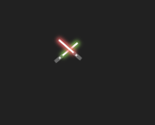

|  |  |
| --- | --- |
| <div id="loader">  <div class="ls-particles ls-part-1"></div>  <div class="ls-particles ls-part-2"></div>  <div class="ls-particles ls-part-3"></div>  <div class="ls-particles ls-part-4"></div>  <div class="ls-particles ls-part-5"></div>  <div class="lightsaber ls-left ls-green"></div>  <div class="lightsaber ls-right ls-red"></div>  </div> | #loader {  width: 80px;  height: 40px;  position: absolute;  top: 50%;  left: 50%;  margin: -20px -40px;  z-index: 1000;  }  .lightsaber {  position: absolute;  width: 4px;  height: 12px;  background-color: #666;  border-radius: 1px;  bottom: 0;  }  .lightsaber.ls-left {  left: 0;  }  .lightsaber.ls-right {  right: 0;  }  .lightsaber:before {  position: absolute;  content: ' ';  display: block;  width: 2px;  height: 25px;  max-height: 1px;  left: 1px;  top: 1px;  background-color: #fff;  border-radius: 1px;  -webkit-transform: rotateZ(180deg);  transform: rotateZ(180deg);  -webkit-transform-origin: center top;  -ms-transform-origin: center top;  transform-origin: center top;  }  .lightsaber:after {  position: absolute;  content: ' ';  display: block;  width: 2px;  height: 2px;  left: 1px;  top: 4px;  background-color: #fff;  border-radius: 50%;  }  .ls-particles {  position: absolute;  left: 42px;  top: 10px;  width: 1px;  height: 5px;  background-color: rgb(51, 51, 51, 0);  -webkit-transform: rotateZ(0deg);  transform: rotateZ(0deg);  }  .lightsaber.ls-green:before {  -webkit-animation: showlightgreen 2s ease-in-out infinite 1s;  animation: showlightgreen 2s ease-in-out infinite 1s;  }  .lightsaber.ls-red:before {  -webkit-animation: showlightred 2s ease-in-out infinite 1s;  animation: showlightred 2s ease-in-out infinite 1s;  }  .lightsaber.ls-left {  -webkit-animation: fightleft 2s ease-in-out infinite 1s;  animation: fightleft 2s ease-in-out infinite 1s;  }  .lightsaber.ls-right {  -webkit-animation: fightright 2s ease-in-out infinite 1s;  animation: fightright 2s ease-in-out infinite 1s;  }  .ls-particles.ls-part-1 {  -webkit-animation: particles1 2s ease-out infinite 1s;  animation: particles1 2s ease-out infinite 1s;  }  .ls-particles.ls-part-2 {  -webkit-animation: particles2 2s ease-out infinite 1s;  animation: particles2 2s ease-out infinite 1s;  }  .ls-particles.ls-part-3 {  -webkit-animation: particles3 2s ease-out infinite 1s;  animation: particles3 2s ease-out infinite 1s;  }  .ls-particles.ls-part-4 {  -webkit-animation: particles4 2s ease-out infinite 1s;  animation: particles4 2s ease-out infinite 1s;  }  .ls-particles.ls-part-5 {  -webkit-animation: particles5 2s ease-out infinite 1s;  animation: particles5 2s ease-out infinite 1s;  }  @-webkit-keyframes showlightgreen {  0% {  max-height: 0;  box-shadow: 0 0 0 0 #87c054;  }  5% {  box-shadow: 0 0 4px 2px #87c054;  }  10% {  max-height: 22px;  }  80% {  max-height: 22px;  }  85% {  box-shadow: 0 0 4px 2px #87c054;  }  100% {  max-height: 0;  box-shadow: 0 0 0 0 #87c054;  }  }  @-webkit-keyframes showlightred {  0% {  max-height: 0;  box-shadow: 0 0 0 0 #f06363;  }  20% {  box-shadow: 0 0 4px 2px #f06363;  }  25% {  max-height: 22px;  }  80% {  max-height: 22px;  }  85% {  box-shadow: 0 0 4px 2px #f06363;  }  100% {  max-height: 0;  box-shadow: 0 0 0 0 #f06363;  }  }  @-webkit-keyframes fightleft {  0% {  -webkit-transform: rotateZ(0deg);  transform: rotateZ(0deg);  left: 0;  bottom: 0;  }  30% {  -webkit-transform: rotateZ(0deg);  transform: rotateZ(0deg);  bottom: 0;  }  40% {  -webkit-transform: rotateZ(45deg);  transform: rotateZ(45deg);  left: 0;  bottom: 2px;  }  45% {  -webkit-transform: rotateZ(65deg);  transform: rotateZ(65deg);  left: 0;  }  65% {  -webkit-transform: rotateZ(410deg);  transform: rotateZ(410deg);  left: 30px;  bottom: 10px;  }  95% {  -webkit-transform: rotateZ(410deg);  transform: rotateZ(410deg);  left: 0;  bottom: 0;  }  100% {  -webkit-transform: rotateZ(360deg);  transform: rotateZ(360deg);  left: 0;  bottom: 0;  }  }  @-webkit-keyframes fightright {  0% {  -webkit-transform: rotateZ(0deg);  transform: rotateZ(0deg);  right: 0;  bottom: 0;  }  30% {  -webkit-transform: rotateZ(0deg);  transform: rotateZ(0deg);  bottom: 0;  }  45% {  -webkit-transform: rotateZ(-45deg);  transform: rotateZ(-45deg);  right: 0;  bottom: 2px;  }  50% {  -webkit-transform: rotateZ(-65deg);  transform: rotateZ(-65deg);  right: 0;  }  68% {  -webkit-transform: rotateZ(-410deg);  transform: rotateZ(-410deg);  right: 27px;  bottom: 13px;  }  95% {  -webkit-transform: rotateZ(-410deg);  transform: rotateZ(-410deg);  right: 0;  bottom: 0;  }  100% {  -webkit-transform: rotateZ(-360deg);  transform: rotateZ(-360deg);  right: 0;  bottom: 0;  }  }  @-webkit-keyframes particles1 {  0% {  background-color: rgba(51, 51, 51,0);  -webkit-transform: rotateZ(35deg) translateY(0px);  transform: rotateZ(35deg) translateY(0px);  }  63% {  background-color: rgba(51, 51, 51,0);  -webkit-transform: rotateZ(35deg) translateY(0px);  transform: rotateZ(35deg) translateY(0px);  }  64% {  background-color: rgba(51, 51, 51,1);  -webkit-transform: rotateZ(35deg) translateY(0px);  transform: rotateZ(35deg) translateY(0px);  }  100% {  background-color: rgba(51, 51, 51,0);  -webkit-transform: rotateZ(35deg) translateY(-30px);  transform: rotateZ(35deg) translateY(-30px);  }  }  @-webkit-keyframes particles2 {  0% {  background-color: rgba(51, 51, 51,0);  -webkit-transform: rotateZ(-65deg) translateY(0px);  transform: rotateZ(-65deg) translateY(0px);  }  63% {  background-color: rgba(51, 51, 51,0);  -webkit-transform: rotateZ(-65deg) translateY(0px);  transform: rotateZ(-65deg) translateY(0px);  }  64% {  background-color: rgba(51, 51, 51,1);  -webkit-transform: rotateZ(-65deg) translateY(0px);  transform: rotateZ(-65deg) translateY(0px);  }  95% {  background-color: rgba(51, 51, 51,0);  -webkit-transform: rotateZ(-65deg) translateY(-40px);  transform: rotateZ(-65deg) translateY(-40px);  }  100% {  background-color: rgba(51, 51, 51,0);  -webkit-transform: rotateZ(-65deg) translateY(-40px);  transform: rotateZ(-65deg) translateY(-40px);  }  }  @-webkit-keyframes particles3 {  0% {  background-color: rgba(51, 51, 51,0);  -webkit-transform: rotateZ(-75deg) translateY(0px);  transform: rotateZ(-75deg) translateY(0px);  }  63% {  background-color: rgba(51, 51, 51,0);  -webkit-transform: rotateZ(-75deg) translateY(0px);  transform: rotateZ(-75deg) translateY(0px);  }  64% {  background-color: rgba(51, 51, 51,1);  -webkit-transform: rotateZ(-75deg) translateY(0px);  transform: rotateZ(-75deg) translateY(0px);  }  97% {  background-color: rgba(51, 51, 51,0);  -webkit-transform: rotateZ(-75deg) translateY(-35px);  transform: rotateZ(-75deg) translateY(-35px);  }  100% {  background-color: rgba(51, 51, 51,0);  -webkit-transform: rotateZ(-75deg) translateY(-35px);  transform: rotateZ(-75deg) translateY(-35px);  }  }  @-webkit-keyframes particles4 {  0% {  background-color: rgba(51, 51, 51,0);  -webkit-transform: rotateZ(-25deg) translateY(0px);  transform: rotateZ(-25deg) translateY(0px);  }  63% {  background-color: rgba(51, 51, 51,0);  -webkit-transform: rotateZ(-25deg) translateY(0px);  transform: rotateZ(-25deg) translateY(0px);  }  64% {  background-color: rgba(51, 51, 51,1);  -webkit-transform: rotateZ(-25deg) translateY(0px);  transform: rotateZ(-25deg) translateY(0px);  }  97% {  background-color: rgba(51, 51, 51,0);  -webkit-transform: rotateZ(-25deg) translateY(-30px);  transform: rotateZ(-25deg) translateY(-30px);  }  100% {  background-color: rgba(51, 51, 51,0);  -webkit-transform: rotateZ(-25deg) translateY(-30px);  transform: rotateZ(-25deg) translateY(-30px);  }  }  @-webkit-keyframes particles5 {  0% {  background-color: rgba(51, 51, 51,0);  -webkit-transform: rotateZ(65deg) translateY(0px);  transform: rotateZ(65deg) translateY(0px);  }  63% {  background-color: rgba(51, 51, 51,0);  -webkit-transform: rotateZ(65deg) translateY(0px);  transform: rotateZ(65deg) translateY(0px);  }  64% {  background-color: rgba(51, 51, 51,1);  -webkit-transform: rotateZ(65deg) translateY(0px);  transform: rotateZ(65deg) translateY(0px);  }  97% {  background-color: rgba(51, 51, 51,0);  -webkit-transform: rotateZ(65deg) translateY(-35px);  transform: rotateZ(65deg) translateY(-35px);  }  100% {  background-color: rgba(51, 51, 51,0);  -webkit-transform: rotateZ(65deg) translateY(-35px);  transform: rotateZ(65deg) translateY(-35px);  }  }  @keyframes showlightgreen {  0% {  max-height: 0;  box-shadow: 0 0 0 0 #87c054;  }  5% {  box-shadow: 0 0 4px 2px #87c054;  }  10% {  max-height: 22px;  }  80% {  max-height: 22px;  }  85% {  box-shadow: 0 0 4px 2px #87c054;  }  100% {  max-height: 0;  box-shadow: 0 0 0 0 #87c054;  }  }  @keyframes showlightred {  0% {  max-height: 0;  box-shadow: 0 0 0 0 #f06363;  }  20% {  box-shadow: 0 0 4px 2px #f06363;  }  25% {  max-height: 22px;  }  80% {  max-height: 22px;  }  85% {  box-shadow: 0 0 4px 2px #f06363;  }  100% {  max-height: 0;  box-shadow: 0 0 0 0 #f06363;  }  }  @keyframes fightleft {  0% {  -webkit-transform: rotateZ(0deg);  transform: rotateZ(0deg);  left: 0;  bottom: 0;  }  30% {  -webkit-transform: rotateZ(0deg);  transform: rotateZ(0deg);  bottom: 0;  }  40% {  -webkit-transform: rotateZ(45deg);  transform: rotateZ(45deg);  left: 0;  bottom: 2px;  }  45% {  -webkit-transform: rotateZ(65deg);  transform: rotateZ(65deg);  left: 0;  }  65% {  -webkit-transform: rotateZ(410deg);  transform: rotateZ(410deg);  left: 30px;  bottom: 10px;  }  95% {  -webkit-transform: rotateZ(410deg);  transform: rotateZ(410deg);  left: 0;  bottom: 0;  }  100% {  -webkit-transform: rotateZ(360deg);  transform: rotateZ(360deg);  left: 0;  bottom: 0;  }  }  @keyframes fightright {  0% {  -webkit-transform: rotateZ(0deg);  transform: rotateZ(0deg);  right: 0;  bottom: 0;  }  30% {  -webkit-transform: rotateZ(0deg);  transform: rotateZ(0deg);  bottom: 0;  }  45% {  -webkit-transform: rotateZ(-45deg);  transform: rotateZ(-45deg);  right: 0;  bottom: 2px;  }  50% {  -webkit-transform: rotateZ(-65deg);  transform: rotateZ(-65deg);  right: 0;  }  68% {  -webkit-transform: rotateZ(-410deg);  transform: rotateZ(-410deg);  right: 27px;  bottom: 13px;  }  95% {  -webkit-transform: rotateZ(-410deg);  transform: rotateZ(-410deg);  right: 0;  bottom: 0;  }  100% {  -webkit-transform: rotateZ(-360deg);  transform: rotateZ(-360deg);  right: 0;  bottom: 0;  }  }  @keyframes particles1 {  0% {  background-color: rgba(51, 51, 51,0);  -webkit-transform: rotateZ(35deg) translateY(0px);  transform: rotateZ(35deg) translateY(0px);  }  63% {  background-color: rgba(51, 51, 51,0);  -webkit-transform: rotateZ(35deg) translateY(0px);  transform: rotateZ(35deg) translateY(0px);  }  64% {  background-color: rgba(51, 51, 51,1);  -webkit-transform: rotateZ(35deg) translateY(0px);  transform: rotateZ(35deg) translateY(0px);  }  100% {  background-color: rgba(51, 51, 51,0);  -webkit-transform: rotateZ(35deg) translateY(-30px);  transform: rotateZ(35deg) translateY(-30px);  }  }  @keyframes particles2 {  0% {  background-color: rgba(51, 51, 51,0);  -webkit-transform: rotateZ(-65deg) translateY(0px);  transform: rotateZ(-65deg) translateY(0px);  }  63% {  background-color: rgba(51, 51, 51,0);  -webkit-transform: rotateZ(-65deg) translateY(0px);  transform: rotateZ(-65deg) translateY(0px);  }  64% {  background-color: rgba(51, 51, 51,1);  -webkit-transform: rotateZ(-65deg) translateY(0px);  transform: rotateZ(-65deg) translateY(0px);  }  95% {  background-color: rgba(51, 51, 51,0);  -webkit-transform: rotateZ(-65deg) translateY(-40px);  transform: rotateZ(-65deg) translateY(-40px);  }  100% {  background-color: rgba(51, 51, 51,0);  -webkit-transform: rotateZ(-65deg) translateY(-40px);  transform: rotateZ(-65deg) translateY(-40px);  }  }  @keyframes particles3 {  0% {  background-color: rgba(51, 51, 51,0);  -webkit-transform: rotateZ(-75deg) translateY(0px);  transform: rotateZ(-75deg) translateY(0px);  }  63% {  background-color: rgba(51, 51, 51,0);  -webkit-transform: rotateZ(-75deg) translateY(0px);  transform: rotateZ(-75deg) translateY(0px);  }  64% {  background-color: rgba(51, 51, 51,1);  -webkit-transform: rotateZ(-75deg) translateY(0px);  transform: rotateZ(-75deg) translateY(0px);  }  97% {  background-color: rgba(51, 51, 51,0);  -webkit-transform: rotateZ(-75deg) translateY(-35px);  transform: rotateZ(-75deg) translateY(-35px);  }  100% {  background-color: rgba(51, 51, 51,0);  -webkit-transform: rotateZ(-75deg) translateY(-35px);  transform: rotateZ(-75deg) translateY(-35px);  }  }  @keyframes particles4 {  0% {  background-color: rgba(51, 51, 51,0);  -webkit-transform: rotateZ(-25deg) translateY(0px);  transform: rotateZ(-25deg) translateY(0px);  }  63% {  background-color: rgba(51, 51, 51,0);  -webkit-transform: rotateZ(-25deg) translateY(0px);  transform: rotateZ(-25deg) translateY(0px);  }  64% {  background-color: rgba(51, 51, 51,1);  -webkit-transform: rotateZ(-25deg) translateY(0px);  transform: rotateZ(-25deg) translateY(0px);  }  97% {  background-color: rgba(51, 51, 51,0);  -webkit-transform: rotateZ(-25deg) translateY(-30px);  transform: rotateZ(-25deg) translateY(-30px);  }  100% {  background-color: rgba(51, 51, 51,0);  -webkit-transform: rotateZ(-25deg) translateY(-30px);  transform: rotateZ(-25deg) translateY(-30px);  }  }  @keyframes particles5 {  0% {  background-color: rgba(51, 51, 51,0);  -webkit-transform: rotateZ(65deg) translateY(0px);  transform: rotateZ(65deg) translateY(0px);  }  63% {  background-color: rgba(51, 51, 51,0);  -webkit-transform: rotateZ(65deg) translateY(0px);  transform: rotateZ(65deg) translateY(0px);  }  64% {  background-color: rgba(51, 51, 51,1);  -webkit-transform: rotateZ(65deg) translateY(0px);  transform: rotateZ(65deg) translateY(0px);  }  97% {  background-color: rgba(51, 51, 51,0);  -webkit-transform: rotateZ(65deg) translateY(-35px);  transform: rotateZ(65deg) translateY(-35px);  }  100% {  background-color: rgba(51, 51, 51,0);  -webkit-transform: rotateZ(65deg) translateY(-35px);  transform: rotateZ(65deg) translateY(-35px);  }  } |



|  |  |
| --- | --- |
| <div class="loader"><div></div></div> | .loader {  display: inline-block;  position: relative;  width: 80px;  height: 80px;  transform: rotate(45deg);  transform-origin: 40px 40px;  }  .loader div {  top: 32px;  left: 32px;  position: absolute;  width: 32px;  height: 32px;  background: red;  animation: loader45 1.2s infinite cubic-bezier(0.215, 0.61, 0.355, 1);  }  .loader div:after,  .loader div:before {  content: " ";  position: absolute;  display: block;  width: 32px;  height: 32px;  background: red;  }  .loader div:before {  left: -24px;  border-radius: 50% 0 0 50%;  }  .loader div:after {  top: -24px;  border-radius: 50% 50% 0 0;  }  @keyframes loader45 {  0% {  transform: scale(0.95);  }  5% {  transform: scale(1.1);  }  39% {  transform: scale(0.85);  }  45% {  transform: scale(1);  }  60% {  transform: scale(0.95);  }  100% {  transform: scale(0.9);  }  } |