SE20B-OSG202
Your name : Đỗ Bá Quang Hưng-QE190032
Your name : Lê Trần Quốc Dũng-QE190033

Lab 4: System Attributes and Using Word Processor

Learning outcome
Upon successful completion of this lab, you will be able
• How to use some commands that concert process and access the system attributes
• To use the word processor application (vi)

Submission

Upload the word file to cms describes some questions as
• Present the content of manipulating of some command (including syntax, what does it for?, examples).
• Capture the terminal screen using the vi application to view the content of file that are typed by you.

NAME
vmstat - Report virtual memory statistics

SYNOPSIS
vmstat [options] [delay [count]]

DESCRIPTION
vmstat reports information about processes, memory, paging, block IO, traps, disks and cpu
activity.

The first report produced gives averages since the last reboot. Additional reports give
information on a sampling period of length delay. The process and memory reports are
instantaneous in either case.
EXAMPLE 1
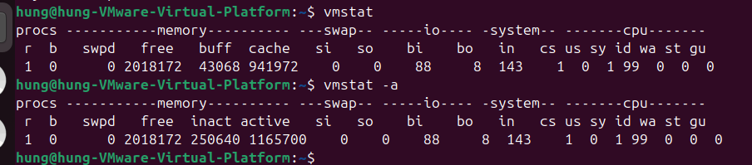

NAME
pstree - display a tree of processes

SYNOPSIS
pstree [-a, --arguments] [-c, --compact] [-h, --highlight-all, -Hpid, --highlight-pid pid]
[-g] --show-pgids] [-l, --long] [-n, --numeric-sort] [-p, --show-pids]
[-s, --show-parents] [-u, --uid-changes] [-Z, --security-context]
[-A, --ascii, -G, --vt100, -U, --unicode] [pid, user]
pstree -V, --version

DESCRIPTION
pstree shows running processes as a tree. The tree is rooted at either pid or init if pid
is omitted. If a user name is specified, all process trees rooted at processes owned by
that user are shown.

pstree visually merges identical branches by putting them in square brackets and prefixing
them with the repetition count, e.g.

init-+-getty
|-getty
|-getty
`-getty

becomes

init---4*[getty]

Child threads of a process are found under the parent process and are shown with the
process name in curly braces, e.g.

icecast2---13*[{icecast2}]

If pstree is called as pstree.x11 then it will prompt the user at the end of the line to
press return and will not return until that has happened. This is useful for when pstree
is run in a xterminal.

Certain kernel or mount parameters, such as the hidepid option for procfs, will hide
information for some processes. In these situations pstree will attempt to build the tree
without this information, showing process names as question marks.
EXAMPLE 2
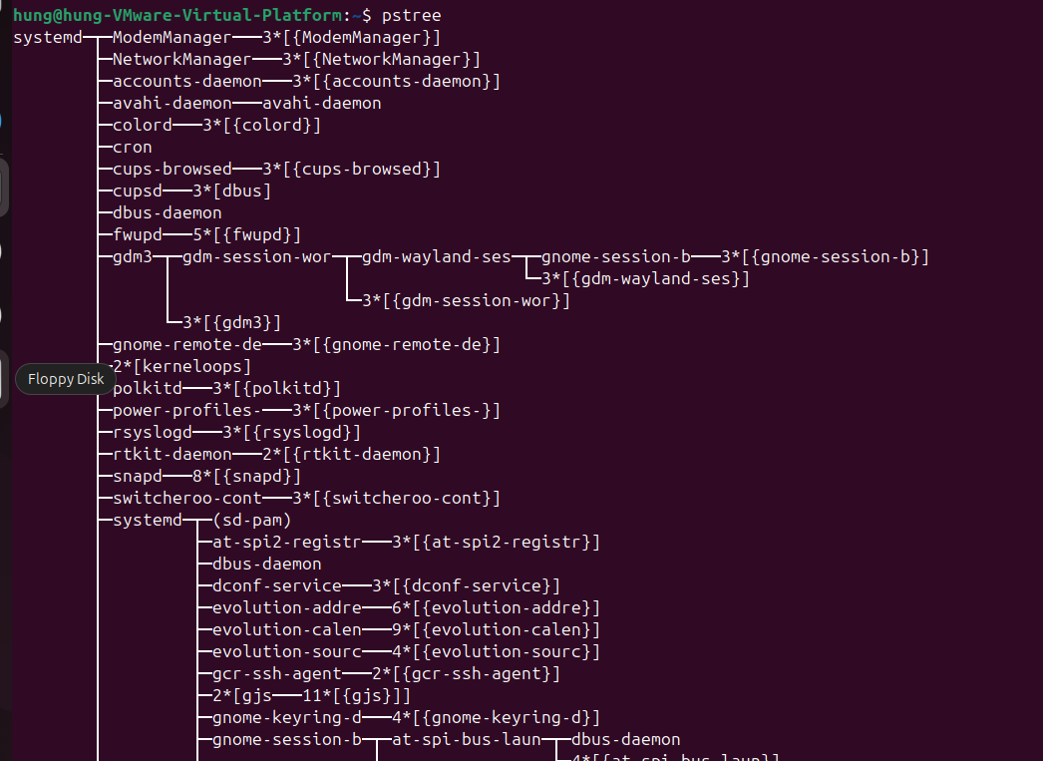
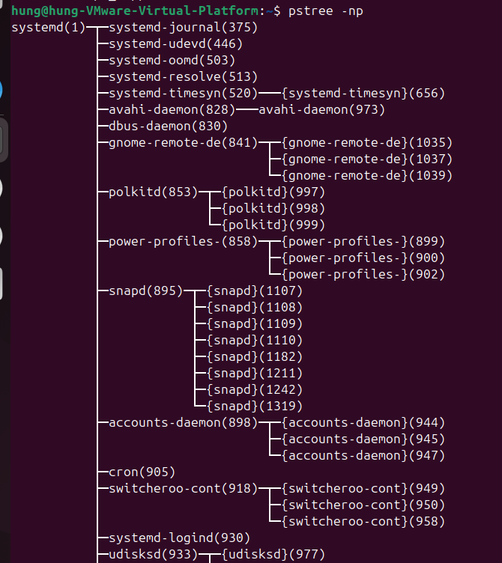

NAME
pgrep, pkill - look up or signal processes based on name and other attributes

SYNOPSIS
pgrep [options] pattern
pkill [options] pattern

DESCRIPTION
pgrep looks through the currently running processes and lists the process IDs which match
the selection criteria to stdout. All the criteria have to match. For example,

$ pgrep -u root sshd

will only list the processes called sshd AND owned by root. On the other hand,

$ pgrep -u root,daemon

will list the processes owned by root OR daemon.

pkill will send the specified signal (by default SIGTERM) to each process instead of
listing them on stdout.

EXAMPLE 3
$ pgrep -u root
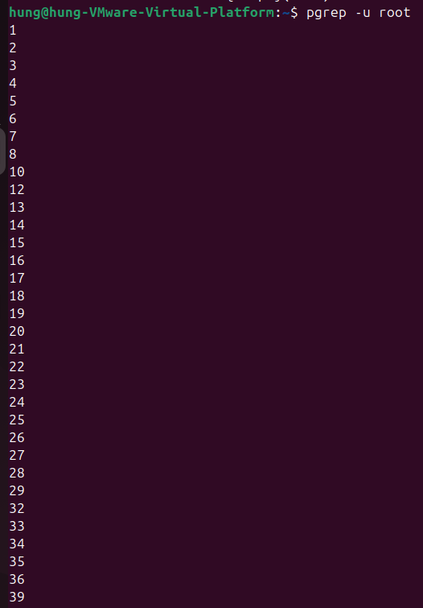
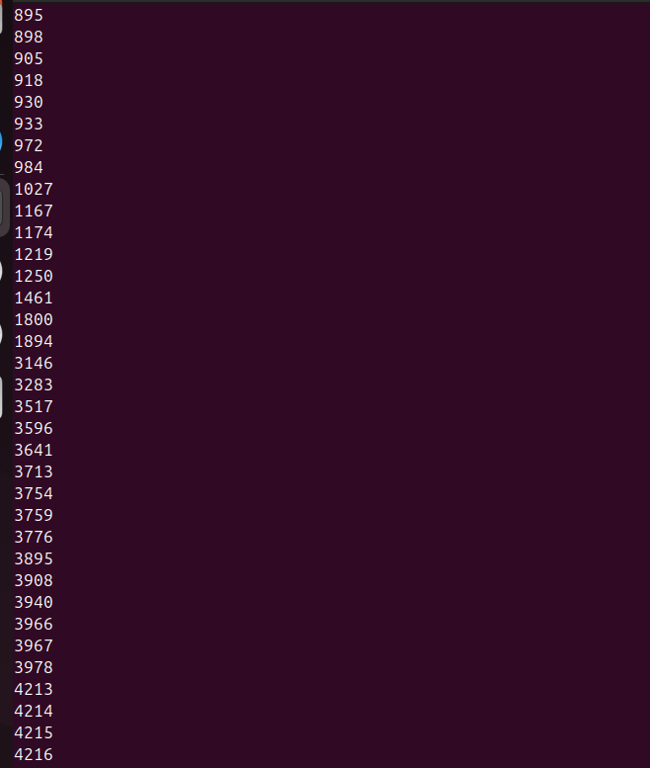

NAME
uptime - Tell how long the system has been running.

SYNOPSIS
uptime [options]

DESCRIPTION
uptime gives a one line display of the following information. The current time, how long
the system has been running, how many users are currently logged on, and the system load
averages for the past 1, 5, and 15 minutes.

This is the same information contained in the header line displayed by w(1).

System load averages is the average number of processes that are either in a runnable or
uninterruptable state. A process in a runnable state is either using the CPU or waiting
to use the CPU. A process in uninterruptable state is waiting for some I/O access, eg
waiting for disk. The averages are taken over the three time intervals. Load averages
are not normalized for the number of CPUs in a system, so a load average of 1 means a
single CPU system is loaded all the time while on a 4 CPU system it means it was idle 75%
of the time.

EXAMPLE 4
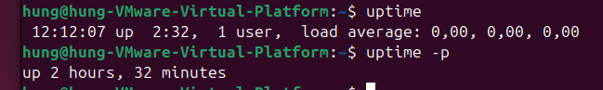

NAME
free - Display amount of free and used memory in the system

SYNOPSIS
free [options]

DESCRIPTION
free displays the total amount of free and used physical and swap memory in the system, as
well as the buffers and caches used by the kernel. The information is gathered by parsing
/proc/meminfo. The displayed columns are:

total Total installed memory (MemTotal and SwapTotal in /proc/meminfo)

used Used memory (calculated as total - free - buffers - cache)

free Unused memory (MemFree and SwapFree in /proc/meminfo)

shared Memory used (mostly) by tmpfs (Shmem in /proc/meminfo)

buffers
Memory used by kernel buffers (Buffers in /proc/meminfo)

cache Memory used by the page cache and slabs (Cached and SReclaimable in /proc/meminfo)

buff/cache
Sum of buffers and cache

available
Estimation of how much memory is available for starting new applications, without
swapping. Unlike the data provided by the cache or free fields, this field takes
into account page cache and also that not all reclaimable memory slabs will be
reclaimed due to items being in use (MemAvailable in /proc/meminfo, available on
kernels 3.14, emulated on kernels 2.6.27+, otherwise the same as free)

EXAMPLE 5

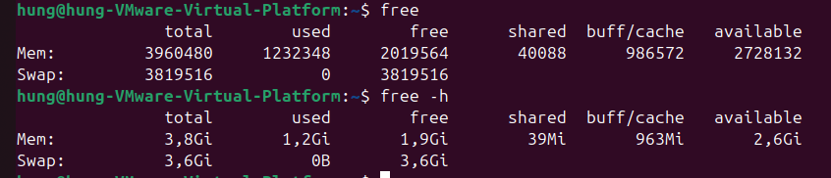NAME
ex, vi, view - text editors

SYNOPSIS
ex [-eRrSsv] [-c cmd] [-t tag] [-w size] [file ...]
vi [-elRrSv] [-c cmd] [-t tag] [-w size] [file ...]
view [-eRrSv] [-c cmd] [-t tag] [-w size] [file ...]

LICENSE
The vi program is freely redistributable. You are welcome to copy, modify and share it
with others under the conditions listed in the LICENSE file. If any company (not
individual!) finds vi sufficiently useful that you would have purchased it, or if any
company wishes to redistribute it, contributions to the authors would be appreciated.

DESCRIPTION
Vi is a screen oriented text editor. Ex is a line‐oriented text editor. Ex and vi are
different interfaces to the same program, and it is possible to switch back and forth
during an edit session. View is the equivalent of using the -R (read‐only) option of vi.

This manual page is the one provided with the nex/nvi versions of the ex/vi text editors.
Nex/nvi are intended as bug‐for‐bug compatible replacements for the original Fourth
Berkeley Software Distribution (4BSD) ex and vi programs. For the rest of this manual
page, nex/nvi is used only when it's necessary to distinguish it from the historic
implementations of ex/vi.

This manual page is intended for users already familiar with ex/vi. Anyone else should
almost certainly read a good tutorial on the editor before this manual page. If you're in
an unfamiliar environment, and you absolutely have to get work done immediately, read the
section after the options description, entitled “Fast Startup”. It's probably enough to
get you going.

The following options are available:

-c Execute cmd immediately after starting the edit session. Particularly useful for
initial positioning in the file, however cmd is not limited to positioning
commands. This is the POSIX 1003.2 interface for the historic “+cmd” syntax.
Nex/nvi supports both the old and new syntax.

-e Start editing in ex mode, as if the command name were ex.

-l Start editing with the lisp and showmatch options set.

-R Start editing in read‐only mode, as if the command name was view, or the readonly
option was set.

-r Recover the specified files, or, if no files are specified, list the files that
could be recovered. If no recoverable files by the specified name exist, the file
is edited as if the -r option had not been specified.

-S Run with the secure edit option set, disallowing all access to external programs.

-s Enter batch mode; applicable only to ex edit sessions. Batch mode is useful when
running ex scripts. Prompts, informative messages and other user oriented message
are turned off, and no startup files or environmental variables are read. This is
the POSIX 1003.2 interface for the historic “-” argument. Nex/nvi supports both
the old and new syntax.

-t Start editing at the specified tag. (See ctags(1)).

-w Set the initial window size to the specified number of lines.

-v Start editing in vi mode, as if the command name was vi or view.

Note that the -F option (which prevented ex/vi from making a full backup of the target
file) has been removed and is no longer available.

Command input for ex/vi is read from the standard input. In the vi interface, it is an
error if standard input is not a terminal. In the ex interface, if standard input is not
a terminal, ex will read commands from it regardless, however, the session will be a batch
mode session, exactly as if the -s option had been specified.

Ex/vi exits 0 on success, and greater than 0 if an error occurs.

EAMPLE 6


