Tên: Lê Trung Kiên

Mssv: 1150080060

Lớp: 11_ĐH_CNPM1

Bài Tập Buổi 8

Thêm dữ liệu cho nhà xuất bản

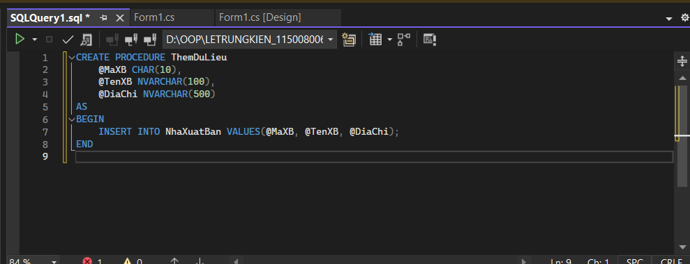

Nút thêm:

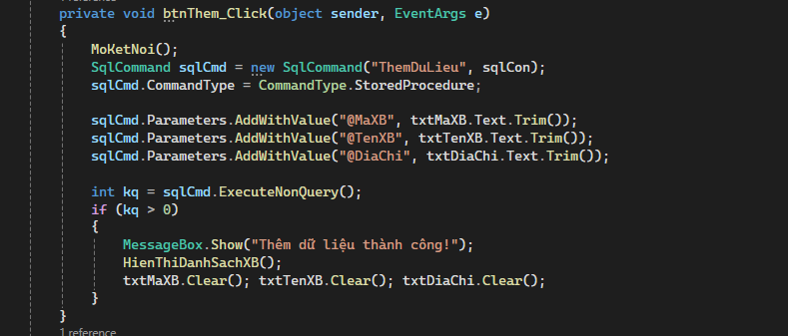

Giao diện:

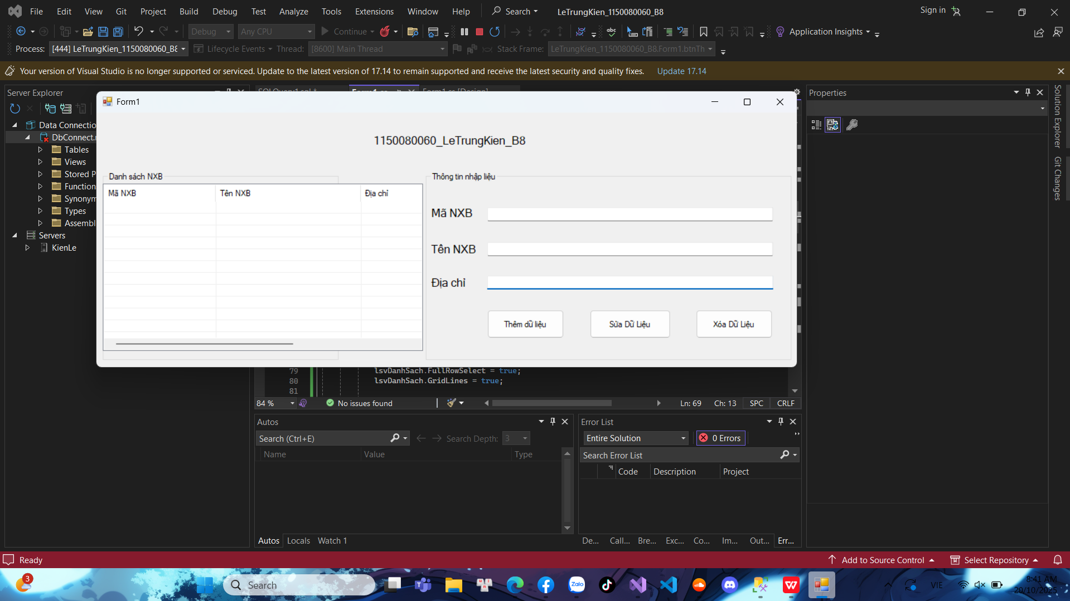

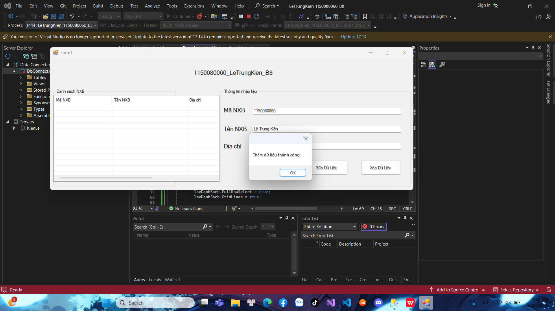

Thêm thành công:

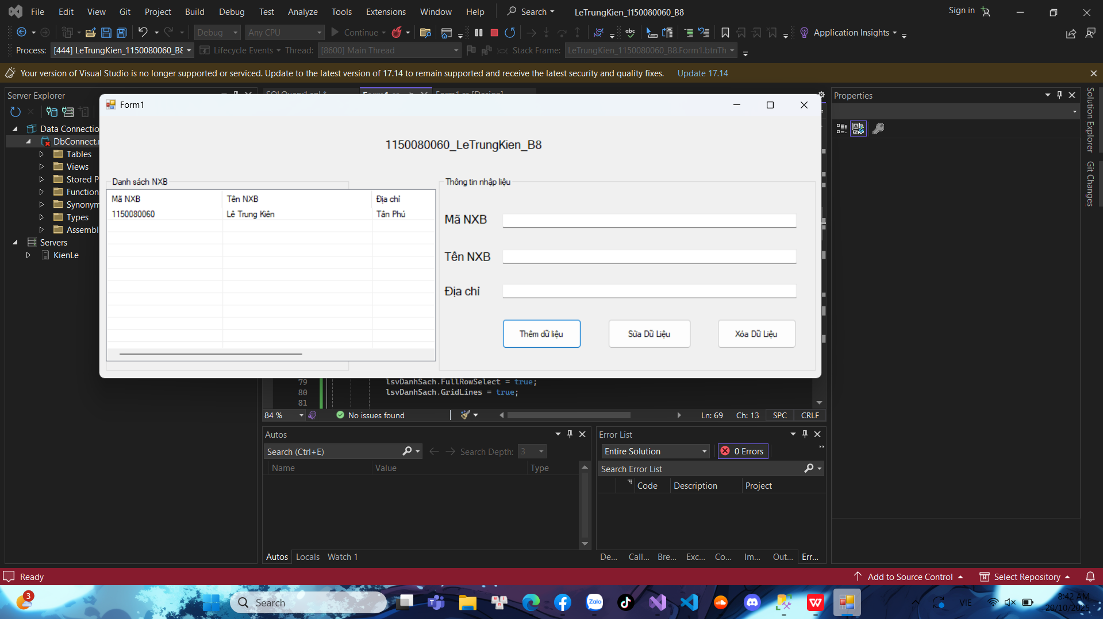

Sửa dữ liệu:

- Thêm procedure

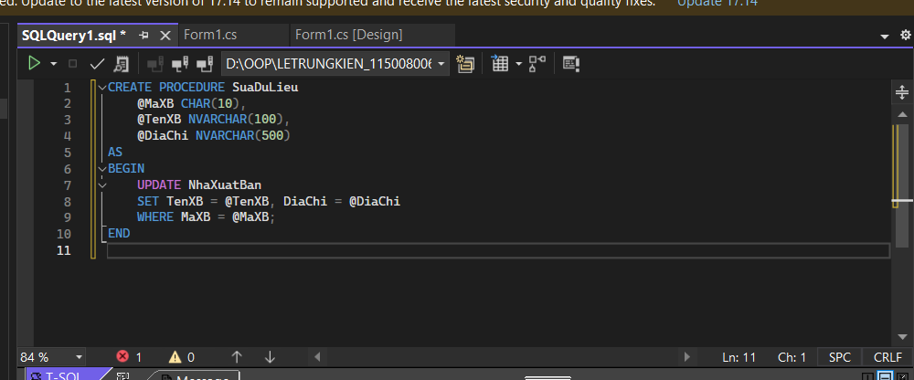

Code Nút sửa:

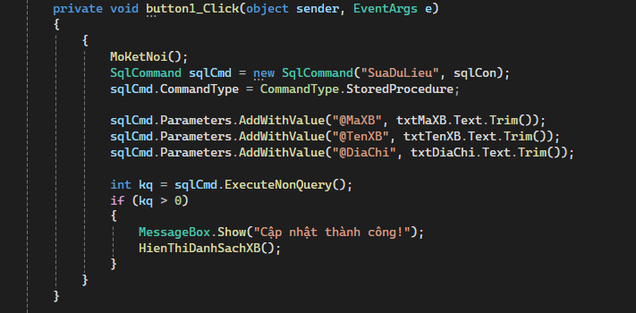

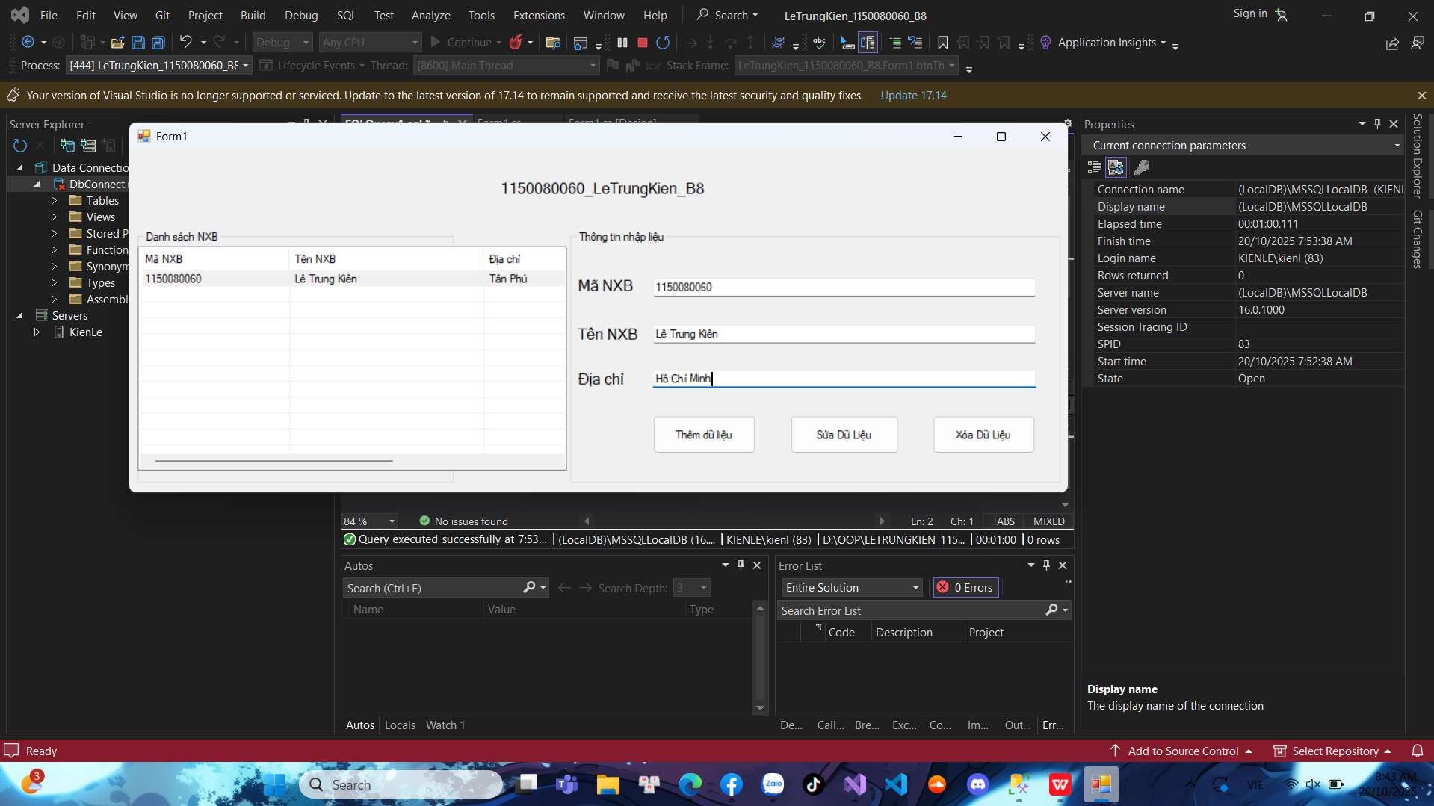

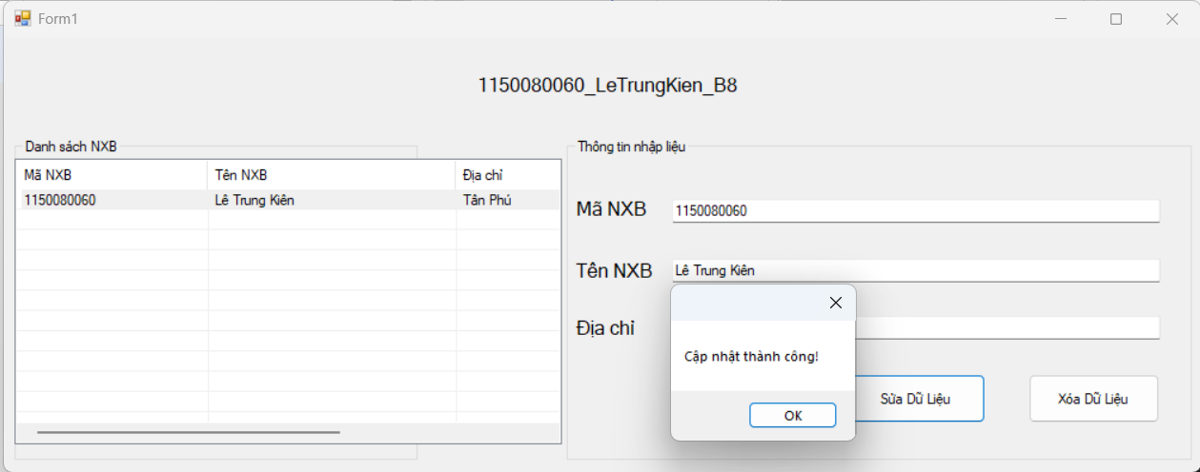

Kết quả:

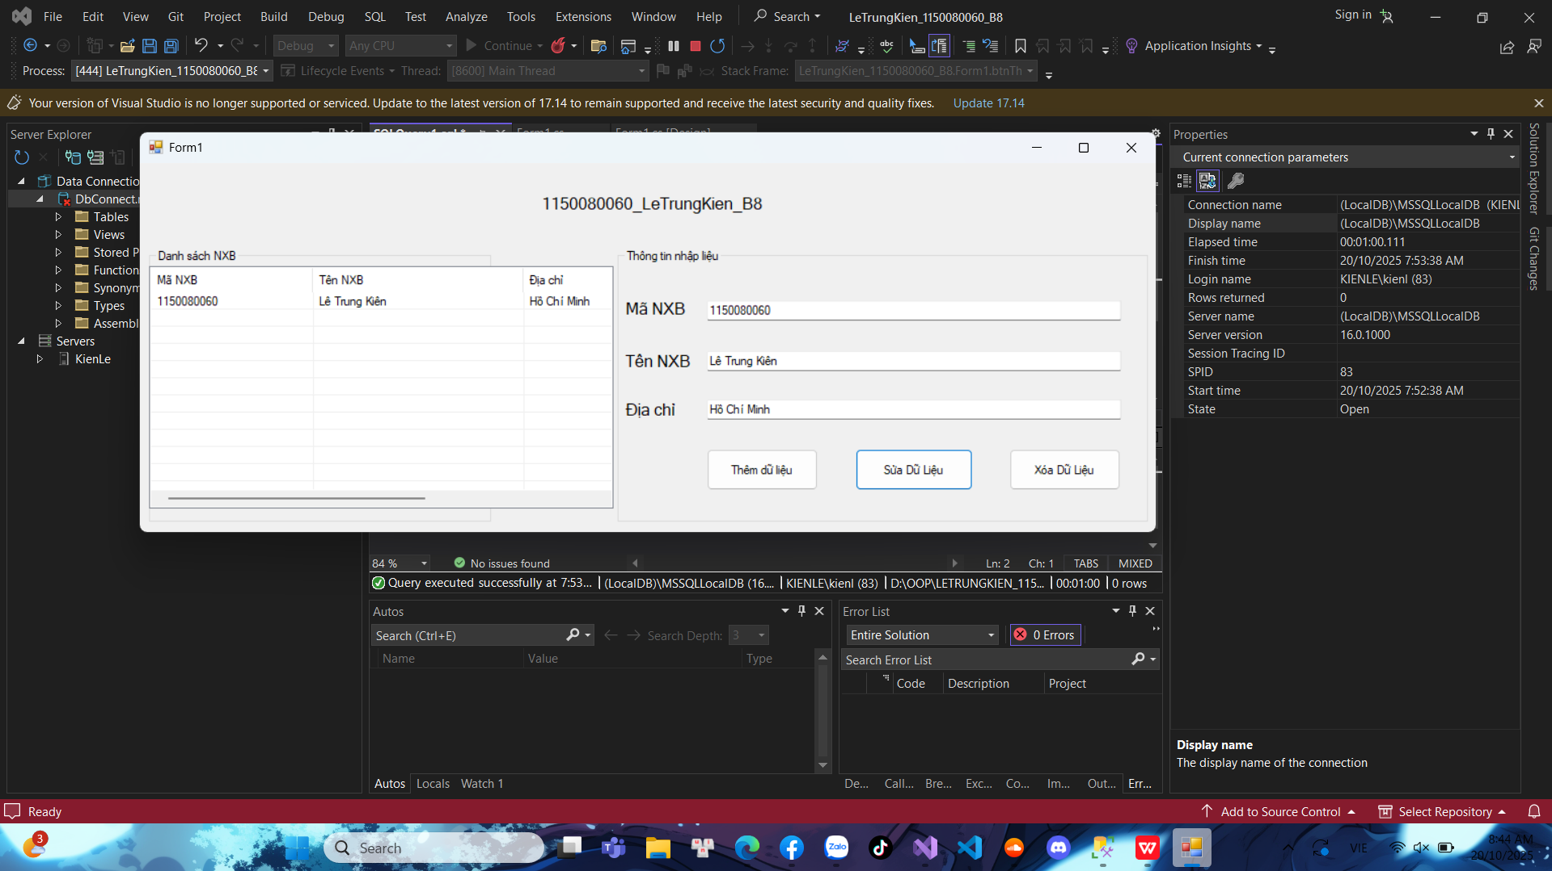

Xóa dữ liệu

Thêm Procedure cho Xóa

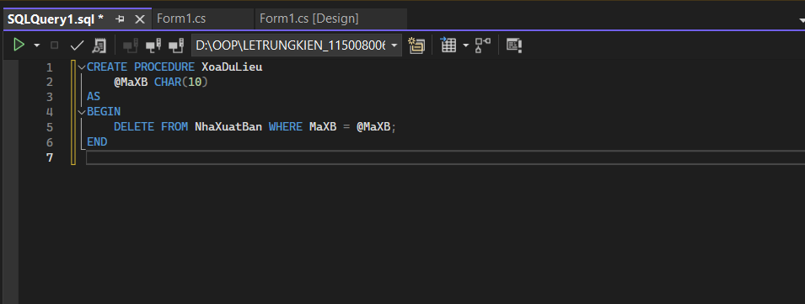

Code nút xóa

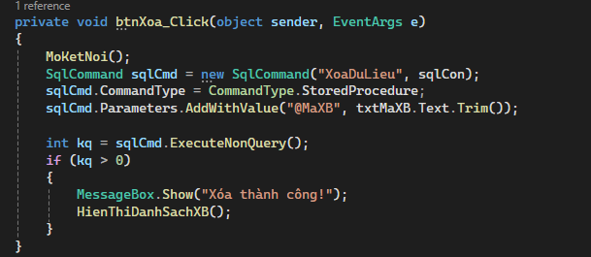

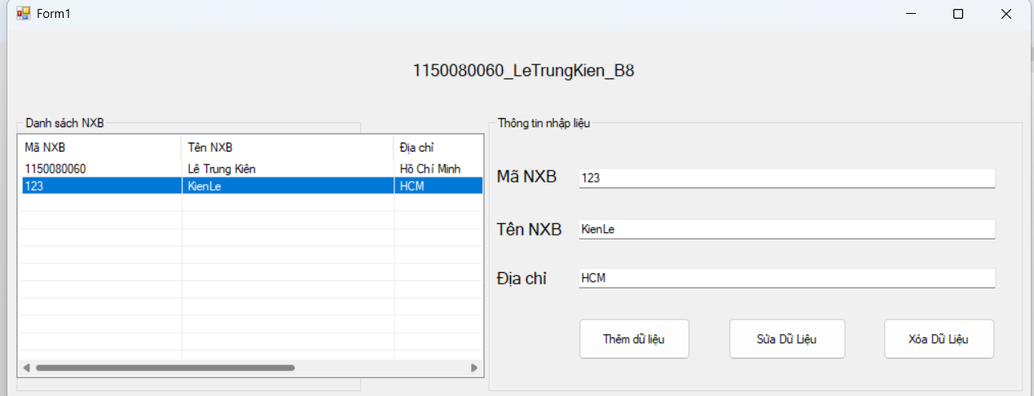

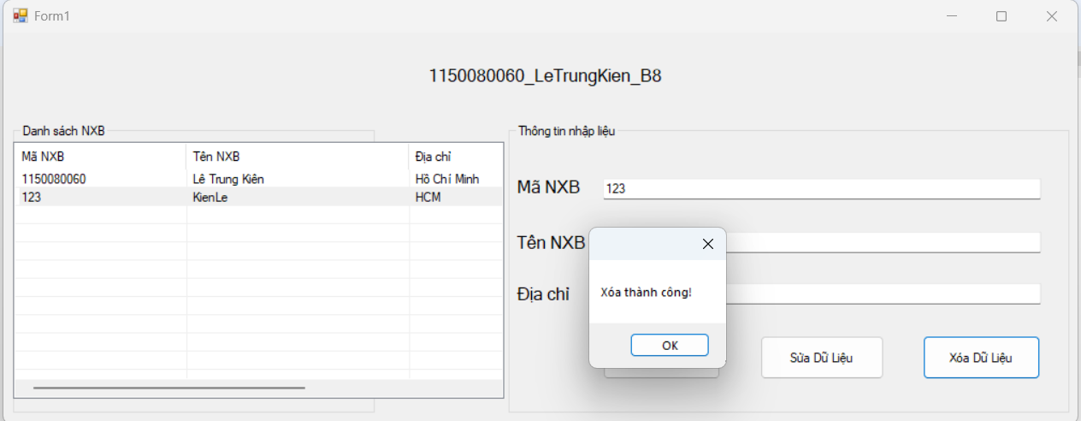

Kết quả:

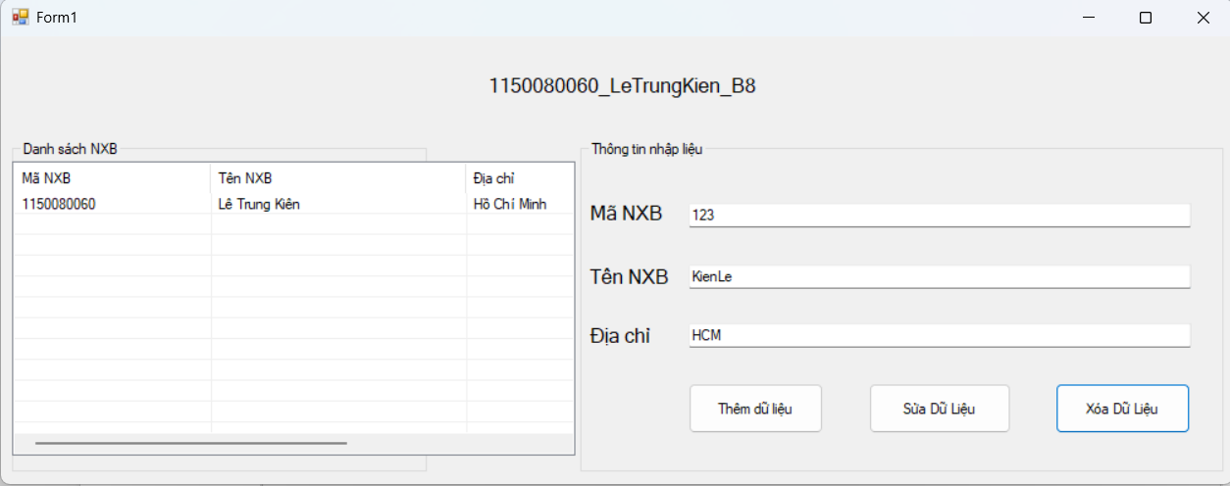

Toàn bộ code:

using System;

using System.Collections.Generic;

using System.ComponentModel;

using System.Data;

using System.Data.SqlClient;

using System.Drawing;

using System.Linq;

using System.Text;

using System.Threading.Tasks;

using System.Windows.Forms;

namespace LeTrungKien_1150080060_B8

{

public partial class Form1 : Form

{

string strCon = @"Data Source=(LocalDB)\MSSQLLocalDB;

AttachDbFilename=D:\OOP\LeTrungKien_1150080060_B8\LeTrungKien_1150080060_B8\DbConnect.mdf;

Integrated Security=True";

SqlConnection sqlCon = null;

public Form1()

{

InitializeComponent();

}

private void MoKetNoi()

{

if (sqlCon == null)

sqlCon = new SqlConnection(strCon);

if (sqlCon.State == ConnectionState.Closed)

sqlCon.Open();

}

private void DongKetNoi()

{

if (sqlCon != null && sqlCon.State == ConnectionState.Open)

sqlCon.Close();

}

private void HienThiDanhSachXB()

{

MoKetNoi();

SqlCommand sqlCmd = new SqlCommand("HienThiXB", sqlCon);

sqlCmd.CommandType = CommandType.StoredProcedure;

SqlDataReader reader = sqlCmd.ExecuteReader();

lsvDanhSach.Items.Clear();

while (reader.Read())

{

string maXB = reader.GetString(0);

string tenXB = reader.GetString(1);

string diaChi = reader.GetString(2);

ListViewItem lvi = new ListViewItem(maXB);

lvi.SubItems.Add(tenXB);

lvi.SubItems.Add(diaChi);

lsvDanhSach.Items.Add(lvi);

}

reader.Close();

}

private void Form1_Load(object sender, EventArgs e)

{

SetupListView();

HienThiDanhSachXB();

}

private void label1_Click(object sender, EventArgs e)

{

}

private void label3_Click(object sender, EventArgs e)

{

}

private void SetupListView()

{

lsvDanhSach.View = View.Details;

lsvDanhSach.FullRowSelect = true;

lsvDanhSach.GridLines = true;

if (lsvDanhSach.Columns.Count == 0)

{

lsvDanhSach.Columns.Add("Mã XB", 100);

lsvDanhSach.Columns.Add("Tên XB", 180);

lsvDanhSach.Columns.Add("Địa chỉ", 260);

}

}

private void btnThem_Click(object sender, EventArgs e)

{

MoKetNoi();

SqlCommand sqlCmd = new SqlCommand("ThemDuLieu", sqlCon);

sqlCmd.CommandType = CommandType.StoredProcedure;

sqlCmd.Parameters.AddWithValue("@MaXB", txtMaXB.Text.Trim());

sqlCmd.Parameters.AddWithValue("@TenXB", txtTenXB.Text.Trim());

sqlCmd.Parameters.AddWithValue("@DiaChi", txtDiaChi.Text.Trim());

int kq = sqlCmd.ExecuteNonQuery();

if (kq > 0)

{

MessageBox.Show("Thêm dữ liệu thành công!");

HienThiDanhSachXB();

txtMaXB.Clear(); txtTenXB.Clear(); txtDiaChi.Clear();

}

}

private void FillInputsFromSelectedItem()

{

if (lsvDanhSach.SelectedItems.Count == 0) return;

var item = lsvDanhSach.SelectedItems[0];

txtMaXB.Text = item.SubItems[0].Text;

txtTenXB.Text = item.SubItems[1].Text;

txtDiaChi.Text = item.SubItems[2].Text;

btnSua.Enabled = btnXoa.Enabled = true;

}

private void lsvDanhSach_SelectedIndexChanged(object sender, EventArgs e)

{

if (lsvDanhSach.SelectedItems.Count == 0)

{

btnSua.Enabled = btnXoa.Enabled = false;

return;

}

FillInputsFromSelectedItem();

}

private void button1_Click(object sender, EventArgs e)

{

{

MoKetNoi();

SqlCommand sqlCmd = new SqlCommand("SuaDuLieu", sqlCon);

sqlCmd.CommandType = CommandType.StoredProcedure;

sqlCmd.Parameters.AddWithValue("@MaXB", txtMaXB.Text.Trim());

sqlCmd.Parameters.AddWithValue("@TenXB", txtTenXB.Text.Trim());

sqlCmd.Parameters.AddWithValue("@DiaChi", txtDiaChi.Text.Trim());

int kq = sqlCmd.ExecuteNonQuery();

if (kq > 0)

{

MessageBox.Show("Cập nhật thành công!");

HienThiDanhSachXB();

}

}

}

private void btnXoa_Click(object sender, EventArgs e)

{

MoKetNoi();

SqlCommand sqlCmd = new SqlCommand("XoaDuLieu", sqlCon);

sqlCmd.CommandType = CommandType.StoredProcedure;

sqlCmd.Parameters.AddWithValue("@MaXB", txtMaXB.Text.Trim());

int kq = sqlCmd.ExecuteNonQuery();

if (kq > 0)

{

MessageBox.Show("Xóa thành công!");

HienThiDanhSachXB();

}

}

}

}