Website: <https://truongwebsitescst336.herokuapp.com/>

The 2 new HTML tags I used are

<cite> and <detail>

The 2 new CSS tags I used are

:lang() and border-radius, and in general multiple border faces.

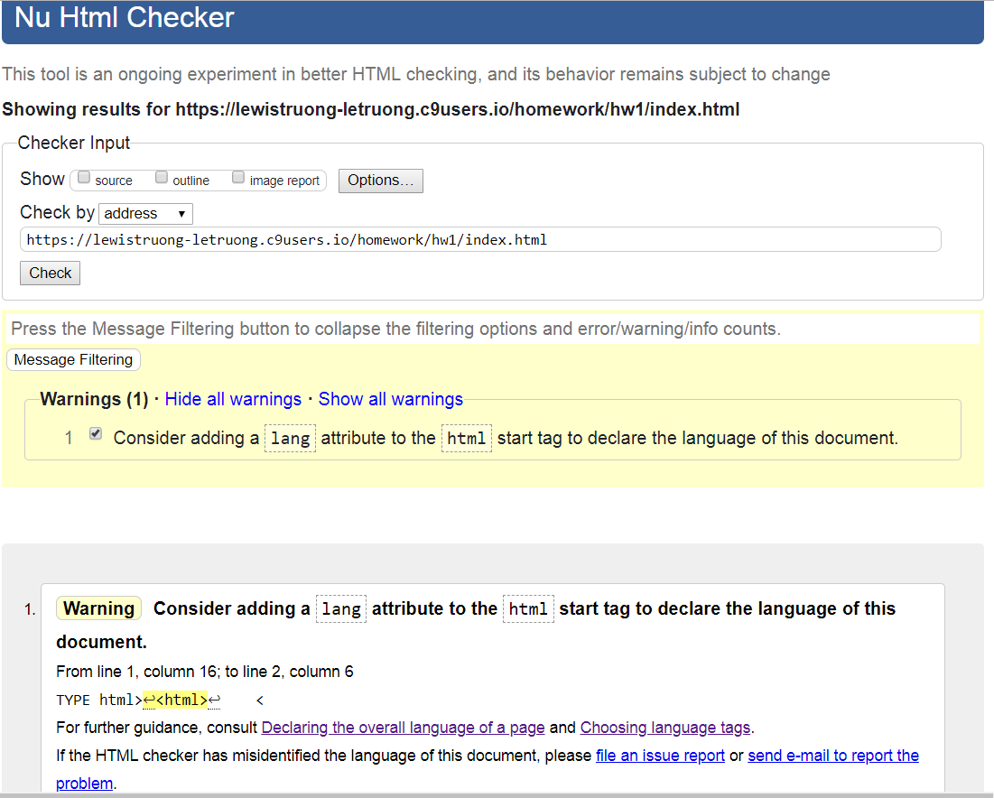

I added in the lang=”en-US” but it still registers an error

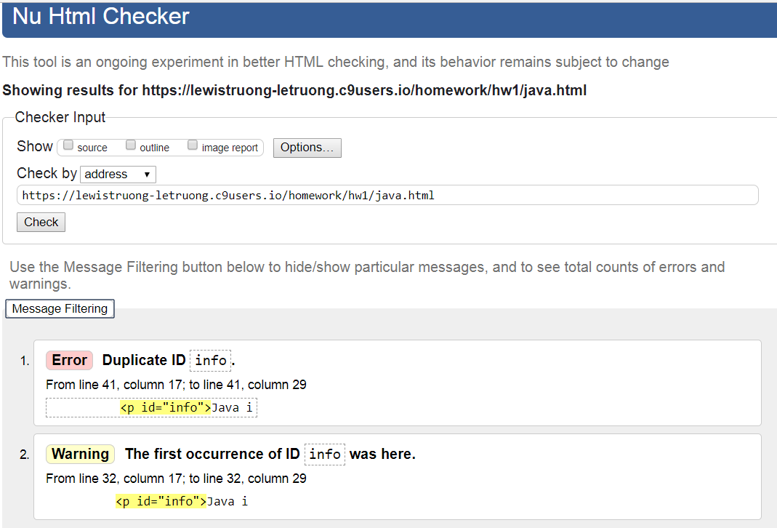

The “duplicate” is due to a break between paragraphs for my ID

