Fair Communication in Health Services using Block Chain

Health Service plays an important role in making our life better. It involves different services from interaction with patient, treatment from specialized doctor, diagnosis of patient, prescribing medicine, generating report, payments etc. To facilitate the service smoothly we need a fair and transparent system which will create a better society , in which person irrespective of age,caste,gender,physical well being will get equal treatement. This is a step to make better future. We will use block chain to create an application which address the need of fair system which keeps track and monitor the service. This can be accomplished by creating 3 chains dedicated to patient, doctor and hospital management. Doctor will look the booked appointment with his id and submit his report with unique hashid which will be an aggregation of patient details and timestamp. Patient will also be able to book appointment with doctor,fill out details and see his report. The patient chain will bring privacy to system in which patient can share his details to only his respective doctor. Hospital management will facilitate the overall service , hospital chain will have the details of the test to be carried out on patient and medicine. Patient can interact with hospital management using the block chain application and see diagnosis report. Each of the transaction will have unique hashid and previous hashid of last activity, in this way we can keep track of the activities. The key of this application is to encourage more doctors, hospital management to participate in fair system. Because of hashId involved, our application can handle a lot of users and their transaction. We can create single application which will serve the need and handle the demand. We will publicly host our application and create awareness in society to use our application for smooth ,fair and hassle free service to patient ,doctor and hospital management so that each of entity involved can save their time.

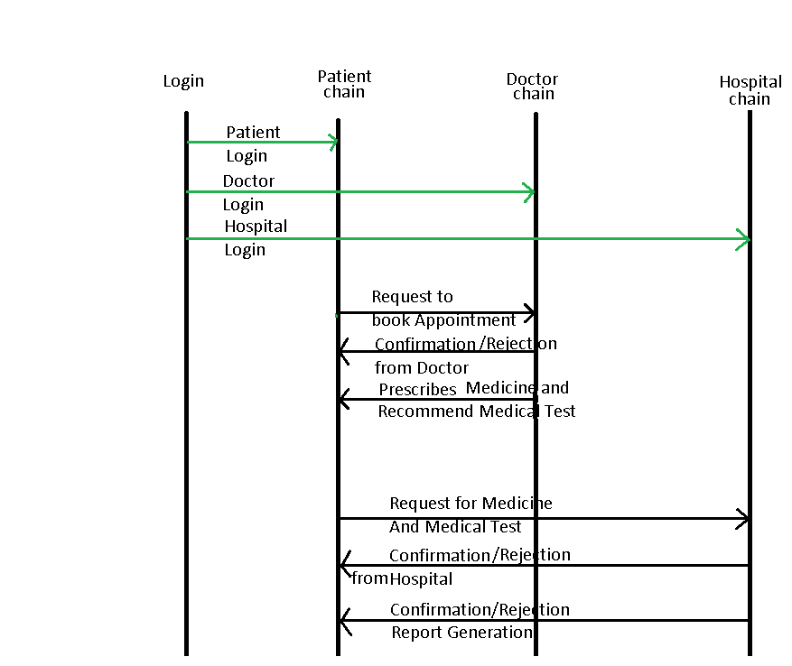

1)Problem space / Topic are addressed?

This project is to build 3 entity running on 3 different chains. 3 different Ganache instance is created, respective solidity code is deployed on three different chains.

2) How you got to your solution

Created 3 different chains on Ganache instance solved the problem of three chains running on different port.

3.) What problem is it solving for people and community, and for whom specifically?

Our solution can solve the problem of long waiting queue problem faced in Health Services. Patient has to wait a long queue to meet the doctor while Test report processing took another waiting queue.Our application can solve the problem with efficiently manage time while processing. Or application is scalable and decentralized in which people can trust the system.

4) Challenges of building the MVP

We build this application using Nodejs,express,HTML,CSS,JavaScript. We created login which differentiate the entity and redirect to different page upon successful signin.

5) Potential negative environmental or social impact & mitigation strategies

People of india is slow to adapt the new technology. We need to create awareness in society to adapt the new technology.

6) What is your business model? How will this make money? Be specific.

First we will deploy our service to some server such as amazon.

Secondly we will create awareness among people using advertisement on different social platform.

Thirdly we will give our service for free with limited access. We will charge fee for premium account to avail full service.

7)Team members:

Shashank srivastava

Full Stack Web development along with problem solving.

Technical Stack Learnt:

                Front-End:  ReactJs,Redux,JavaScript, HTML,CSS,Bootstrap

                Back-End:  NodeJs,MYSQL

Problem Solving:  Data Structures And Algorithms with Java.

Participated in various coding contests organized by platform.

Worked on various project.