Name: Le Van Thanh

ID: 20181924

Homework 2:

1. Three phase full wave diode rectifier:

a, Resistive load:

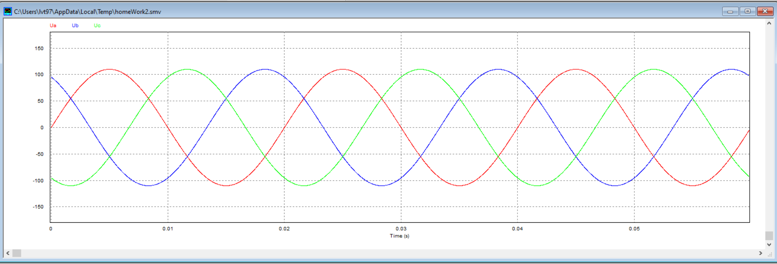

*Figure 1: The voltage of three phase*

*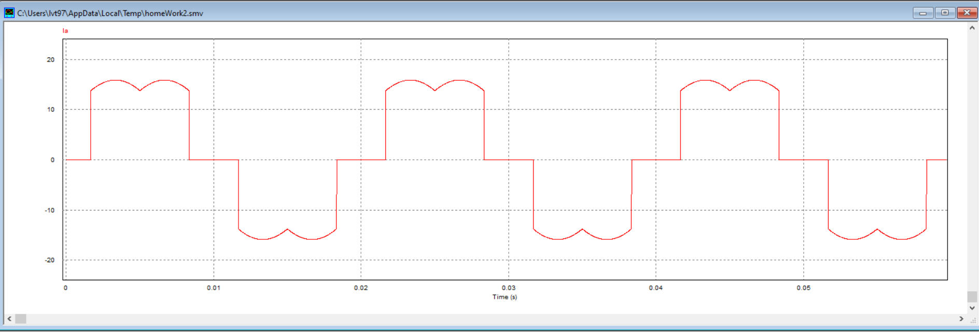*

*Figure 2: The current of phase A*

*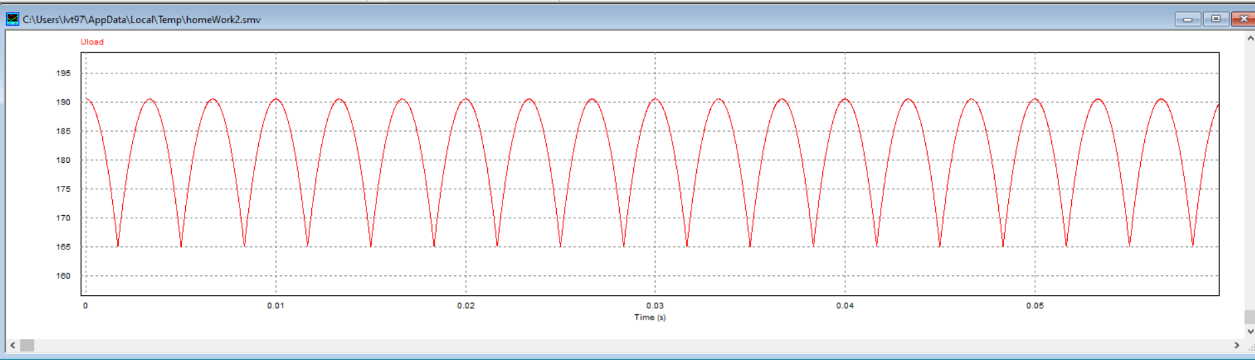*

*Figure 3: The load voltage*

b, Inductive load:

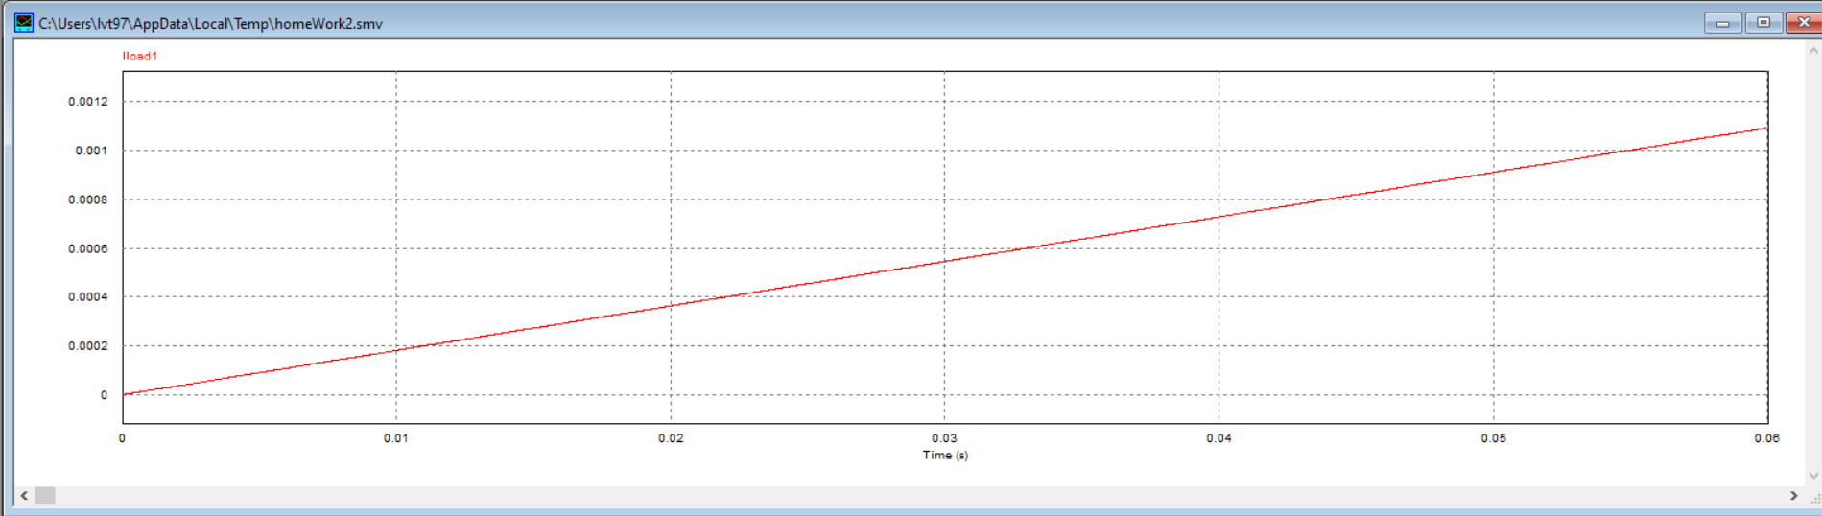

*Figure 4: The current of load*

*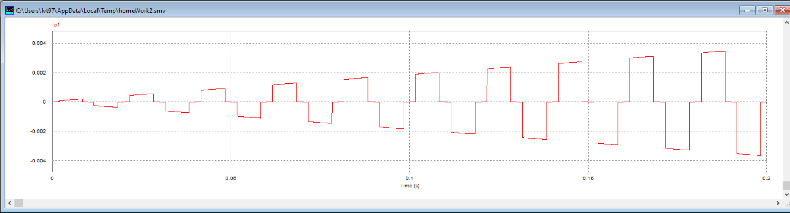*

*Figure 5: The current of phase a*

c, The capacitive load:

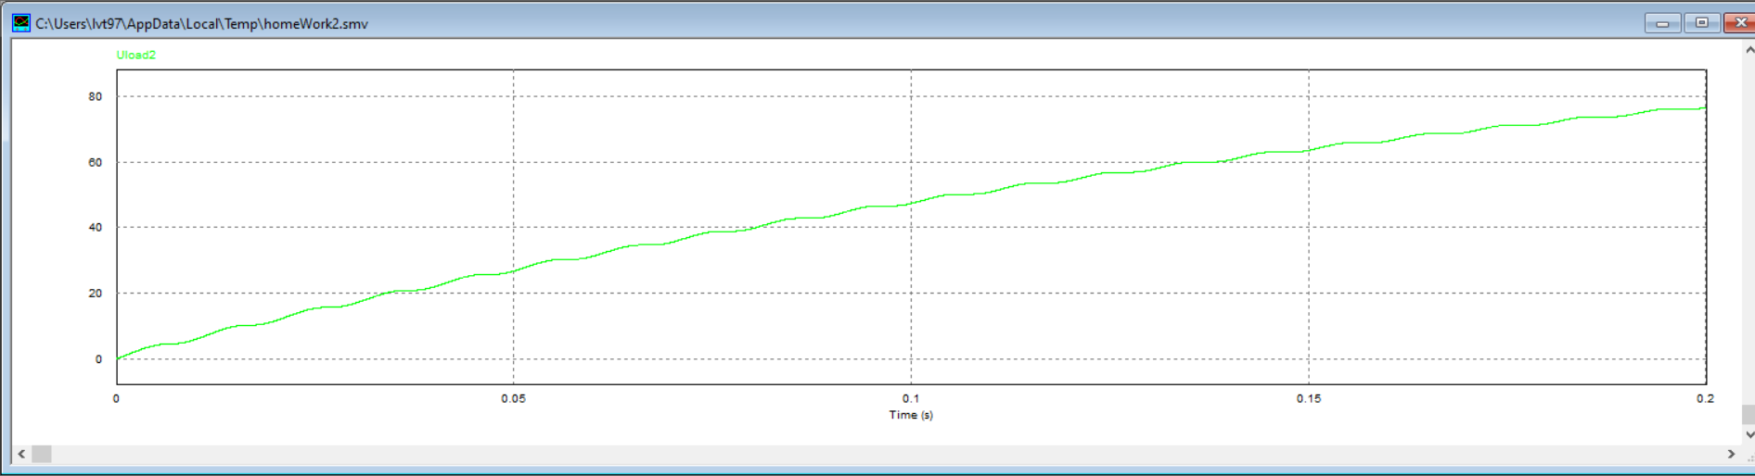

*Figure 6: The load voltage*

1. *Single phase thyristor full bridge rectifier:*

*a, Resistive load:*

*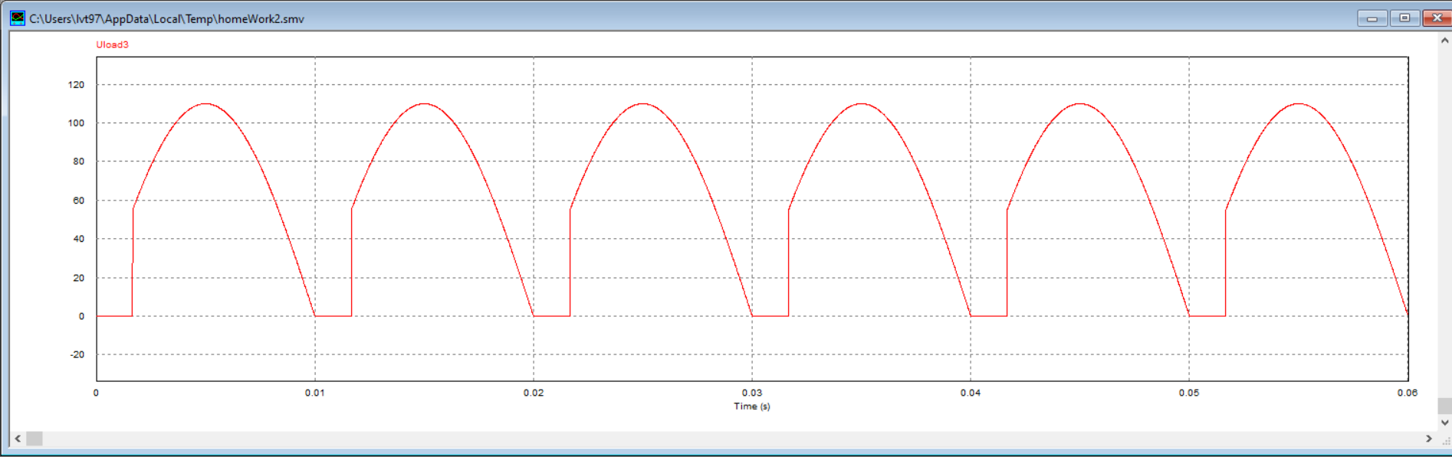*

*Figure 7: The load voltage with alpha=50*

*b, Inductive load:*

*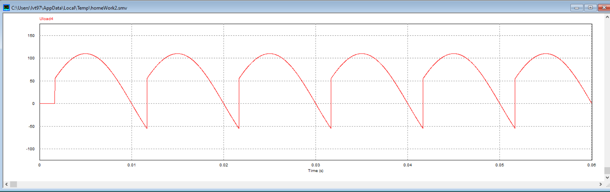*

*Figure 7: The voltage of load*