How to use the smart contract?
The contract is deployed on the Simalia blockchain, which is the Starknet test blockchain.
To view the contract, you can access it via Starkscan, a website that allows you to see the different contracts and accounts on the blockchain.
Links:
https://sepolia.starkscan.co/contract/0x06b0b8c0cb6b228942212a074ca4eaf036379dce58eac1d17ab4b56af4bcfc9b#overview
Contract Address:
0x06b0b8c0cb6b228942212a074ca4eaf036379dce58eac1d17ab4b56af4bcfc9b
Interacting with the contract
First, go to the Read/Write Contract tab.
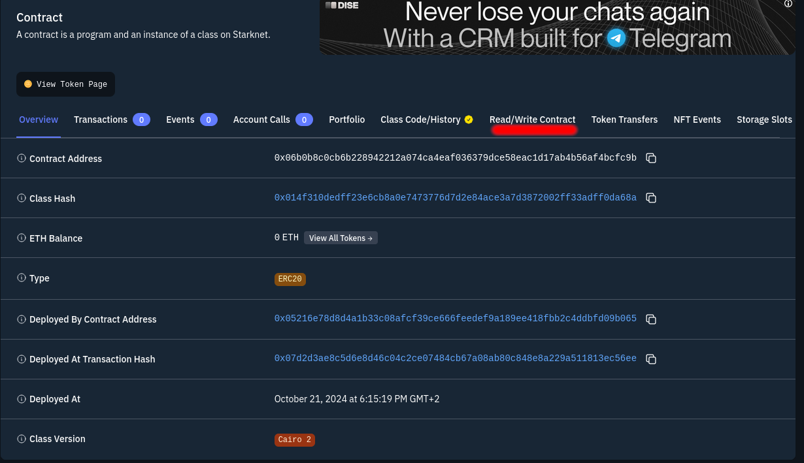

You will be taken to a page that gives access to the contract’s content.
For example, here I requested the balance of the following account:
0x05216E78D8D4A1B33c08AFCF39cE666FEEDef9A189eE418FBB2c4DDBfd09B065
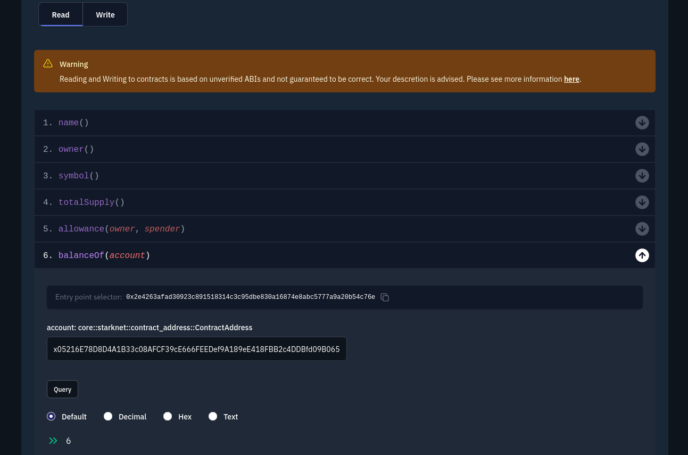
In the Write tab, you can call the different functions of the contract.
To do this, you need to connect a compatible wallet like ArgentX, which will pay the gas fees (the costs required for each modification on the blockchain).
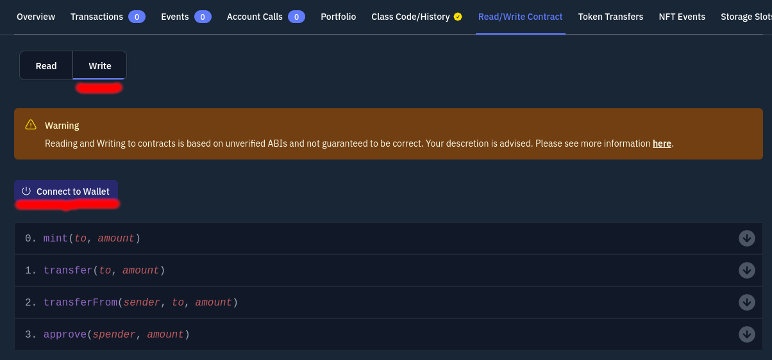

For example, here I created 233 tokens (2) for account (1):
0x05216E78D8D4A1B33c08AFCF39cE666FEEDef9A189eE418FBB2c4DDBfd09B065
