Honors Project Part 2

Leanne Mangeni

2023-11-28

f = 'wine.data'  
data <- read.csv('wine.data')  
colnames(data) <- c("Class", "Alcohol","Malic Acid", "Ash", "Alca of Ash", "Magnesium","Total Phenols", "Flavnoids", "Nonflavavnoid phonels","Proanthocyanins","Color intensity", "Hue", " OD280 of diluted wine", "Proline")  
data

## Class Alcohol Malic Acid Ash Alca of Ash Magnesium Total Phenols Flavnoids  
## 1 1 13.20 1.78 2.14 11.2 100 2.65 2.76  
## 2 1 13.16 2.36 2.67 18.6 101 2.80 3.24  
## 3 1 14.37 1.95 2.50 16.8 113 3.85 3.49  
## 4 1 13.24 2.59 2.87 21.0 118 2.80 2.69  
## 5 1 14.20 1.76 2.45 15.2 112 3.27 3.39  
## 6 1 14.39 1.87 2.45 14.6 96 2.50 2.52  
## 7 1 14.06 2.15 2.61 17.6 121 2.60 2.51  
## 8 1 14.83 1.64 2.17 14.0 97 2.80 2.98  
## 9 1 13.86 1.35 2.27 16.0 98 2.98 3.15  
## 10 1 14.10 2.16 2.30 18.0 105 2.95 3.32  
## 11 1 14.12 1.48 2.32 16.8 95 2.20 2.43  
## 12 1 13.75 1.73 2.41 16.0 89 2.60 2.76  
## 13 1 14.75 1.73 2.39 11.4 91 3.10 3.69  
## 14 1 14.38 1.87 2.38 12.0 102 3.30 3.64  
## 15 1 13.63 1.81 2.70 17.2 112 2.85 2.91  
## 16 1 14.30 1.92 2.72 20.0 120 2.80 3.14  
## 17 1 13.83 1.57 2.62 20.0 115 2.95 3.40  
## 18 1 14.19 1.59 2.48 16.5 108 3.30 3.93  
## 19 1 13.64 3.10 2.56 15.2 116 2.70 3.03  
## 20 1 14.06 1.63 2.28 16.0 126 3.00 3.17  
## 21 1 12.93 3.80 2.65 18.6 102 2.41 2.41  
## 22 1 13.71 1.86 2.36 16.6 101 2.61 2.88  
## 23 1 12.85 1.60 2.52 17.8 95 2.48 2.37  
## 24 1 13.50 1.81 2.61 20.0 96 2.53 2.61  
## 25 1 13.05 2.05 3.22 25.0 124 2.63 2.68  
## 26 1 13.39 1.77 2.62 16.1 93 2.85 2.94  
## 27 1 13.30 1.72 2.14 17.0 94 2.40 2.19  
## 28 1 13.87 1.90 2.80 19.4 107 2.95 2.97  
## 29 1 14.02 1.68 2.21 16.0 96 2.65 2.33  
## 30 1 13.73 1.50 2.70 22.5 101 3.00 3.25  
## 31 1 13.58 1.66 2.36 19.1 106 2.86 3.19  
## 32 1 13.68 1.83 2.36 17.2 104 2.42 2.69  
## 33 1 13.76 1.53 2.70 19.5 132 2.95 2.74  
## 34 1 13.51 1.80 2.65 19.0 110 2.35 2.53  
## 35 1 13.48 1.81 2.41 20.5 100 2.70 2.98  
## 36 1 13.28 1.64 2.84 15.5 110 2.60 2.68  
## 37 1 13.05 1.65 2.55 18.0 98 2.45 2.43  
## 38 1 13.07 1.50 2.10 15.5 98 2.40 2.64  
## 39 1 14.22 3.99 2.51 13.2 128 3.00 3.04  
## 40 1 13.56 1.71 2.31 16.2 117 3.15 3.29  
## 41 1 13.41 3.84 2.12 18.8 90 2.45 2.68  
## 42 1 13.88 1.89 2.59 15.0 101 3.25 3.56  
## 43 1 13.24 3.98 2.29 17.5 103 2.64 2.63  
## 44 1 13.05 1.77 2.10 17.0 107 3.00 3.00  
## 45 1 14.21 4.04 2.44 18.9 111 2.85 2.65  
## 46 1 14.38 3.59 2.28 16.0 102 3.25 3.17  
## 47 1 13.90 1.68 2.12 16.0 101 3.10 3.39  
## 48 1 14.10 2.02 2.40 18.8 103 2.75 2.92  
## 49 1 13.94 1.73 2.27 17.4 108 2.88 3.54  
## 50 1 13.05 1.73 2.04 12.4 92 2.72 3.27  
## 51 1 13.83 1.65 2.60 17.2 94 2.45 2.99  
## 52 1 13.82 1.75 2.42 14.0 111 3.88 3.74  
## 53 1 13.77 1.90 2.68 17.1 115 3.00 2.79  
## 54 1 13.74 1.67 2.25 16.4 118 2.60 2.90  
## 55 1 13.56 1.73 2.46 20.5 116 2.96 2.78  
## 56 1 14.22 1.70 2.30 16.3 118 3.20 3.00  
## 57 1 13.29 1.97 2.68 16.8 102 3.00 3.23  
## 58 1 13.72 1.43 2.50 16.7 108 3.40 3.67  
## 59 2 12.37 0.94 1.36 10.6 88 1.98 0.57  
## 60 2 12.33 1.10 2.28 16.0 101 2.05 1.09  
## 61 2 12.64 1.36 2.02 16.8 100 2.02 1.41  
## 62 2 13.67 1.25 1.92 18.0 94 2.10 1.79  
## 63 2 12.37 1.13 2.16 19.0 87 3.50 3.10  
## 64 2 12.17 1.45 2.53 19.0 104 1.89 1.75  
## 65 2 12.37 1.21 2.56 18.1 98 2.42 2.65  
## 66 2 13.11 1.01 1.70 15.0 78 2.98 3.18  
## 67 2 12.37 1.17 1.92 19.6 78 2.11 2.00  
## 68 2 13.34 0.94 2.36 17.0 110 2.53 1.30  
## 69 2 12.21 1.19 1.75 16.8 151 1.85 1.28  
## 70 2 12.29 1.61 2.21 20.4 103 1.10 1.02  
## 71 2 13.86 1.51 2.67 25.0 86 2.95 2.86  
## 72 2 13.49 1.66 2.24 24.0 87 1.88 1.84  
## 73 2 12.99 1.67 2.60 30.0 139 3.30 2.89  
## 74 2 11.96 1.09 2.30 21.0 101 3.38 2.14  
## 75 2 11.66 1.88 1.92 16.0 97 1.61 1.57  
## 76 2 13.03 0.90 1.71 16.0 86 1.95 2.03  
## 77 2 11.84 2.89 2.23 18.0 112 1.72 1.32  
## 78 2 12.33 0.99 1.95 14.8 136 1.90 1.85  
## 79 2 12.70 3.87 2.40 23.0 101 2.83 2.55  
## 80 2 12.00 0.92 2.00 19.0 86 2.42 2.26  
## 81 2 12.72 1.81 2.20 18.8 86 2.20 2.53  
## 82 2 12.08 1.13 2.51 24.0 78 2.00 1.58  
## 83 2 13.05 3.86 2.32 22.5 85 1.65 1.59  
## 84 2 11.84 0.89 2.58 18.0 94 2.20 2.21  
## 85 2 12.67 0.98 2.24 18.0 99 2.20 1.94  
## 86 2 12.16 1.61 2.31 22.8 90 1.78 1.69  
## 87 2 11.65 1.67 2.62 26.0 88 1.92 1.61  
## 88 2 11.64 2.06 2.46 21.6 84 1.95 1.69  
## 89 2 12.08 1.33 2.30 23.6 70 2.20 1.59  
## 90 2 12.08 1.83 2.32 18.5 81 1.60 1.50  
## 91 2 12.00 1.51 2.42 22.0 86 1.45 1.25  
## 92 2 12.69 1.53 2.26 20.7 80 1.38 1.46  
## 93 2 12.29 2.83 2.22 18.0 88 2.45 2.25  
## 94 2 11.62 1.99 2.28 18.0 98 3.02 2.26  
## 95 2 12.47 1.52 2.20 19.0 162 2.50 2.27  
## 96 2 11.81 2.12 2.74 21.5 134 1.60 0.99  
## 97 2 12.29 1.41 1.98 16.0 85 2.55 2.50  
## 98 2 12.37 1.07 2.10 18.5 88 3.52 3.75  
## 99 2 12.29 3.17 2.21 18.0 88 2.85 2.99  
## 100 2 12.08 2.08 1.70 17.5 97 2.23 2.17  
## 101 2 12.60 1.34 1.90 18.5 88 1.45 1.36  
## 102 2 12.34 2.45 2.46 21.0 98 2.56 2.11  
## 103 2 11.82 1.72 1.88 19.5 86 2.50 1.64  
## 104 2 12.51 1.73 1.98 20.5 85 2.20 1.92  
## 105 2 12.42 2.55 2.27 22.0 90 1.68 1.84  
## 106 2 12.25 1.73 2.12 19.0 80 1.65 2.03  
## 107 2 12.72 1.75 2.28 22.5 84 1.38 1.76  
## 108 2 12.22 1.29 1.94 19.0 92 2.36 2.04  
## 109 2 11.61 1.35 2.70 20.0 94 2.74 2.92  
## 110 2 11.46 3.74 1.82 19.5 107 3.18 2.58  
## 111 2 12.52 2.43 2.17 21.0 88 2.55 2.27  
## 112 2 11.76 2.68 2.92 20.0 103 1.75 2.03  
## 113 2 11.41 0.74 2.50 21.0 88 2.48 2.01  
## 114 2 12.08 1.39 2.50 22.5 84 2.56 2.29  
## 115 2 11.03 1.51 2.20 21.5 85 2.46 2.17  
## 116 2 11.82 1.47 1.99 20.8 86 1.98 1.60  
## 117 2 12.42 1.61 2.19 22.5 108 2.00 2.09  
## 118 2 12.77 3.43 1.98 16.0 80 1.63 1.25  
## 119 2 12.00 3.43 2.00 19.0 87 2.00 1.64  
## 120 2 11.45 2.40 2.42 20.0 96 2.90 2.79  
## 121 2 11.56 2.05 3.23 28.5 119 3.18 5.08  
## 122 2 12.42 4.43 2.73 26.5 102 2.20 2.13  
## 123 2 13.05 5.80 2.13 21.5 86 2.62 2.65  
## 124 2 11.87 4.31 2.39 21.0 82 2.86 3.03  
## 125 2 12.07 2.16 2.17 21.0 85 2.60 2.65  
## 126 2 12.43 1.53 2.29 21.5 86 2.74 3.15  
## 127 2 11.79 2.13 2.78 28.5 92 2.13 2.24  
## 128 2 12.37 1.63 2.30 24.5 88 2.22 2.45  
## 129 2 12.04 4.30 2.38 22.0 80 2.10 1.75  
## 130 3 12.86 1.35 2.32 18.0 122 1.51 1.25  
## 131 3 12.88 2.99 2.40 20.0 104 1.30 1.22  
## 132 3 12.81 2.31 2.40 24.0 98 1.15 1.09  
## 133 3 12.70 3.55 2.36 21.5 106 1.70 1.20  
## 134 3 12.51 1.24 2.25 17.5 85 2.00 0.58  
## 135 3 12.60 2.46 2.20 18.5 94 1.62 0.66  
## 136 3 12.25 4.72 2.54 21.0 89 1.38 0.47  
## 137 3 12.53 5.51 2.64 25.0 96 1.79 0.60  
## 138 3 13.49 3.59 2.19 19.5 88 1.62 0.48  
## 139 3 12.84 2.96 2.61 24.0 101 2.32 0.60  
## 140 3 12.93 2.81 2.70 21.0 96 1.54 0.50  
## 141 3 13.36 2.56 2.35 20.0 89 1.40 0.50  
## 142 3 13.52 3.17 2.72 23.5 97 1.55 0.52  
## 143 3 13.62 4.95 2.35 20.0 92 2.00 0.80  
## 144 3 12.25 3.88 2.20 18.5 112 1.38 0.78  
## 145 3 13.16 3.57 2.15 21.0 102 1.50 0.55  
## 146 3 13.88 5.04 2.23 20.0 80 0.98 0.34  
## 147 3 12.87 4.61 2.48 21.5 86 1.70 0.65  
## 148 3 13.32 3.24 2.38 21.5 92 1.93 0.76  
## 149 3 13.08 3.90 2.36 21.5 113 1.41 1.39  
## 150 3 13.50 3.12 2.62 24.0 123 1.40 1.57  
## 151 3 12.79 2.67 2.48 22.0 112 1.48 1.36  
## 152 3 13.11 1.90 2.75 25.5 116 2.20 1.28  
## 153 3 13.23 3.30 2.28 18.5 98 1.80 0.83  
## 154 3 12.58 1.29 2.10 20.0 103 1.48 0.58  
## 155 3 13.17 5.19 2.32 22.0 93 1.74 0.63  
## 156 3 13.84 4.12 2.38 19.5 89 1.80 0.83  
## 157 3 12.45 3.03 2.64 27.0 97 1.90 0.58  
## 158 3 14.34 1.68 2.70 25.0 98 2.80 1.31  
## 159 3 13.48 1.67 2.64 22.5 89 2.60 1.10  
## 160 3 12.36 3.83 2.38 21.0 88 2.30 0.92  
## 161 3 13.69 3.26 2.54 20.0 107 1.83 0.56  
## 162 3 12.85 3.27 2.58 22.0 106 1.65 0.60  
## 163 3 12.96 3.45 2.35 18.5 106 1.39 0.70  
## 164 3 13.78 2.76 2.30 22.0 90 1.35 0.68  
## 165 3 13.73 4.36 2.26 22.5 88 1.28 0.47  
## 166 3 13.45 3.70 2.60 23.0 111 1.70 0.92  
## 167 3 12.82 3.37 2.30 19.5 88 1.48 0.66  
## 168 3 13.58 2.58 2.69 24.5 105 1.55 0.84  
## 169 3 13.40 4.60 2.86 25.0 112 1.98 0.96  
## 170 3 12.20 3.03 2.32 19.0 96 1.25 0.49  
## 171 3 12.77 2.39 2.28 19.5 86 1.39 0.51  
## 172 3 14.16 2.51 2.48 20.0 91 1.68 0.70  
## 173 3 13.71 5.65 2.45 20.5 95 1.68 0.61  
## 174 3 13.40 3.91 2.48 23.0 102 1.80 0.75  
## 175 3 13.27 4.28 2.26 20.0 120 1.59 0.69  
## 176 3 13.17 2.59 2.37 20.0 120 1.65 0.68  
## 177 3 14.13 4.10 2.74 24.5 96 2.05 0.76  
## Nonflavavnoid phonels Proanthocyanins Color intensity Hue  
## 1 0.26 1.28 4.380000 1.050  
## 2 0.30 2.81 5.680000 1.030  
## 3 0.24 2.18 7.800000 0.860  
## 4 0.39 1.82 4.320000 1.040  
## 5 0.34 1.97 6.750000 1.050  
## 6 0.30 1.98 5.250000 1.020  
## 7 0.31 1.25 5.050000 1.060  
## 8 0.29 1.98 5.200000 1.080  
## 9 0.22 1.85 7.220000 1.010  
## 10 0.22 2.38 5.750000 1.250  
## 11 0.26 1.57 5.000000 1.170  
## 12 0.29 1.81 5.600000 1.150  
## 13 0.43 2.81 5.400000 1.250  
## 14 0.29 2.96 7.500000 1.200  
## 15 0.30 1.46 7.300000 1.280  
## 16 0.33 1.97 6.200000 1.070  
## 17 0.40 1.72 6.600000 1.130  
## 18 0.32 1.86 8.700000 1.230  
## 19 0.17 1.66 5.100000 0.960  
## 20 0.24 2.10 5.650000 1.090  
## 21 0.25 1.98 4.500000 1.030  
## 22 0.27 1.69 3.800000 1.110  
## 23 0.26 1.46 3.930000 1.090  
## 24 0.28 1.66 3.520000 1.120  
## 25 0.47 1.92 3.580000 1.130  
## 26 0.34 1.45 4.800000 0.920  
## 27 0.27 1.35 3.950000 1.020  
## 28 0.37 1.76 4.500000 1.250  
## 29 0.26 1.98 4.700000 1.040  
## 30 0.29 2.38 5.700000 1.190  
## 31 0.22 1.95 6.900000 1.090  
## 32 0.42 1.97 3.840000 1.230  
## 33 0.50 1.35 5.400000 1.250  
## 34 0.29 1.54 4.200000 1.100  
## 35 0.26 1.86 5.100000 1.040  
## 36 0.34 1.36 4.600000 1.090  
## 37 0.29 1.44 4.250000 1.120  
## 38 0.28 1.37 3.700000 1.180  
## 39 0.20 2.08 5.100000 0.890  
## 40 0.34 2.34 6.130000 0.950  
## 41 0.27 1.48 4.280000 0.910  
## 42 0.17 1.70 5.430000 0.880  
## 43 0.32 1.66 4.360000 0.820  
## 44 0.28 2.03 5.040000 0.880  
## 45 0.30 1.25 5.240000 0.870  
## 46 0.27 2.19 4.900000 1.040  
## 47 0.21 2.14 6.100000 0.910  
## 48 0.32 2.38 6.200000 1.070  
## 49 0.32 2.08 8.900000 1.120  
## 50 0.17 2.91 7.200000 1.120  
## 51 0.22 2.29 5.600000 1.240  
## 52 0.32 1.87 7.050000 1.010  
## 53 0.39 1.68 6.300000 1.130  
## 54 0.21 1.62 5.850000 0.920  
## 55 0.20 2.45 6.250000 0.980  
## 56 0.26 2.03 6.380000 0.940  
## 57 0.31 1.66 6.000000 1.070  
## 58 0.19 2.04 6.800000 0.890  
## 59 0.28 0.42 1.950000 1.050  
## 60 0.63 0.41 3.270000 1.250  
## 61 0.53 0.62 5.750000 0.980  
## 62 0.32 0.73 3.800000 1.230  
## 63 0.19 1.87 4.450000 1.220  
## 64 0.45 1.03 2.950000 1.450  
## 65 0.37 2.08 4.600000 1.190  
## 66 0.26 2.28 5.300000 1.120  
## 67 0.27 1.04 4.680000 1.120  
## 68 0.55 0.42 3.170000 1.020  
## 69 0.14 2.50 2.850000 1.280  
## 70 0.37 1.46 3.050000 0.906  
## 71 0.21 1.87 3.380000 1.360  
## 72 0.27 1.03 3.740000 0.980  
## 73 0.21 1.96 3.350000 1.310  
## 74 0.13 1.65 3.210000 0.990  
## 75 0.34 1.15 3.800000 1.230  
## 76 0.24 1.46 4.600000 1.190  
## 77 0.43 0.95 2.650000 0.960  
## 78 0.35 2.76 3.400000 1.060  
## 79 0.43 1.95 2.570000 1.190  
## 80 0.30 1.43 2.500000 1.380  
## 81 0.26 1.77 3.900000 1.160  
## 82 0.40 1.40 2.200000 1.310  
## 83 0.61 1.62 4.800000 0.840  
## 84 0.22 2.35 3.050000 0.790  
## 85 0.30 1.46 2.620000 1.230  
## 86 0.43 1.56 2.450000 1.330  
## 87 0.40 1.34 2.600000 1.360  
## 88 0.48 1.35 2.800000 1.000  
## 89 0.42 1.38 1.740000 1.070  
## 90 0.52 1.64 2.400000 1.080  
## 91 0.50 1.63 3.600000 1.050  
## 92 0.58 1.62 3.050000 0.960  
## 93 0.25 1.99 2.150000 1.150  
## 94 0.17 1.35 3.250000 1.160  
## 95 0.32 3.28 2.600000 1.160  
## 96 0.14 1.56 2.500000 0.950  
## 97 0.29 1.77 2.900000 1.230  
## 98 0.24 1.95 4.500000 1.040  
## 99 0.45 2.81 2.300000 1.420  
## 100 0.26 1.40 3.300000 1.270  
## 101 0.29 1.35 2.450000 1.040  
## 102 0.34 1.31 2.800000 0.800  
## 103 0.37 1.42 2.060000 0.940  
## 104 0.32 1.48 2.940000 1.040  
## 105 0.66 1.42 2.700000 0.860  
## 106 0.37 1.63 3.400000 1.000  
## 107 0.48 1.63 3.300000 0.880  
## 108 0.39 2.08 2.700000 0.860  
## 109 0.29 2.49 2.650000 0.960  
## 110 0.24 3.58 2.900000 0.750  
## 111 0.26 1.22 2.000000 0.900  
## 112 0.60 1.05 3.800000 1.230  
## 113 0.42 1.44 3.080000 1.100  
## 114 0.43 1.04 2.900000 0.930  
## 115 0.52 2.01 1.900000 1.710  
## 116 0.30 1.53 1.950000 0.950  
## 117 0.34 1.61 2.060000 1.060  
## 118 0.43 0.83 3.400000 0.700  
## 119 0.37 1.87 1.280000 0.930  
## 120 0.32 1.83 3.250000 0.800  
## 121 0.47 1.87 6.000000 0.930  
## 122 0.43 1.71 2.080000 0.920  
## 123 0.30 2.01 2.600000 0.730  
## 124 0.21 2.91 2.800000 0.750  
## 125 0.37 1.35 2.760000 0.860  
## 126 0.39 1.77 3.940000 0.690  
## 127 0.58 1.76 3.000000 0.970  
## 128 0.40 1.90 2.120000 0.890  
## 129 0.42 1.35 2.600000 0.790  
## 130 0.21 0.94 4.100000 0.760  
## 131 0.24 0.83 5.400000 0.740  
## 132 0.27 0.83 5.700000 0.660  
## 133 0.17 0.84 5.000000 0.780  
## 134 0.60 1.25 5.450000 0.750  
## 135 0.63 0.94 7.100000 0.730  
## 136 0.53 0.80 3.850000 0.750  
## 137 0.63 1.10 5.000000 0.820  
## 138 0.58 0.88 5.700000 0.810  
## 139 0.53 0.81 4.920000 0.890  
## 140 0.53 0.75 4.600000 0.770  
## 141 0.37 0.64 5.600000 0.700  
## 142 0.50 0.55 4.350000 0.890  
## 143 0.47 1.02 4.400000 0.910  
## 144 0.29 1.14 8.210000 0.650  
## 145 0.43 1.30 4.000000 0.600  
## 146 0.40 0.68 4.900000 0.580  
## 147 0.47 0.86 7.650000 0.540  
## 148 0.45 1.25 8.420000 0.550  
## 149 0.34 1.14 9.400000 0.570  
## 150 0.22 1.25 8.600000 0.590  
## 151 0.24 1.26 10.800000 0.480  
## 152 0.26 1.56 7.100000 0.610  
## 153 0.61 1.87 10.520000 0.560  
## 154 0.53 1.40 7.600000 0.580  
## 155 0.61 1.55 7.900000 0.600  
## 156 0.48 1.56 9.010000 0.570  
## 157 0.63 1.14 7.500000 0.670  
## 158 0.53 2.70 13.000000 0.570  
## 159 0.52 2.29 11.750000 0.570  
## 160 0.50 1.04 7.650000 0.560  
## 161 0.50 0.80 5.880000 0.960  
## 162 0.60 0.96 5.580000 0.870  
## 163 0.40 0.94 5.280000 0.680  
## 164 0.41 1.03 9.580000 0.700  
## 165 0.52 1.15 6.620000 0.780  
## 166 0.43 1.46 10.680000 0.850  
## 167 0.40 0.97 10.260000 0.720  
## 168 0.39 1.54 8.660000 0.740  
## 169 0.27 1.11 8.500000 0.670  
## 170 0.40 0.73 5.500000 0.660  
## 171 0.48 0.64 9.899999 0.570  
## 172 0.44 1.24 9.700000 0.620  
## 173 0.52 1.06 7.700000 0.640  
## 174 0.43 1.41 7.300000 0.700  
## 175 0.43 1.35 10.200000 0.590  
## 176 0.53 1.46 9.300000 0.600  
## 177 0.56 1.35 9.200000 0.610  
## OD280 of diluted wine Proline  
## 1 3.40 1050  
## 2 3.17 1185  
## 3 3.45 1480  
## 4 2.93 735  
## 5 2.85 1450  
## 6 3.58 1290  
## 7 3.58 1295  
## 8 2.85 1045  
## 9 3.55 1045  
## 10 3.17 1510  
## 11 2.82 1280  
## 12 2.90 1320  
## 13 2.73 1150  
## 14 3.00 1547  
## 15 2.88 1310  
## 16 2.65 1280  
## 17 2.57 1130  
## 18 2.82 1680  
## 19 3.36 845  
## 20 3.71 780  
## 21 3.52 770  
## 22 4.00 1035  
## 23 3.63 1015  
## 24 3.82 845  
## 25 3.20 830  
## 26 3.22 1195  
## 27 2.77 1285  
## 28 3.40 915  
## 29 3.59 1035  
## 30 2.71 1285  
## 31 2.88 1515  
## 32 2.87 990  
## 33 3.00 1235  
## 34 2.87 1095  
## 35 3.47 920  
## 36 2.78 880  
## 37 2.51 1105  
## 38 2.69 1020  
## 39 3.53 760  
## 40 3.38 795  
## 41 3.00 1035  
## 42 3.56 1095  
## 43 3.00 680  
## 44 3.35 885  
## 45 3.33 1080  
## 46 3.44 1065  
## 47 3.33 985  
## 48 2.75 1060  
## 49 3.10 1260  
## 50 2.91 1150  
## 51 3.37 1265  
## 52 3.26 1190  
## 53 2.93 1375  
## 54 3.20 1060  
## 55 3.03 1120  
## 56 3.31 970  
## 57 2.84 1270  
## 58 2.87 1285  
## 59 1.82 520  
## 60 1.67 680  
## 61 1.59 450  
## 62 2.46 630  
## 63 2.87 420  
## 64 2.23 355  
## 65 2.30 678  
## 66 3.18 502  
## 67 3.48 510  
## 68 1.93 750  
## 69 3.07 718  
## 70 1.82 870  
## 71 3.16 410  
## 72 2.78 472  
## 73 3.50 985  
## 74 3.13 886  
## 75 2.14 428  
## 76 2.48 392  
## 77 2.52 500  
## 78 2.31 750  
## 79 3.13 463  
## 80 3.12 278  
## 81 3.14 714  
## 82 2.72 630  
## 83 2.01 515  
## 84 3.08 520  
## 85 3.16 450  
## 86 2.26 495  
## 87 3.21 562  
## 88 2.75 680  
## 89 3.21 625  
## 90 2.27 480  
## 91 2.65 450  
## 92 2.06 495  
## 93 3.30 290  
## 94 2.96 345  
## 95 2.63 937  
## 96 2.26 625  
## 97 2.74 428  
## 98 2.77 660  
## 99 2.83 406  
## 100 2.96 710  
## 101 2.77 562  
## 102 3.38 438  
## 103 2.44 415  
## 104 3.57 672  
## 105 3.30 315  
## 106 3.17 510  
## 107 2.42 488  
## 108 3.02 312  
## 109 3.26 680  
## 110 2.81 562  
## 111 2.78 325  
## 112 2.50 607  
## 113 2.31 434  
## 114 3.19 385  
## 115 2.87 407  
## 116 3.33 495  
## 117 2.96 345  
## 118 2.12 372  
## 119 3.05 564  
## 120 3.39 625  
## 121 3.69 465  
## 122 3.12 365  
## 123 3.10 380  
## 124 3.64 380  
## 125 3.28 378  
## 126 2.84 352  
## 127 2.44 466  
## 128 2.78 342  
## 129 2.57 580  
## 130 1.29 630  
## 131 1.42 530  
## 132 1.36 560  
## 133 1.29 600  
## 134 1.51 650  
## 135 1.58 695  
## 136 1.27 720  
## 137 1.69 515  
## 138 1.82 580  
## 139 2.15 590  
## 140 2.31 600  
## 141 2.47 780  
## 142 2.06 520  
## 143 2.05 550  
## 144 2.00 855  
## 145 1.68 830  
## 146 1.33 415  
## 147 1.86 625  
## 148 1.62 650  
## 149 1.33 550  
## 150 1.30 500  
## 151 1.47 480  
## 152 1.33 425  
## 153 1.51 675  
## 154 1.55 640  
## 155 1.48 725  
## 156 1.64 480  
## 157 1.73 880  
## 158 1.96 660  
## 159 1.78 620  
## 160 1.58 520  
## 161 1.82 680  
## 162 2.11 570  
## 163 1.75 675  
## 164 1.68 615  
## 165 1.75 520  
## 166 1.56 695  
## 167 1.75 685  
## 168 1.80 750  
## 169 1.92 630  
## 170 1.83 510  
## 171 1.63 470  
## 172 1.71 660  
## 173 1.74 740  
## 174 1.56 750  
## 175 1.56 835  
## 176 1.62 840  
## 177 1.60 560

head(data)

## Class Alcohol Malic Acid Ash Alca of Ash Magnesium Total Phenols Flavnoids  
## 1 1 13.20 1.78 2.14 11.2 100 2.65 2.76  
## 2 1 13.16 2.36 2.67 18.6 101 2.80 3.24  
## 3 1 14.37 1.95 2.50 16.8 113 3.85 3.49  
## 4 1 13.24 2.59 2.87 21.0 118 2.80 2.69  
## 5 1 14.20 1.76 2.45 15.2 112 3.27 3.39  
## 6 1 14.39 1.87 2.45 14.6 96 2.50 2.52  
## Nonflavavnoid phonels Proanthocyanins Color intensity Hue  
## 1 0.26 1.28 4.38 1.05  
## 2 0.30 2.81 5.68 1.03  
## 3 0.24 2.18 7.80 0.86  
## 4 0.39 1.82 4.32 1.04  
## 5 0.34 1.97 6.75 1.05  
## 6 0.30 1.98 5.25 1.02  
## OD280 of diluted wine Proline  
## 1 3.40 1050  
## 2 3.17 1185  
## 3 3.45 1480  
## 4 2.93 735  
## 5 2.85 1450  
## 6 3.58 1290

# Orthonormal basis for subspace U using PCA  
U <- prcomp(data)$rotation  
  
# Function computing the novelty of an instance x with respect to subspace U  
novelty <- function(x, U) {  
 projection <- x %*% U  
 novelty <- sqrt(sum((x - projection %*% t(U))^2))  
 return(novelty)  
}  
  
# Applying novelty function to each row of data  
n <- apply(data, 1, function(x) novelty(x, U))  
  
plot(n, type = "l", xlab = "Instance", ylab = "Novelty", main = "Novelty of Instances")

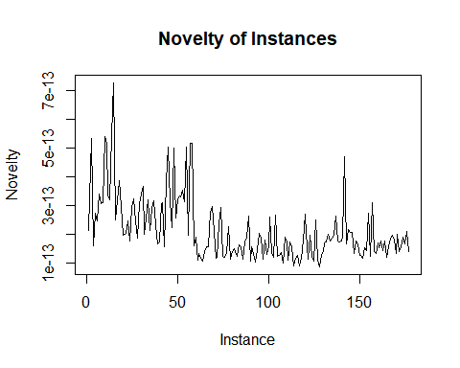

summary(n)

## Min. 1st Qu. Median Mean 3rd Qu. Max.   
## 8.649e-14 1.387e-13 1.790e-13 2.160e-13 2.675e-13 7.276e-13

IQR = 2.675e-13 - 1.387e-13  
upper = 1.387e-13 + 1.5*IQR  
lower = 1.387e-13 - 1.5* IQR  
# Identify instances that stand out (e.g., those with higher novelty)  
outliers <- which(n > upper) # Set an appropriate threshold  
outliers <- which(n < lower)  
cat("Instances that stand out:", outliers, "\n")

## Instances that stand out:

## An outlier can be thought of as data where some entries are considerably further from a group or mean. A novelty is a point of new data that is being compared to the original data in order to classify where it fits within the group. In the graph there are no novelties but if I were to add a new data point that might change.

class1 <- data[1:59, ]  
class2 <- data[60:129, ]  
class3<-data[61:178, ]  
head(class1)

## Class Alcohol Malic Acid Ash Alca of Ash Magnesium Total Phenols Flavnoids  
## 1 1 13.20 1.78 2.14 11.2 100 2.65 2.76  
## 2 1 13.16 2.36 2.67 18.6 101 2.80 3.24  
## 3 1 14.37 1.95 2.50 16.8 113 3.85 3.49  
## 4 1 13.24 2.59 2.87 21.0 118 2.80 2.69  
## 5 1 14.20 1.76 2.45 15.2 112 3.27 3.39  
## 6 1 14.39 1.87 2.45 14.6 96 2.50 2.52  
## Nonflavavnoid phonels Proanthocyanins Color intensity Hue  
## 1 0.26 1.28 4.38 1.05  
## 2 0.30 2.81 5.68 1.03  
## 3 0.24 2.18 7.80 0.86  
## 4 0.39 1.82 4.32 1.04  
## 5 0.34 1.97 6.75 1.05  
## 6 0.30 1.98 5.25 1.02  
## OD280 of diluted wine Proline  
## 1 3.40 1050  
## 2 3.17 1185  
## 3 3.45 1480  
## 4 2.93 735  
## 5 2.85 1450  
## 6 3.58 1290

head(class2)

## Class Alcohol Malic Acid Ash Alca of Ash Magnesium Total Phenols Flavnoids  
## 60 2 12.33 1.10 2.28 16.0 101 2.05 1.09  
## 61 2 12.64 1.36 2.02 16.8 100 2.02 1.41  
## 62 2 13.67 1.25 1.92 18.0 94 2.10 1.79  
## 63 2 12.37 1.13 2.16 19.0 87 3.50 3.10  
## 64 2 12.17 1.45 2.53 19.0 104 1.89 1.75  
## 65 2 12.37 1.21 2.56 18.1 98 2.42 2.65  
## Nonflavavnoid phonels Proanthocyanins Color intensity Hue  
## 60 0.63 0.41 3.27 1.25  
## 61 0.53 0.62 5.75 0.98  
## 62 0.32 0.73 3.80 1.23  
## 63 0.19 1.87 4.45 1.22  
## 64 0.45 1.03 2.95 1.45  
## 65 0.37 2.08 4.60 1.19  
## OD280 of diluted wine Proline  
## 60 1.67 680  
## 61 1.59 450  
## 62 2.46 630  
## 63 2.87 420  
## 64 2.23 355  
## 65 2.30 678

head(class3)

## Class Alcohol Malic Acid Ash Alca of Ash Magnesium Total Phenols Flavnoids  
## 61 2 12.64 1.36 2.02 16.8 100 2.02 1.41  
## 62 2 13.67 1.25 1.92 18.0 94 2.10 1.79  
## 63 2 12.37 1.13 2.16 19.0 87 3.50 3.10  
## 64 2 12.17 1.45 2.53 19.0 104 1.89 1.75  
## 65 2 12.37 1.21 2.56 18.1 98 2.42 2.65  
## 66 2 13.11 1.01 1.70 15.0 78 2.98 3.18  
## Nonflavavnoid phonels Proanthocyanins Color intensity Hue  
## 61 0.53 0.62 5.75 0.98  
## 62 0.32 0.73 3.80 1.23  
## 63 0.19 1.87 4.45 1.22  
## 64 0.45 1.03 2.95 1.45  
## 65 0.37 2.08 4.60 1.19  
## 66 0.26 2.28 5.30 1.12  
## OD280 of diluted wine Proline  
## 61 1.59 450  
## 62 2.46 630  
## 63 2.87 420  
## 64 2.23 355  
## 65 2.30 678  
## 66 3.18 502

PCA(data)$eig

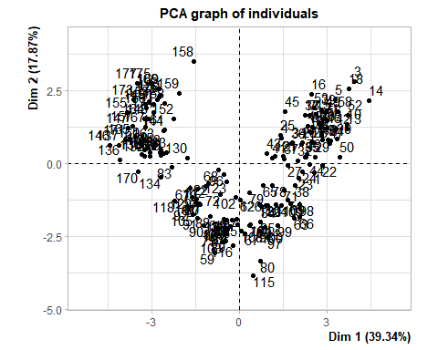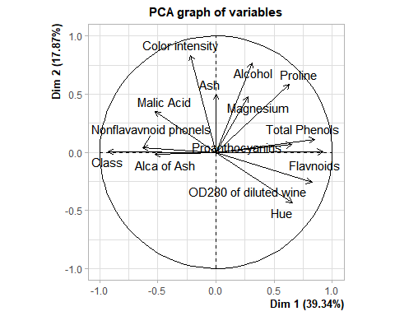

## eigenvalue percentage of variance cumulative percentage of variance  
## comp 1 5.50696397 39.3354569 39.33546  
## comp 2 2.50138044 17.8670031 57.20246  
## comp 3 1.45334314 10.3810224 67.58348  
## comp 4 0.93225916 6.6589940 74.24248  
## comp 5 0.88748703 6.3391931 80.58167  
## comp 6 0.67554155 4.8252968 85.40697  
## comp 7 0.55520509 3.9657506 89.37272  
## comp 8 0.35224772 2.5160551 91.88877  
## comp 9 0.29568648 2.1120463 94.00082  
## comp 10 0.25772754 1.8409110 95.84173  
## comp 11 0.22584600 1.6131857 97.45492  
## comp 12 0.16837702 1.2026930 98.65761  
## comp 13 0.12996398 0.9283141 99.58592  
## comp 14 0.05797089 0.4140778 100.00000

# The PCA graph of variables shows the correlations between each column of the wine dataset. Vectors that are grouped have a positive correlation with each other. However, if the vectors are on opposite sides of the y-axis that implies there is a negative correlation. The length of each vector depicts how well each variable is represented in the data. For example, alcohol content has a better representation compared to magnesium content.   
#Finally. the first two principal components explain about 57% of the variance in our data. I ran the same command between wine classes 1-3. Between each class, the less variance within a dataset correlates with the lower cumulative percentage of variance in the first two principal components.

PCA(class2)$eig

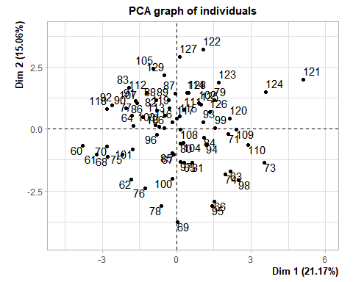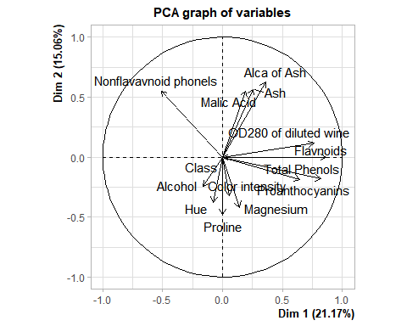

## eigenvalue percentage of variance cumulative percentage of variance  
## comp 1 2.96382210 21.170158 21.17016  
## comp 2 2.10903861 15.064561 36.23472  
## comp 3 1.65819590 11.844256 48.07898  
## comp 4 1.48981198 10.641514 58.72049  
## comp 5 1.21276719 8.662623 67.38311  
## comp 6 1.00000000 7.142857 74.52597  
## comp 7 0.91934670 6.566762 81.09273  
## comp 8 0.70247301 5.017664 86.11040  
## comp 9 0.47731586 3.409399 89.51980  
## comp 10 0.46010417 3.286458 92.80625  
## comp 11 0.37574991 2.683928 95.49018  
## comp 12 0.30821431 2.201531 97.69171  
## comp 13 0.23611148 1.686511 99.37822  
## comp 14 0.08704878 0.621777 100.00000

PCA(class3)$eig

## Warning in PCA(class3): Missing values are imputed by the mean of the variable:  
## you should use the imputePCA function of the missMDA package

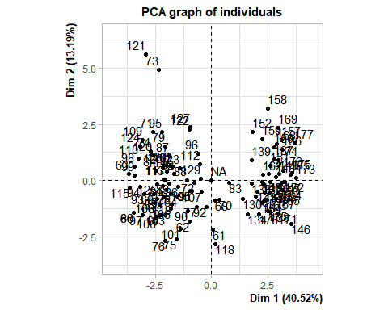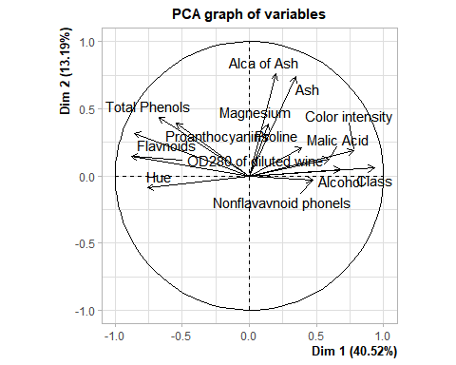

## eigenvalue percentage of variance cumulative percentage of variance  
## comp 1 5.67230416 40.5164583 40.51646  
## comp 2 1.84631881 13.1879915 53.70445  
## comp 3 1.60235767 11.4454120 65.14986  
## comp 4 1.06576000 7.6125714 72.76243  
## comp 5 0.76540730 5.4671950 78.22963  
## comp 6 0.72332168 5.1665834 83.39621  
## comp 7 0.54908380 3.9220271 87.31824  
## comp 8 0.48265329 3.4475235 90.76576  
## comp 9 0.38777023 2.7697873 93.53555  
## comp 10 0.25280182 1.8057273 95.34128  
## comp 11 0.22454347 1.6038819 96.94516  
## comp 12 0.18450615 1.3179011 98.26306  
## comp 13 0.16274019 1.1624299 99.42549  
## comp 14 0.08043144 0.5745103 100.00000

PCA(class1)$eig

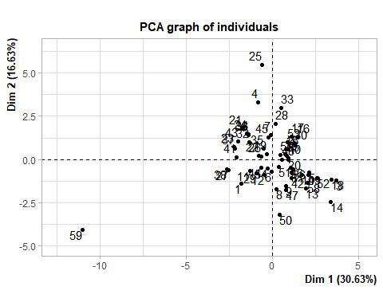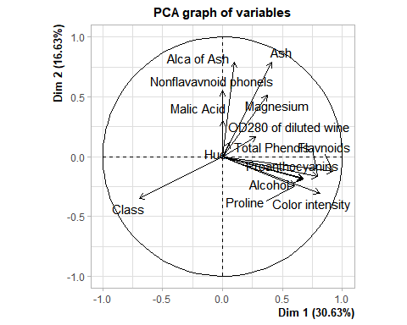

## eigenvalue percentage of variance cumulative percentage of variance  
## comp 1 4.28869764 30.6335546 30.63355  
## comp 2 2.32822393 16.6301709 47.26373  
## comp 3 2.11912302 15.1365930 62.40032  
## comp 4 1.14772632 8.1980451 70.59836  
## comp 5 0.83038391 5.9313136 76.52968  
## comp 6 0.73189767 5.2278405 81.75752  
## comp 7 0.68949928 4.9249948 86.68251  
## comp 8 0.48776938 3.4840670 90.16658  
## comp 9 0.38653781 2.7609843 92.92756  
## comp 10 0.30710035 2.1935740 95.12114  
## comp 11 0.26044412 1.8603152 96.98145  
## comp 12 0.19451855 1.3894182 98.37087  
## comp 13 0.15920291 1.1371636 99.50803  
## comp 14 0.06887512 0.4919651 100.00000