|  | **EOD**  (<7 days) | **LOD**  (7-89 days) | **VLOD**  (90-365 days) | **Older Children**  (1-17 years) | **Adults**  ( 18 years) | **Total Infants**  ( 1 year) | **Total** |
| --- | --- | --- | --- | --- | --- | --- | --- |
| **Total** | 2 | 48 | 20 | 10 | 7 | 70 | 87 |
| **Serotype** | | | | | | | |
| Ia | 2 (100%) | 7 (15%) | 6 (30%) | 5 (50%) | 1 (14%) | 15 (21.4%) | 21 (24.1%) |
| Ib | 0 (0%) | 2 (4%) | 4 (20%) | 1 (10%) | 0 (0%) | 6 (8.6%) | 7 (8%) |
| II | 0 (0%) | 2 (4%) | 0 (0%) | 0 (0%) | 1 (14%) | 2 (2.9%) | 3 (3.4%) |
| III | 0 (0%) | 36 (75%) | 9 (45%) | 1 (10%) | 2 (29%) | 45 (64.3%) | 48 (55.2%) |
| IV | 0 (0%) | 1 (2%) | 0 (0%) | 1 (10%) | 2 (29%) | 1 (1.4%) | 4 (4.6%) |
| V | 0 (0%) | 0 (0%) | 1 (5%) | 2 (20%) | 1 (14%) | 1 (1.4%) | 4 (4.6%) |
| **Clonal Complex (CC)** | | | | | | | |
| 1 | 0 (0%) | 0 (0%) | 1 (5%) | 2 (20%) | 1 (14%) | 1 (1.4%) | 4 (4.6%) |
| 12 | 0 (0%) | 3 (6%) | 4 (20%) | 1 (10%) | 0 (0%) | 7 (10%) | 8 (9.2%) |
| 17 | 0 (0%) | 31 (65%) | 9 (45%) | 1 (10%) | 0 (0%) | 40 (57.1%) | 41 (47.1%) |
| 19 | 0 (0%) | 6 (12%) | 0 (0%) | 0 (0%) | 3 (43%) | 6 (8.6%) | 9 (10.3%) |
| 23 | 2 (100%) | 7 (15%) | 6 (30%) | 5 (50%) | 1 (14%) | 15 (21.4%) | 21 (24.1%) |
| 459 | 0 (0%) | 1 (2%) | 0 (0%) | 1 (10%) | 2 (29%) | 1 (1.4%) | 4 (4.6%) |

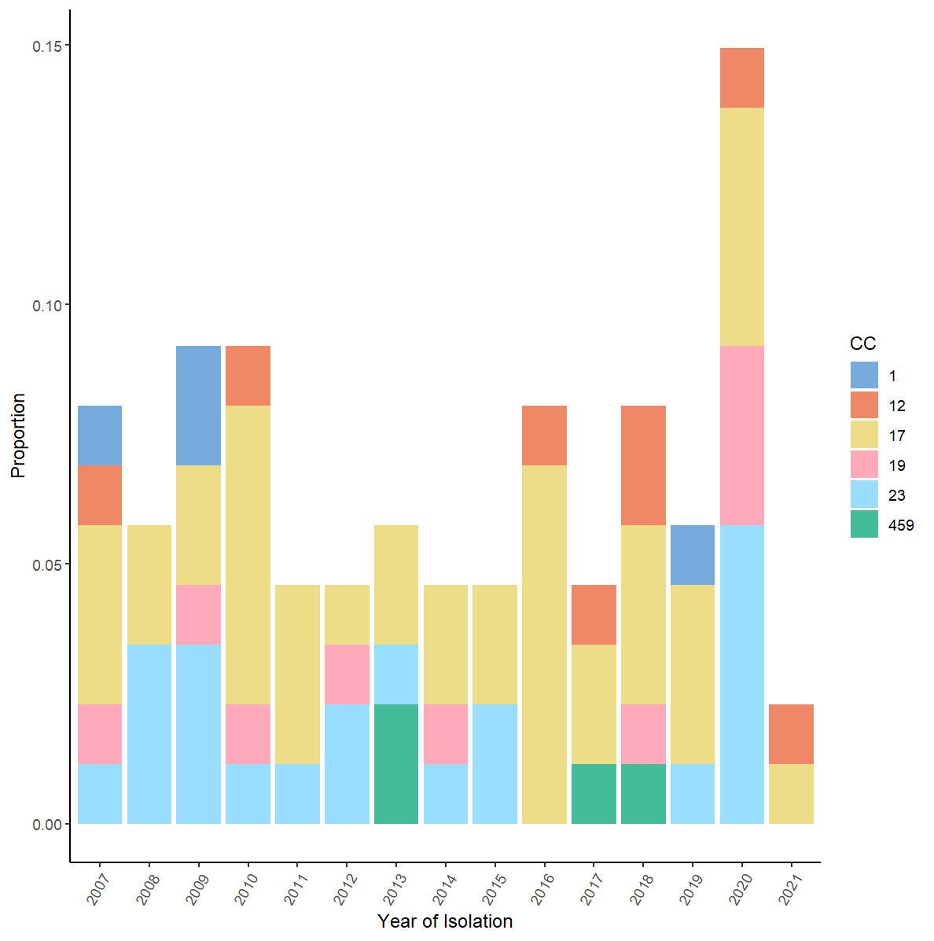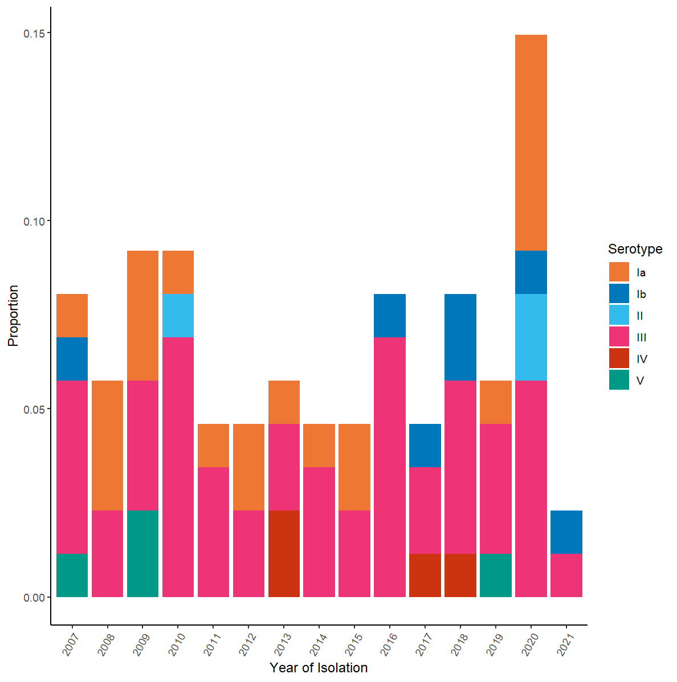

**Figure 1. Distribution of Serotypes and CCs. Panel A – Across age groups. Panel B - over time.**

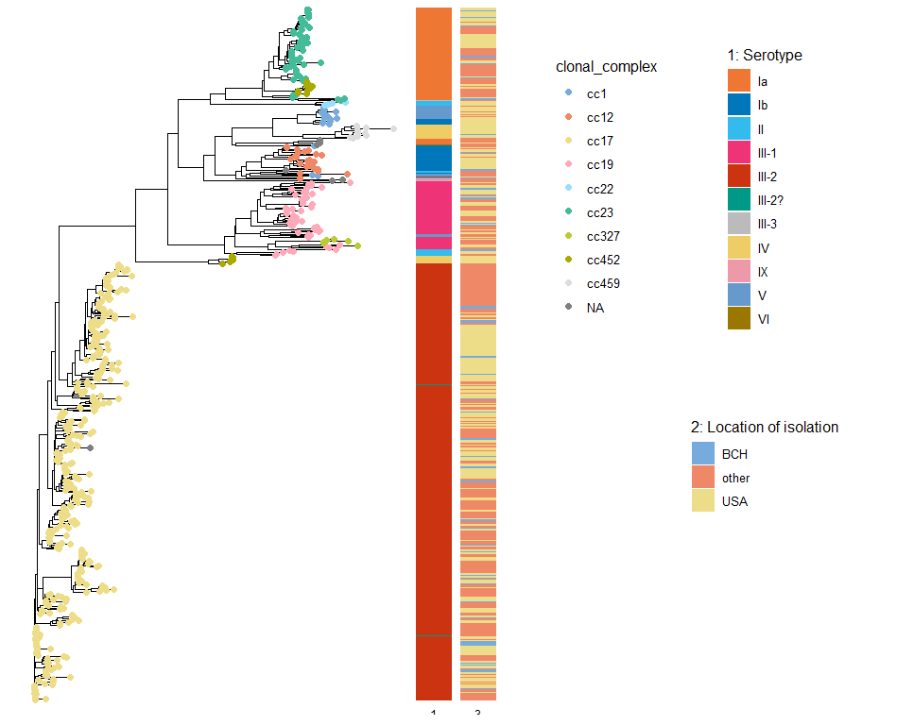

**Figure 2A.**

**Figure 2B.**

**Table 1. Association of several Laboratory metrics with the clinical outcomes Age of onset, ICU admission and Meningitis.** The presumed causal direction of the associations investigated is from “Infant” and “Meningitis” to the various laboratory metrics, and from the various laboratory metrics to “ICU admission”. For the binary exposures of “Infant” and “Meningitis”, we used Wilcoxon test to investigate their association with continuous laboratory metrics and logistic regression for the binary metrics.For the binary outcome of “ICU admission”, we used logistic regression to investigate the effect of both continuous and binary laboratory metrics.

|  | **Hb**  Mean (SD) | **WBC**  Mean (SD) | **Leukocytosis**  N (%) | **Leukopenia**  N (%) | **Platelet**  Mean (SD) | **ANC**  Mean (SD) | **Neutropenia**  N (%) |
| --- | --- | --- | --- | --- | --- | --- | --- |
| **Infant** | | | | | | | |
| **> 1 year**  (N=17) | 11.55 (2.45) | 10.48 (7.91) | 0 (0) | 14 (87.5) | 253.82 (205.15) | 8.15 (6.68) | 3 (18.8) |
| **< 1 year**  (N=70) | 10.9 (2.25) | 9.19 (6.38) | 1 (1.5) | 51 (75) | 334.81 (162.48) | 5.56 (4.85) | 17 (25) |
| **p-value** | 0.304 | 0.641 | 0.997 | 0.293 | 0.059 | 0.202 | 0.599 |
| **ICU admission among infants (N=70)** | | | | | | | |
| **Other**  **(N=39)** | 10.89 (1.76) | 11.67 (6.04) | 1 (2.6) | 25 (65.8) | 390.53 (166.06) | 7.15 (4.63) | 4 (10.5) |
| **ICU**  **(N=31)** | 10.9 (2.79) | 6.05 (5.41) | 0 (0) | 26 (86.7) | 264.23 (128.8) | 3.54 (4.42) | 13 (43.3) |
| **p-value** | 0.98 | 0.001 | 0.992 | 0.056 | 0.003 | 0.004 | 0.004 |
| **Meningitis among infants (N=70)** | | | | | | | |
| **No**  **(N=57)** | 10.76 (2.28) | 9.8 (6.43) | 1 (1.8) | 41 (74.5) | 344.71 (174.34) | 6.12 (4.87) | 10 (18.2) |
| **Yes**  **(N=13)** | 11.48 (2.12) | 6.61 (5.66) | 0 (0) | 10 (76.9) | 292.92 (90.92) | 3.18 (4.15) | 7 (53.8) |
| **p-value** | 0.204 | 0.07 | 0.997 | 0.859 | 0.285 | 0.013 | 0.012 |

**Table 2. Association of virulence factors with ICU admission.** The OR, 95% CI and p-values were obtained from logistic regression.

|  | **ICU**  **(N=31)** | **Other**  **(N=39)** | **Crude OR (95% CI)** | **P-value** |
| --- | --- | --- | --- | --- |
| **ALP protein family** | | | | |
| ALP1 | 10 | 5 | 3.24 (0.97 - 10.79) | 0.056 |
| ALP23 | 0 | 2 | 0.00 (0.00 - Inf) | 0.992 |
| ALPHA | 4 | 3 | 1.78 (0.37 - 8.61) | 0.475 |
| RIB | 17 | 29 | 0.42 (0.15 - 1.15) | 0.091 |
| **Pilus Islands** | | | | |
| PI1 | 18 | 31 | 0.36 (0.12 - 1.03) | 0.056 |
| PI2A1 | 14 | 7 | 3.76 (1.28 - 11.10) | 0.016 |
| PI2A2 | 3 | 3 | 1.29 (0.24 - 6.86) | 0.769 |
| PI2B | 13 | 25 | 0.40 (0.15 - 1.06) | 0.067 |
| **SRR Variants** | | | | |
| SRR1 | 17 | 12 | 2.73 (1.02 - 7.29) | 0.045 |
| SRR2 | 14 | 26 | 0.41 (0.16 - 1.09) | 0.073 |
| **Sip Protein Variants** | | | | |
| Sip.1a | 3 | 5 | 0.73 (0.16 - 3.32) | 0.682 |
| Sip.3a | 28 | 34 | 1.37 (0.30 - 6.25) | 0.682 |
| **Other Virulence factors** | | | | | |
| HVGA | 14 | 26 | 0.41 (0.16 - 1.09) | 0.073 |
| lmb | 30 | 39 | 0.00 (0.00 - Inf) | 0.991 |
| scpB | 30 | 38 | 0.79 (0.05 - 13.15) | 0.869 |
| hylB | 28 | 37 | 0.50 (0.08 - 3.23) | 0.470 |
| fbsB | 24 | 31 | 0.88 (0.28 - 2.78) | 0.834 |

**Figure 3.**

**Supplementary Table 2. The distribution of resistance genes across CCs and overall.**

|  |  | **CC1 (N=4)** | **CC12 (N=7)** | **CC17 (N=40)** | **CC19 (N=8)** | **CC23 (N=20)** | **CC459 (N=4)** | **Total (N=87)** | |
| --- | --- | --- | --- | --- | --- | --- | --- | --- | --- |
| **Aminoglycosides Resistance** | | | | | | | | | |
|  | ANT6IA | 0 (0%) | 0 (0%) | 4 (10%) | 0 (0%) | 0 (0%) | 0 (0%) | 4 (5%) | |
|  | APH3III | 0 (0%) | 0 (0%) | 4 (10%) | 0 (0%) | 0 (0%) | 0 (0%) | 4 (5%) | |
| **Total** | | **0 (0%)** | **0 (0%)** | **4 (10%)** | **0 (0%)** | **0 (0%)** | **0 (0%)** | **4 (5%)** | |
| **Tetracyclines Resistance** | | | | | | | | | |
|  | TETM | 4 (100%) | 6 (75%) | 39 (95%) | 7 (78%) | 18 (86%) | 2 (50%) | 76 (87%) | |
|  | TETO | 0 (0%) | 0 (0%) | 6 (15%) | 2 (22%) | 0 (0%) | 0 (0%) | 8 (9%) | |
| **Total** | | **4 (100%)** | **6 (75%)** | 6 (75%) | **8 (89%)** | **18 (86%)** | **2 (50%)** | **78 (90%)** | |  | |
| **MLSB Resistance** | |  |  |  |  |  |  |  | |  | |
|  | ERMA | 2 (50%) | 1 (14%) | 1 (2%) | 2 (25%) | 0 (0%) | 4 (100%) | 11 (13%) | |
|  | ERMB | 0 (0%) | 2 (29%) | 9 (22%) | 2 (25%) | 0 (0%) | 0 (0%) | 13 (15%) | |
|  | ERMT | 0 (0%) | 1 (14%) | 6 (15%) | 0 (0%) | 0 (0%) | 0 (0%) | 7 (8%) | |
| **Total** | | **2 (50%)** | **4 (57%)** | **16 (39%)** | **5 (56%)** | **0 (0%)** | **4 (100%)** | **31 (36%)** | |
| **M type Resistance** | |  |  |  |  |  |  |  | |  |
|  | MEFA | 2 (50%) | 1 (14%) | 1 (2%) | 3 (33%) | 0 (0%) | 4 (100%) | 11 (13%) | |
|  | MSRD | 0 (0%) | 2 (29%) | 9 (22%) | 2 (22%) | 0 (0%) | 0 (0%) | 13 (15%) | |
| **Total** |  | **0 (0%)** | **0 (0%)** | **0 (0%)** | **1 (11%)** | **5 (24%)** | **0 (0%)** | **6 (7%)** | |
| **Fluoroquinolone Resistance** | | | | | | | | | |
|  | GYRA | 0 (0%) | 2 (29%) | 0 (0%) | 0 (0%) | 0 (0%) | 0 (0%) | 2 (2%) | |
|  | PARC | 0 (0%) | 2 (29%) | 1 (2%) | 0 (0%) | 0 (0%) | 0 (0%) | 3 (3%) | |
| **Total** | | **0 (0%)** | **4 (0%)** | **1 (2%)** | **0 (0%)** | **0 (0%)** | **0 (0%)** | **5 (1%)** | |  | |

**Supplementary Table 3. Distribution of Clonal complexes (CCs) and Sequence Types (STs) by Age group.**

|  |  | **EOD**  (<7 days) | **LOD**  (7-89 days) | **VLOD**  (90-365 days) | **Older Children**  (1-17 years) | **Adults**  ( 18 years) | **Total (N=87)** |
| --- | --- | --- | --- | --- | --- | --- | --- |
| **CC1** | | | | | | | |
|  | ST1 | 0 (0%) | 0 (0%) | 1 (5%) | 2 (20%) | 1 (14%) | 4 |
| **CC12** | | | | | | | |
|  | ST10 | 0 (0%) | 1 (2%) | 1 (5%) | 1 (10%) | 0 (0%) | 3 |
|  | ST8 | 0 (0%) | 1 (2%) | 3 (15%) | 0 (0%) | 0 (0%) | 4 |
|  | NF | 0 (0%) | 1 (2%) | 0 (0%) | 0 (0%) | 0 (0%) | 1 |
| **Total** | | **0 (0%)** | **3 (6%)** | **4 (20%)** | **1 (10%)** | **0 (0%)** | **8** |
| **CC17** | | | | | | | |
|  | ST109 | 0 (0%) | 1 (2%) | 1 (5%) | 0 (0%) | 0 (0%) | 2 |
|  | ST1470 | 0 (0%) | 2 (4%) | 1 (5%) | 0 (0%) | 0 (0%) | 3 |
|  | ST17 | 0 (0%) | 26 (54%) | 5 (25%) | 1 (10%) | 0 (0%) | 32 |
|  | ST17* | 0 (0%) | 1 (2%) | 0 (0%) | 0 (0%) | 0 (0%) | 1 |
|  | ST31 | 0 (0%) | 0 (0%) | 2 (10%) | 0 (0%) | 0 (0%) | 2 |
|  | ST860 | 0 (0%) | 1 (2%) | 0 (0%) | 0 (0%) | 0 (0%) | 1 |
| **Total** | | **0 (0%)** | **31 (65%)** | **9 (45%)** | **1 (10%)** | **0 (0%)** | **41** |
| **CC19** | | | | | | | |
|  | ST19 | 0 (0%) | 3 (6%) | 0 (0%) | 0 (0%) | 2 (29%) | 5 |
|  | ST28 | 0 (0%) | 1 (2%) | 0 (0%) | 0 (0%) | 1 (14%) | 2 |
|  | ST335 | 0 (0%) | 1 (2%) | 0 (0%) | 0 (0%) | 0 (0%) | 1 |
|  | ST1563* | 0 (0%) | 1 (2%) | 0 (0%) | 0 (0%) | 0 (0%) | 1 |
| **Total** | | **0 (0%)** | **6 (12%)** | **0 (0%)** | **0 (0%)** | **3 (43%)** | **9** |
| **CC23** | | | | | | | | | |
|  | ST1747 | 0 (0%) | 0 (0%) | 1 (5%) | 0 (0%) | 0 (0%) | 1 |
|  | ST23 | 2 (100%) | 6 (12%) | 5 (25%) | 4 (40%) | 0 (0%) | 17 |
|  | ST88 | 0 (0%) | 0 (0%) | 0 (0%) | 1 (10%) | 1 (14%) | 2 |
|  | ST88* | 0 (0%) | 1 (2%) | 0 (0%) | 0 (0%) | 0 (0%) | 1 |
| **Total** | | **2 (100%)** | **7 (15%)** | **6 (30%)** | **5 (50%)** | **1 (14%)** | **21** |
| **CC459** | | | | | | | | |
|  | ST459 | 0 (0%) | 1 (2%) | 0 (0%) | 1 (10%) | 2 (29%) | 4 |
| **Others** | | | | | | | | |
|  | NF | 0 (0%) | 1 (2%) | 0 (0%) | 0 (0%) | 0 (0%) | 1 |

**Supplementary Table 4. Housekeeping gene composition unique genes in each ST .**

| **ST** | **N (%)** | | **adhP** | **pheS** | **atr** | **glnA** | **sdhA** | **glcK** | **tkt** | **mismatches** |
| --- | --- | --- | --- | --- | --- | --- | --- | --- | --- | --- |
| **Known STs** | | | | | | | | | | |
| **17** | 32 | (37%) | 2 | 1 | 1 | 2 | 1 | 1 | 1 | 0 |
| **23** | 17 | (20%) | 5 | 4 | 6 | 3 | 2 | 1 | 3 | 0 |
| **19** | 5 | (6%) | 1 | 1 | 3 | 2 | 2 | 2 | 2 | 0 |
| **1** | 4 | (5%) | 1 | 1 | 2 | 1 | 1 | 2 | 2 | 0 |
| **459** | 4 | (5%) | 1 | 1 | 3 | 1 | 41 | 12 | 2 | 0 |
| **8** | 4 | (5%) | 4 | 1 | 4 | 1 | 3 | 3 | 2 | 0 |
| **10** | 3 | (3%) | 9 | 1 | 4 | 1 | 3 | 3 | 2 | 0 |
| **1470** | 3 | (3%) | 2 | 1 | 188 | 2 | 1 | 1 | 1 | 0 |
| **109** | 2 | (2%) | 2 | 1 | 1 | 10 | 1 | 1 | 1 | 0 |
| **28** | 2 | (2%) | 1 | 1 | 3 | 5 | 2 | 2 | 2 | 0 |
| **31** | 2 | (2%) | 2 | 1 | 1 | 6 | 1 | 1 | 1 | 0 |
| **88** | 2 | (2%) | 5 | 10 | 6 | 3 | 2 | 1 | 3 | 0 |
| **1747** | 1 | (1%) | 5 | 141 | 6 | 3 | 2 | 1 | 3 | 0 |
| **335** | 1 | (1%) | 1 | 1 | 43 | 2 | 2 | 2 | 2 | 0 |
| **860** | 1 | (1%) | 157 | 1 | 1 | 2 | 1 | 1 | 1 | 0 |
| **Known STs with mismatches** | | | | | | | | | | |
| **1563\*** | 1 | (1%) | 1 | 1 | 202* | 2 | 2 | 2 | 2 | atr_202/1snp |
| **17\*** | 1 | (1%) | 2 | 1 | 1* | 2 | 1 | 1 | 1 | atr_1/1snp |
| **88\*** | 1 | (1%) | 5 | 10 | 6 | 3 | 2 | 1* | 3 | glcK_1/1snp |
| **New ST profile** | | | | | | | | | | |
| **NF** | 1 | (1%) | 4 | 1 | 4 | 4 | 3 | 3 | 2 | 0 |

**Supplementary Table 5. Distribution of capsular polysaccharide and protein vaccine targets across age groups and overall.** Rows marked with a * indicated vaccines currently undergoing clinical trials.

|  | **EOD**  (<7 days) | **LOD**  (7-89 days) | **VLOD**  (90-365 days) | **Older Children**  (1-17 years) | **Adults**  ( 18 years) | **Total Infants (N=70)** | **Total (N=87)** |
| --- | --- | --- | --- | --- | --- | --- | --- |
| **Capsular polysaccharide vaccine** | | | | | | | |
| trivalent | 2 (100%) | 45 (94%) | 19 (95%) | 7 (70%) | 3 (43%) | 66 (94%) | 76 (87%) |
| hexavalent* | 2 (100%) | 48 (100%) | 20 (100%) | 10 (100%) | 7 (100%) | 70 (100%) | 87 (100%) |
| **Capsular polysaccharide vaccine** | | | | | | | |
| Alpha-like proteins | | | | | | | |
| RIB | 0 (0%) | 37 (77%) | 9 (45%) | 1 (10%) | 3 (43%) | 46 (66%) | 50 (57%) |
| ALPHA C | 0 (0%) | 3 (6%) | 4 (20%) | 1 (10%) | 0 (0%) | 7 (10%) | 8 (9%) |
| ALP1 | 2 (100%) | 7 (15%) | 6 (30%) | 5 (50%) | 2 (29%) | 15 (21%) | 22 (25%) |
| ALP23 | 0 (0%) | 1 (2%) | 1 (5%) | 3 (30%) | 2 (29%) | 2 (3%) | 7 (8%) |
| GBS-NN2* (Alpha C+Rib+ Alp1+Alp23) | 2 (100%) | 48 (100%) | 20 (100%) | 10 (100%) | 7 (100%) | 70 (100%) | 87 (100%) |
| Pilus proteins | | | | | | | |
| PI1 | 0 (0%) | 36 (75%) | 13 (65%) | 6 (60%) | 6 (86%) | 49 (70%) | 61 (70%) |
| PI2a1 | 2 (100%) | 8 (17%) | 11 (55%) | 7 (70%) | 1 (14%) | 21 (30%) | 29 (33%) |
| PI2a2 | 0 (0%) | 6 (12%) | 0 (0%) | 0 (0%) | 3 (43%) | 6 (9%) | 9 (10%) |
| PI2b | 0 (0%) | 30 (62%) | 8 (40%) | 1 (10%) | 0 (0%) | 38 (54%) | 39 (45%) |
| PI1+PI2a1+ PI2a2+PI2b | 2 (100%) | 48 (100%) | 20 (100%) | 10 (100%) | 7 (100%) | 70 (100%) | 87 (100%) |
| SRR proteins | | | | | | | |
| SRR1 | 2 (100%) | 16 (33%) | 11 (55%) | 9 (90%) | 6 (86%) | 29 (41%) | 44 (51%) |
| SRR2 | 0 (0%) | 31 (65%) | 9 (45%) | 1 (10%) | 0 (0%) | 40 (57%) | 41 (47%) |
| SRR1+SRR2 | 2 (100%) | 47 (98%) | 20 (100%) | 10 (100%) | 6 (86%) | 69 (99%) | 85 (98%) |
| Sip protein | | | | | | | |
| Sip.1a | 0 (0%) | 7 (15%) | 1 (5%) | 3 (30%) | 6 (86%) | 8 (11%) | 17 (20%) |
| Sip.3a | 2 (100%) | 41 (85%) | 19 (95%) | 7 (70%) | 1 (14%) | 62 (89%) | 70 (80%) |
| Sip | 2 (100%) | 48 (100%) | 20 (100%) | 10 (100%) | 7 (100%) | 70 (100%) | 87 (100%) |
| **Capsular polysaccharide vaccine** | | | | | | | |
| C5a | 2 (100%) | 47 (98%) | 19 (95%) | 8 (80%) | 6 (86%) | 68 (97%) | 82 (94%) |
| Lmb | 2 (100%) | 47 (98%) | 20 (100%) | 10 (100%) | 7 (100%) | 69 (99%) | 86 (99%) |
| FbsB | 2 (100%) | 38 (79%) | 15 (75%) | 6 (60%) | 1 (14%) | 55 (79%) | 62 (71%) |