How to install/run MPI with Visual Studio on Windows 10: The easy way (2020)

Prerequisites:

* Have Visual Studio installed and make sure you have desktop dev with C++ installed too.

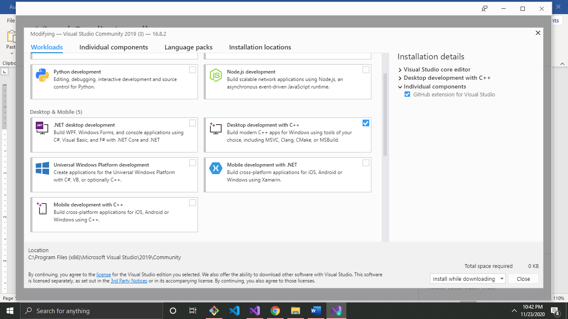

Installation:

1. Navigate to <https://www.microsoft.com/en-us/download/details.aspx?id=100593>
2. Download both of the MS-MPI installations.

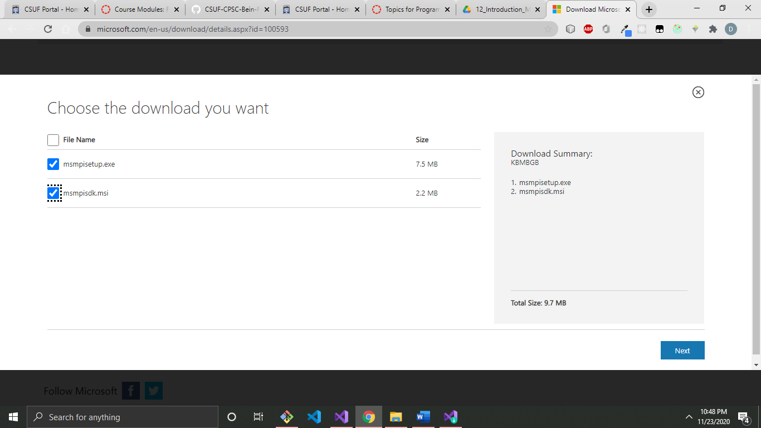

1. Run both of the installations
2. Now, with the MPI SDK installed you can use it on every Win32 Console App project.

Note: On every new project you have to configure your project to recognize the MPI SDK or else your compiler will complain that MPI does not exists.

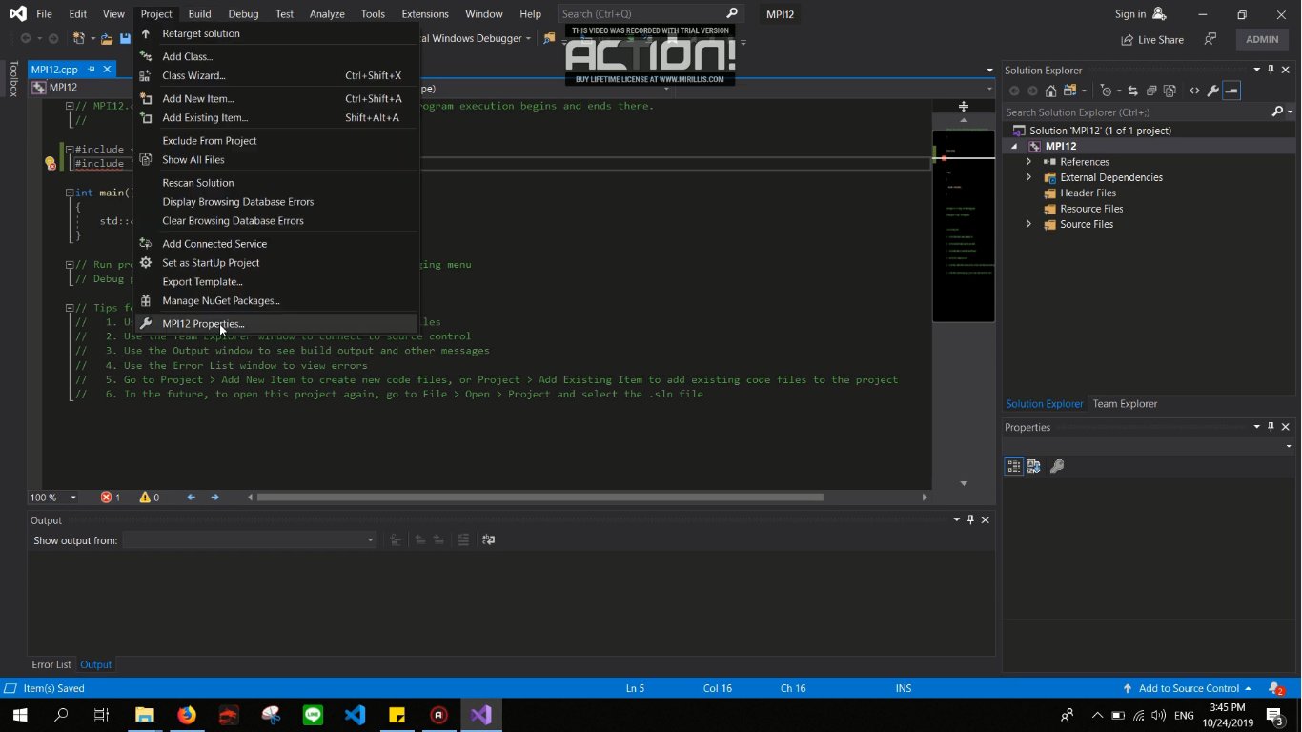5. On a new Win32 console app project, navigate to the projects/properties.

6. On the C/C++ section, click and open the *Additional Include Directories*, click on the edit, and find your SDK folder. Here is mine.

C:\Program Files (x86)\Microsoft SDKs\MPI\Include

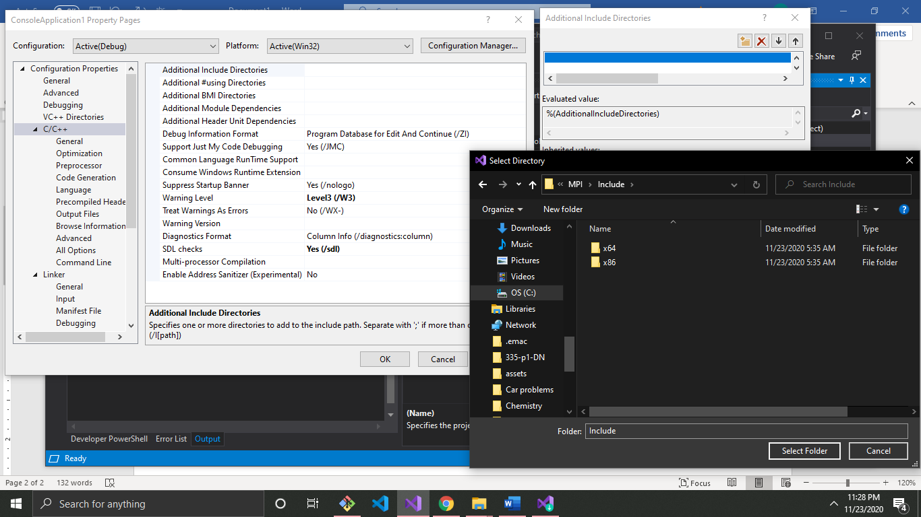

7. On the Linker section, click and open the *Additional Library Directories*, edit the field and find your lib directory.   
Note: This is for a 64 bit OS if you have a 32 bit find the 32 bit folder.

C:\Program Files (x86)\Microsoft SDKs\MPI\Lib\x86  
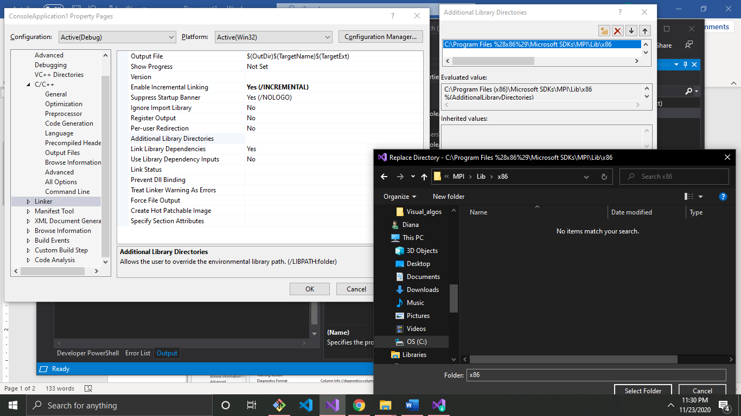

8. Within the Linker section find the Input subsection. Edit the *Additional Dependencies* by overwriting the field with this command.

msmpi.lib

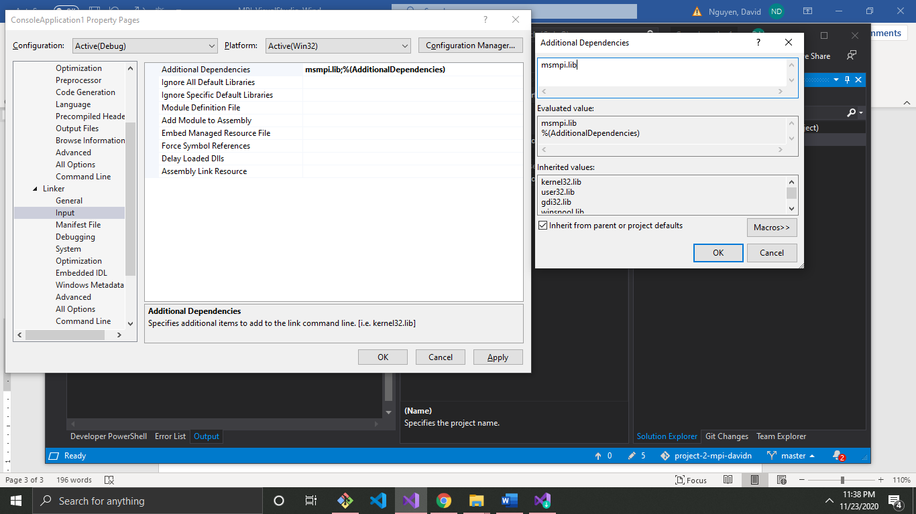

9. Click Apply.

10. Now you should be able to use the <mpi.h> SDK without any problems.

Execution:

1. Your program will compile without running any shell commands with *Start Without Debugging* Shortcut: Ctrl+f5.

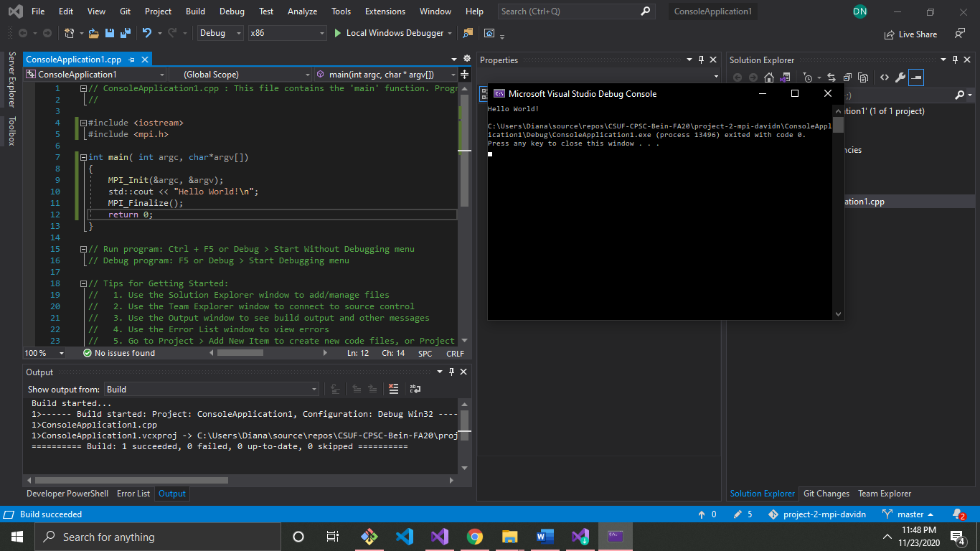

Note: However, the program will execute and only run one process.

If you want to run multiple processes, you will run a BASH command on the executable.

mpiexec -n 5 *filename*.exe

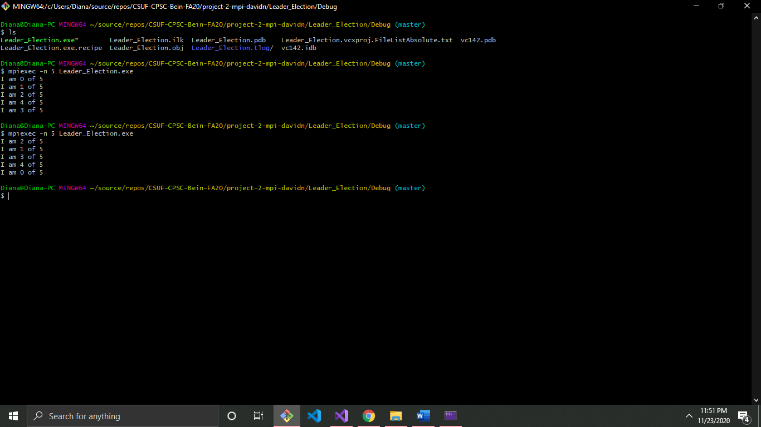

Note: you can choose any # of processes you want and whatever file name you want.