David Nguyen

Professor Siska

CPSC 481-04

18 October 2020

A\* Star Project Report

Total tile count: 114

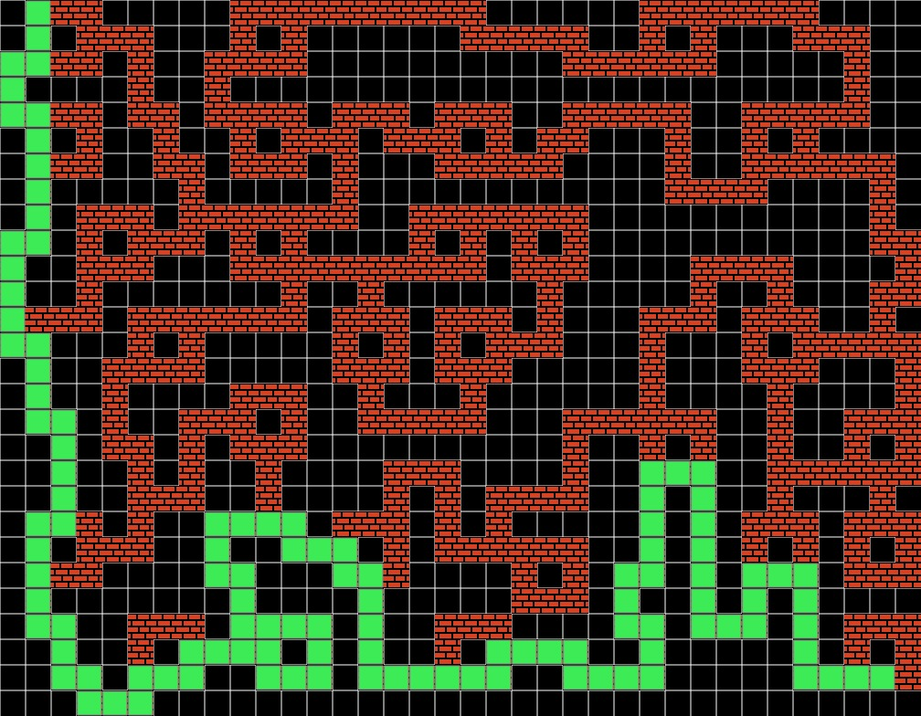

I used the professor’s skeleton code. I tried to use the book’s pseudocode on A\* as reference. The javathcript library has bare emacs lisp api like car, cdr, and list. Javathcript did not have the sort function I needed to sort the open list. So far the explorer has reached the destination.

Untrained Weights

self.bias = [list([0.3, 0.5, 0.6, 0.7]),

list([0.2, 0.1, 0.3, 0.2, 0.4, 0.5, 0.6, 0.2])]

elf.weights = [list([[.3, .45, 0.12, 0.12, 0.89, 0.25, 0.16, 0.56, 0.12, 0.43],

[0.12, 0.23, 0.15, 0.62, 0.821,

0.512, 0.123, 0.321, 0.9, .5],

[0.64, 0.52, 0.24, 0.93, 0.84,

0.64, 0.52, 0.34, 0.6, 0.7],

[0.52, 0.12, 0.84, 0.51, 0.321, 0.123, 0.721, 0.632, 0.5, 0.3],

[0.21, 0.42, 0.64, 0.21, 0.1, 0.823, 0.921, 0.532, 0.15, 0.233],

[0.32, 0.22, 0.24, 0.31, 0.6, 0.523, 0.321, 0.432, 0.55, 0.13]]),

list([[0.123, 0.21, 0.21, 0.123],

[0.412, 0.31, 0.731, 0.365],

[0.231, 0.521, 0.441, 0.3852],

[0.521, 0.41, 0.581, 0.112],

[0.412, 0.891, 0.712, 0.321],

[0.221, 0.551, 0.213, 0.555],

[0.812, 0.231, 0.367, 0.888],

[0.512, 0.231, 0.751, 0.121]])]

Trained Weights