CMST 283 – TWIST Use Case 1.1

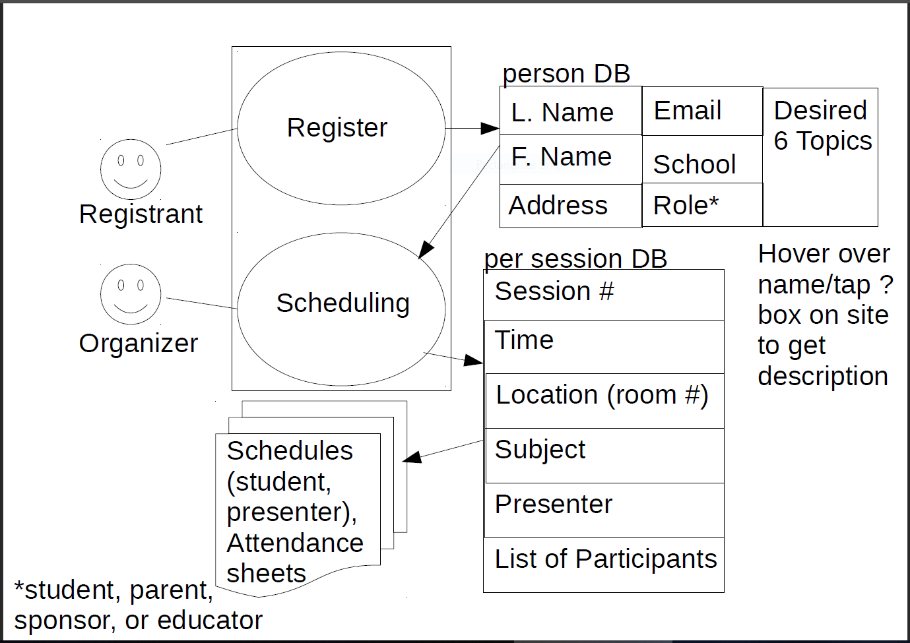

|  |  |
| --- | --- |
| Title | Event Scheduling |
| Primary Actor | Event Organizer |
| Secondary Actor | Registrants |
| Business Goal | To create usable schedules for any and all participants in the TWIST event. |
| Precondition | - Obtain room #’s and their capacities  - Establish Dates and Times of the event |
| Minimal Guarantee | Speakers and prospective students become aware of the annual TWIST event. |
| Success Guarantee | A large number of schedules will be prepared and provided for the attendees of the TWIST event. |
| Trigger Events | The higher ups decide that it’s time to prepare for the next annual TWIST event. |
| Primary Pathway | People register for the TWIST event, their information is stored in a database, and this data is used to create schedules. |
| Alternative Pathway(s) | -- |
| Exception Pathways(s) | A minimal quantity of people, or no people at all, register to take part in the TWIST event. |
| Main Sequence | 1. Get speakers for these topics.  2. Organize potential topics for the event.  3. Organize presenter information.  a. Topic  4. Recruit participants from the school districts across the state.  5. Organize the Participants (information to registration database, emails to the  Participant and the Organizer—the latter weeds out any ‘fake’ registrations).  a. Choose up to six topics to present at the event.  6. Registration closes.  7. Program creates a suggested schedule based on the given information.  a. Participants are assigned to Speakers, who are assigned to Room (#)s.  b. First come, first served  8. The organizer may edit the provided schedule. |
| Variant Sequence | -- |