TY CSE CETL | Parallel Programming Lab | AY 2026-27
Experiment No. 1
Introduction to Parallel Programming, System Configuration and OpenMP Setup
Student Name | Om Ramesh Mane
PRN | 245100006
Batch | T7
Prepared On | 31 July 2026
Source Material | Experiment_no_1.pdf and 24 supporting screenshots
This report completes all tasks from Experiment 1, documents the OpenMP setup on Linux, presents the two required OpenMP programs, summarizes the host system configuration, and estimates the processor's theoretical peak floating-point performance.

Assignment Scope
Task | What Was Completed
Study the fundamentals of parallel computing and shared memory programming. | Explained the basic ideas of concurrency, shared address space, synchronization, and thread-level parallelism.
Install and configure OpenMP on Linux. | Verified package update, `build-essential`, GCC 15.2.0, and OpenMP compiler support with `-fopenmp`.
Write and run a Hello World OpenMP program. | Created `hello.cpp`, observed interleaved output, and improved it using a `critical` section.
Identify processor characteristics. | Collected architecture, cores, threads, frequency, cache hierarchy, RAM, and instruction-set information from Linux commands.
Calculate theoretical peak FLOPS. | Estimated FP32 and FP64 peak throughput using AVX2 + FMA and the processor's published frequencies.
Compare FLOPS with OpenMP thread count and summarize suitability. | Compared the 14 OpenMP threads with the 12 physical cores / 14 logical threads and concluded the system is suitable for shared-memory parallel work.

Fundamentals of Parallel Computing
Parallel computing is the execution of multiple operations at the same time so that a problem finishes faster than it would on one processing unit. The main goal is to reduce total execution time, improve throughput, and make better use of multi-core processors.
Shared memory programming means that all threads run inside the same process and can directly access the same variables in memory. This makes communication fast, but it also creates the possibility of data races when two or more threads update the same data without coordination.
OpenMP is a shared-memory API for C, C++, and Fortran. It uses compiler directives such as `#pragma omp parallel`, library routines such as `omp_get_thread_num()`, and environment variables to control thread creation and scheduling.
The three most important ideas demonstrated in this experiment are: creating a team of threads, identifying each thread by its ID, and synchronizing output using a `critical` section so that multiple threads do not write to the terminal at the same time.

OpenMP Setup on Linux
The OpenMP environment was prepared in Kali Linux by updating the package list, verifying that `build-essential` was installed, and confirming that GCC 15.2.0 was available. The compiler also accepted the `-fopenmp` flag, which confirms OpenMP support.
Command | Observation
sudo apt update | Updated the package index.
sudo apt install build-essential | Verified the build tools were already installed.
gcc --version | Confirmed GCC 15.2.0 was available.
gcc -fopenmp --version | Confirmed OpenMP-enabled compilation support.

Programming Task 1: Hello World OpenMP Program
The first program created a parallel region and printed the thread ID from every thread. During the first run, the terminal output became interleaved because several threads wrote to the console simultaneously. To make the output cleaner, a `critical` section was added around the `cout` statement.
Final `hello.cpp` source code
#include <iostream>
#include <omp.h>
using namespace std;
int main()
{
#pragma omp parallel
{
#pragma omp critical
{
cout << "Hello from thread " << omp_get_thread_num() << endl;
}
}
return 0;
}
Compilation command: `g++ -fopenmp hello.cpp -o hello`
Execution command: `./hello`
Observation: the system created 14 threads by default, and the output demonstrated that OpenMP successfully distributed execution across the available logical processing units.

Programming Task 2: Thread Count and Core Comparison
The second program counted the number of OpenMP threads, printed the ID of each thread, and compared the thread count with the number of logical CPU cores reported by the runtime.
`threads.cpp` source code
#include <iostream>
#include <omp.h>
using namespace std;
int main()
{
int total_threads = 0;
int logical_cores = omp_get_num_procs();
#pragma omp parallel
{
#pragma omp single
{
total_threads = omp_get_num_threads();
cout << "Total OpenMP Threads : " << total_threads << endl;
cout << "Logical CPU Cores : " << logical_cores << endl;
if (total_threads == logical_cores)
cout << "OpenMP threads match the logical CPU cores." << endl;
else
cout << "OpenMP threads do not match the logical CPU cores." << endl;
cout << endl;
}
#pragma omp critical
{
cout << "Thread ID : " << omp_get_thread_num() << endl;
}
}
return 0;
}
Compilation command: `g++ -fopenmp threads.cpp -o threads`
Execution command: `./threads`
Observed result: the program reported 14 OpenMP threads and 14 logical CPU cores, followed by thread IDs from 0 to 13. This confirms that the default OpenMP team size matched the logical processor count on the host system.

System Configuration Summary
Parameter | Observed Value | Source
Processor model | Intel(R) Core(TM) Ultra 5 125U | lscpu / cpuinfo
Architecture | x86_64, 32-bit and 64-bit modes supported | lscpu
Physical cores | 12 | lscpu + Intel published spec
Logical processors | 14 | lscpu / nproc / OpenMP
Threads per core | 2 on performance cores (hybrid design overall) | lscpu
Clock frequency | 400 MHz minimum observed, 4.3 GHz maximum turbo | lscpu + Intel spec
Cache hierarchy | L1d 352 KiB, L1i 640 KiB, L2 10 MiB, L3 12 MiB | lscpu
Main memory | 15 GiB RAM, 4 GiB swap | free -h
Virtualization | VT-x supported | lscpu
Important SIMD flags | SSE, SSE2, SSE4.1, SSE4.2, AVX, AVX2, FMA | cpu flags

Comparison with Published Processor Specifications
The Linux command outputs closely match Intel's published specifications for the Intel Core Ultra 5 125U. Intel lists 12 total cores, 14 total threads, a 4.3 GHz maximum turbo frequency, 12 MB Intel Smart Cache, and AVX2 support. These values are consistent with the values observed in the screenshots.
Item | Observed | Intel Published Spec | Match
Model | Intel Core Ultra 5 125U | Intel Core Ultra 5 125U | Yes
Total cores | 12 | 12 | Yes
Total threads | 14 | 14 | Yes
Max turbo frequency | 4.3 GHz | 4.3 GHz | Yes
Cache | 12 MiB L3 reported as Smart Cache | 12 MB Intel Smart Cache | Yes
Instruction extensions | SSE4.1, SSE4.2, AVX, AVX2, FMA | SSE4.1, SSE4.2, AVX2 | Compatible
Published reference used for comparison: Intel ARK, `Intel Core Ultra 5 Processor 125U Specifications`.

Theoretical Peak FLOPS Calculation
The CPU flags show AVX2 and FMA support. For a 256-bit AVX2 vector, one instruction can process 8 single-precision (FP32) numbers or 4 double-precision (FP64) numbers at a time. Because one fused multiply-add operation counts as two floating-point operations, the simplified throughput used for this report is:
FP32 FLOPs per cycle per core = 8 × 2 = 16
FP64 FLOPs per cycle per core = 4 × 2 = 8
Assignment-style upper bound assuming all 12 physical cores run at the same 4.3 GHz turbo frequency:
Peak FP32 FLOPS = 12 × 4.3 × 16 = 825.6 GFLOPS
Peak FP64 FLOPS = 12 × 4.3 × 8 = 412.8 GFLOPS
Hybrid-aware estimate using Intel's published turbo frequencies for each core type:
P-cores: 2 × 4.3 × 16 = 137.6 GFLOPS (FP32)
E-cores: 8 × 3.6 × 16 = 460.8 GFLOPS (FP32)
LP E-cores: 2 × 2.1 × 16 = 67.2 GFLOPS (FP32)
Total hybrid-aware FP32 peak = 665.6 GFLOPS
Total hybrid-aware FP64 peak = 332.8 GFLOPS
The upper-bound value is useful for a simple classroom estimate, while the hybrid-aware result is more realistic because the Intel Core Ultra 5 125U does not run every core type at 4.3 GHz.

Comparison of Theoretical FLOPS and OpenMP Threads
The system created 14 OpenMP threads, which matches the 14 logical processors reported by Linux. However, the processor has 12 physical cores, so the thread count should not be interpreted as 14 full-performance compute cores. Two of the logical threads come from Hyper-Threading on the performance cores.
A useful interpretation is that OpenMP can expose concurrency across all 14 logical execution contexts, while the real floating-point throughput remains limited by the 12 physical cores, their SIMD width, and their operating frequency.
Metric | Value
OpenMP threads created | 14
Logical CPU cores | 14
Physical CPU cores | 12
Upper-bound FP32 peak | 825.6 GFLOPS
Hybrid-aware FP32 peak | 665.6 GFLOPS
Upper-bound FP64 peak | 412.8 GFLOPS
Hybrid-aware FP64 peak | 332.8 GFLOPS

Suitability of the Host System for Parallel Computing
The host system is well suited for introductory and moderate shared-memory parallel programming. It provides 12 physical cores, 14 logical threads, AVX2/FMA support, a 4.3 GHz turbo frequency, and roughly 15 GiB RAM. These characteristics are strong enough for OpenMP-based labs, parallel loops, reductions, matrix-style workloads, and small to medium scientific programs.
Its main advantage is that OpenMP setup is simple and the machine can immediately expose thread-level parallelism without requiring a distributed cluster. The main limitation is that logical threads do not double the number of floating-point execution units, so the performance gain from 14 threads will depend on workload type, memory access pattern, synchronization overhead, and whether the code is compute-bound or memory-bound.
Conclusion: the system satisfies all the experiment requirements and is a suitable platform for learning and testing shared-memory parallel programming with OpenMP.

References
1. Experiment No. 1 assignment sheet: `Experiment_no_1.pdf`.
2. Intel ARK. `Intel Core Ultra 5 Processor 125U Specifications`. https://www.intel.com/content/www/us/en/products/sku/237330/intel-core-ultra-5-processor-125u-12m-cache-up-to-4-30-ghz/specifications.html
3. Linux commands used in this experiment: `lscpu`, `cat /proc/cpuinfo`, `nproc`, `free -h`, and GCC/OpenMP commands shown in the screenshots.

Appendix A: Screenshot Evidence
The following images are the original experiment screenshots used to verify installation steps, command outputs, source code, and program execution.
Figure A1. Package list updated in Kali Linux using `sudo apt update`.
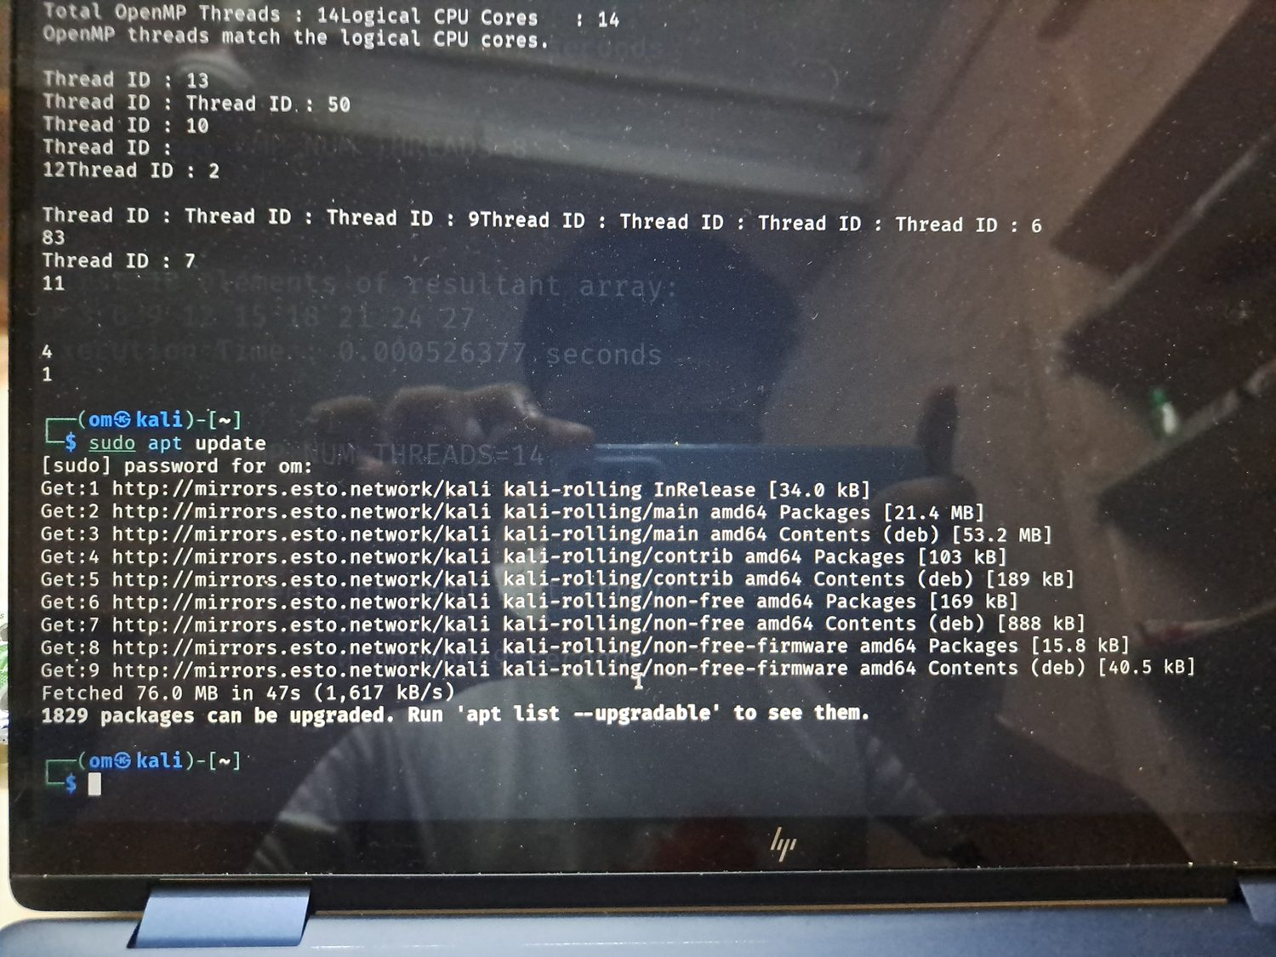
Figure A2. Verification that `build-essential` was already installed.
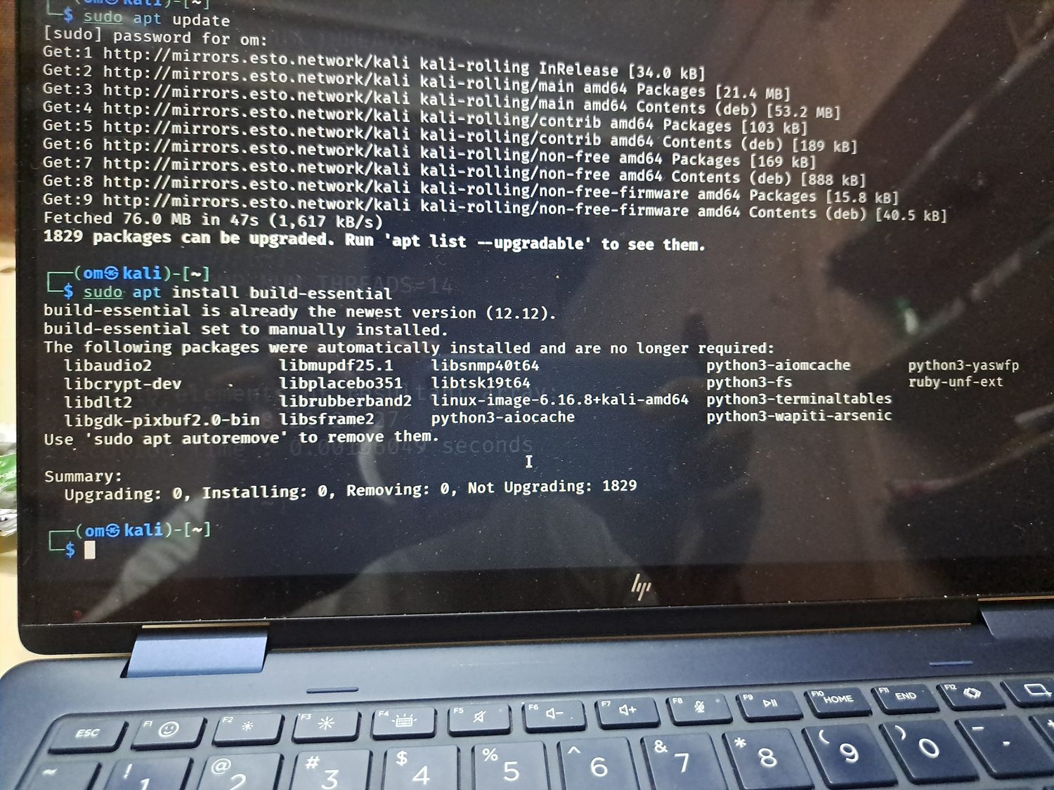

Figure A3. GCC version output confirming the compiler installation.
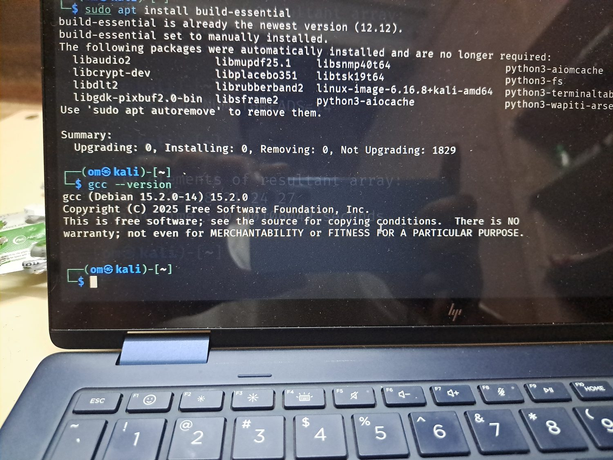
Figure A4. Verification that GCC accepts the `-fopenmp` option.
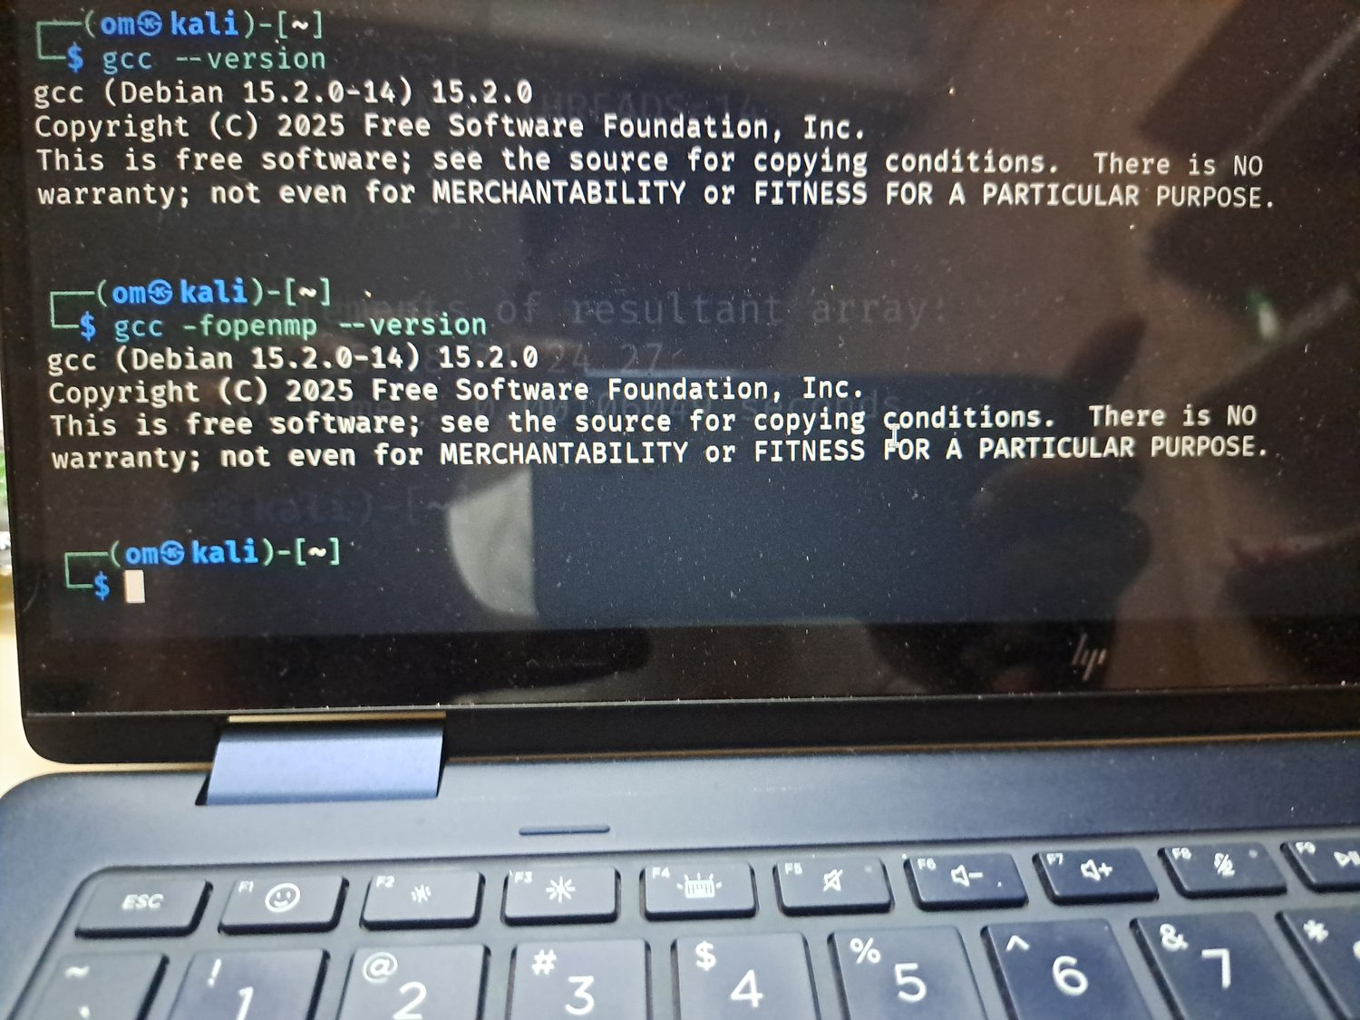

Figure A5. First part of `lscpu` showing architecture, core count, and CPU model.
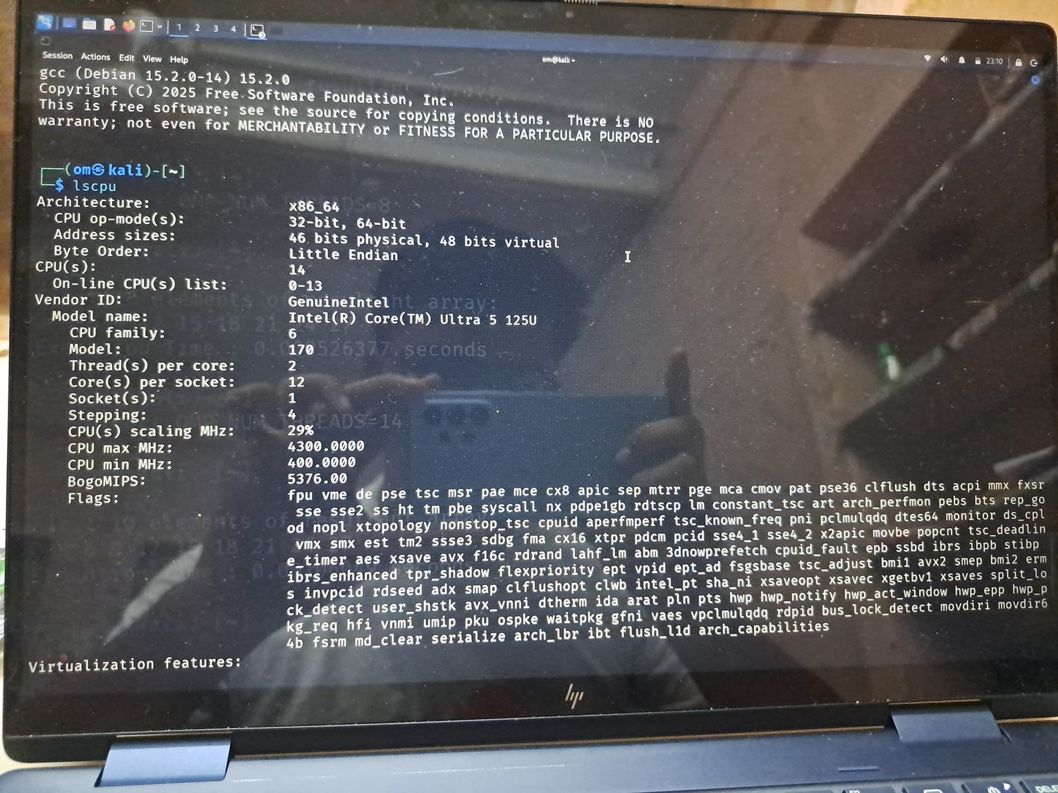
Figure A6. Second part of `lscpu` showing virtualization, cache, and NUMA details.
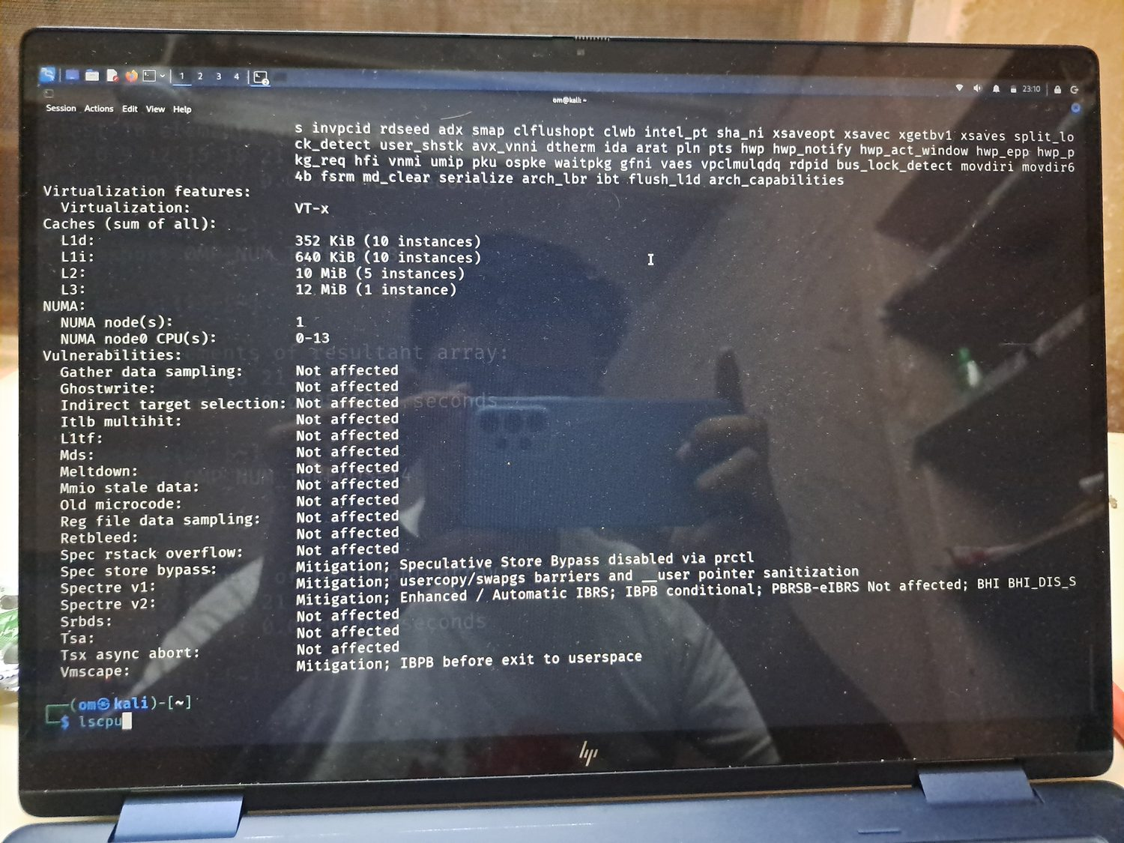

Figure A7. Beginning of `/proc/cpuinfo` output for processor 0.
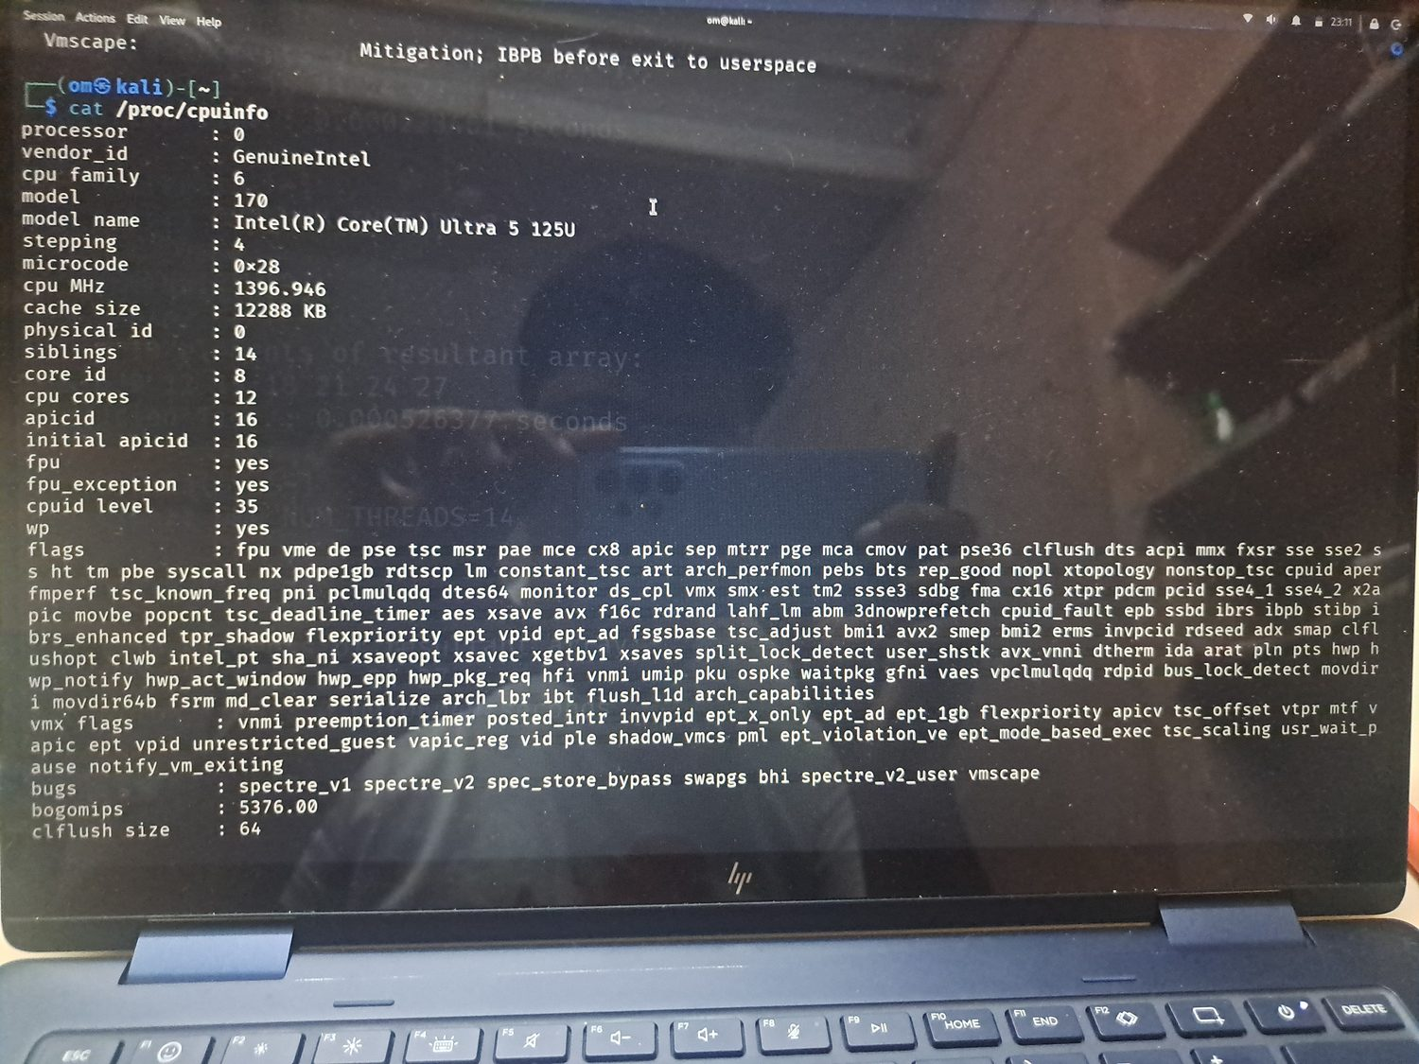
Figure A8. Continuation of `/proc/cpuinfo` output.
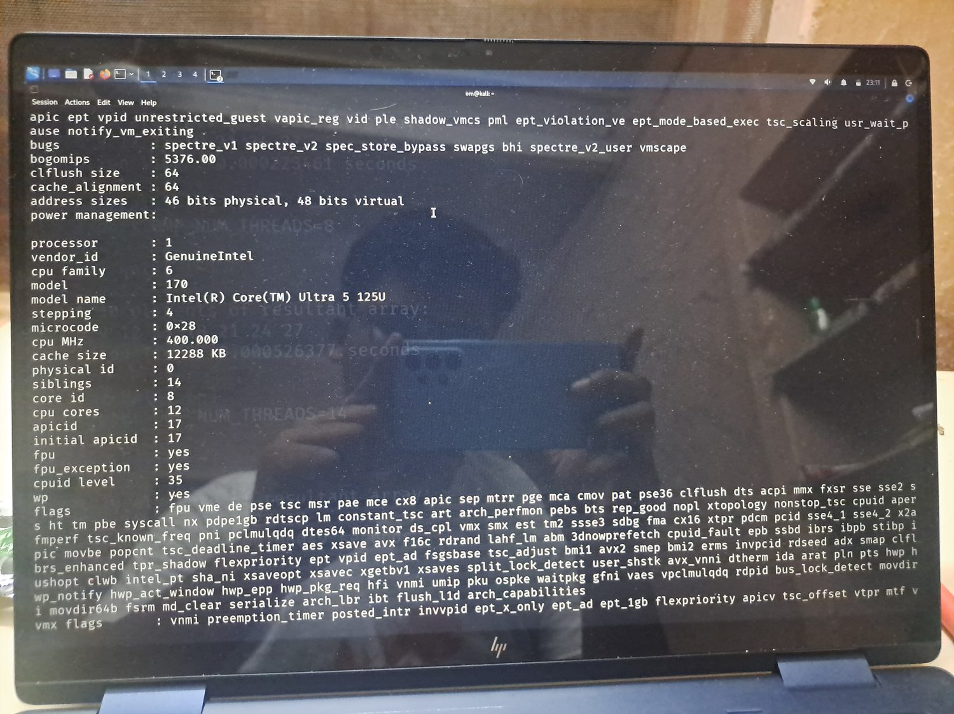

Figure A9. Additional `/proc/cpuinfo` entries for logical processors.
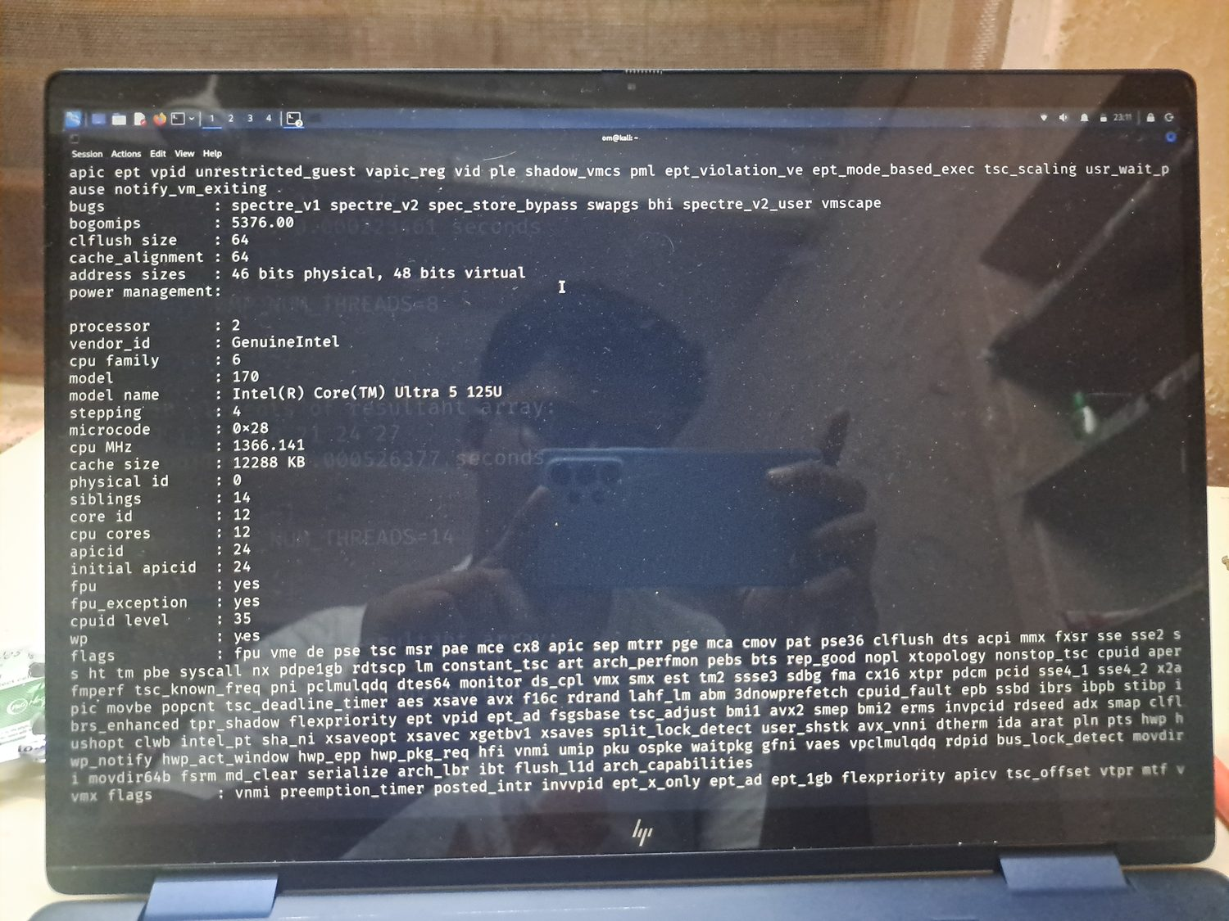
Figure A10. Additional `/proc/cpuinfo` entries confirming processor details.
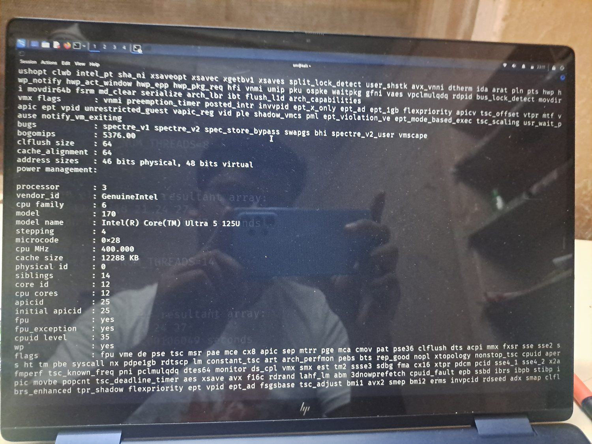

Figure A11. Additional `/proc/cpuinfo` entries showing repeated model information.
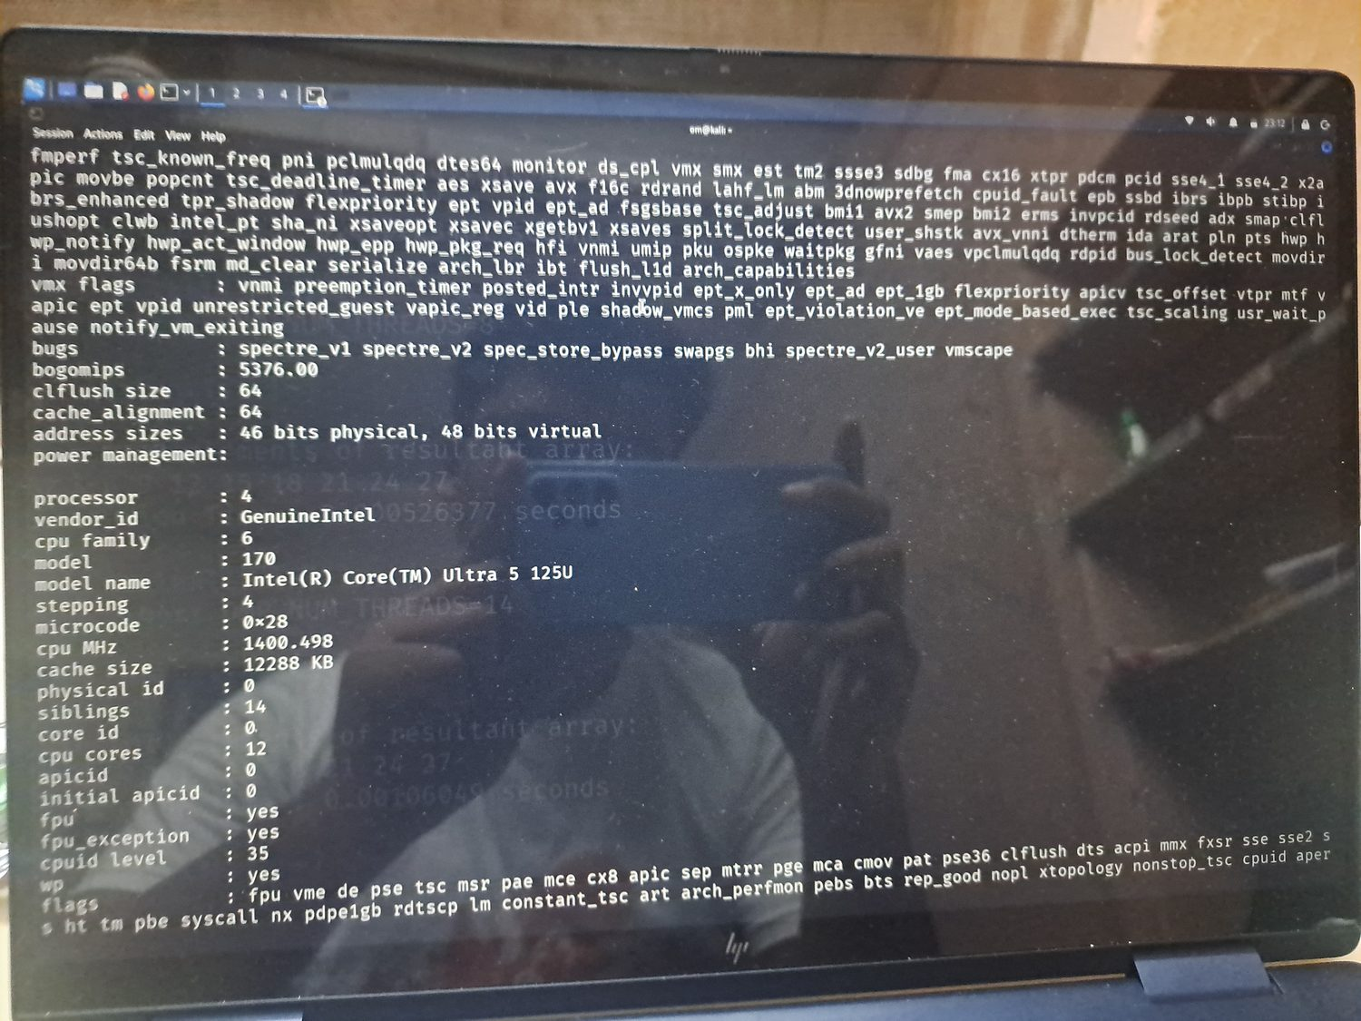
Figure A12. Additional `/proc/cpuinfo` entries showing consistent CPU flags and cache data.
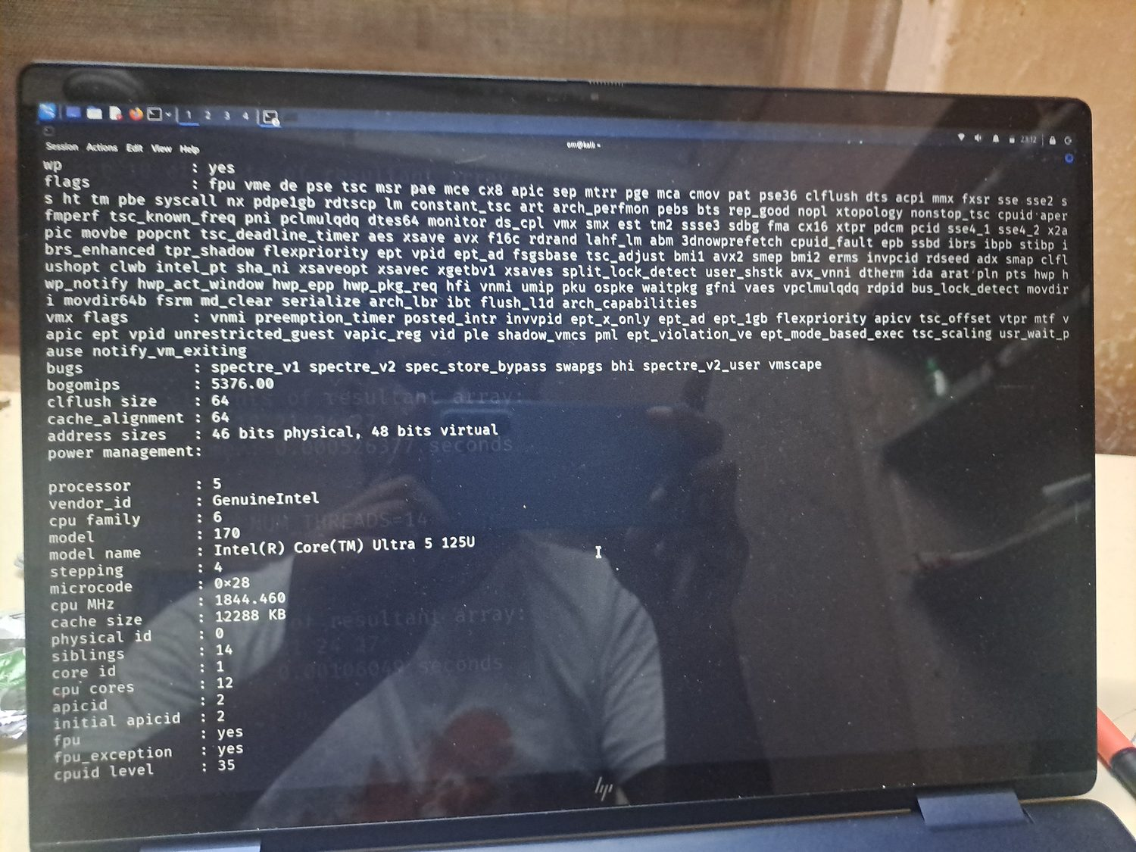

Figure A13. `nproc` output showing 14 available logical processing units.
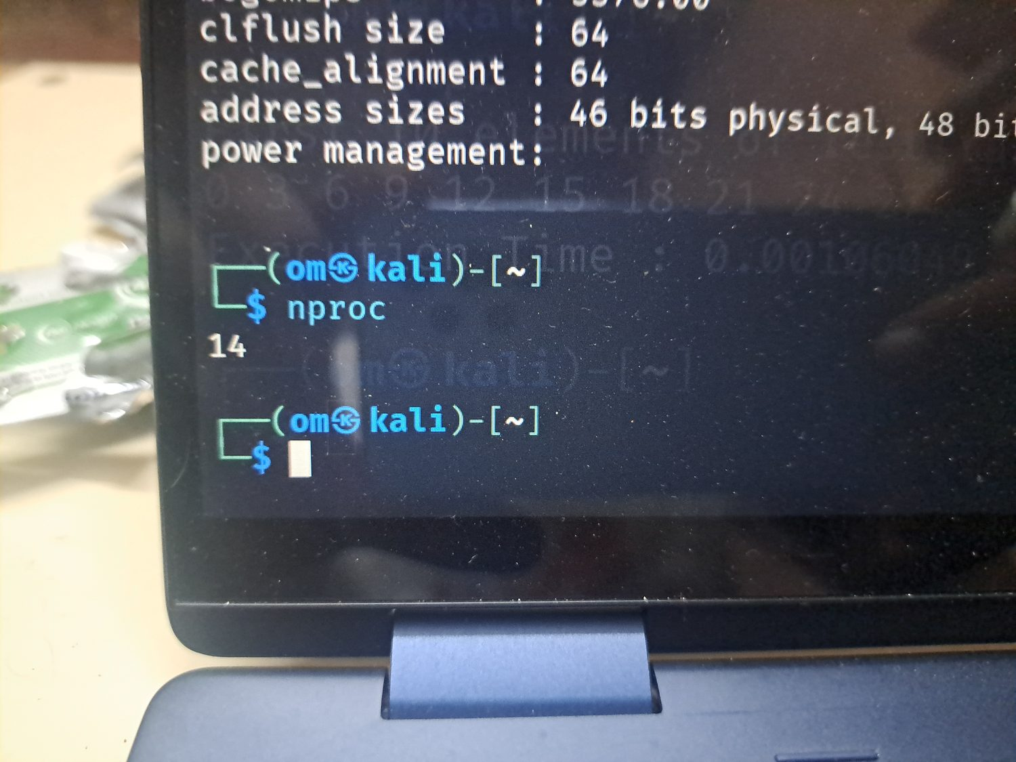
Figure A14. `free -h` output showing approximately 15 GiB RAM and 4 GiB swap.
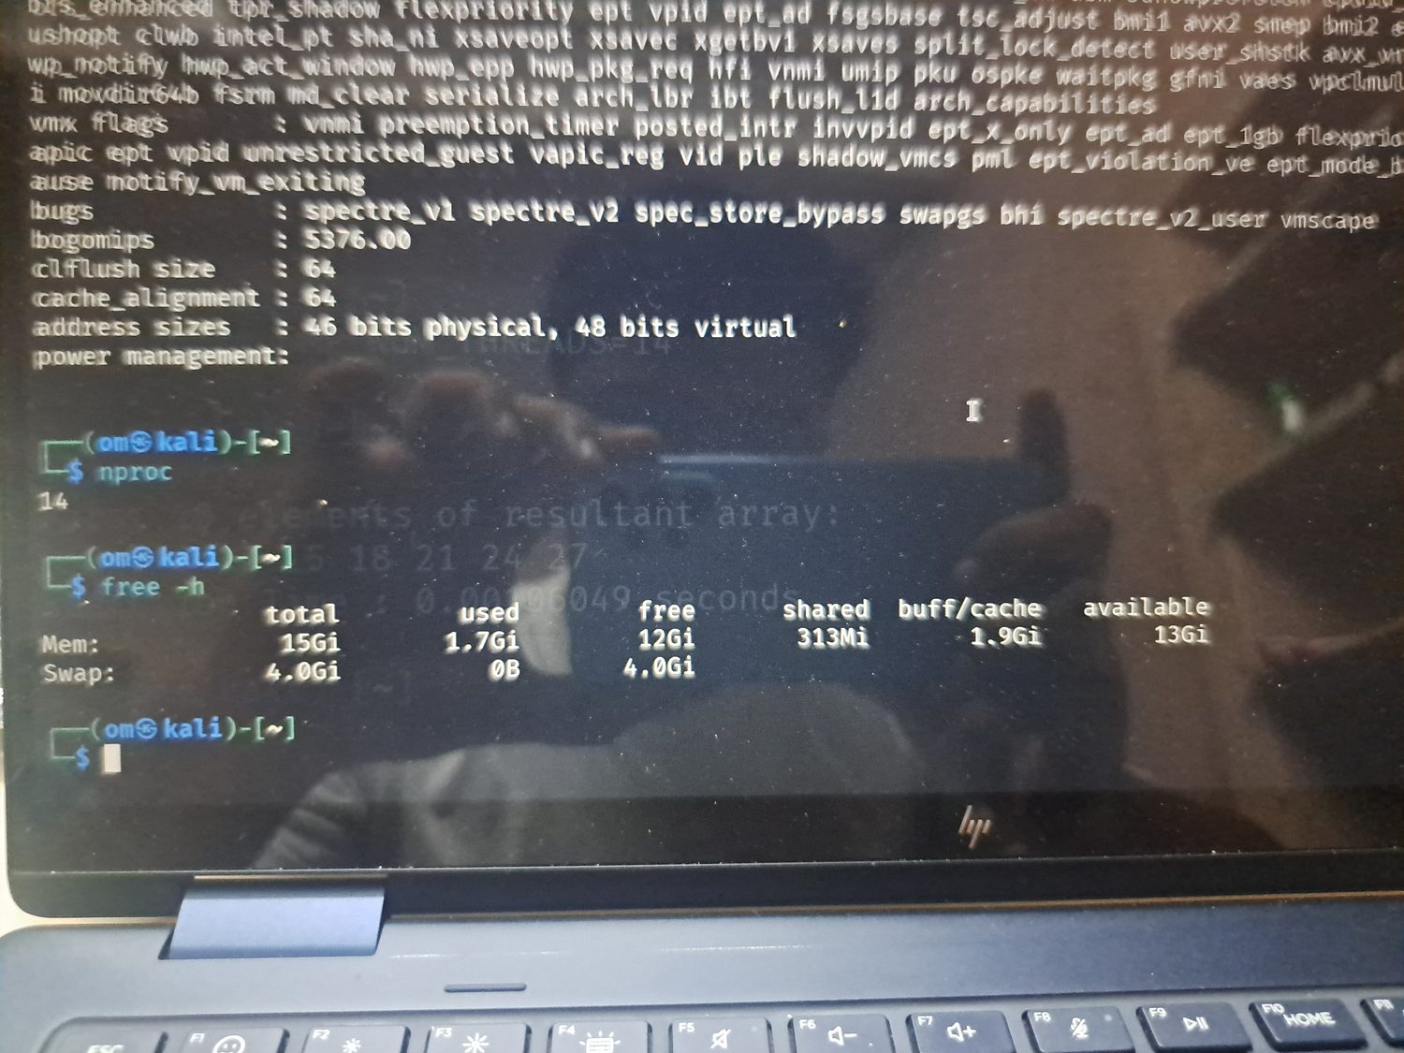

Figure A15. `lscpu | grep "Model name"` confirming Intel Core Ultra 5 125U.
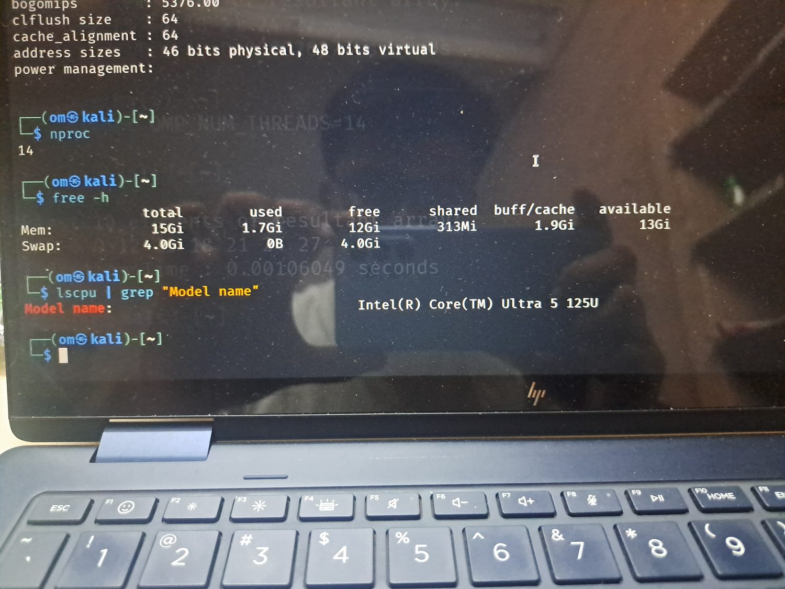
Figure A16. Initial `hello.cpp` OpenMP source code.
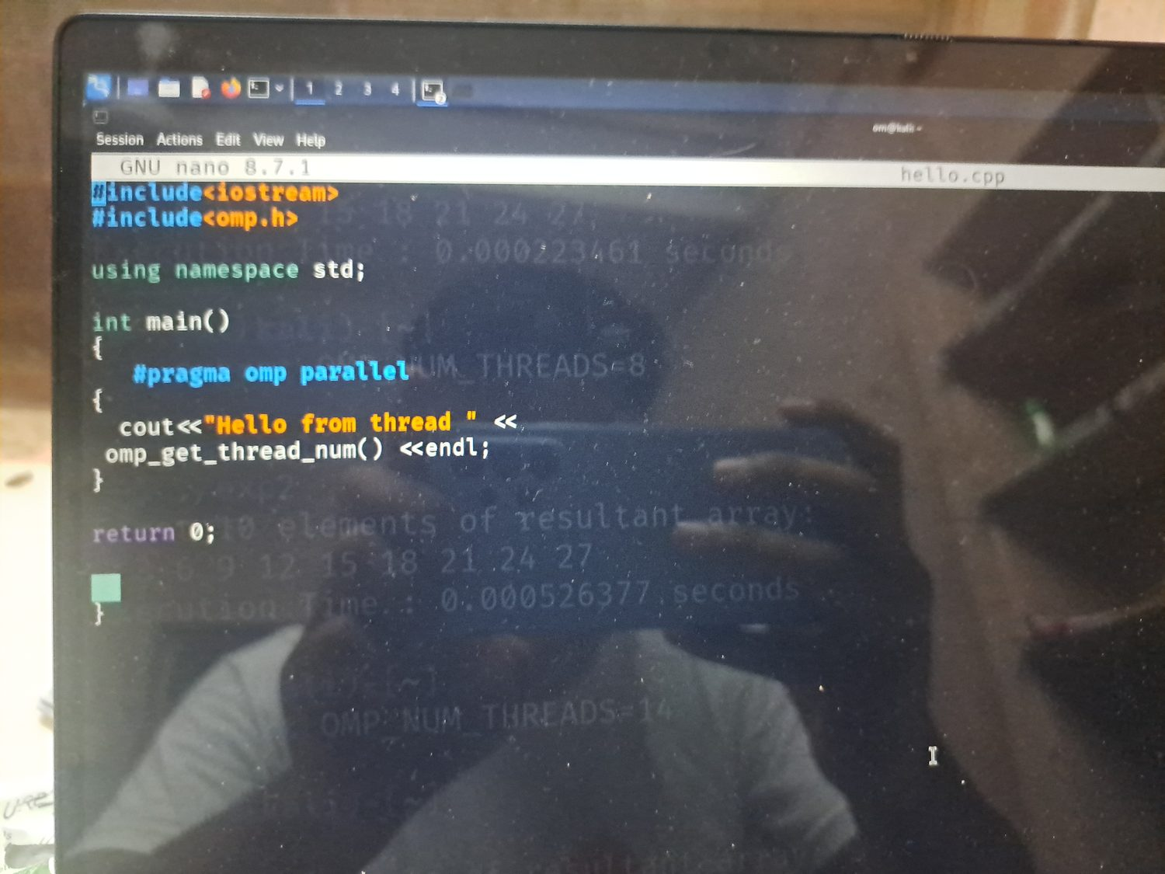

Figure A17. First execution of the Hello World program with interleaved output.
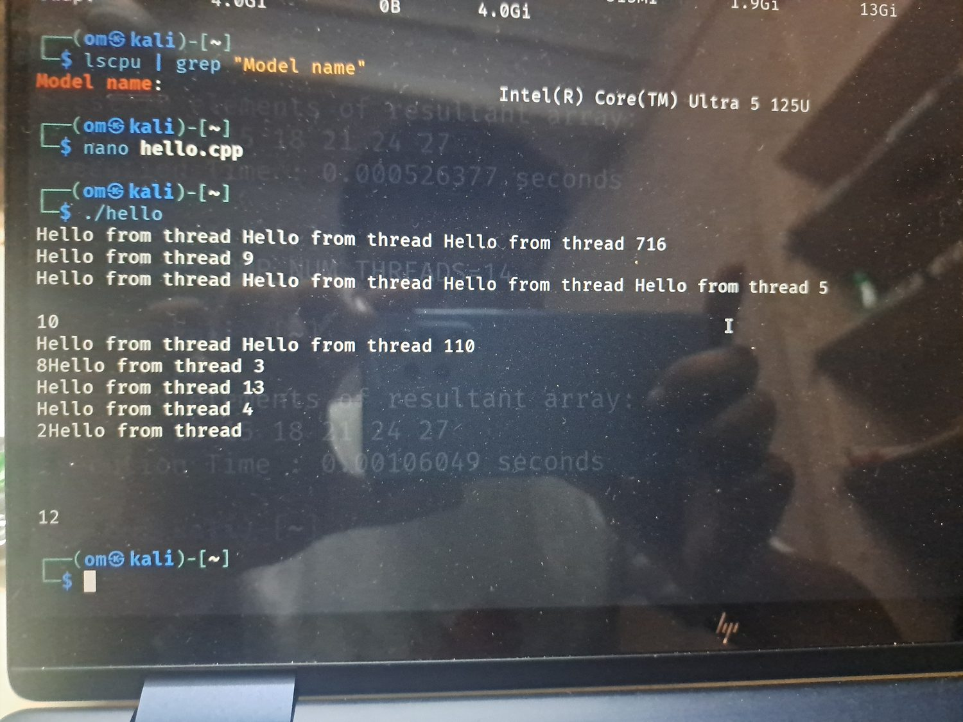
Figure A18. Revised `hello.cpp` with a `critical` section for cleaner output.
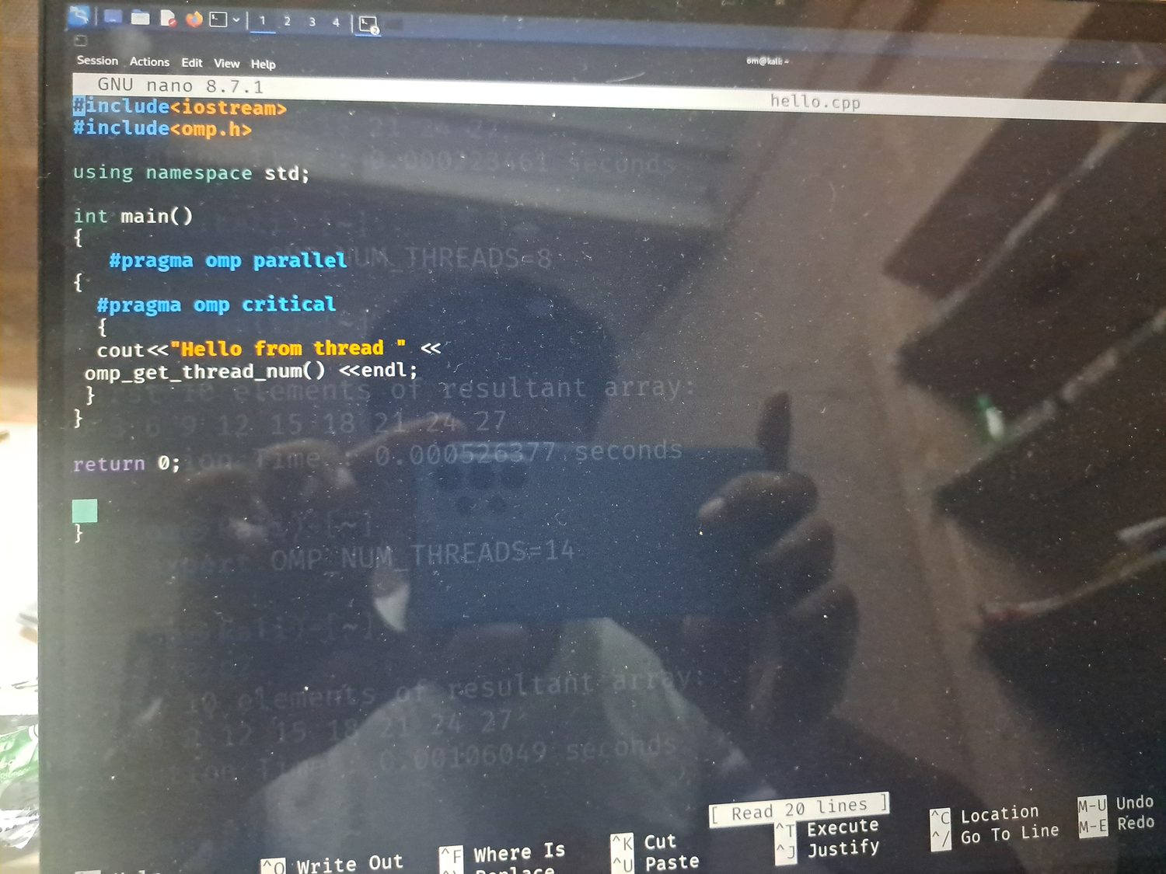

Figure A19. Subsequent Hello World output after modifying the program.
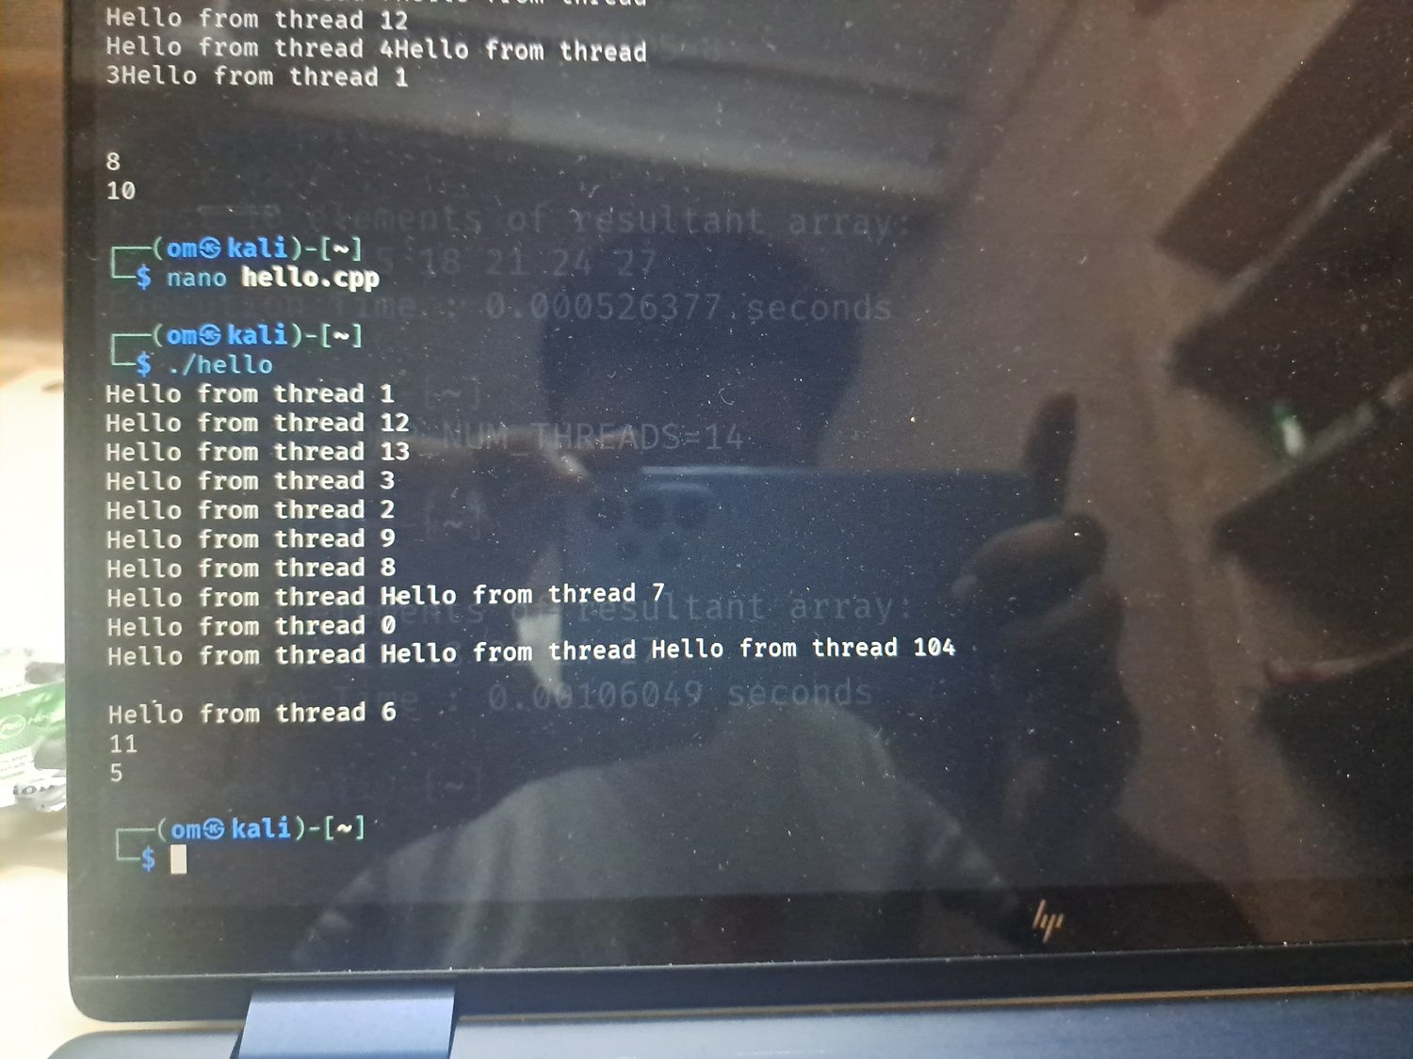
Figure A20. Attempt to run `threads` before compiling it.
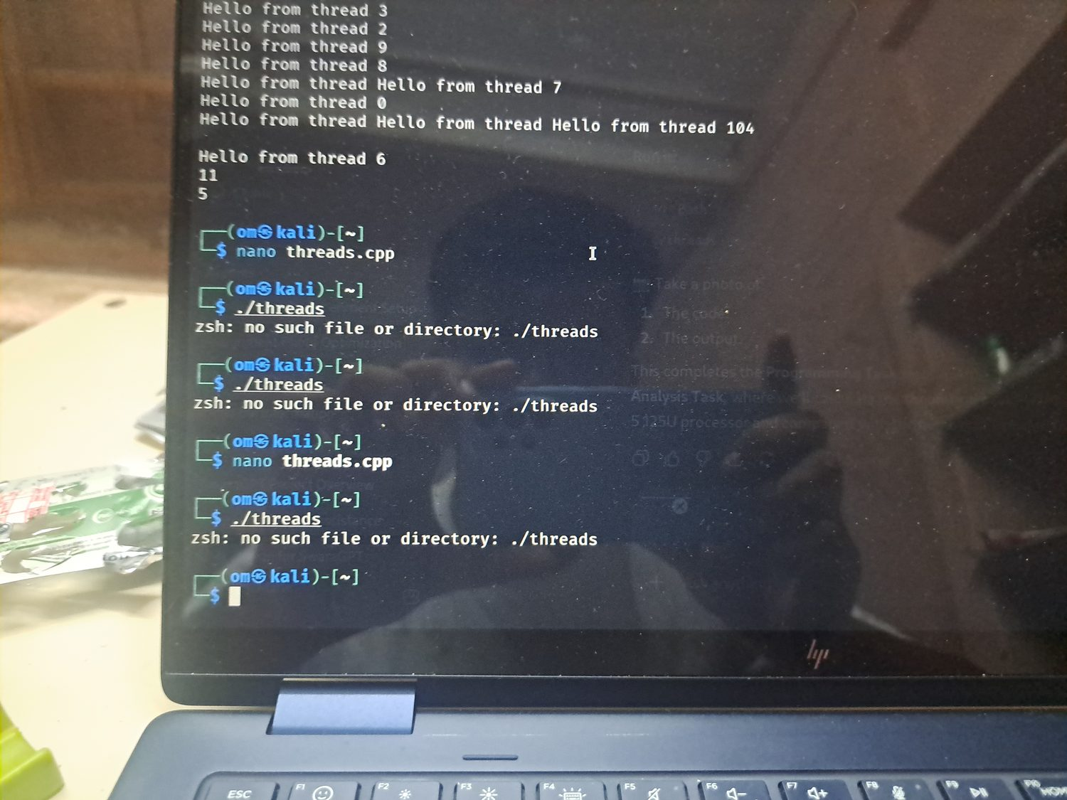

Figure A21. `threads.cpp` program used to compare OpenMP threads and logical cores.
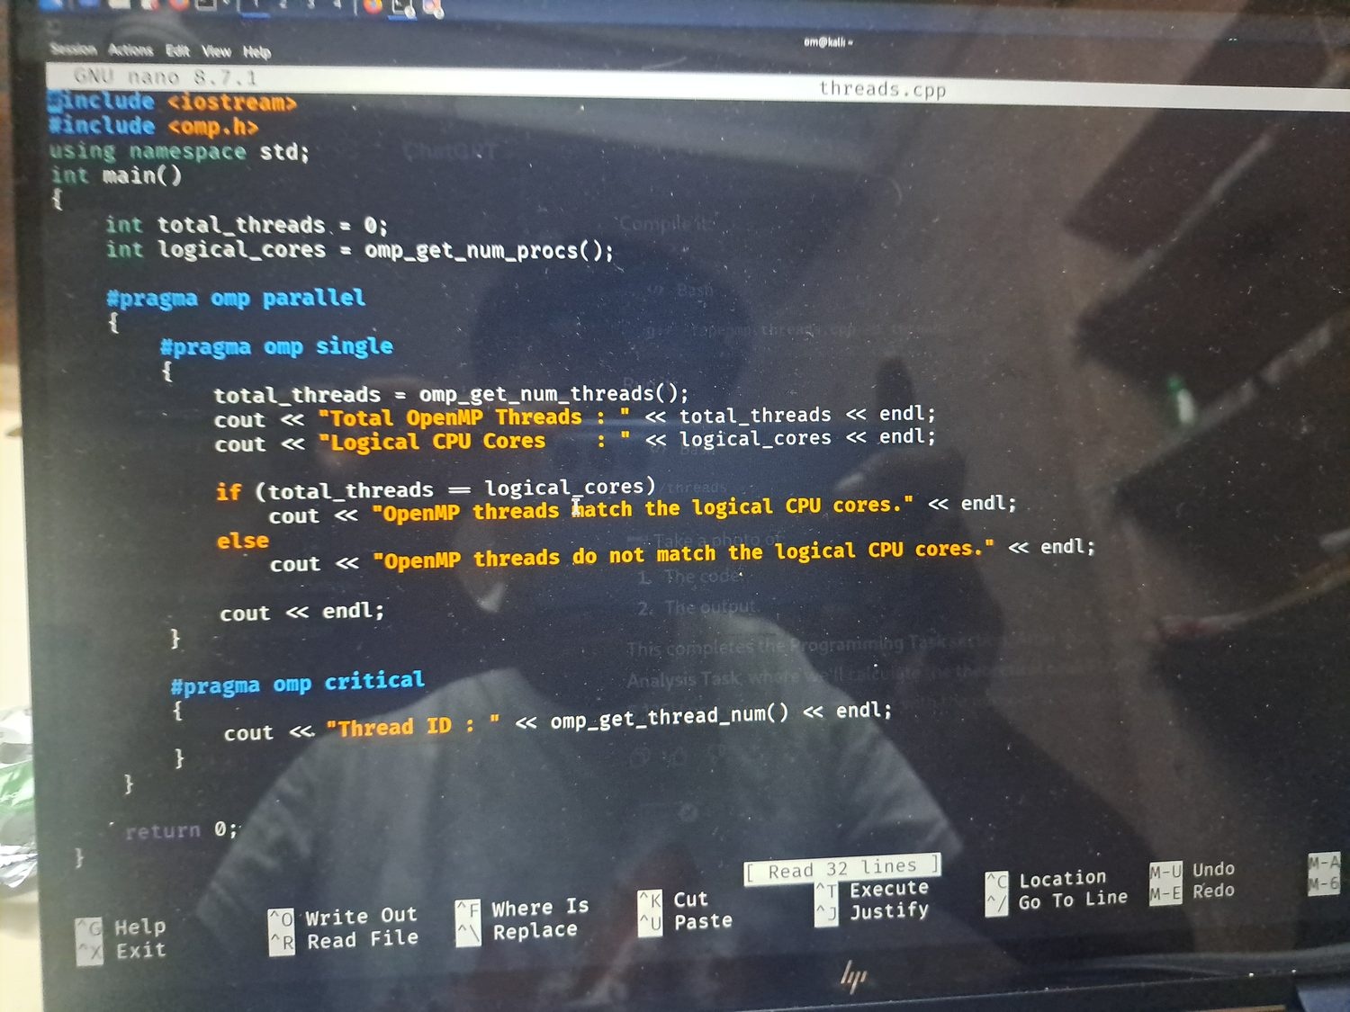
Figure A22. Compilation typo using `-forenmp`, which produced an error and was corrected.
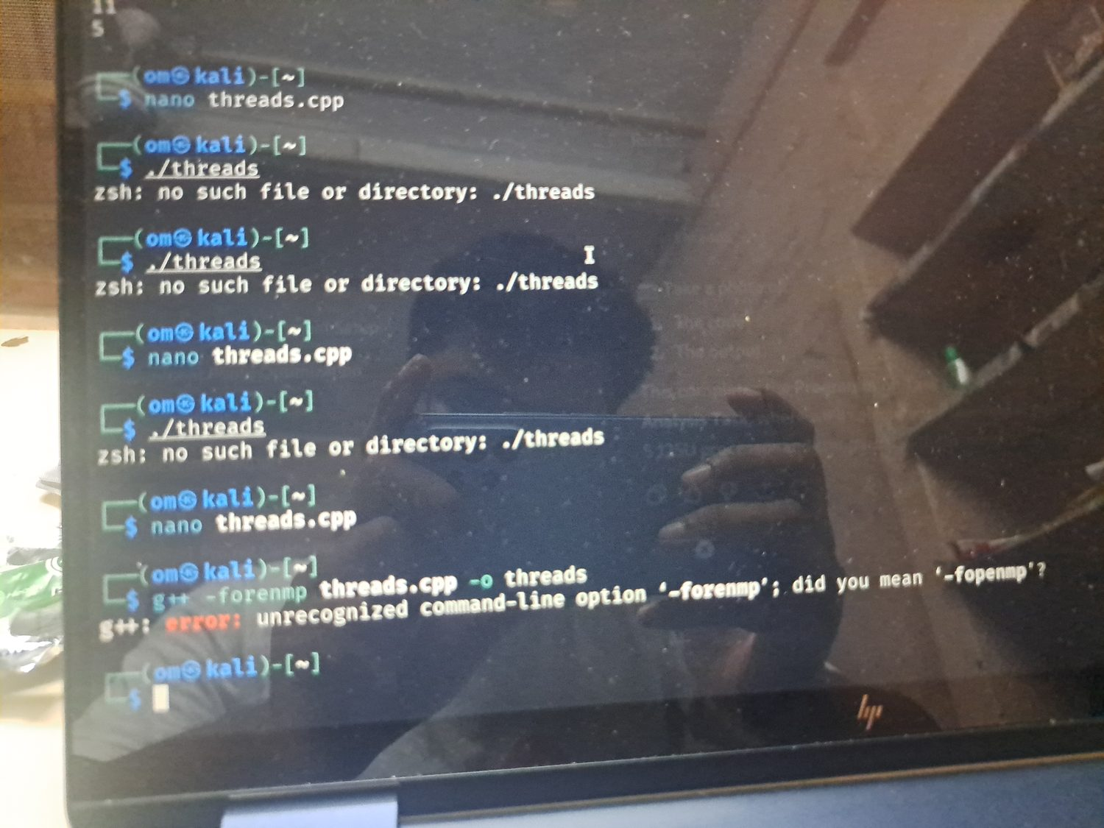

Figure A23. Successful execution of the `threads` program.
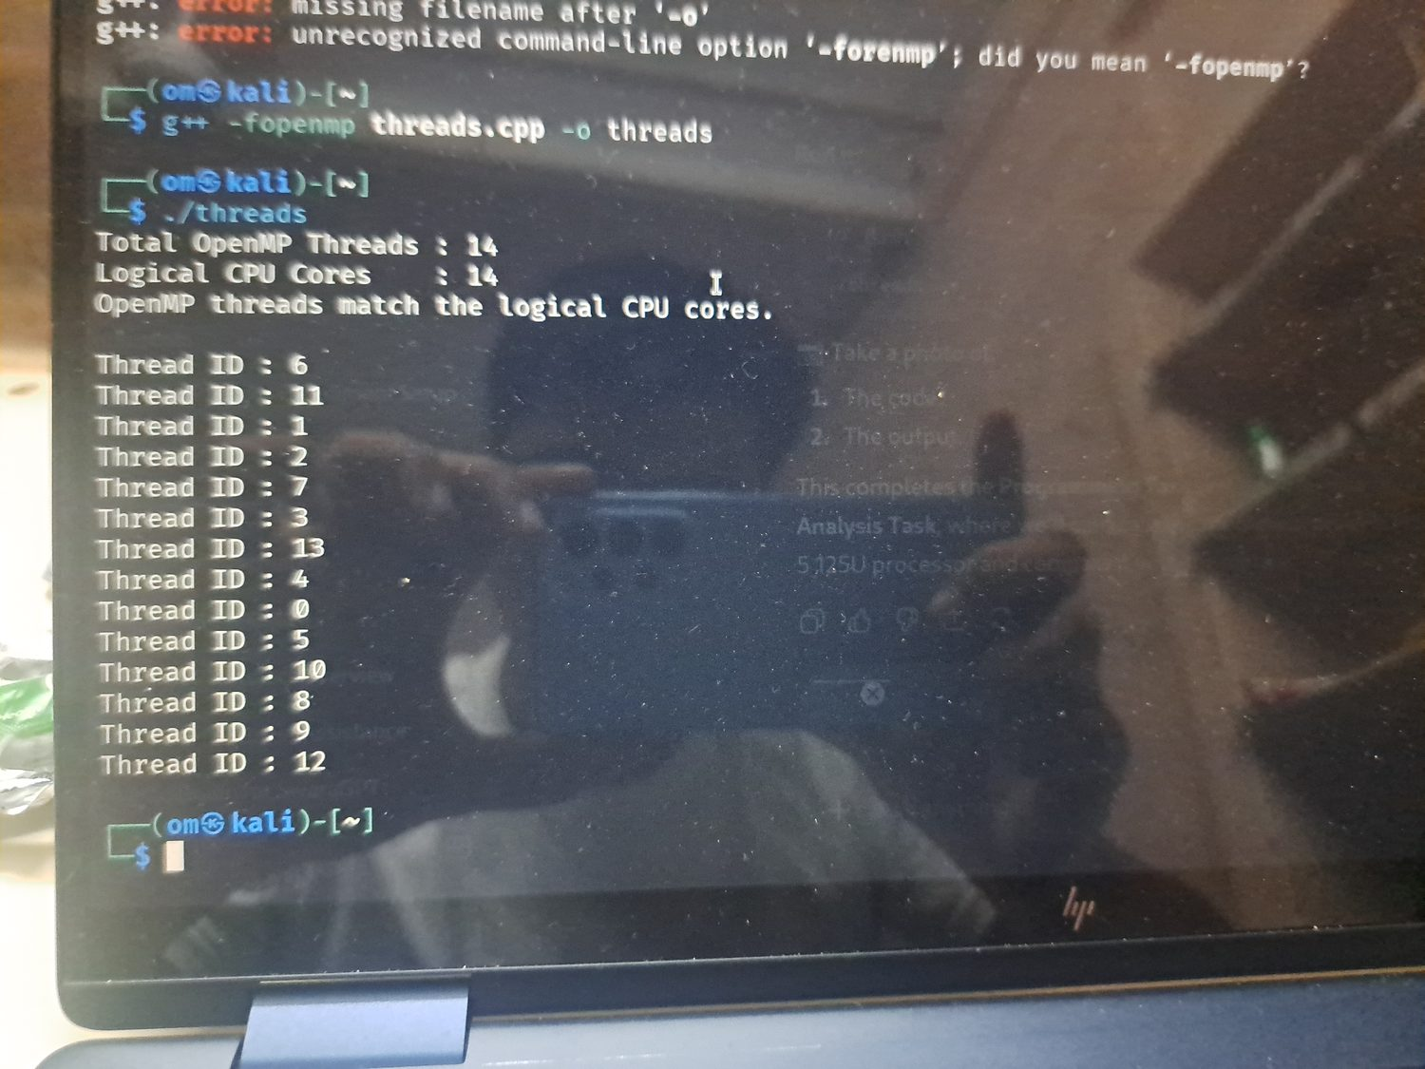
Figure A24. `lscpu | grep Flags` output showing SSE, AVX, AVX2, and related CPU flags.
