Tree Detection using YOLO

Overview
A system for detecting trees in aerial/drone images using YOLO model (YOLO v11) at multiple resolutions. This approach enhances detection across varying object sizes by processing images at different scales. Features include:
- Multi-scale detection: process images at 5 resolutions (1.0x, 0.75x, 0.50x, 0.30x, 0.25x)
- Tiled processing: Handle large images through overlapping tiles
- Outputs: CSV, GeoJSON, and visualization files (.jpg)
- Coordinate transformation: Convert between pixel, image, and geographic coordinates

Usage
- Command line Interface

python detection.py --image_path /path/to/image.tif --model_path /path/to/model.pt --output_dir /path/to/output --conf_threshold 0.25

Parameter | Type | Default | Description
--image_path | Str | Required | Path to input geoTIFF/image file
--model_path | Str | Required | Path to YOLO model weights (.pt file)
--output_dir | Str | Required | Directory to save the output files
--conf_threshold | float | 0.25 | Confidence threshold for detection

- Core Functions

detect_at_multiple_resolutions() : main function that performs multi-resolution tree detection
params:
  - image_path (str) : path to input image
  - model (YOLO) : loaded yolo model instance
  - output_dir (str) : output directory file
  - tile_size (int) : size of processing tile (default: 640)
  - overlap (int) : size of overlap between tiles (default 32)
  - resolutions (list) : scale factor for multi-resolution processing
  - conf_threshold (float) : detection confidence threshold
returns:
  - all_points (list) : point object in geographic coordinates
  - detection_points_pixel (list) : detection points in pixel coordinates
  - detection_boxes (list) : bounding box coordinates
  - counts_per_tile (list) : detection count per tile

Algorithm Details

- Multi-resolution Strategy

resolutions = [1.0, 0.75, 0.5, 0.3, 0.25] # Scale factors

- Tiling Process
for y in range(0, new_height, tile_size - overlap):
for x in range(0, new_width, tile_size - overlap):
- Tile Size: 640x640 pixels (standard YOLO input size)
- Overlap: 32 pixels to prevent edge artifacts
- Edge Handling: Skips tiles smaller than 50% of tile size

Output Files
- Data Files
File | Format | Description
multi_resolution_detections.csv | CSV | Detection points with metadata
multi_resolution_points.geojson | GeoJSON | Geographic coordinates of detections
multi_resolution_boxes.csv | CSV | Bounding box coordinates
multi_resolution_tile_counts.csv | CSV | Detection statistics per tile

- Visualization Files
File | Description
multi_resolution_detection.png | Individual resolution detection maps
combined_multi_resolution.png | All detections overlaid on original image

Terminal Summary
=== MULTI-RESOLUTION DETECTION SUMMARY ===
Resolution 1.0x: 156 detections, avg confidence: 0.834
Resolution 0.75x: 142 detections, avg confidence: 0.819
Resolution 0.5x: 128 detections, avg confidence: 0.802
Resolution 0.3x: 95 detections, avg confidence: 0.791
Resolution 0.25x: 87 detections, avg confidence: 0.785

Total unique detections: 608
Overall average confidence: 0.806

Sample Output
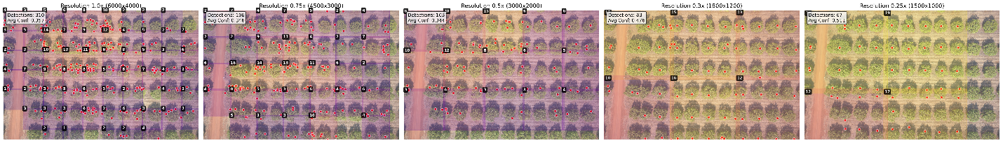
multi_resolution_detection.png

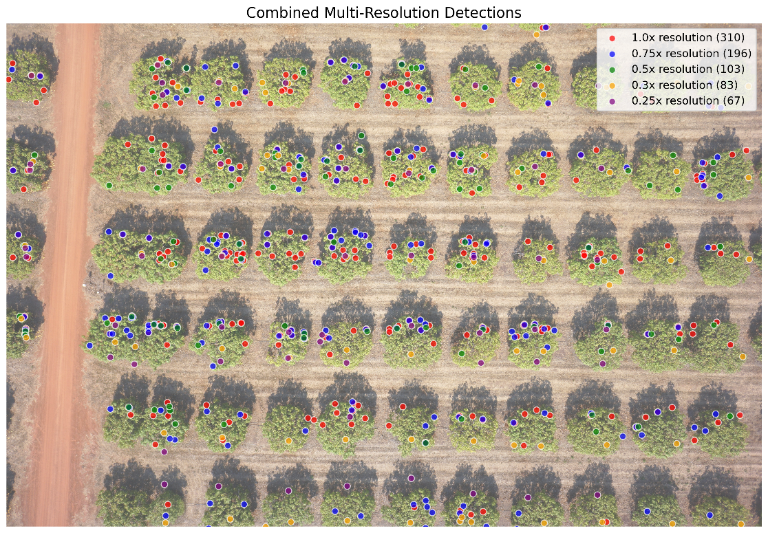
combined_multi_resolution.png

