|  |  |
| --- | --- |
| ECE497 test memo | |
| To | Dr. Mark Yoder |
| **From** | Samuel Lawrence |
| **Date** | October 27, 2016 |
| Subject | Response time comparison of mmap, gpio, kernel model and pru. |

1. Summary

There are many ways of implementing General Purpose IO software on the beagle bone. Abstracted implementations such as bonescript sacrifice low latency for other features, but there are a few other implementations that should be evaluated as well.

A program as functionally similar as possible was created for each GPIO implementation. The response time between an input trigger and an output was measured using an oscilloscope.

Implementations to be examined:

1. Bonescript (JavaScript library): Bonescript was used to set a GPIO output to be the same as another input.
2. Mmap (memory mapped I/O): This is a program written in C that runs in the foreground by default. It copies the value of a GPIO input and sets another output to be the same.
3. Kernel module: This is a program written in c that is loaded into the kernel with the “lsmod” command. An interrupt handler is attached to a GPIO pin that is set as an input. Once an interrupt is received, another GPIO pin is **toggled**.
4. Pru (programmable real-time unit): A c program was copied to a hardware pru unit on the beagle bone. It copies the value of a gpio input to another output.

2. Scope

This test is meant to be a cursory performance comparison of GPIO implementations on the beagle bone. Software optimizations were not the focus of this experiment although a reasonable attempt was made to make the code optimized.

1. Test results

|  |  |
| --- | --- |
| Implementation | Latency |
| Bonescript | 2.37 ms |
| Mmap | 17.12 us |
| Kernel | 406 ns |
| Pru | 29.6 ns |

3.1 bonescript (JavaScript)

Bonescript has a mean latency of 2.37ms.

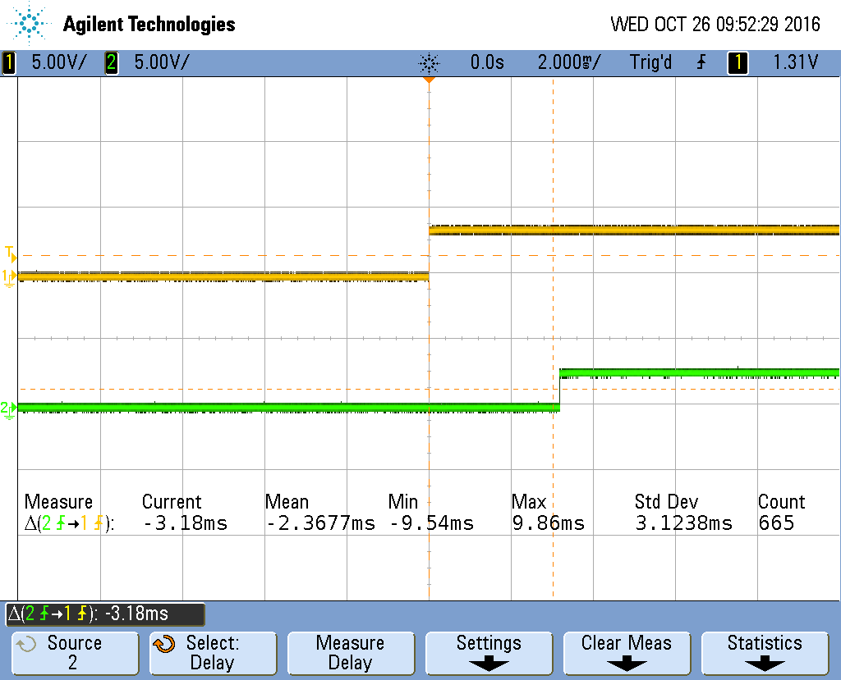

3.2 mmap

Mmap has a mean latency of 17.12 us.

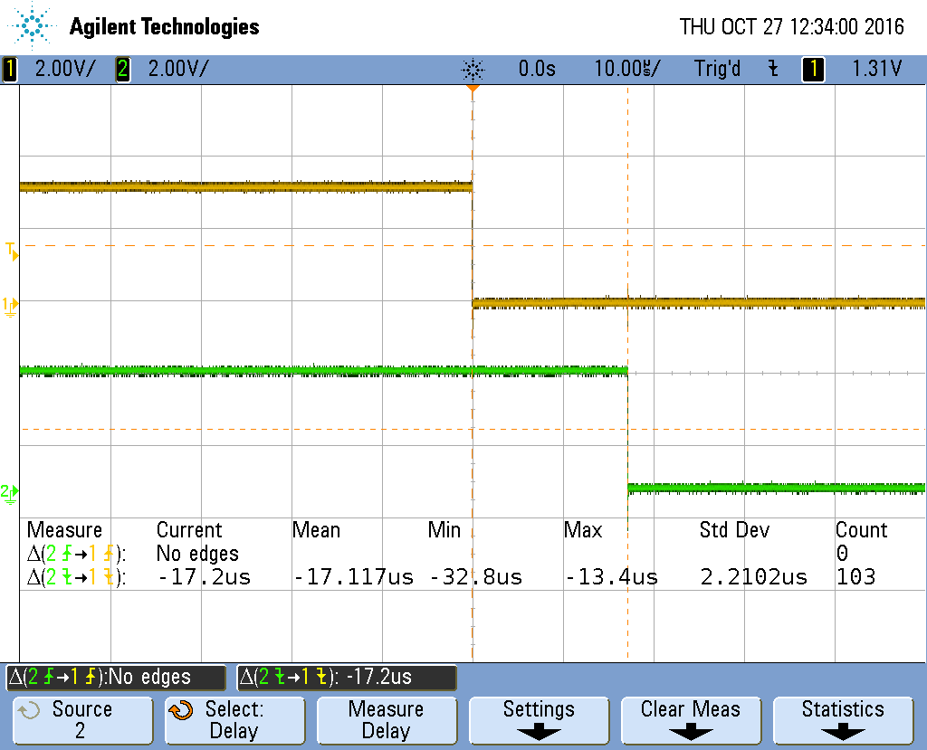

3.3 kernel

Bonescript has a mean latency of 406 ns.

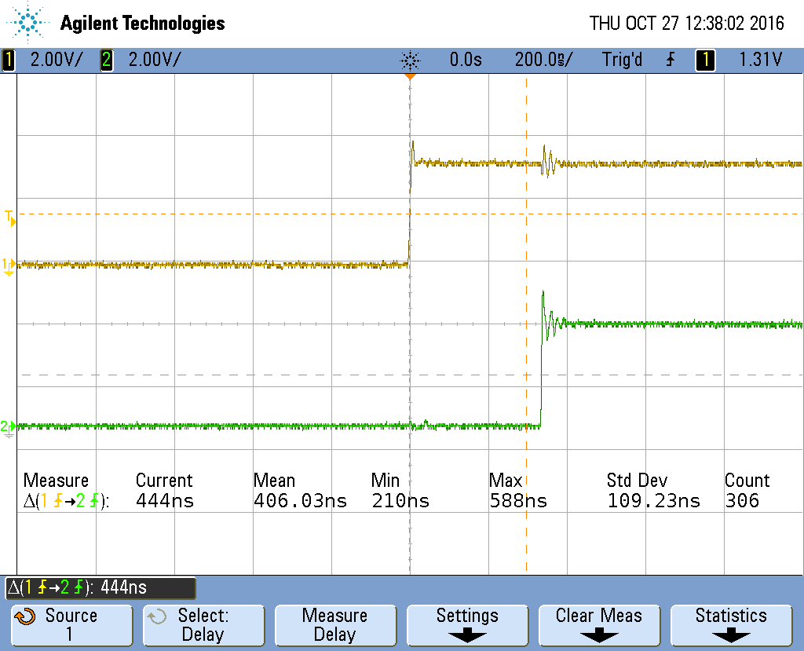

3.4 pru

Bonescript has a mean latency of 29.6ns.

