INDEPENDENT TECHNICAL REVIEW

Motion Control Architecture Review
  - Straight-line and 360° pivot behavior in radio-robot-elite
Project: radio-robot-elite
Repository state: pid-debugging branch; read-only review
Review date: 18 July 2026
Scope: 700 mm straight motion, 360° pivot, trajectory generation, wheel control, simulator, and configuration surface
Disposition: Architecture correction recommended before further tuning

Primary conclusion The endpoint pulses are software-generated behavior, not unavoidable simulator noise. The one-dimensional Ruckig solve is broadly appropriate; scheduling, time-shifted sampling, empirical target padding, terminal replanning, heading corrections, and output shaping alter the motion after the trajectory has been solved.

Executive summary
- Fix the control-cycle order before tuning anything else. A new Pilot reference currently waits about two 50 ms simulation cycles before the wheel PID consumes it.
- Stop sampling ahead in trajectory time. The lead-ramp transformation invalidates the end-to-end acceleration and jerk guarantees.
- Remove straight target padding, terminal top-up trajectories, pivot lead slopes, and minimum-speed heading nudges from ideal motion execution.
- Separate an ideal trajectory simulator from a hardware-parity simulator. The current simulator intentionally includes 130 ms wheel lag, duty quantization, deadband, slew limiting, write throttling, and reversal dwell.
- Pass Ruckig acceleration into the wheel controller and use model-based feedforward. Velocity-only feedforward must lag during acceleration and braking.
- Remove the 18 PlannerConfig fields that have no live firmware consumer, and do not promote the turn-windage lookup table into production.
Review basis. This report is based on a read-only inspection of the current source tree, the two supplied wheel-velocity plots, and the checked-in turn-windage sweep results. No repository files were modified.

1. Evidence from the supplied traces
The two plots already establish an important fact: the commanded traces themselves contain the terminal behavior under dispute. These are not merely noisy measurements reacting to a clean reference.

1.1 Straight-line trace
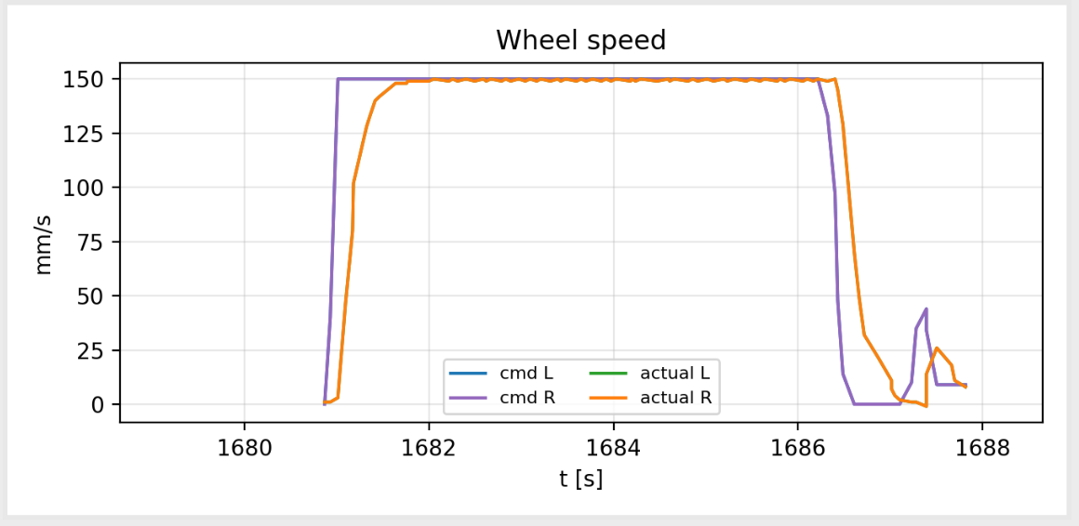
Figure 1. Supplied straight-motion wheel-speed trace. The command returns to zero and then issues a distinct positive top-up lobe.
- The second lobe is present in the command, so it is generated by the controller rather than by measurement noise.
- At a 150 mm/s ceiling, the straight-target formula adds 1.5 + 0.102 × 150 = 16.8 mm to the planned target.
- If the measured position still stops short, the executor launches another jerk trajectory and aims one settle epsilon—3 mm—past the remaining distance.
Source: src/firm/motion/executor.cpp:639–645, 666–685, 937–970

1.2 360° pivot trace
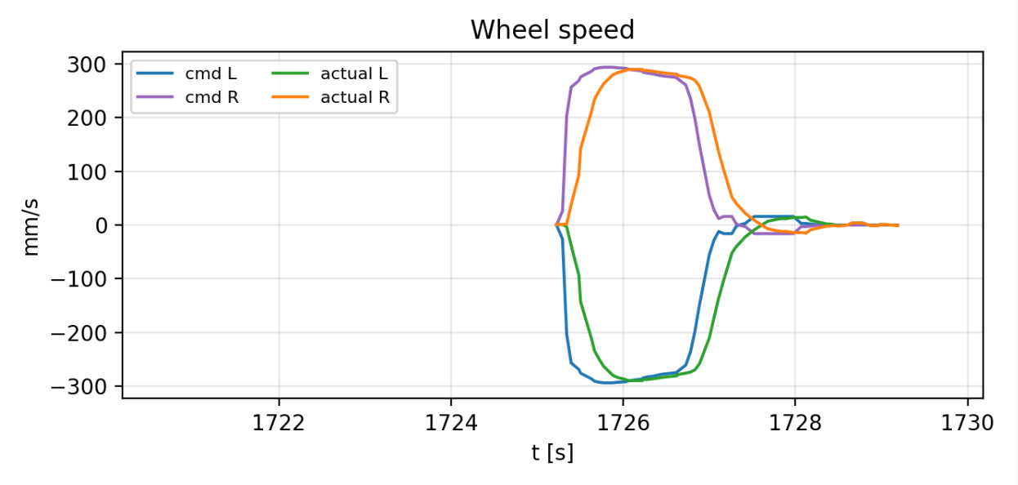
Figure 2. Supplied 360° pivot wheel-speed trace. Both commanded and measured wheel velocities show a sign-changing terminal correction.
- The main pivot ends with residual angular motion, after which heading feedback adds a separate correction phase.
- When the planned angular velocity is near zero and the heading remains outside tolerance, Pilot enforces a 16 mm/s minimum wheel-speed equivalent.
- The resulting coast, tolerance crossing, and possible reversal explain the visible sign-changing tail.
Source: src/firm/app/pilot.cpp:25–65; src/firm/motion/executor.cpp:973–1165

2. Review findings
ID | Severity | Finding | Primary effect
F1 | High | Control stages execute in the wrong order | Two-cycle command latency and compensating lead parameters
F2 | High | Lead sampling time-warps the Ruckig output | End-to-end command is not jerk-limited
F3 | High | Endpoint compensation creates new motion | Straight top-up pulse and pivot correction tail
F4 | High | Simulator mixes ideal and hardware-parity goals | Exact tracking is impossible under current shaping
F5 | High | Wheel feedforward omits acceleration | Predictable ramp lag and braking error
F6 | Medium | Planner configuration contains dead fields | Large tuning surface with no behavioral value
F7 | High | Windage fits a delay artifact; repeated pivots retain bad state | Biased final turns and hidden reliability defect

2.1 F1 — control-cycle scheduling defect
The executable sequence does not match the nearby comments. Both motor ticks run first and consume existing wheel targets; Drive then converts the previously staged twist; Pilot produces the current twist later in the cycle; the Ruckig solve runs at the end of the cycle. In the 50 ms simulator, a newly sampled reference therefore takes approximately 100 ms to reach the wheel PID.
current: motor PID → Drive(previous twist) → Pilot(new twist) → plan
required: read sensors → odometry → Pilot → Drive → wheel control → write duty
The configured 0.20 s plan lead is being used as a timing patch for this pipeline plus the 0.13 s wheel lag. Correcting the stage order removes the need for trajectory-time compensation and makes latency explicit.
Source: src/firm/app/robot_loop.cpp:432–438, 479–485, 510–519; src/sim/sim_harness.h:360–364, 459–461

2.2 F2 — lead sampling breaks the jerk guarantee
The executor samples each trajectory at elapsed + lead rather than at elapsed. During lead ramp-in, lead equals elapsed, so the reference is effectively evaluated at 2t. The sampled velocity remains continuous, but its derivatives no longer respect the solved constraints.
v_cmd(t) = v_plan(t + min(L, t))
for t < L: v_cmd(t) = v_plan(2t)
therefore: a_cmd = 2·a_plan and j_cmd = 4·j_plan
When the lead stops growing, the time-map derivative changes from two to one. Unless planned acceleration happens to be zero at that instant, commanded acceleration changes discontinuously. The Ruckig trajectory remains valid internally; the emitted command is not the trajectory Ruckig certified.
Source: src/firm/motion/executor.cpp:873–916

2.3 F3 — endpoint behavior is explicitly synthesized
Straight motion is altered twice. First, a terminal straight is planned longer using an empirical speed-dependent distance lead. Second, a stopped shortfall starts a new forward-only trajectory, with a further 3 mm cross-bias. The visible straight-line pulse is the expected output of that logic.
Pivot motion receives an additional rate-dependent velocity lead. After the planned motion, heading PD and the minimum-speed floor are allowed to continue commanding the wheels. The correction tail is therefore outside the original jerk-limited trajectory.
Source: src/firm/motion/executor.cpp:104–138, 617–650, 681–685, 904–916, 937–970; src/firm/app/pilot.cpp:35–65

2.4 F4 — deterministic does not mean ideal
The plotted command is the NezhaMotor velocity setpoint, not applied power. The simulated wheel plant applies the previous duty command through a first-order model with a 0.13 s time constant and 500 mm/s per unit duty. The production-like motor path then quantizes duty to integer percent, limits nonzero writes to 25 Hz, applies slew limiting, and retains production deadband and reversal dwell defaults.
plant: dv/dt = (K·u − v) / τ
current simulator constants: K = 500 mm/s per unit duty, τ = 0.13 s
The velocity update is analytically discretized, but position is advanced with position += newVelocity × dt, which is Euler integration. The simulator is repeatable, but it is neither an ideal actuator nor a fully exact continuous-state plant.
Source: src/sim/sim_ctypes.cpp:210–217; src/tests/sim/plant/wheel_plant.h:40–45; src/tests/sim/plant/wheel_plant.cpp:10–17; src/firm/devices/nezha_motor.cpp:486–516

2.5 F5 — the controller lacks model feedforward
The current wheel controller feeds forward velocity only, then relies on proportional and integral feedback to correct transient error. For the exact first-order plant used by the simulator, the missing acceleration term is known analytically.
continuous inverse: u_ff = (v_ref + τ·a_ref) / K
exact discrete inverse:
A = exp(−dt/τ)
u[k] = (v_ref[k+1] − A·v[k]) / ((1−A)·K)
Ruckig already calculates acceleration, but that state is discarded before the wheel-control layer. Passing reference acceleration through Drive would allow predictable feedforward, leaving feedback to handle model error rather than the nominal ramp itself.
Source: src/firm/devices/velocity_pid.cpp:30–91; src/firm/motion/jerk_trajectory.cpp:212–239

2.6 F6 — configuration surface exceeds live behavior
PlannerConfig contains 35 fields. Eighteen appear in generated schemas and patch-copying code but have no live firmware consumer. Keeping these names suggests adjustable behavior that no longer exists and makes every diagnosis look like a tuning problem.
arrive_tol turn_in_place_gate v_wheel_max
steer_headroom wheel_step_max track_k_s
track_k_theta track_k_cross trim_v_max
trim_omega_max replan_err_pos replan_err_theta
replan_hold replan_min_period replan_max
handoff_tol_pos handoff_tol_v arrive_vel_tol
Source: src/firm/messages/planner.h:227–262; src/firm/app/pilot.h:98–131

2.7 F7 — windage addresses the hump, not the target
The checked-in windage experiment fits deterministic overshoot across 480 fresh-boot runs. Its own comments acknowledge that the firmware still rings toward the biased command. At 360° and 4 rad/s, the baseline final heading is closer to the requested target than the compensated final heading.
Run | Command | Peak heading | Final heading | Assessment
Baseline | 360.000° | 362.825° | 360.108° | Overshoot hump; accurate final
Windage | 357.175° | 358.078° | 357.310° | Smaller hump; biased final

The sweep also creates a fresh SimLoop for every run because repeated pivots accumulate executor state and can reach solve failure after roughly five commands. That is a separate reliability defect and should be exposed by a permanent same-boot regression test rather than hidden by test isolation.
Source: src/tests/sim/turn_windage_sweep.py:61–68, 222–273; src/tests/notebooks/out/turn_windage_baseline.csv; turn_windage_compensated.csv

3. Simpler target architecture
Design rule Plan once, sample once, map once. A discrete move should have one scalar trajectory and one terminal zero—not a primary plan followed by correction trajectories.

3.1 One scalar progress variable
Represent every move by scalar path progress q(t). Straight motion uses distance as q; an in-place pivot uses heading as q. Wheel references are a deterministic geometric mapping from q̇ and q̈.
straight:
v_left = q̇
v_right = q̇
pivot:
v_left = −(trackWidth/2)·q̇
v_right = +(trackWidth/2)·q̇
Solve from (q, q̇, q̈) = (0, 0, 0) to (target, 0, 0), subject to velocity, acceleration, and jerk limits. Sample q, q̇, and q̈ at exactly the current trajectory time.

3.2 Explicit control pipeline
sense wheels and heading
↓
update odometry
↓
sample q, q̇, q̈ at time t
↓
map reference to left/right wheels
↓
model feedforward + small state feedback
↓
write duty → advance plant
Latency belongs in timestamps and the actuator model. It should not be represented by independently tunable trajectory leads, target windage, or post-plan corrective motion.

3.3 Separate simulator purposes
- Ideal motion mode: apply the planned wheel state directly, or use an exact discrete inverse without quantization and shaping. Use this mode for trajectory and geometry acceptance.
- Hardware-parity mode: preserve lag, duty quantization, write rate, deadband, slew, and reversal protection. Use this mode to validate controller robustness and realistic settling.
- Do not require the hardware-parity plot to show actual velocity exactly overlaying the velocity setpoint. Require bounded, monotonic, non-ringing tracking instead.

3.4 Completion semantics
At t ≥ trajectory duration, command zero once. In ideal mode, completion follows the solved terminal state. In hardware-parity mode, measured tolerances may delay the completion event, but they should not silently authorize another motion trajectory. A large endpoint disagreement is a tracking failure or fault, not a reason to rewrite the request.

4. Simplification and parameter reduction

4.1 Remove from normal motion execution
- plan_lead, terminal_lead, and independent heading-age bias tuning once the cycle schedule is corrected
- straight lead bias and speed slope
- pivot overshoot lead slope
- terminal shortfall top-up trajectory and its 3 mm cross-bias
- normal-operation retarget and reanchor solves
- frame-offset and pending-correction flags that exist only to support those replans
- minimum-speed heading floor in ideal simulation
- turn-windage lookup tables
- the 18 unconsumed PlannerConfig fields and their wire-patch plumbing

4.2 Preserve
- Ruckig's position-control solve with explicit current and target position, velocity, and acceleration
- linear and angular velocity/acceleration/jerk constraints
- the motion queue and command lifecycle, provided they do not alter an active trajectory
- gross divergence, timeout, and emergency-stop protection as explicit safety/fault mechanisms
- hardware-only deadband and reversal protection where the Nezha device requires them

4.3 Reduced parameter model
Domain | Recommended parameters | Comment
Planner | linear vmax, amax, jmax; angular vmax, amax, jmax | Six physical constraints; retain separate linear deceleration only if it is a real requirement
Geometry | track width | Robot geometry, not trajectory tuning
Actuator | gain K, time constant τ, optional small feedback gain | Identifies the simulated or measured plant
Completion | position/heading tolerance, rate tolerance, hold time | Hardware verification only; not permission to replan
Safety | timeout and gross divergence threshold | Fault policy kept separate from nominal tracking

4.4 Reduce executor responsibility
executor.cpp is 1,171 lines and executor.h is 637 lines. Executor currently owns queueing, solving, chaining, time compensation, measurement frames, divergence correction, terminal heading control, dwell logic, timeout, and emergency behavior. The goal should be deletion first, then four narrow responsibilities:
- Pure trajectory: solve and sample one scalar path.
- Reference mapper: convert q, q̇, q̈ into wheel references.
- Wheel controller: convert wheel references and measurements into duty.
- Lifecycle and safety: queue, completion event, timeout, stop, and explicit faults.

5. Acceptance criteria

5.1 700 mm straight
- Exactly one velocity lobe per wheel.
- No nonzero command after the first terminal zero.
- No reversal, top-up, or second solve.
- Emitted acceleration and jerk remain within configured bounds, including start and stop.
- Final left and right wheel position equals 700 mm within the declared numerical tolerance.
- Final wheel velocity and acceleration are zero.

5.2 360° pivot
- Wheel distances equal ±π × trackWidth for an in-place 2π rotation.
- Heading equals 2π within the declared numerical tolerance.
- One positive and one negative wheel-velocity lobe.
- No wheel sign change after terminal deceleration begins.
- No heading-PD or minimum-speed tail after the planned endpoint in ideal mode.

5.3 Cross-cutting tests
- Numerically differentiate the emitted wheel setpoints and assert velocity, acceleration, and jerk limits—not merely the absence of a one-tick jump.
- Test the pure trajectory, ideal actuator, and hardware-parity actuator as separate layers.
- Run dozens of consecutive straight and pivot commands in the same boot to expose stale executor state.
- Fail when a correction lobe, direction reversal, second solve, or solve-failure event appears.
- Record requested endpoint, planned endpoint, measured endpoint, and reason for completion as separate telemetry values.

6. Recommended refactoring sequence
- Lock the behavior down with end-to-end numerical jerk and single-lobe tests for the 700 mm straight and 360° pivot.
- Correct the cycle order by separating motor sensor collection from control/output application.
- Pass acceleration references through the mapping layer and add model-based wheel feedforward.
- Add an explicit ideal simulator mode and correct the analytical position update in the hardware-parity plant.
- Delete plan leads, target padding, terminal top-ups, pivot lead slopes, and ideal-mode heading nudges; rerun the acceptance tests after each removal.
- Remove dead PlannerConfig fields and shrink Executor around one active scalar plan plus lifecycle and safety.
- Only after the architecture is stable, tune the small number of physical plant and hardware-completion parameters on the real robot.
Review judgment Further tuning of the existing lead, top-up, dwell, minimum-speed, and windage parameters is unlikely to produce a clean and general motion system. It will continue moving the correction artifacts between the main lobe and the terminal tail. The appropriate next step is architectural simplification.

Appendix A — source map
The following locations support the principal findings. Line numbers refer to the repository state reviewed on 18 July 2026.
Location | Relevance
src/firm/app/robot_loop.cpp:420–520 | Actual motor, Drive, Pilot, odometry, and planning cycle order
src/firm/motion/executor.cpp:39–138 | Settle, top-up, straight-lead, and pivot-lead constants
src/firm/motion/executor.cpp:617–695 | Straight retarget and empirical target padding
src/firm/motion/executor.cpp:873–970 | Time-shifted sampling and terminal top-up trigger
src/firm/app/pilot.cpp:25–65 | Heading PD and minimum-speed terminal floor
src/firm/motion/jerk_trajectory.cpp:84–169 | Ruckig position solve, retarget, and reanchor behavior
src/firm/devices/velocity_pid.cpp:30–91 | Velocity-only feedforward and PI feedback
src/firm/devices/nezha_motor.cpp:420–551 | Deadband, reversal dwell, quantization, write throttling, and slew
src/tests/sim/plant/wheel_plant.cpp:7–18 | First-order velocity plant and Euler position integration
src/sim/sim_harness.h:360–461 | 50 ms cycle, motor gains, production-parity shaping, and lead configuration
src/firm/messages/planner.h:227–262 | Thirty-five-field PlannerConfig
src/firm/app/pilot.h:98–131 | Patch copying for fields without live consumers
src/tests/sim/turn_windage_sweep.py:61–68 | Fresh-boot workaround for accumulated rotational solve state
src/tests/notebooks/out/turn_windage_*.csv | Baseline and compensated turn outcomes

Appendix B — final assessment
A deterministic simulator can produce exact, presentation-quality straight and pivot trajectories, but only when the simulator's purpose is explicit. The trajectory reference can be mathematically exact; an ideal actuator can follow it exactly; a hardware-parity actuator can be required to follow it cleanly within a stated tolerance. The present design conflates those layers and compensates for its own scheduling and plant dynamics by modifying the requested trajectory. Removing those compensations is both the shortest path to clean motion and the largest available simplification of the codebase.

