**Pumpkin data analysis**

The heaviest pumpkin grown was from the year 2591, weighing 2701.149 lbs, from the Sugar Pie variety and grown in the city Los Angeles, state province California from the country Australia. The relationship between estimated and actual pumpkin weights (lbs) is shown in Figure 1. The estimated weight is inaccurate for predicting the actual weight since many pumpkins are estimated as 0 lbs. Additionally, there are two extreme outliers where the estimated weights are 11034 lbs and 9814 lbs when the actual pumpkin weights were 324.6130, and 1411.2377, respectively. However, as pumpkin weight increases for the majority of pumpkins, so does the estimated weight.

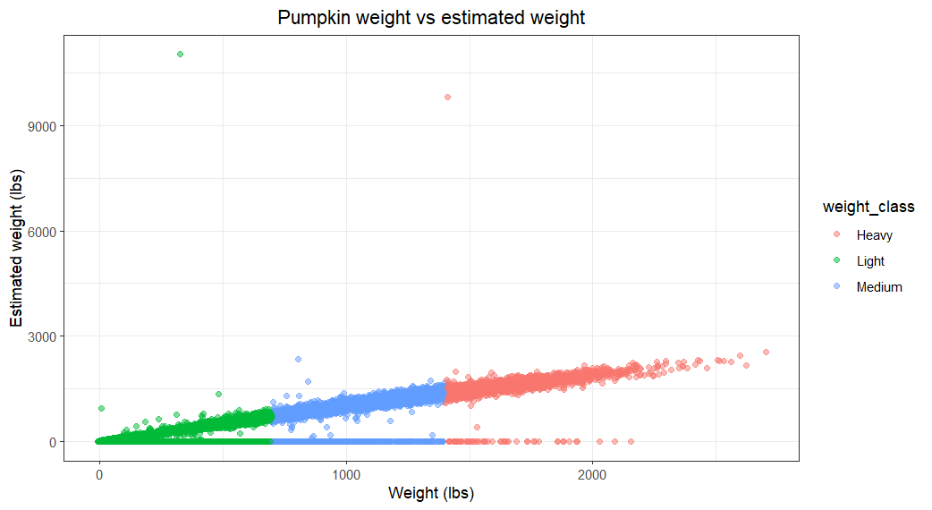

Figure 1 – Pumpkin weight vs estimate weight. Points are coloured according to the weight class of the pumpkins. Pumpkins less than 700 lbs are categorized as light. Pumpkins greater or equal to 700 lbs but less than 1400 lbs are considered medium. Heavy pumpkins are greater or equal to 1400 lbs.

The mean weight of pumpkins (lbs) from the countries Australia, UK, and USA are 767, 771, and 778, respectively. The country with the highest mean pumpkin wight is the USA with a value of 778 lbs. Table 1 shows the mean weights (lbs) for each pumpkin variety from these three countries. The Sugar Pie variety from Australia has the lowest mean weight of 748 lbs.

Table 1 – Mean pumpkin weights (lbs) of each variety from each country. Values are rounded to whole numbers.

|  |  |  |  |
| --- | --- | --- | --- |
|  | Mean pumpkin weight (lbs) from country | | |
| Variety | Australia | UK | USA |
| Long Pie | 778 | 751 | 760 |
| Naples Long | 768 | 751 | 797 |
| Sugar Pie | 748 | 811 | 786 |
| Yuxijiangbinggua | 773 | 772 | 766 |

A boxplot of the mean weights (lbs) for the three countries is shown in Figure 2. All three countries have a similar interquartile range, median, and present outliers above ~2100 lbs.

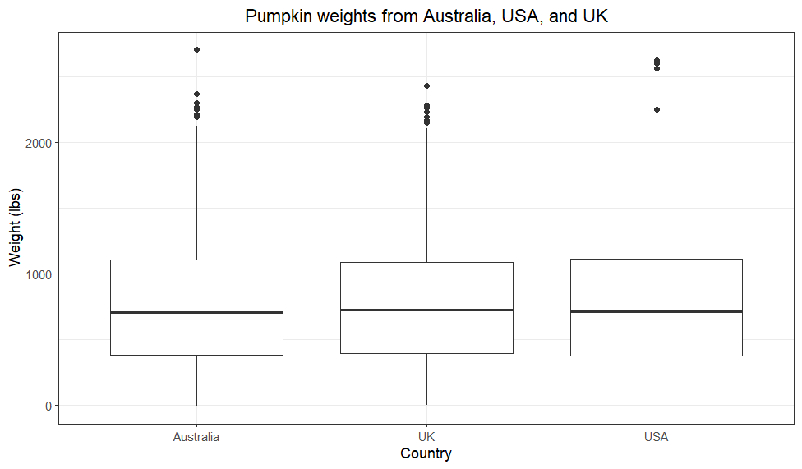

Figure 2 – Boxplot of pumpkin weights (lbs) from Australia, USA, and UK. Outliers are shown as black dots.

A boxplot for each pumpkin variety from each of the three countries is shown in Figure 3. Interestingly, all varieties from each country also have a similar interquartile range, and median. For most varieties from each country, outliers exist above ~2100 lbs. However, there are no outliers present for Australian Long Pie, UK Sugar Pie, and USA Yuxijiangbinggua pumpkins.

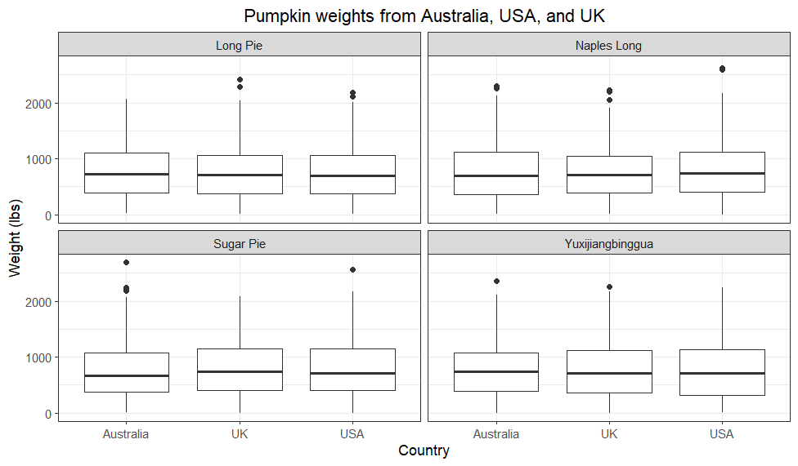

Figure 3 – Boxplot of pumpkin weights (lbs) of each variety from Australia, USA, and UK. Outliers are shown as black dots.