APPLICATION DEVELOPMENT 1 (DESKTOP)

Assignment 1

*GitHub：https://github.com/LeahFu/WLH-Assignment1.git*

**Group Name:** WLH Group.

**Group Members:** Wei Zhu, Lei Fu, Hua Zhang

1.The Admin window.

When click any line of the product list table, the text boxes will be automatically filled by the data which you select. You can use <Clear> button to clear all contents of the text boxes.

* **Search**

Input Product ID, then click the <Search> button, the Product Name, Amount, Price will be displayed.

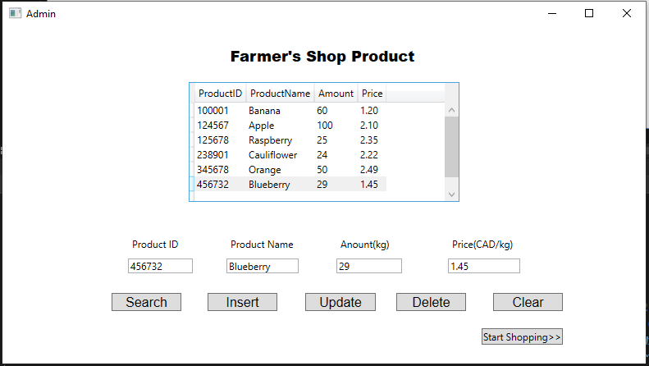

* **Insert**

Input Product ID, Product Name, Amount, Price, then click the <Insert> button, when insert succussed, it will pop-up success dialogue box, and a new record add to database.

* **Update**

Select any record of the list ,then modify any attribute you want, then click the <Update> button, when update succussed, it will pop-up success dialogue box, and this record will be updated in database.

* **Delete**

Select any record of the list, then click the <Delete> button, when update succussed, it will pop-up success dialogue box, and this record will be deleted in database.

2. The Sales window.