## Overview

Demonstrate your understanding of loops by completing the following individual checkpoint assignment.

## Assignment

Write a Python Program that does each of the following:

1. Use a while loop to ask the user for a positive number (>= 0). Continue asking as long as the number is negative, then display the number. For example:

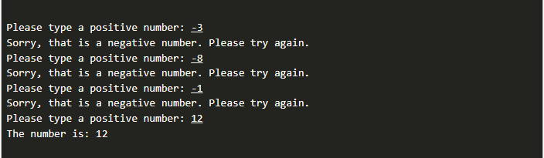

1. Use a **while** loop, to simulate a child asking their parent for a piece of candy. Have the program keep looping until the user answers "yes", then have the program output "Thank you." For example:

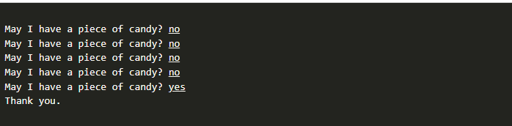

## Testing Procedure

Verify that your program works correctly by following each step in this testing procedure:

1. For the positive number program, enter several negative numbers, then a positive one.
2. Try entering a positive number first, and ensure that it doesn't ask again.
3. Try entering 0 and ensure that it correctly treats it as a positive number.
4. For the piece of candy program, test your last loop by entering different amounts of no's before finally saying yes.
5. Try saying "yes" the very first time, and ensure that it works as expected.

## Submission

When complete, please report your progress in the associated I-Learn quiz.