## Overview

Demonstrate your understanding of **for** loops.

## Assignment

Write a Python Program that does each of the following:

1. Given the following list of items (copy and paste this line into your program):

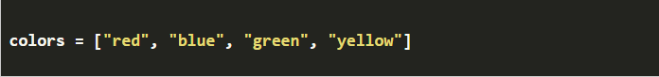

Use a **for** loop to iterate through this list one by one and display each item on its own line as follows:

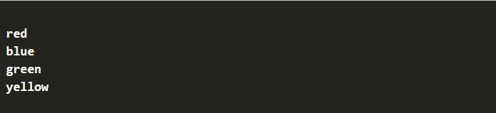

1. Use a **for** loop to display the numbers 1–8, one number on each line as follows:

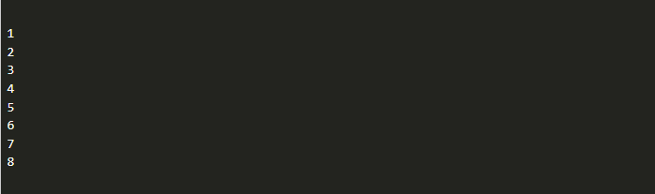

1. Use a **for** loop to display the even numbers (hint: count by two) 2–20, one number on each line as follows:

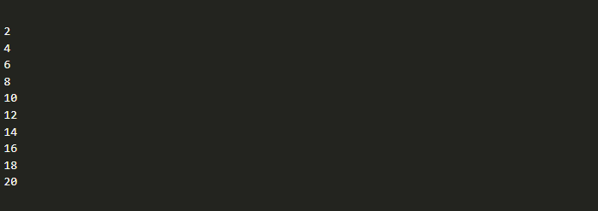

## Testing Procedure

Verify that your program works correctly by following each step in this testing procedure:

* + Verify that the colors display as desired.
  + Verify that your output for part 2 does **not** include 0.
  + Verify that your output for part 2 does **not** include 9.
  + Verify that your output for part 3 does **not** include any odd numbers.
  + Verify that your output for part 3 starts at 2 and ends at 20.

## Submission

When complete, please report your progress in the associated I-Learn quiz.