**Lists of Numbers**

## Assignment

Ask the user for a series of numbers, and append each one to a list. Stop when they enter **0**.

Once you have a list, have your program do the following:

### CORE REQUIREMENTS

Work through these core requirements step-by-step to complete the program. Please don't skip ahead and do the whole thing at once, because others on your team may benefit from building the program up slowly.

1. Compute the sum, or total, of the numbers in the list.
2. Compute the average of the numbers in the list.
3. Find the maximum, or largest, number in the list.

The following shows the expected output:

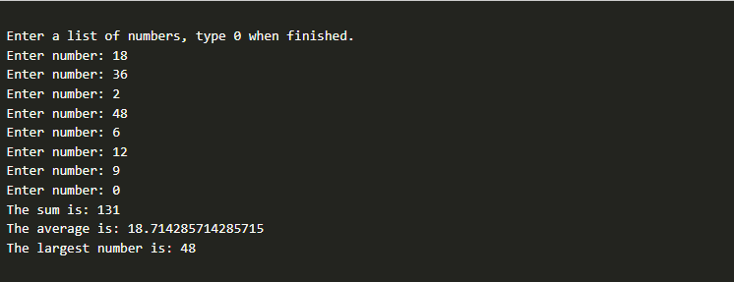

### STRETCH CHALLENGE

1. Have the user enter both positive and negative numbers, then find the smallest positive number (the positive number that is closest to zero).
2. Sort the numbers in the list and display the new, sorted list. Hint: There are python libraries that can help you here, try searching the internet for them.

The following shows the expected output after completing the stretch challenges:

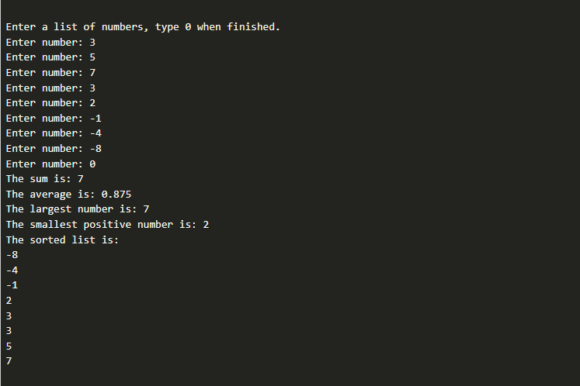

## Submission

When complete, please report your progress in the associated I-Learn quiz.

If you decided to do additional work on the program after your team activity, either by yourself or with others, feel free to include that additional work when you report on your progress in I-Learn.