**Multiple Lists**

## Instructions

Help your teammates complete the following programming assignment.

## Overview

Sometimes you have two lists that you want to keep in sync with each other. For example, in this assignment, you will track bank accounts and the balances in each one.

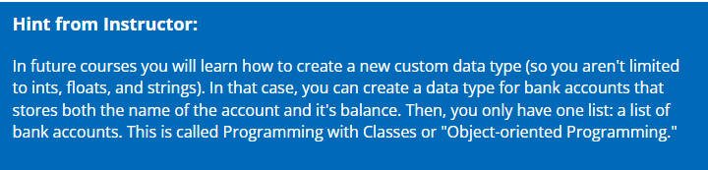

## Assignment

### CORE REQUIREMENTS

Work through these core requirements step-by-step to complete the program. Please don't skip ahead and do the whole thing at once, because others on your team may benefit from building the program up slowly.

1. Create two lists, one for the names of the bank accounts, and one for the balances.

Ask the user for the name of the bank account and then for it's current balance. Keep looping until the user types "quit" for the name of an account. For each one, add the name and the balance to the appropriate list.

1. Loop through the lists using an index and display the name of the account with the balance next to it.
2. Compute and display the total balance in all of the accounts and the average balance.

The following shows the expected output:

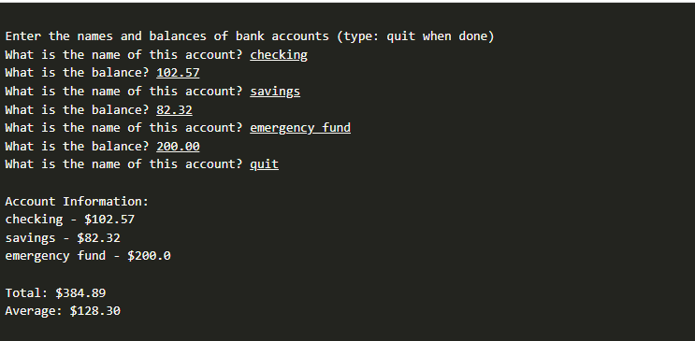

### STRETCH CHALLENGE

1. Determine which bank account has the highest balance and display the name and balance of that account.
2. Change your display so that it shows the index of the account next to the name.

After displaying the list, ask the user if they want to update an account. If they respond with **yes**, ask for the index of the account, and the new balance.

1. Change the last step into a loop, so that the user can keep updating accounts until they say no. After each update, display the new list of balances.

The following shows the expected output after completing the stretch challenges:

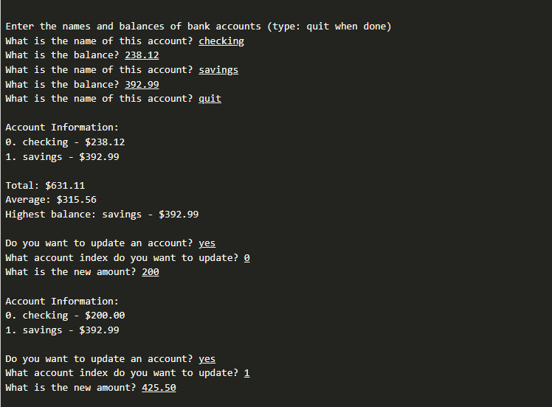

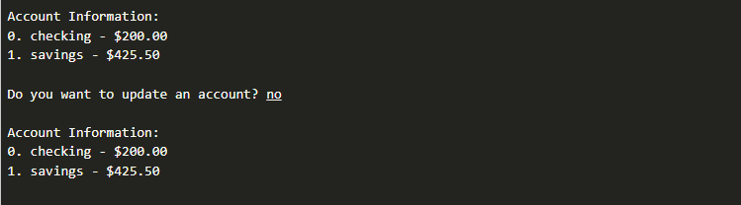

## Submission

When complete, please report your progress in the associated I-Learn quiz.

If you decided to do additional work on the program after your team activity, either by yourself or with others, feel free to include that additional work when you report on your progress in I-Learn.