## Overview

This checkpoint is designed to help you practice writing basic functions.

## Assignment

Write three functions:

* **display_regular**—Receives a string and prints it out, exactly as received.
* **display_uppercase**—Receives a string, converts it to upper case, and then prints it out.
* **display_lowercase**—Receives a string, converts it to lower case, and then prints it out.

In your program below the functions, ask the user to type a message. Then, pass that message to each of the three functions, so it it displays it each way, as shown:

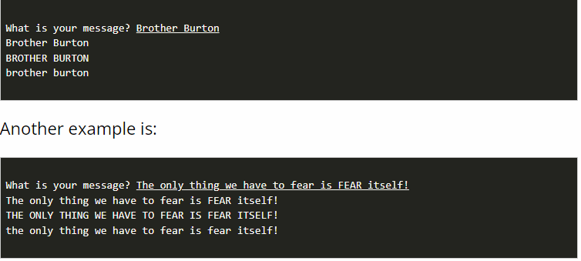

## Testing Procedure

Verify that your program works correctly by following each step in this testing procedure:

Try your program with each of the following conditions and ensure that it works as expected.

1. A single word
2. A phrase with multiple words
3. A word in ALL CAPS
4. A phrase where each word starts with a capital
5. An empty string

## Submission

When complete, please report your progress in the associated I-Learn quiz.