Game Type: I plan on making a point and click room escape game. The game will feature several screens and various different rooms that the player must navigate their way through, solving puzzles to find items, and figuring out how to utilize those items to progress further and eventually escape.

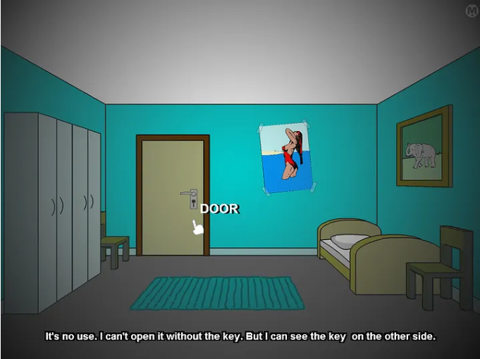

Keyboard/Controller Movement: The game will utilize mouse controls, clicking arrows on the side of your screen to move between different screens, and interacting with objects in the environment and in your inventory. Specific objects and areas of the screen will require the player to click on them to uncover hidden objects, pick up items, interact with and solve puzzles, and click items in their inventory to use them in certain places on the screen, potentially even dragging the item from their inventory to specific places.

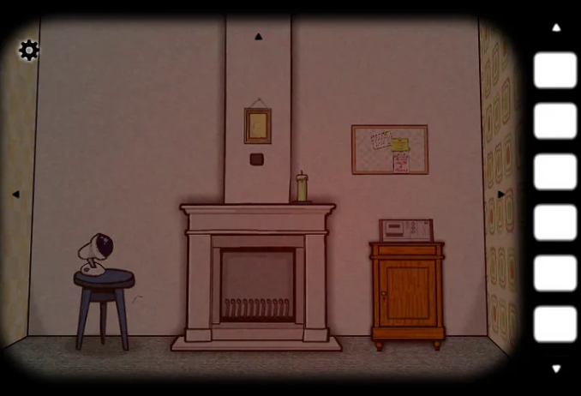

Objective of the game + Final Victory screen: The objective will be to solve a sequence of puzzles to open one, or possibly multiple, different locked doors. Ideally it would feature a chain of interconnected rooms, each posing different challenges for the player to overcome. The player would need to not only solve puzzles in the current room, but even backtrack to previous rooms to utilize newly found items in older rooms to acquire necessary items for progression. The final product would feel like several small puzzles that all interconnect together into one large puzzle. Final victory will be achieved when you have fully escaped all rooms.

Enemy types: As a point and click adventure style game, there wouldn’t be traditional enemies, rather puzzles that would serve as the “antagonist” to the player. However, there could be certain puzzles that involve enemy-like elements where the player must, for instance, navigate to the end of a maze while being followed by something that, if it touches them, would force them to restart the puzzle.  
  
Special Effects that will be used: There would be an expandable inventory that, when a tab is moused over, slides the inventory into the main screen. Animations could be used to signify puzzle completion, and the environment would change to signify it.

Ideas of what different levels you will create: I would like to create different levels in the form of several different rooms that the player has to traverse through, each with a different theme, and more difficult puzzles the farther the player gets.   
  
Pictures of what your UI / Menus may look like: The UI would have a space that could be hovered over or clicked on to expand the player’s inventory screen. The inventory itself would have pictures of the items in different boxes. Opening puzzles would each open different UI’s corresponding to the type of puzzle it is.

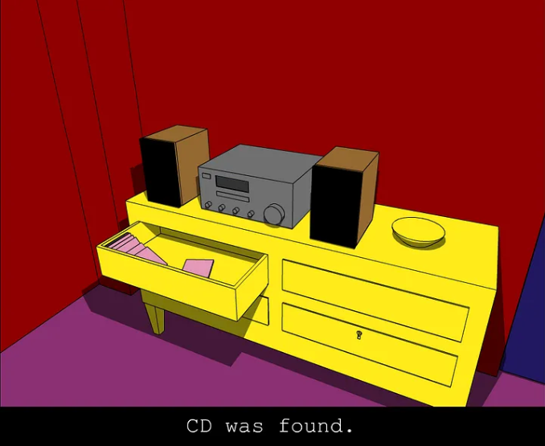

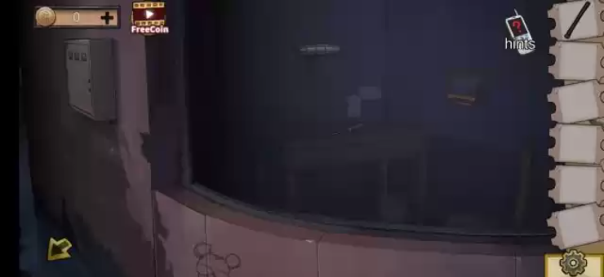

List of techs that may be used in your game: The game will make use of scene switching to swap between different rooms, and a flag system to keep track of progress the player has made between each different scene. The puzzles themselves would also utilize different techs depending on the type of puzzle, such as pathfinding for an enemy in a maze, or perhaps even basic AI if there’s a puzzle that makes you compete against someone else to win.