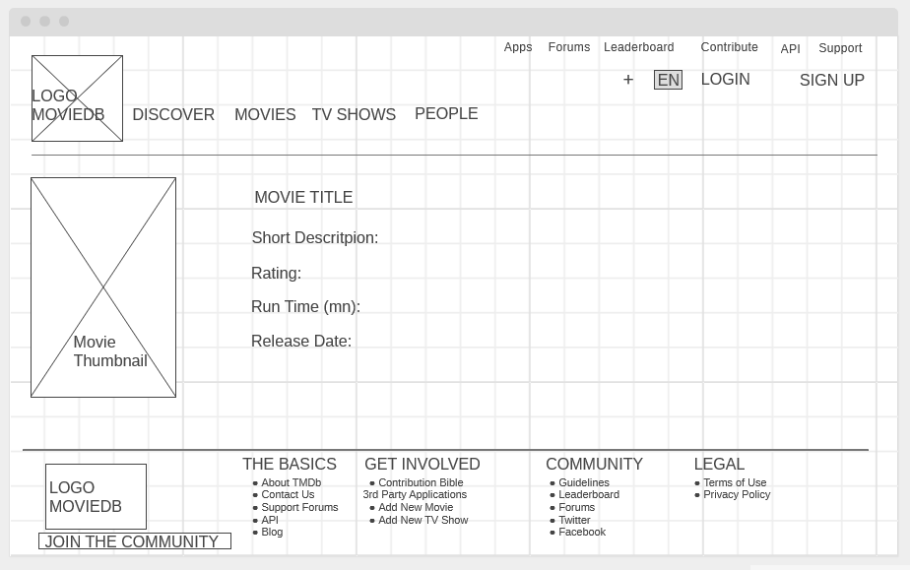

Displayinfo Component

SideLeft Component