**7 reasons why eBooks are better than books**

**TEXT:**

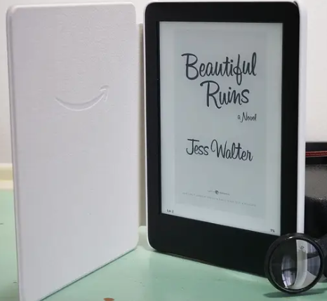 I have always been a book worm. When I was eight, I even won an award for "being an avid, spontaneous reader". Growing up, my room was full of shelves upon shelves of paperbacks and hardcovers. I kept a journal to remember all the books I had read. I scorned people who bent the corners of pages instead of using a bookmark, I hated when book spines cracked or covers bent.

When eBooks came on the scene, I thought they were ridiculous. Why would I want to read on a digital device when I could hold a lovely physical book, when I could smell the pages and have the satisfaction of turning real pages? I was, in short, a book fanatic.

I tell you all this because I'm never not surprised that I am now an eBook evangelist.

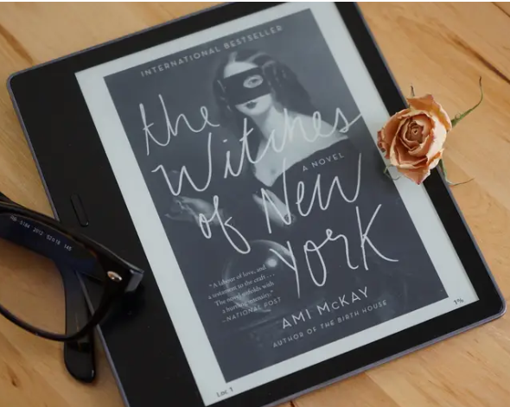 It all started when I (accidentally) became a tech reporter and I started to review e-readers. At first, I disliked having to test them and eagerly awaited going back to my paperbacks, but then I started traveling a lot for work and something clicked: eBooks are good!

**eBooks vs. books: Why are eBooks better?**

1. They are much more portable than physical books, so you can carry dozens if not hundreds or thousands of them around with you on a device that weighs less than half a pound.
2. You can download them in a matter of minutes so you don't have to wait for them to be delivered if you ordered them online.
3. You don't have to go to the store to buy them.
4. They are never out of stock because they are digital files.
5. You can get many eBooks for free from Project Gutenberg, Amazon, and your local library.
6. eBooks often go on sale, so you can get bestsellers for $1 to $5. You can follow BookBub for deal alerts.
7. They come with fun features like sharing highlighted quotations on social media, looking up words in the dictionary as you read, digital bookmarks, and much more.

Convinced yet? You should be! Now that I've got you, here's some more information on where to buy eBooks and where to get free eBooks.

You can read eBooks with or without an e-reader — all you need is a smartphone or tablet. You can get eBooks from a lot of sources, including Amazon, Kobo, the Nook store, and more.

It's easy to find free eBooks from a variety of sources like Amazon. My favorite avenue is the Libby app from Overdrive, which gives me access to all the eBooks I can borrow from my local library.

**Now go forth and read eBooks!**

**Jul 10th , 2021, 10:14 PM (Adapted)**

**Task 1 : Find words closest in meaning to the following**

1. Enthusiastic = 3. Look down on =
2. Despise = 4. Take for temporary use =

**Task 4: Answer the following questions from the text**

1. What is the purpose of the writer?
2. The writer reads a lot of books but how can she keep track of all the book she has read?
3. How did the author switch from being a book fanatic to an ebooks evangelist?
4. Summarize in just a few words the reasons mentioned in the text on why are ebooks better?
5. What about you do you like reading books or ebooks? Why?

**Task 3: Explain the meaning of these two expressions**

1. “book worm”
2. “ebook evangelist”

**Task 2: True or false ?**

1. The writer lost count of how many books she has read
2. She can’t believe that she loves ebooks now
3. Digital books are cheap

* **YOU WRITE:**

**Your best friend likes reading e-books and you prefer reading printed books. Write a short informal letter in order to persuade your friend to switch to printed books. Give clear reasons and facts that support your opinion.**

**You can use these clues**

* Printed books help you de-stress, sleep better
* keep you focused
* collectible
* they don’t hurt your eyes
* book-smell
* you absorb more information …
* the drawbacks (disadvantages) of ebooks