1. Individual turn   
  
 **HOUSE, HOME, ENVIRONMENT**: Individual long turn 1

**City life vs. country life**

Material 1:

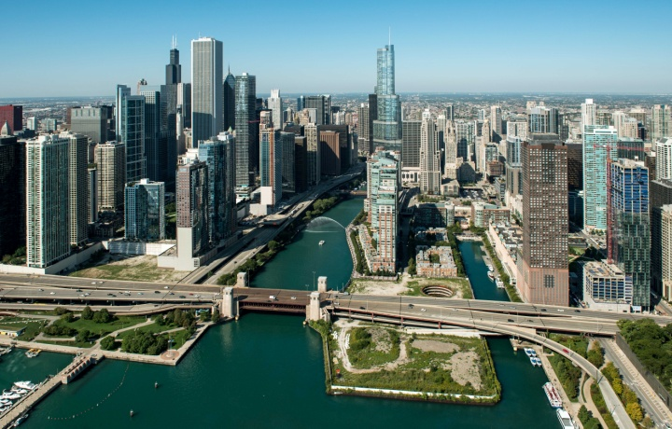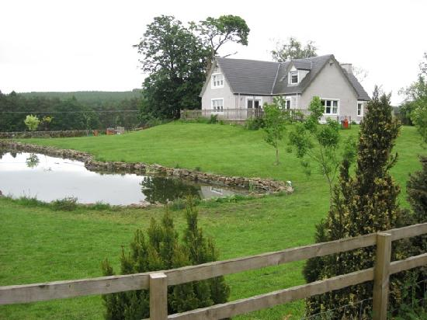

You are a regular member in your school’s debate club. You draw a topic and need to give a short presentation about living in the city vs. living in the country. In your presentation you should:

* **Compare** the pictures (Material 1)
* **Discuss** the advantages and disadvantages of living in the city and living in the country (Material 2).
* **Speculate about** future housing trends.

2. Dialogue   
  
After your discussion, some debate club members ask you the following questions:  
  
- **Describe** your personal living situation: do you live in the country or the city?  
  
- **Analyze** the advantages and disadvantages of commuting (Material 3)

- **Make a recommendation** regarding transportation for students at the TGM.

Material 2:

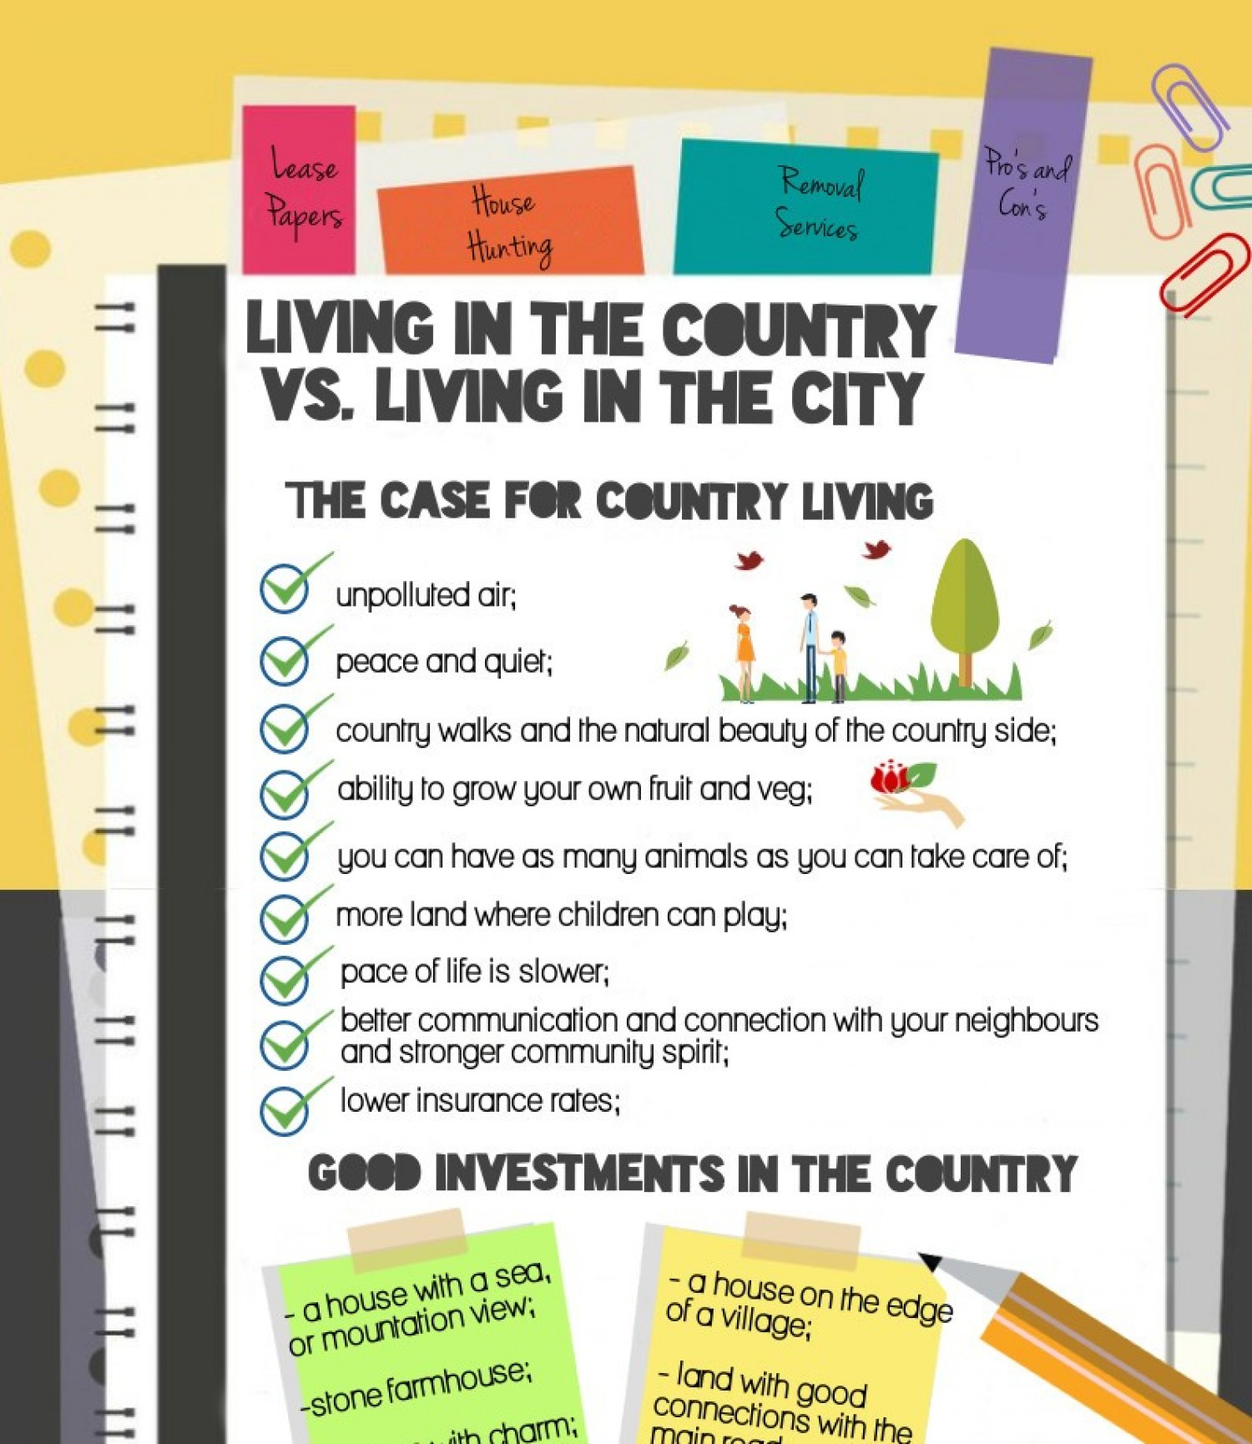

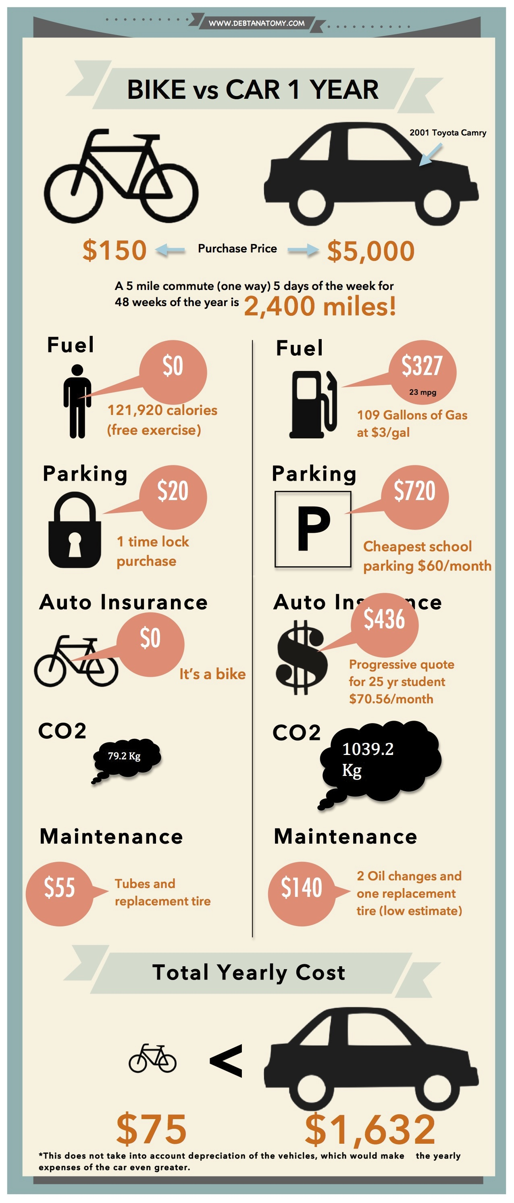Material 3: