Task 5 — Overall Solution Connectivity
Smart Turtle Breeding System (STBS) · Assignment 1b

5.1 Graphical representation
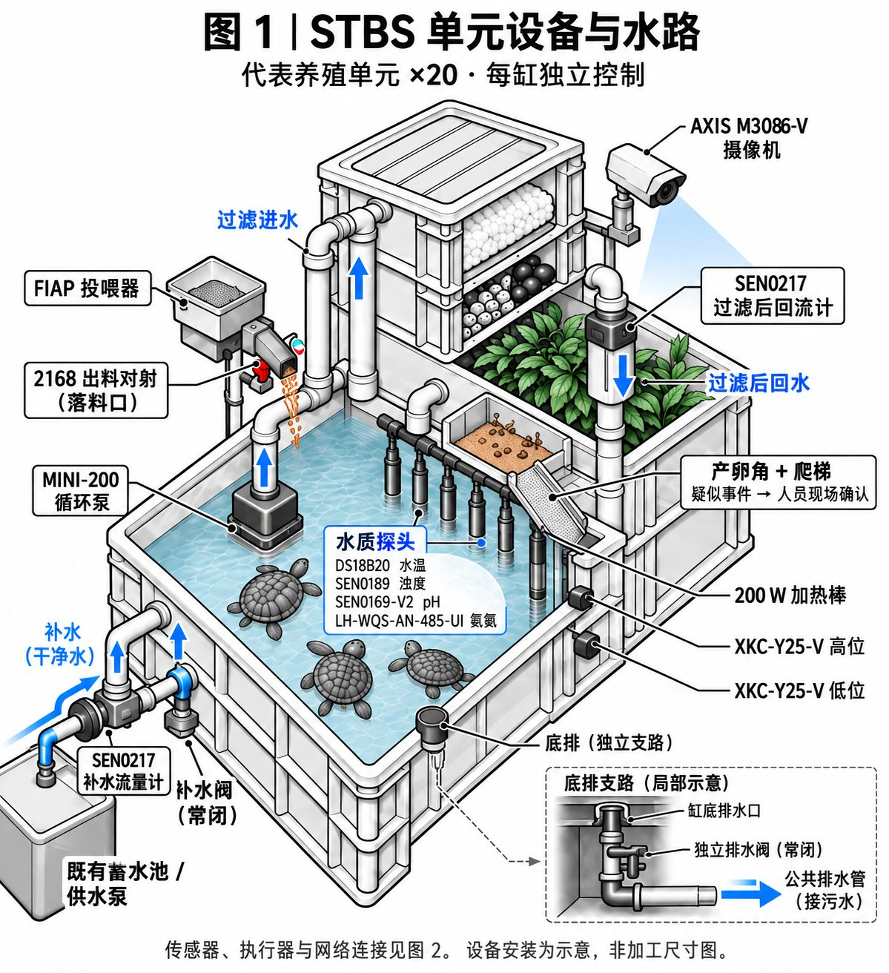
Figure 1. Representative tank: devices and water paths (one of 20 identical units).

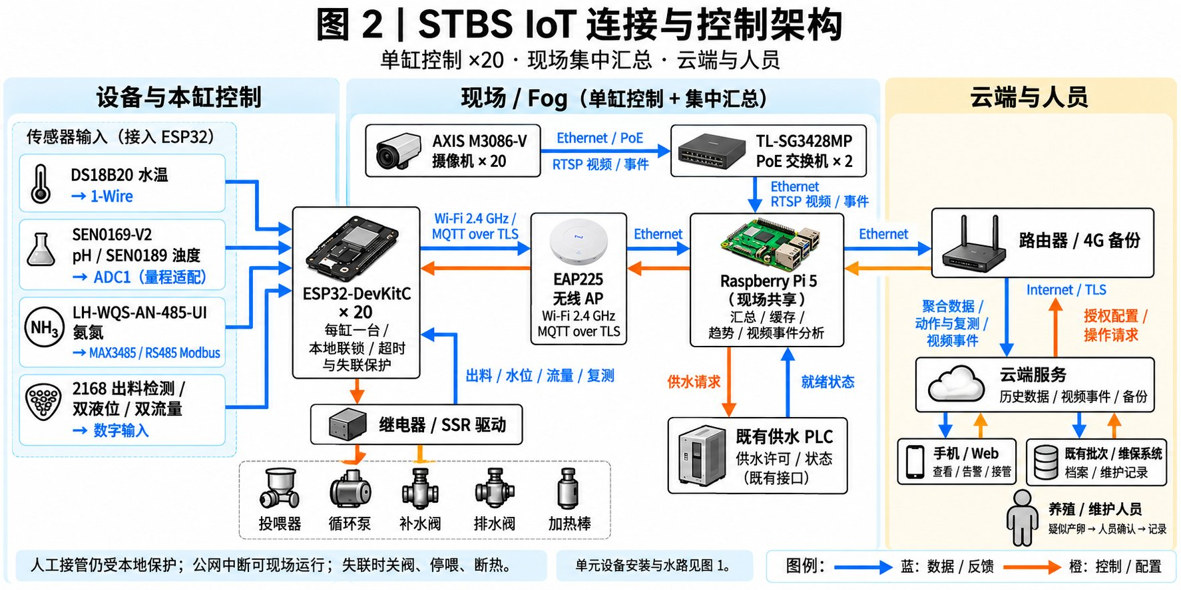
Figure 2. IoT connectivity and control architecture: device layer, field/fog layer, cloud, user applications and existing systems.
Legend (Figure 2): blue = data and feedback (upstream); orange = control and configuration (downstream).

5.2 Description of the diagram (max 150 words)
Figure 1 shows one of twenty identical tanks. Four probes (temperature, turbidity, pH, ammonia) hang in the water; high and low level sensors sit on the outer wall; two flow meters meter make-up water and filter return; a break-beam unit checks feed delivery; a camera covers the tank and its nesting corner. Circulation pump, drain valve, make-up valve, feeder and heater are driven from the tank's ESP32 box. Figure 2 follows the data path: probes and digital inputs reach that box over 1-Wire, ADC channels, RS485 and GPIO; each ESP32 joins the site access point over Wi-Fi with MQTT/TLS. Cameras stream over PoE to two switches. A Raspberry Pi 5 aggregates records, buffers outages, runs the behaviour model on event clips and coordinates the supply PLC. Aggregated data and approved commands reach the cloud, the staff app and existing batch and maintenance systems through the router.
(Word count: 146 words)

Figure notes — what to say when presenting
- Figure 1 answers where: every device sits where its measurement or action is physically valid (probes submerged, camera high, valves on the branches).
- Figure 2 answers how: four layers, two flow directions, and one labelled technology per link.
- Local autonomy: the ESP32 keeps level interlock, 32 °C cut-out and a link watchdog, so a WAN outage never stops the tank; a link loss closes valves, stops feeding and heating, and keeps circulation.
- Honest boundary: nesting is inferred from visual behaviour only and still needs staff confirmation; the camera cannot locate eggs under the substrate.

