LeanMindset V4
UI Handoff Package
  - Protected V3 baseline • Lifecycle-aware Labs • Mobile member app + separate admin workflow

STATUS DESIGN & IMPLEMENTATION SPECIFICATION — DO NOT DEPLOY
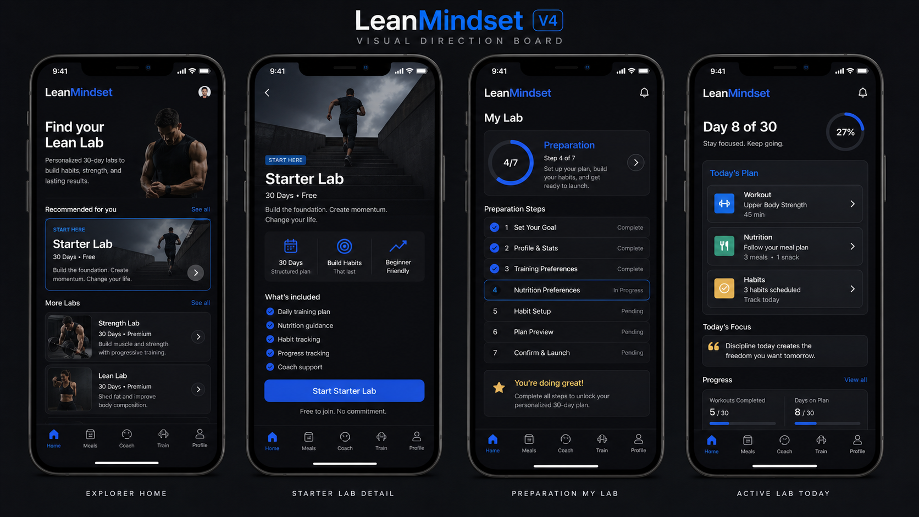
This visual direction board establishes tone only. The existing V3 code and assets—not this board—are the source of truth for protected navigation, typography, icons, spacing, and unchanged screen regions.

1. Non-negotiable V4 boundary
- Duplicate V3 into a separate V4 folder/branch/workspace before editing.
- Do not modify, mix with, overwrite, merge into, or delete V3. V3 must remain rollback-safe.
- Do not deploy. Do not upload to Apple. Do not upload to TestFlight. Do not change production services, production data, app-store metadata, certificates, or release configuration.
- Stop after local V4 implementation and verification. Production work requires explicit written approval.

2. Source-of-truth hierarchy
1) Existing V3 implementation for protected components and unchanged screens. 2) This document for V4 state logic, copy, routes, and changed content regions. 3) Screen images for layout intent. If an image conflicts with V3 chrome, preserve V3 chrome. Cursor must never reconstruct an existing component from a screenshot when it can import the existing V3 component.

3. LOCKED / KEEP EXACTLY AS V3
- DO NOT TOUCH — Welcome Back / Login
- DO NOT TOUCH — OTP and verification
- DO NOT TOUCH — Password reset and authentication states
- DO NOT TOUCH — Existing five-tab bottom navigation component
- DO NOT TOUCH — Exact Home, Meals, Coach, Train, Profile icons and labels
- DO NOT TOUCH — Typography family, scale, weights, and line-height tokens
- DO NOT TOUCH — Black/grey backgrounds, blue primary accent, limited yellow accent
- DO NOT TOUCH — Existing cards, spacing, buttons, radii, shadows, imagery, and loaders
- DO NOT TOUCH — Existing screens and components not named as changed in this handoff
- DO NOT TOUCH — Existing analytics, API contracts, auth, notifications, and accessibility behavior unless a V4 state explicitly requires an additive change
Never add a sixth “Labs” tab. Labs enter through Home; after approval, Home links to My Lab. Profile may expose one membership/status row only.

4. Lifecycle state model
State | Home | Meals | Coach / Check-in | My Lab
Explorer | One premium Find your Lean Lab card; useful general content | Meal Ideas + one Lab CTA | Chat available; check-in unavailable | Not shown
Requested / Pending | Pending status card replaces sales CTA | Explorer Meal Ideas | Chat available; check-in unavailable | Request status only
Approved / 2-day Preparation | Approval/start countdown + preparation progress | Keep Explorer ideas until Day 1 | Chat available; check-in scheduled for Day 1 | Preparation command center
Active Lab | Day/plan summary; no Lab sales card | Reuse existing detailed V3 Meals UI with Lab data | Chat + daily check-in | Today / Resources / Check-ins / Progress
Completed Lab | Completion/result summary | Return to general ideas or preserved history | Chat remains; active check-in closes | Results / History / What’s next

5. Click-by-click navigation
- Explorer enrollment: Home → Find your Lean Lab → Explore Labs → Starter Lab → Join Starter Lab → Confirm → Request submitted → Home pending state
- Coach approval: Admin → Enrollments → Request → Review → Approve + assign start date → user receives approval state
- Preparation: Approval card → Start preparing → My Lab → Baseline / Grocery List / Supplements / Health Check / Program Guide → mark each complete → Ready for Day 1
- Active day: Home → Continue my day → My Lab Today → task → relevant existing tab/detail → return to Today; Meals / Coach / Train remain accessible from protected bottom nav
- Daily check-in: Coach → Daily Check-in → complete Weight / Meals / Water / Workout / Mood / note → Submit → confirmation → My Lab status updates
- Completion: Home completion card → Results → My Lab history; Lab sales card stays absent while completed history is present
- Admin follow-up: Admin Overview → Client → Today / adherence / alerts / recent conversation → Reply or open Check-in detail

6. Screen inventory and acceptance notes

01 Home Lab Discovery Enrollment
- 01 Explorer Home: Explorer Home — complete-state reference. Every visible card is explicit; destinations are separate files; do not invent below-fold modules.
- 02 Lab Catalog: Lean Labs — complete-state reference. Every visible card is explicit; destinations are separate files; do not invent below-fold modules.
- 03 Starter Lab Detail: Starter Lab — complete-state reference. Every visible card is explicit; destinations are separate files; do not invent below-fold modules.
- 04 Join Confirm: Request to join? — complete-state reference. Every visible card is explicit; destinations are separate files; do not invent below-fold modules.
- 05 Request Submitted: Request submitted — complete-state reference. Every visible card is explicit; destinations are separate files; do not invent below-fold modules.
- 06 Pending Home: Starter Lab — complete-state reference. Every visible card is explicit; destinations are separate files; do not invent below-fold modules.

02 Preparation My Lab
- 07 Approved Welcome: You’re in! — complete-state reference. Every visible card is explicit; destinations are separate files; do not invent below-fold modules.
- 08 Preparation Hub: My Lab — complete-state reference. Every visible card is explicit; destinations are separate files; do not invent below-fold modules.
- 09 Baseline: Baseline — complete-state reference. Every visible card is explicit; destinations are separate files; do not invent below-fold modules.
- 10 Grocery List: Grocery List — complete-state reference. Every visible card is explicit; destinations are separate files; do not invent below-fold modules.
- 11 Supplements: Supplements — complete-state reference. Every visible card is explicit; destinations are separate files; do not invent below-fold modules.
- 12 Health Check: Health Check-in — complete-state reference. Every visible card is explicit; destinations are separate files; do not invent below-fold modules.
- 13 Program Guide: Program Guide — complete-state reference. Every visible card is explicit; destinations are separate files; do not invent below-fold modules.
- 14 Preparation Complete: Ready for Day 1 — complete-state reference. Every visible card is explicit; destinations are separate files; do not invent below-fold modules.

03 Active Completed Lab
- 15 Active Home: Starter Lab — complete-state reference. Every visible card is explicit; destinations are separate files; do not invent below-fold modules.
- 16 My Lab Today: My Lab — complete-state reference. Every visible card is explicit; destinations are separate files; do not invent below-fold modules.
- 17 Problem Day: Let’s reset today — complete-state reference. Every visible card is explicit; destinations are separate files; do not invent below-fold modules.
- 18 Progress: Progress — complete-state reference. Every visible card is explicit; destinations are separate files; do not invent below-fold modules.
- 19 Completed Home: Starter Lab complete — complete-state reference. Every visible card is explicit; destinations are separate files; do not invent below-fold modules.
- 20 Results: Your Results — complete-state reference. Every visible card is explicit; destinations are separate files; do not invent below-fold modules.

04 Meals Coach Train Profile
- 21 Meal Ideas: Meal Ideas — complete-state reference. Every visible card is explicit; destinations are separate files; do not invent below-fold modules.
- 22 Active Meals: Today’s Meals — complete-state reference. Every visible card is explicit; destinations are separate files; do not invent below-fold modules.
- 23 Coach Explorer: Coach — complete-state reference. Every visible card is explicit; destinations are separate files; do not invent below-fold modules.
- 24 Daily Checkin: Daily Check-in — complete-state reference. Every visible card is explicit; destinations are separate files; do not invent below-fold modules.
- 25 Train Explorer: Train — complete-state reference. Every visible card is explicit; destinations are separate files; do not invent below-fold modules.
- 26 Train Active: Train — complete-state reference. Every visible card is explicit; destinations are separate files; do not invent below-fold modules.
- 27 Profile Lab Access: Profile — complete-state reference. Every visible card is explicit; destinations are separate files; do not invent below-fold modules.

05 Admin Workflow (separate responsive web app)
- A1 Enrollment Queue: Enrollment requests
- A2 Request Review: Review: Mani A
- A3 Client Overview: Mani A — Day 8/30
- A4 Checkins: Daily check-ins
- A5 Alerts: Coach alerts
- A6 Message: Coach conversation

7. Cursor master implementation prompt
You are implementing LeanMindset V4 as a separate, local-only iteration.
FIRST, STOP AND PROTECT V3
1. Identify the current V3 root and current branch/workspace.
2. Duplicate V3 into a separate V4 folder/branch/workspace. Use a clearly named V4 location.
3. Verify V3 and V4 are distinct. Record both absolute paths and the git status/commit before editing.
4. Make every code change only inside V4. V3 must remain untouched and rollback-safe.
5. Do not deploy. Do not upload to Apple or TestFlight. Do not change production, release, signing, certificates, app-store metadata, live databases, or production configuration.
SOURCE-OF-TRUTH ORDER
A. Existing V3 code/assets are authoritative for every protected or unchanged component.
B. The LeanMindset V4 handoff document is authoritative for lifecycle states, copy, navigation, and changed content regions.
C. PNG screens communicate layout intent only. If a PNG differs from V3 chrome, retain V3 chrome.
DO NOT TOUCH / DO NOT REDESIGN
- Welcome Back/Login, OTP, password reset, and other unchanged auth screens.
- The exact existing five-tab bottom navigation, icons, labels, sizing, spacing, safe-area behavior, active states, and routes. Never add a Labs tab.
- Existing typography, black/grey visual system, blue primary accent, limited yellow accent, card system, buttons, backgrounds, spacing, radii, shadows, imagery, and loaders.
- Existing screens and components unless this specification explicitly identifies a changed state or content region.
- Existing business logic, APIs, analytics, authentication, accessibility, and notifications except for the smallest additive changes required by an explicit V4 state.
REUSE, DO NOT REBUILD
Import and reuse V3 components/assets directly. Extend via props, composition, feature flags, and state-aware content. Do not trace screenshots. Do not create lookalike icons. Do not replace existing navigation or screen shells. Before modifying a protected shared component, stop and explain why composition cannot meet the requirement.
IMPLEMENTATION ORDER
1. Add a typed Lab lifecycle state: explorer, requested, approved_preparing, active, completed. Include start date, day, preparation tasks, daily tasks, check-in, and progress data.
2. Add routes/screens exactly in the screen inventory. Long content must live in explicit detail screens. Never invent content hidden below a screenshot.
3. Wire click paths exactly as documented. Back behavior must return to the originating overview and preserve state.
4. Home: alter only the state-aware content region. Explorer gets one Lab CTA; pending gets request status; preparation gets countdown/progress; active gets today summary; completed gets results summary.
5. Meals: explorer shows Meal Ideas; active reuses the existing V3 detailed Meals screen with Lab data.
6. Coach: preserve chat. Gate Daily Check-in until active; expose it during active; close it after completion while retaining history if V3 supports history.
7. Train: change only if needed to display today’s Lab workout using existing V3 Train components. Explorer retains general workouts.
8. Profile: add at most one My Lab membership/status row when needed. No catalogue in Profile.
9. Build Admin as a separate responsive web workflow, not inside the member mobile app.
QUALITY GATES BEFORE HANDOFF
- Automated route/state tests cover all five lifecycle states.
- Screenshot tests cover every changed/new screen size and state.
- Compare protected V3 screens/components pixel-for-pixel or by approved visual regression threshold; unexplained change is a failure.
- Verify accessibility labels, focus order, dynamic type/text scaling, contrast, keyboard behavior for Admin, loading/empty/error/offline states, and no dead-end routes.
- Verify all content is visible or navigates to an explicit detail screen; no hidden or inferred below-fold content.
- Provide a change manifest: reused V3 components, new V4 components, changed files, routes, state mapping, test results, and known gaps.
- End with a local review build only. Do not deploy or publish.
If any requested behavior conflicts with V3 architecture, pause and report the exact conflict with the smallest additive option. Do not use the conflict as permission to redesign.

8. Delivery checklist
☐ V4 workspace proven separate from V3 before edits
☐ All 27 mobile screens and 6 admin states mapped
☐ All five lifecycle states testable
☐ Protected V3 visual regression passes
☐ No sixth navigation item
☐ No hidden-content assumptions
☐ No deployment, Apple upload, TestFlight upload, or production change
☐ Change manifest and local verification evidence supplied

9. Screen image appendix

01 Explorer Home
01 Home Lab Discovery Enrollment
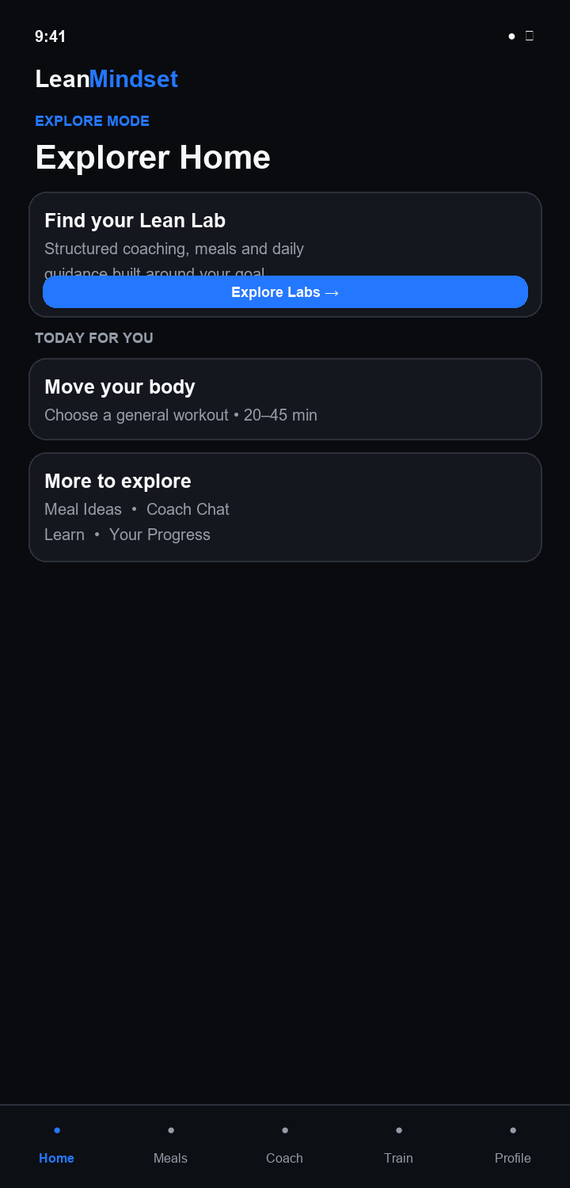

02 Lab Catalog
01 Home Lab Discovery Enrollment
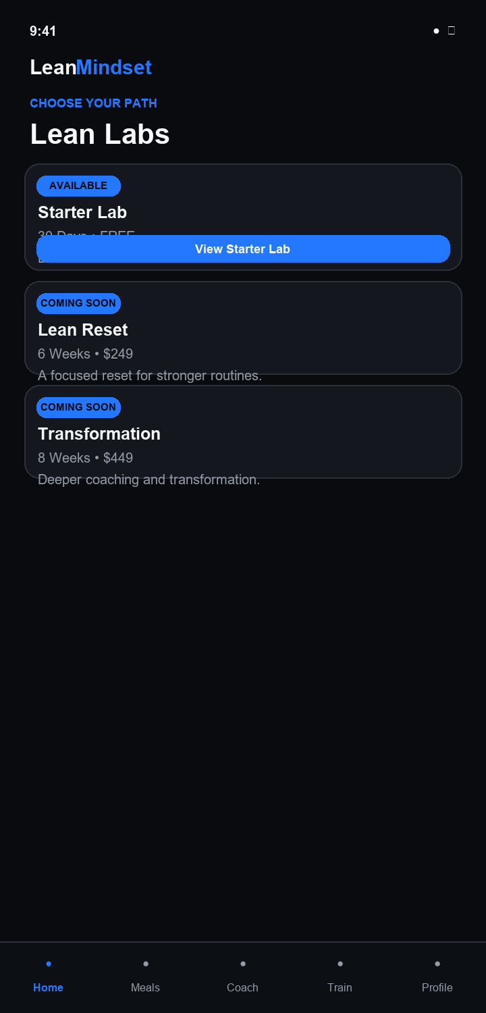

03 Starter Lab Detail
01 Home Lab Discovery Enrollment
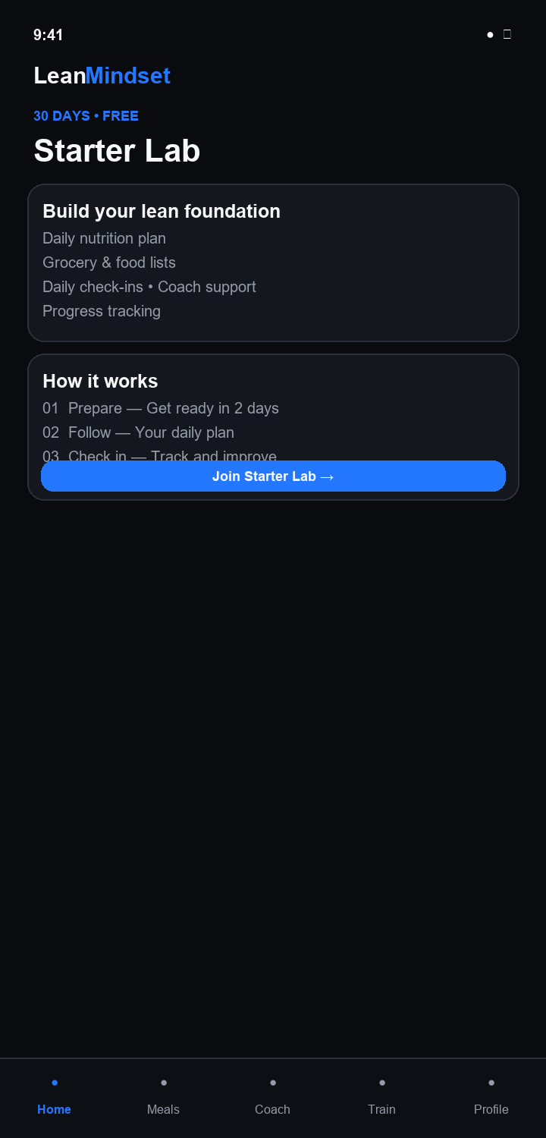

04 Join Confirm
01 Home Lab Discovery Enrollment
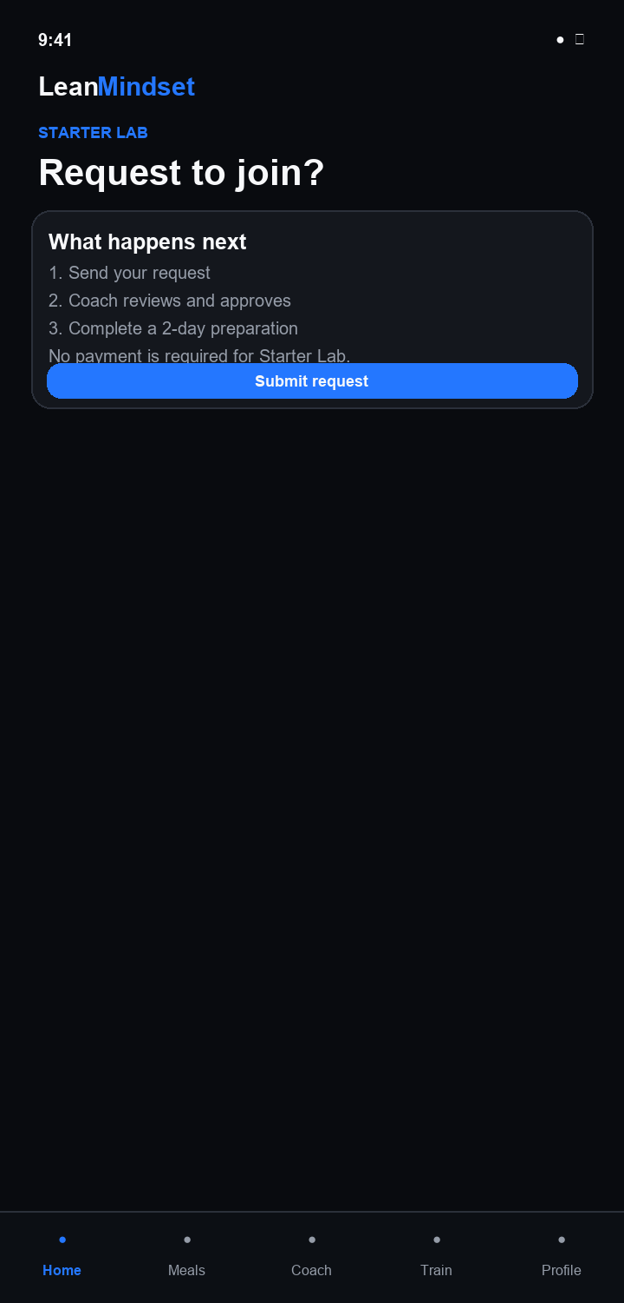

05 Request Submitted
01 Home Lab Discovery Enrollment
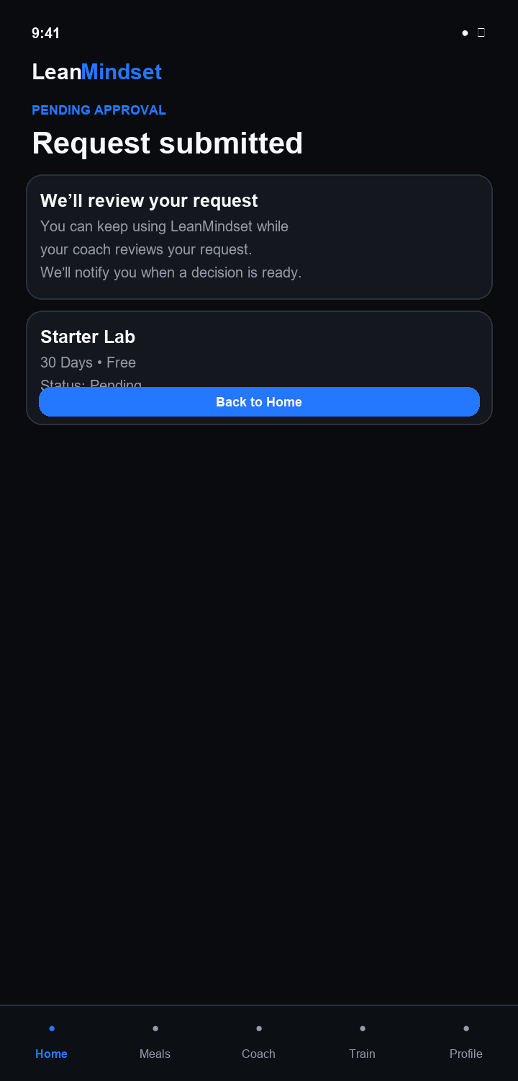

06 Pending Home
01 Home Lab Discovery Enrollment
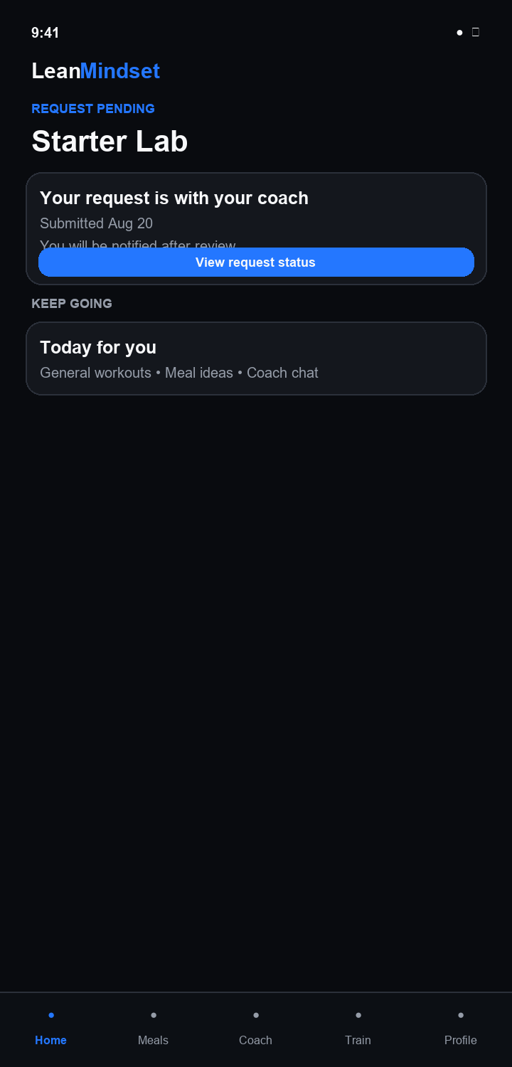

07 Approved Welcome
02 Preparation My Lab
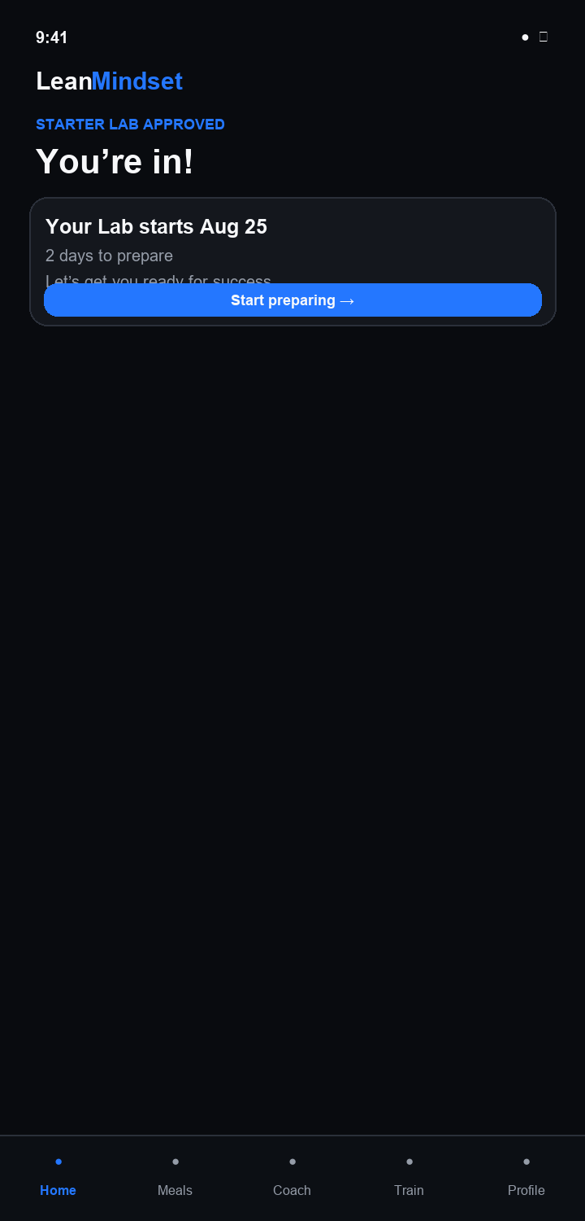

08 Preparation Hub
02 Preparation My Lab
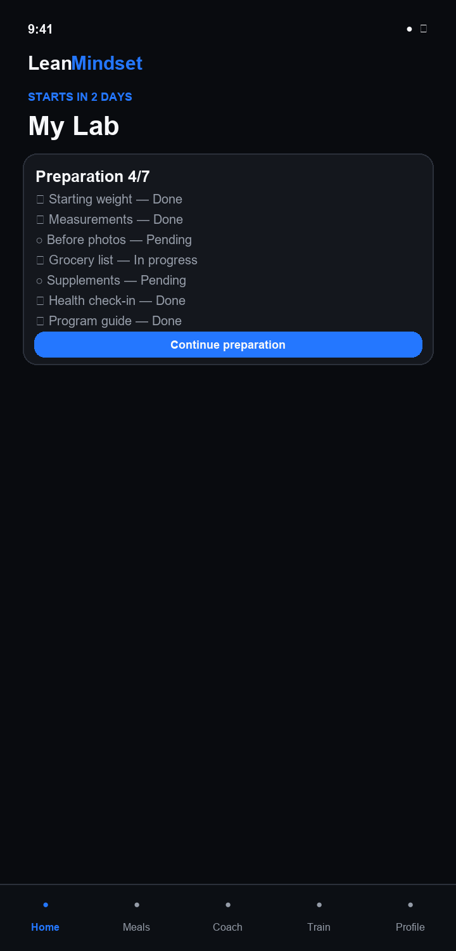

09 Baseline
02 Preparation My Lab
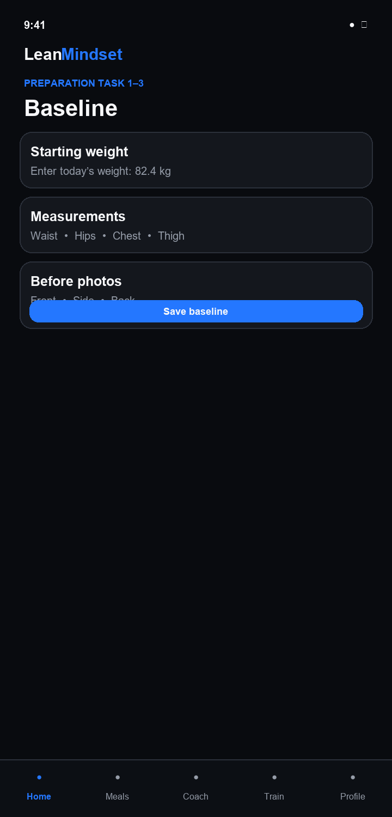

10 Grocery List
02 Preparation My Lab
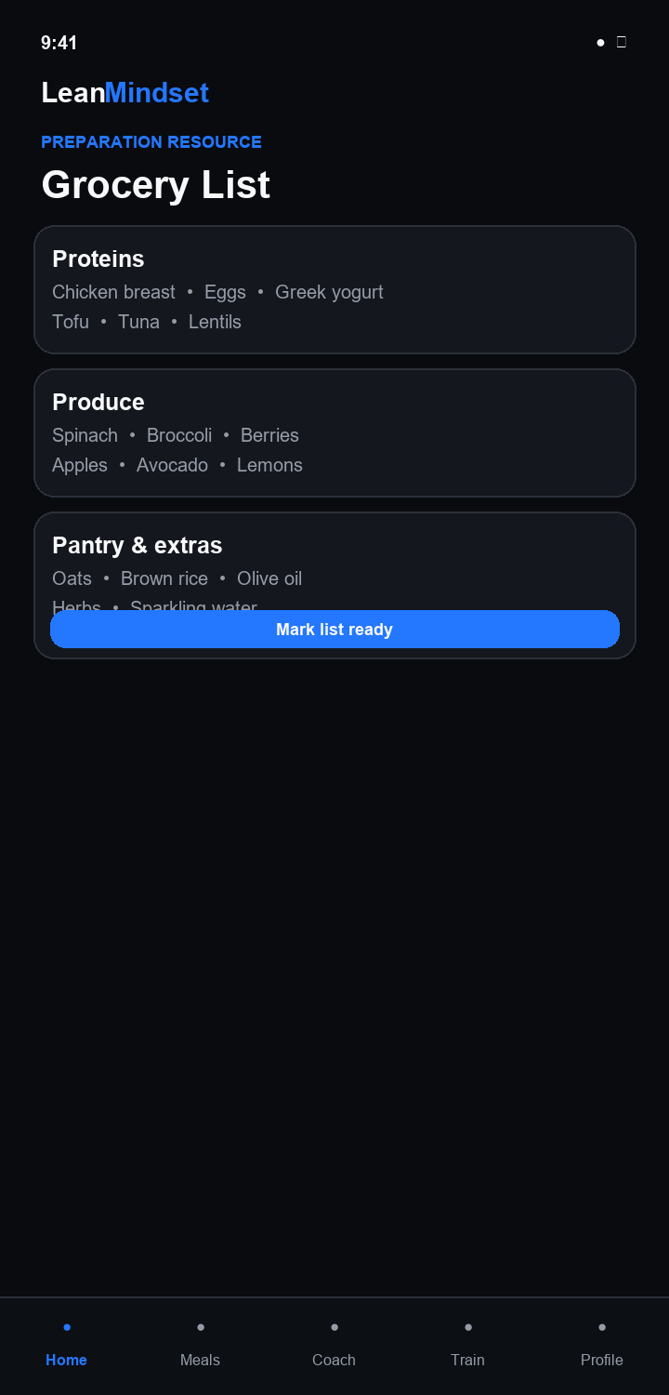

11 Supplements
02 Preparation My Lab
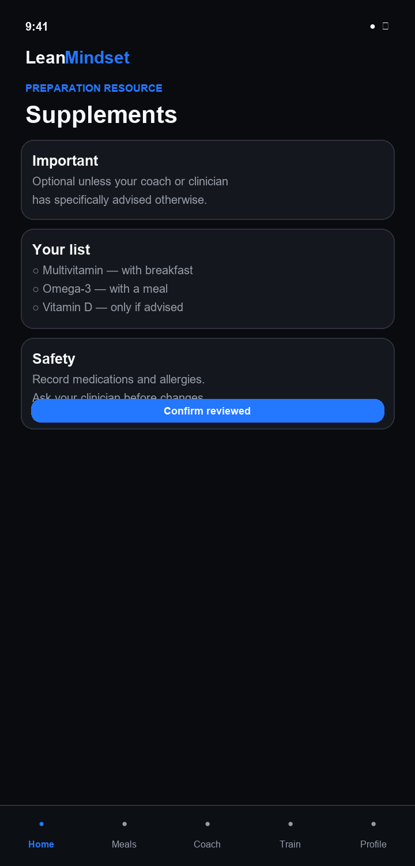

12 Health Check
02 Preparation My Lab
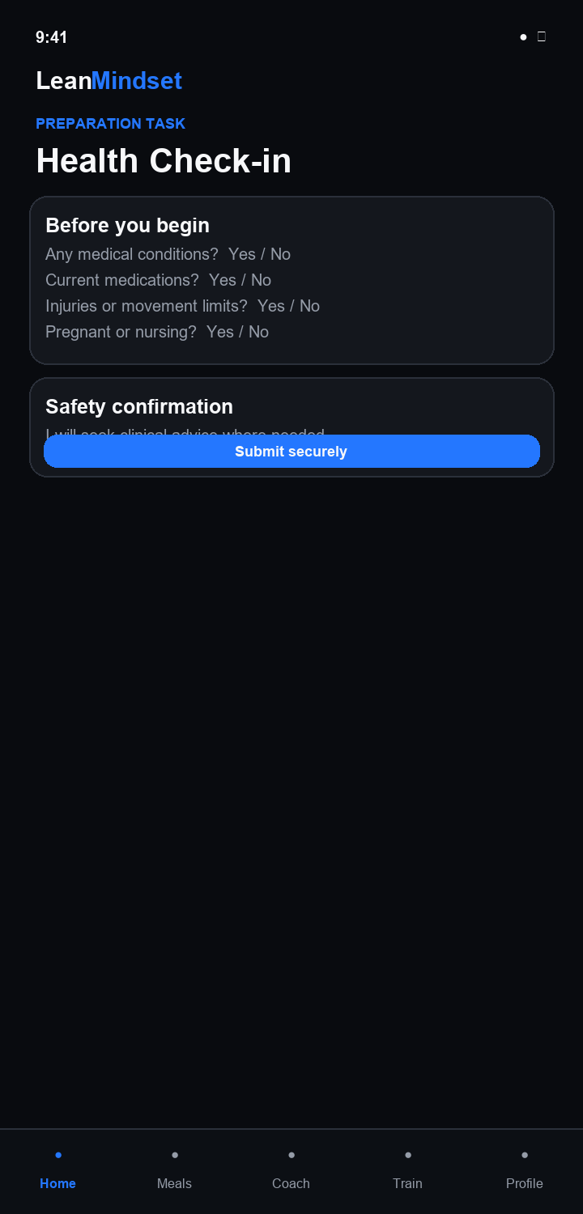

13 Program Guide
02 Preparation My Lab
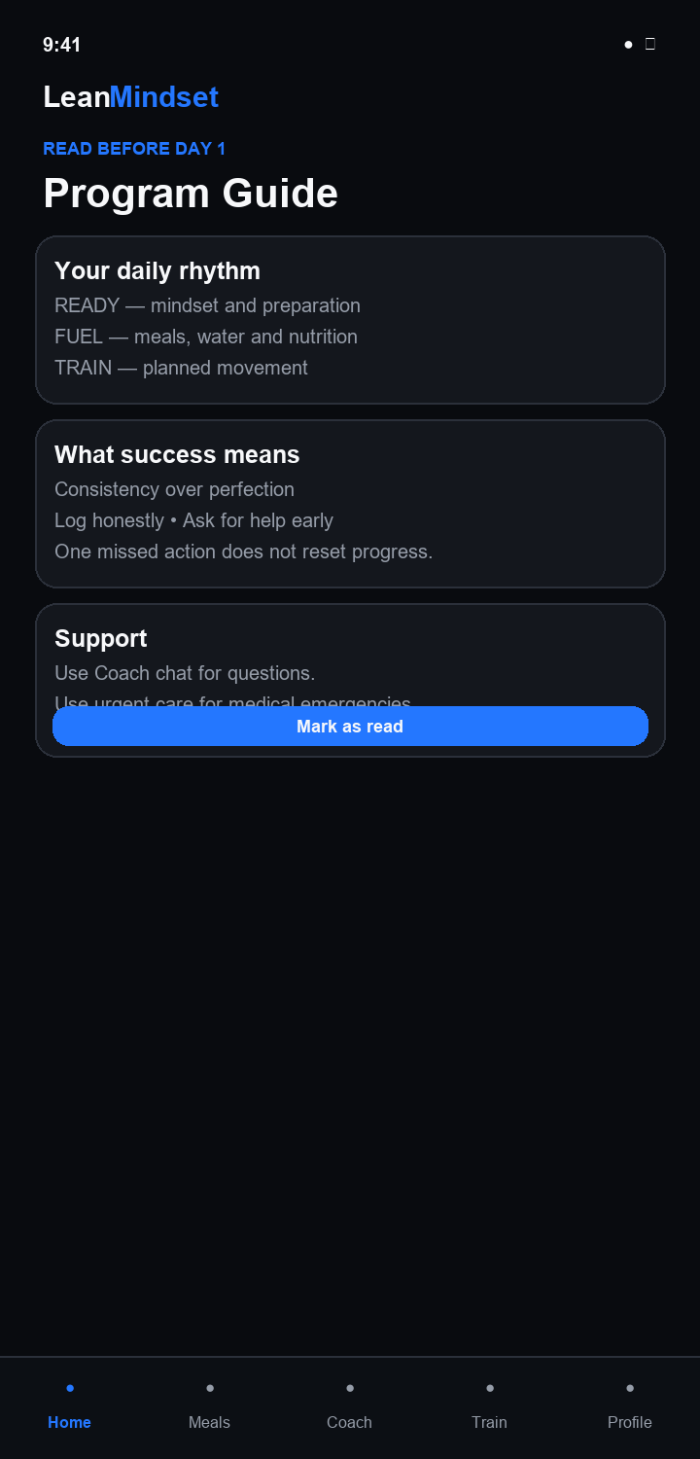

14 Preparation Complete
02 Preparation My Lab
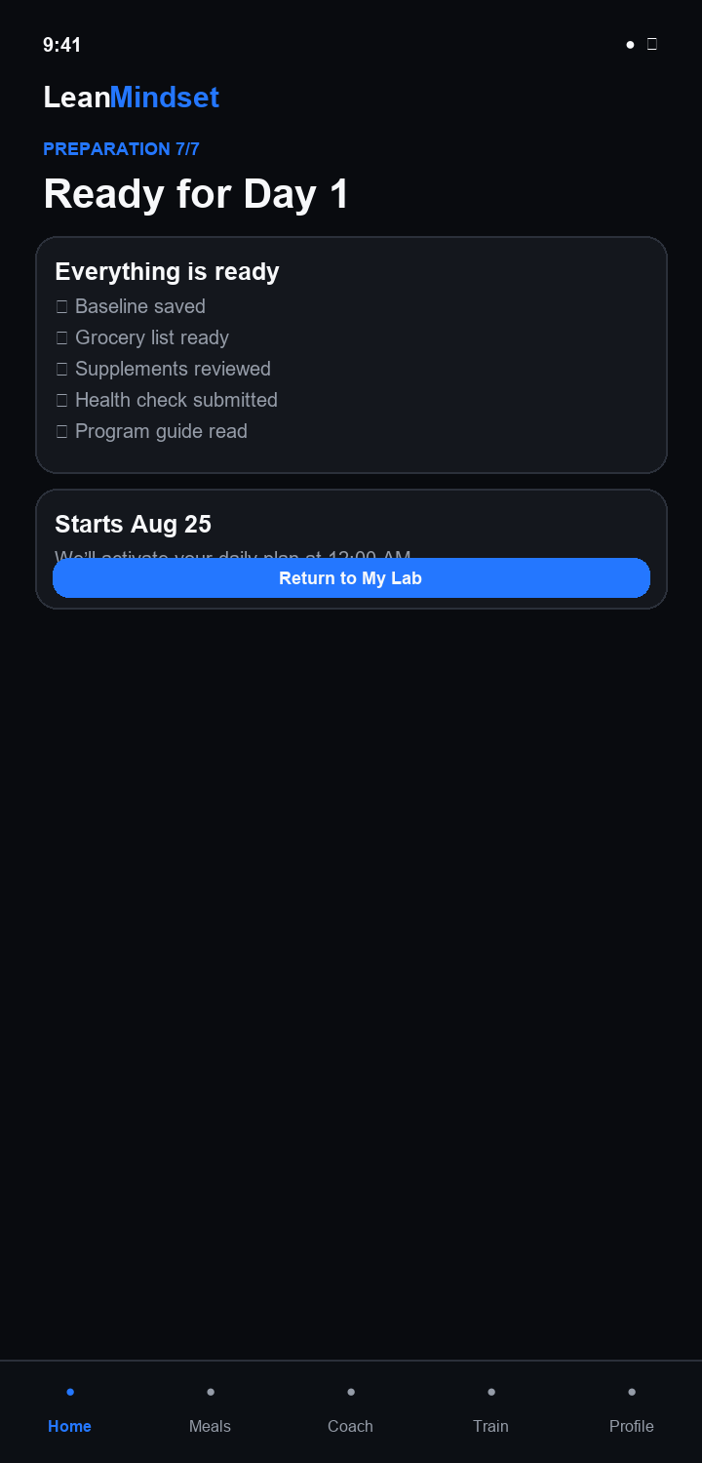

15 Active Home
03 Active Completed Lab
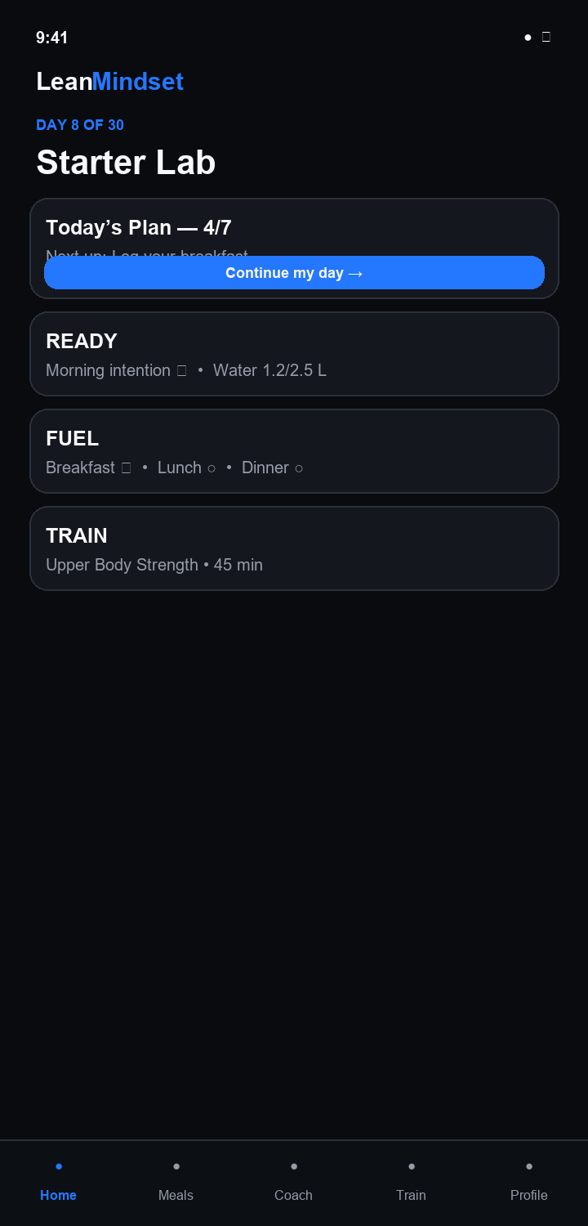

16 My Lab Today
03 Active Completed Lab
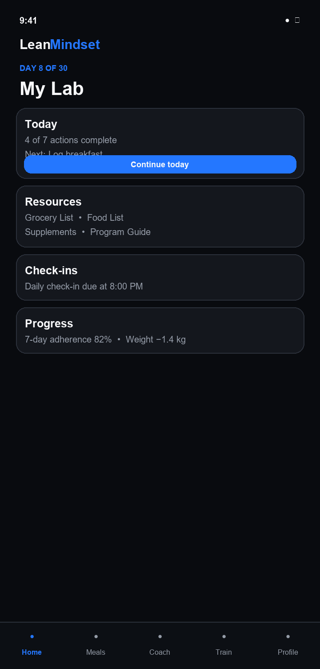

17 Problem Day
03 Active Completed Lab
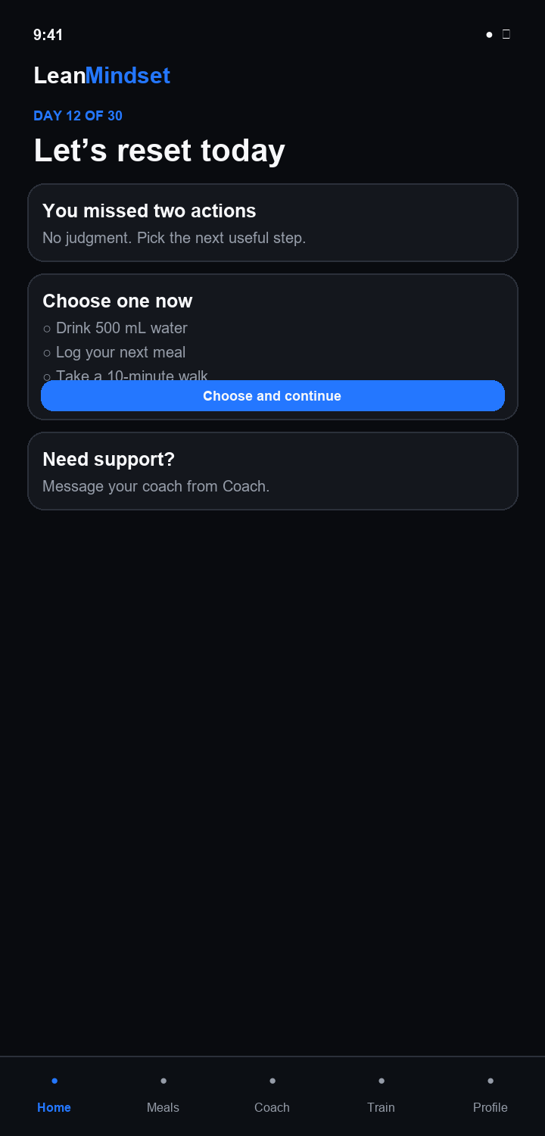

18 Progress
03 Active Completed Lab
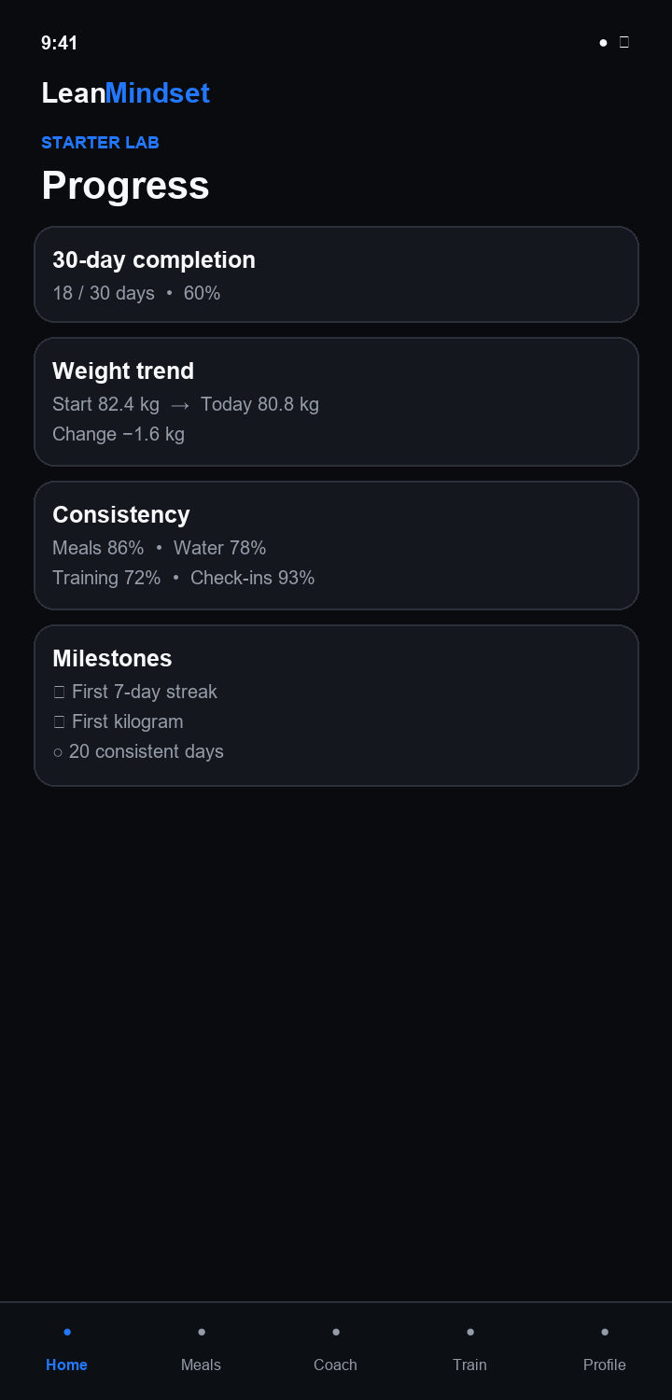

19 Completed Home
03 Active Completed Lab
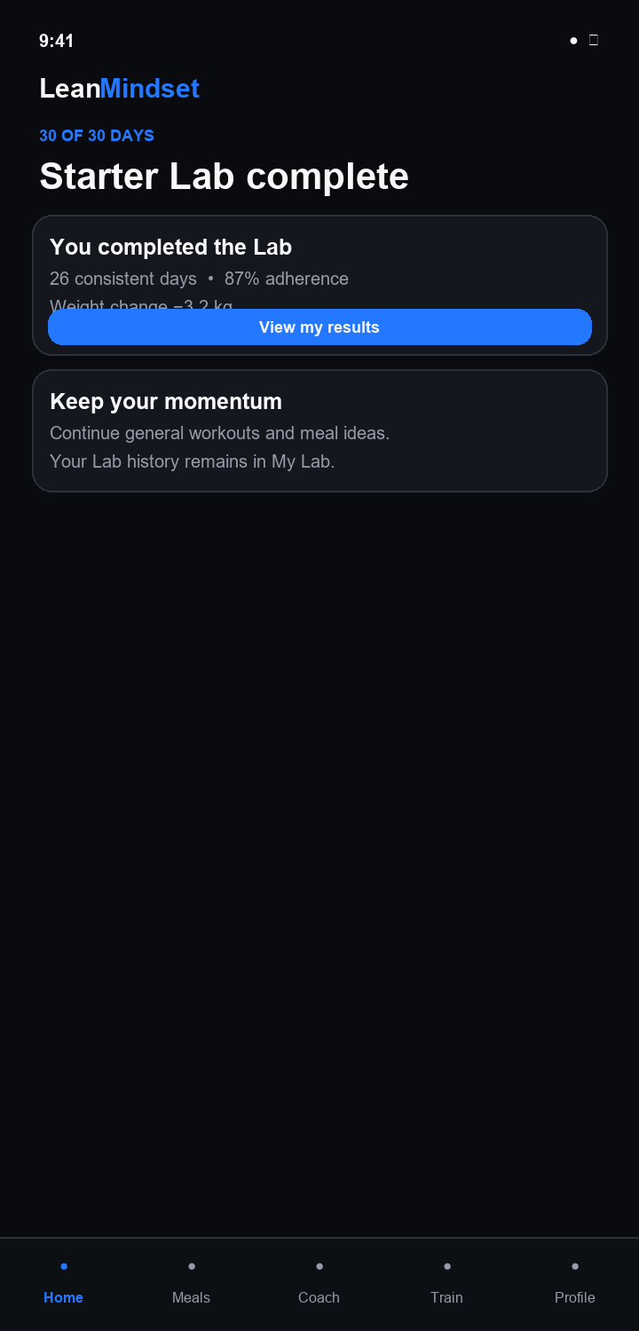

20 Results
03 Active Completed Lab
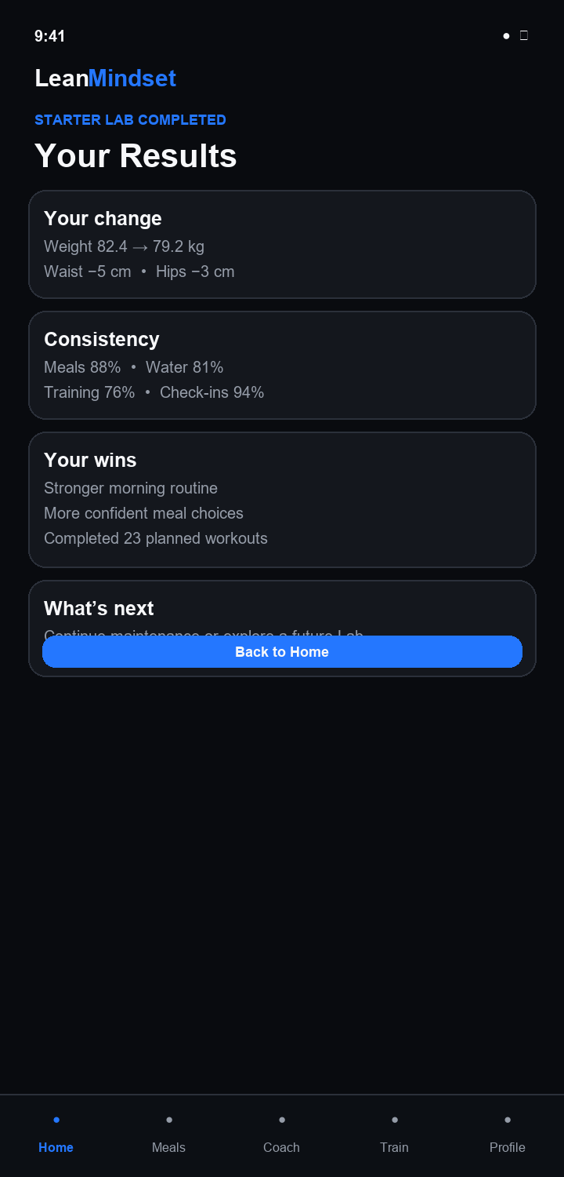

21 Meal Ideas
04 Meals Coach Train Profile
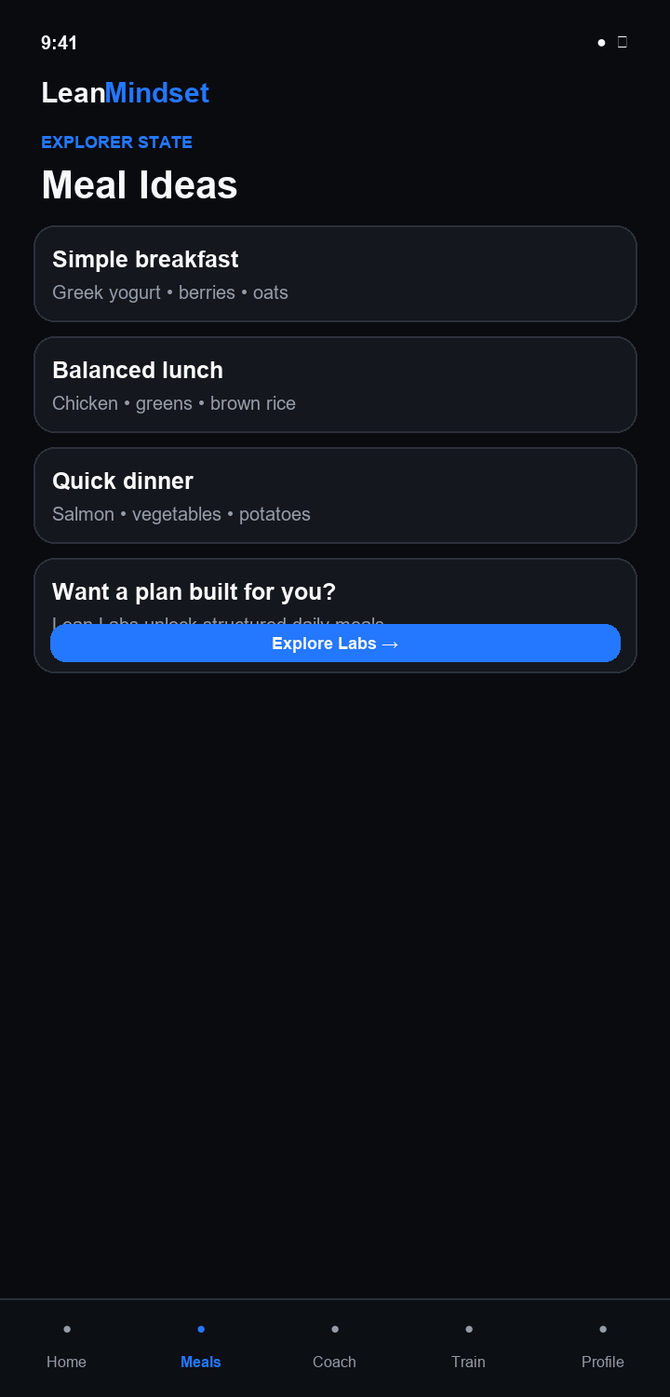

22 Active Meals
04 Meals Coach Train Profile
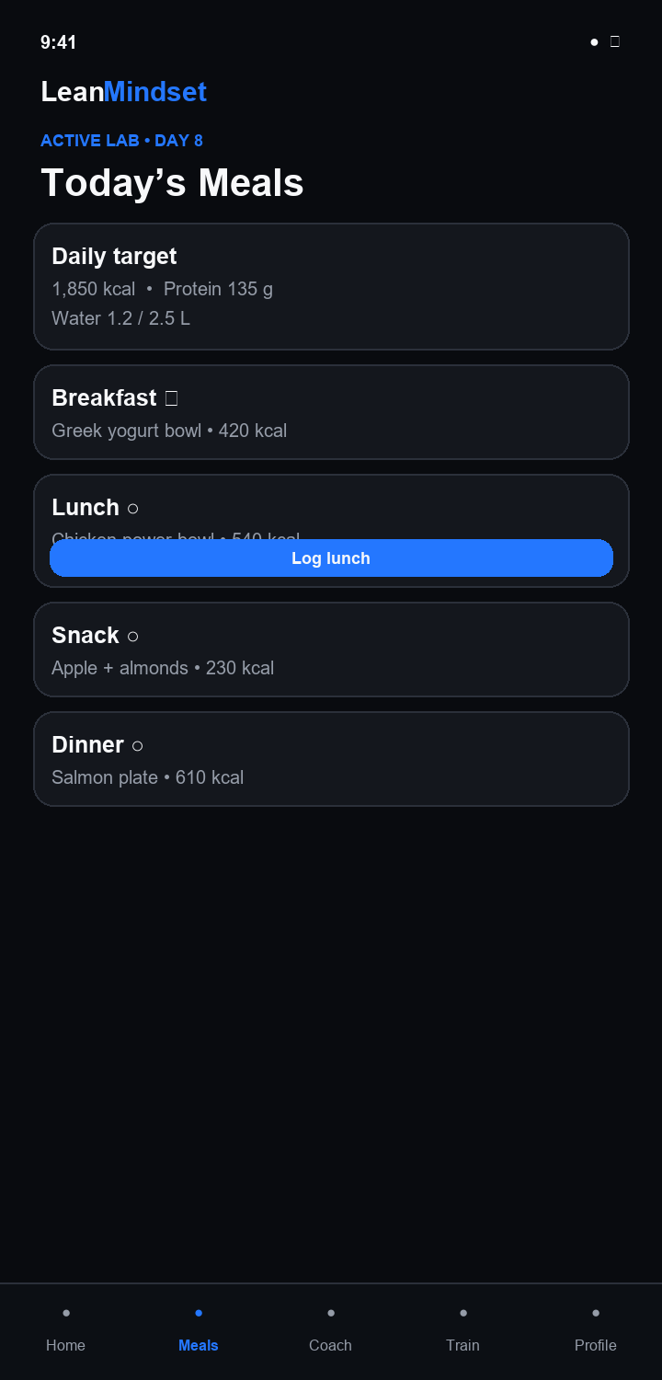

23 Coach Explorer
04 Meals Coach Train Profile
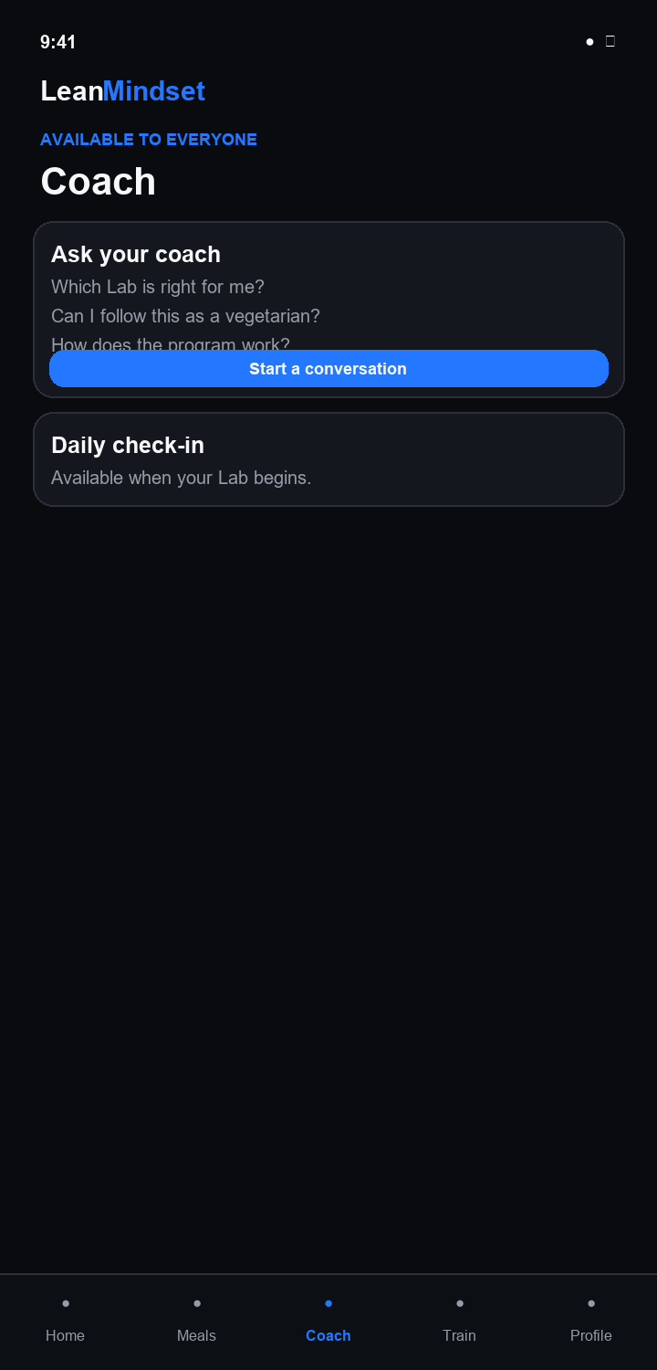

24 Daily Checkin
04 Meals Coach Train Profile
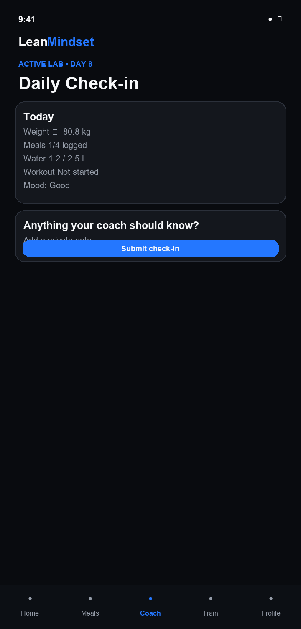

25 Train Explorer
04 Meals Coach Train Profile
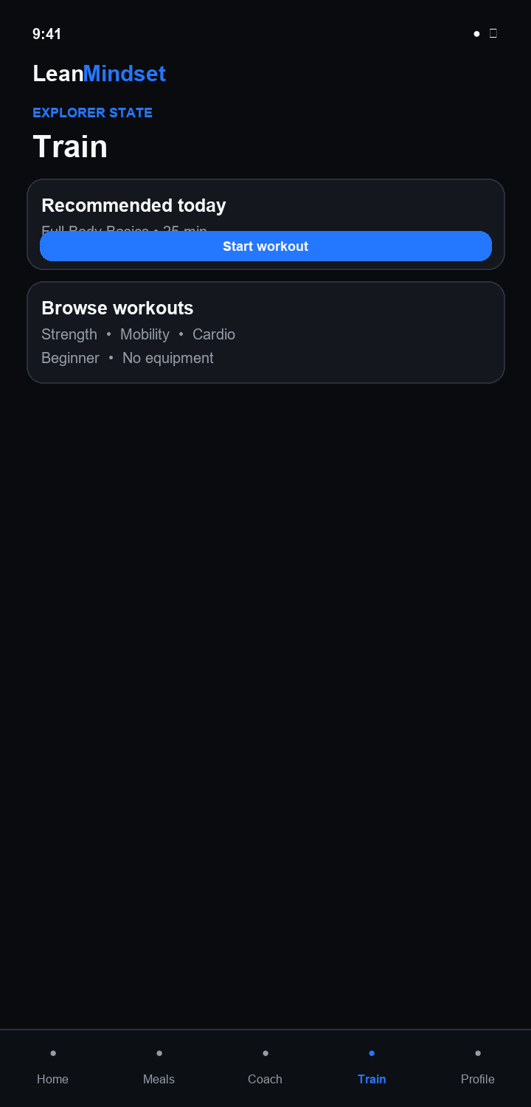

26 Train Active
04 Meals Coach Train Profile
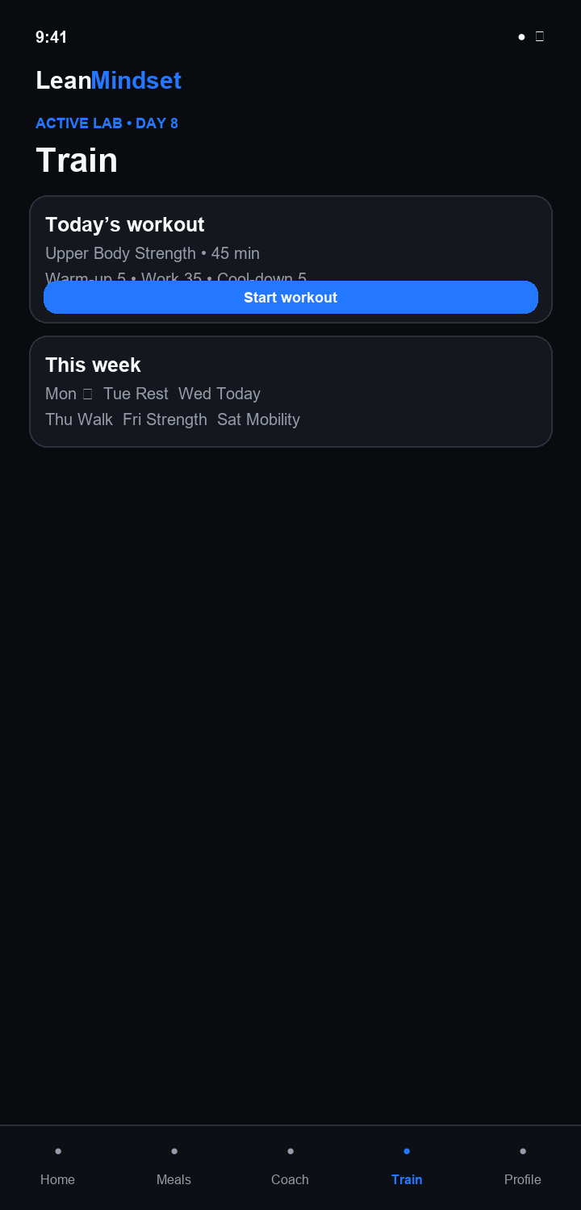

27 Profile Lab Access
04 Meals Coach Train Profile
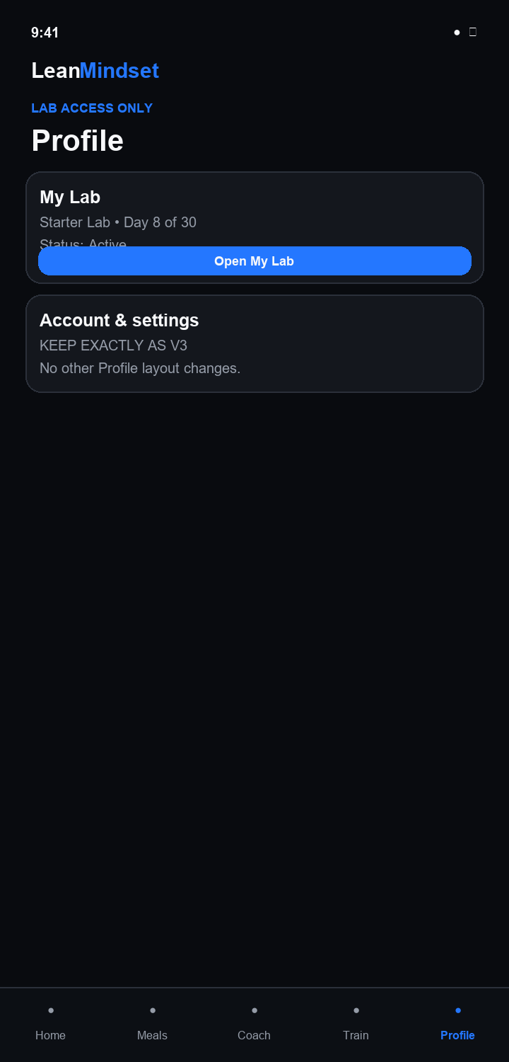

A1 Enrollment Queue
05 Admin Workflow
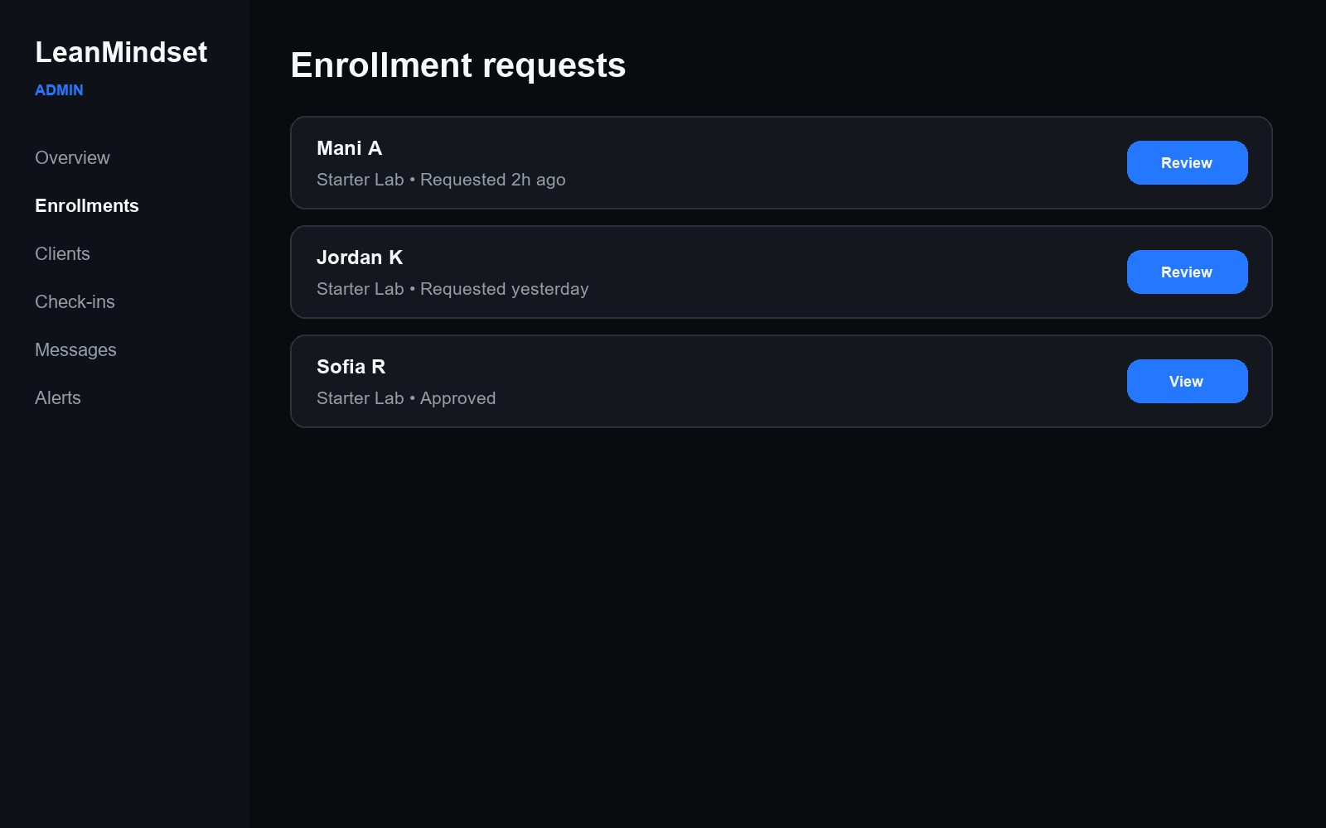

A2 Request Review
05 Admin Workflow
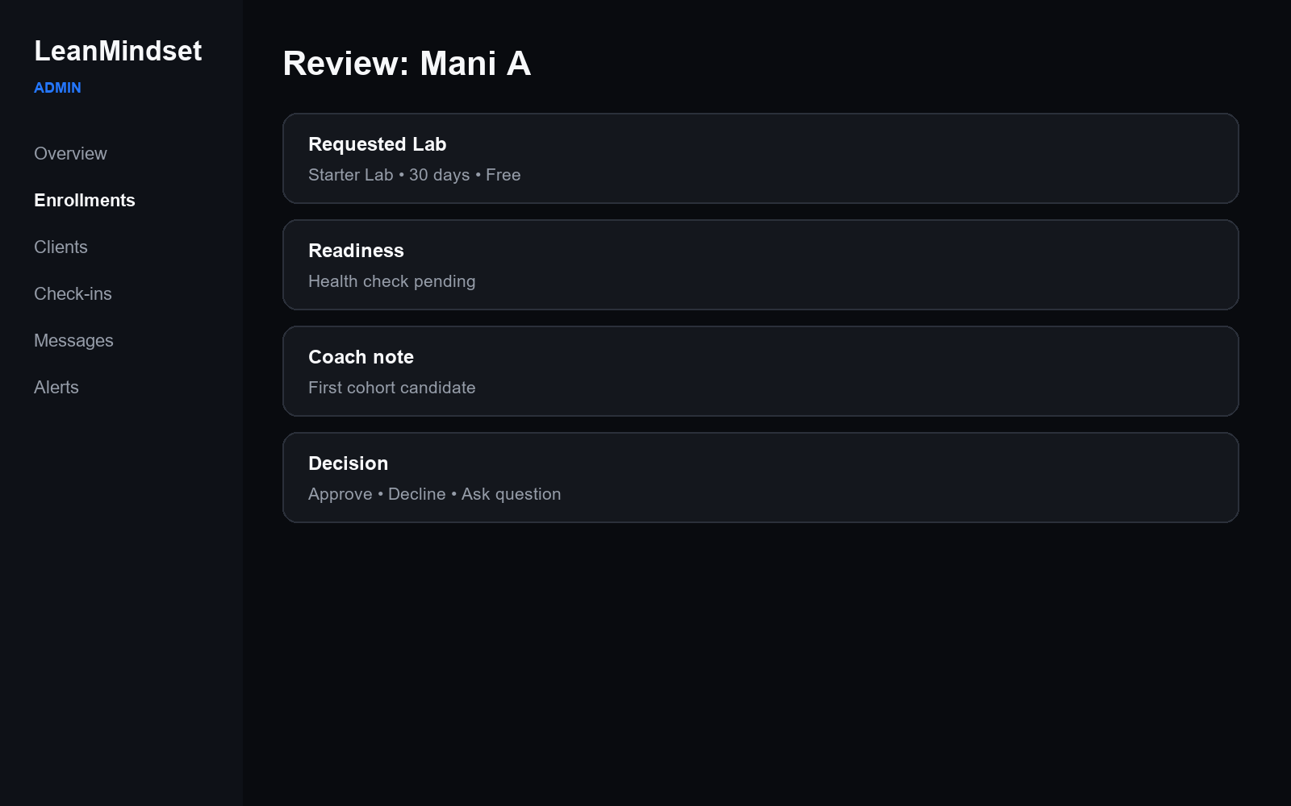

A3 Client Overview
05 Admin Workflow
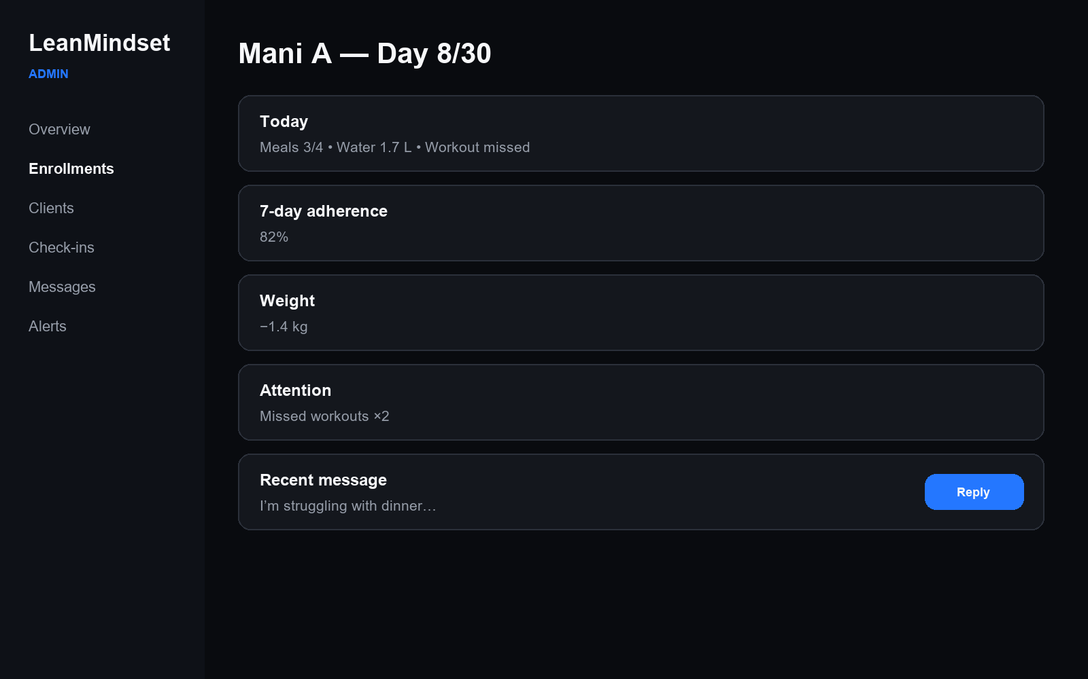

A4 Checkins
05 Admin Workflow
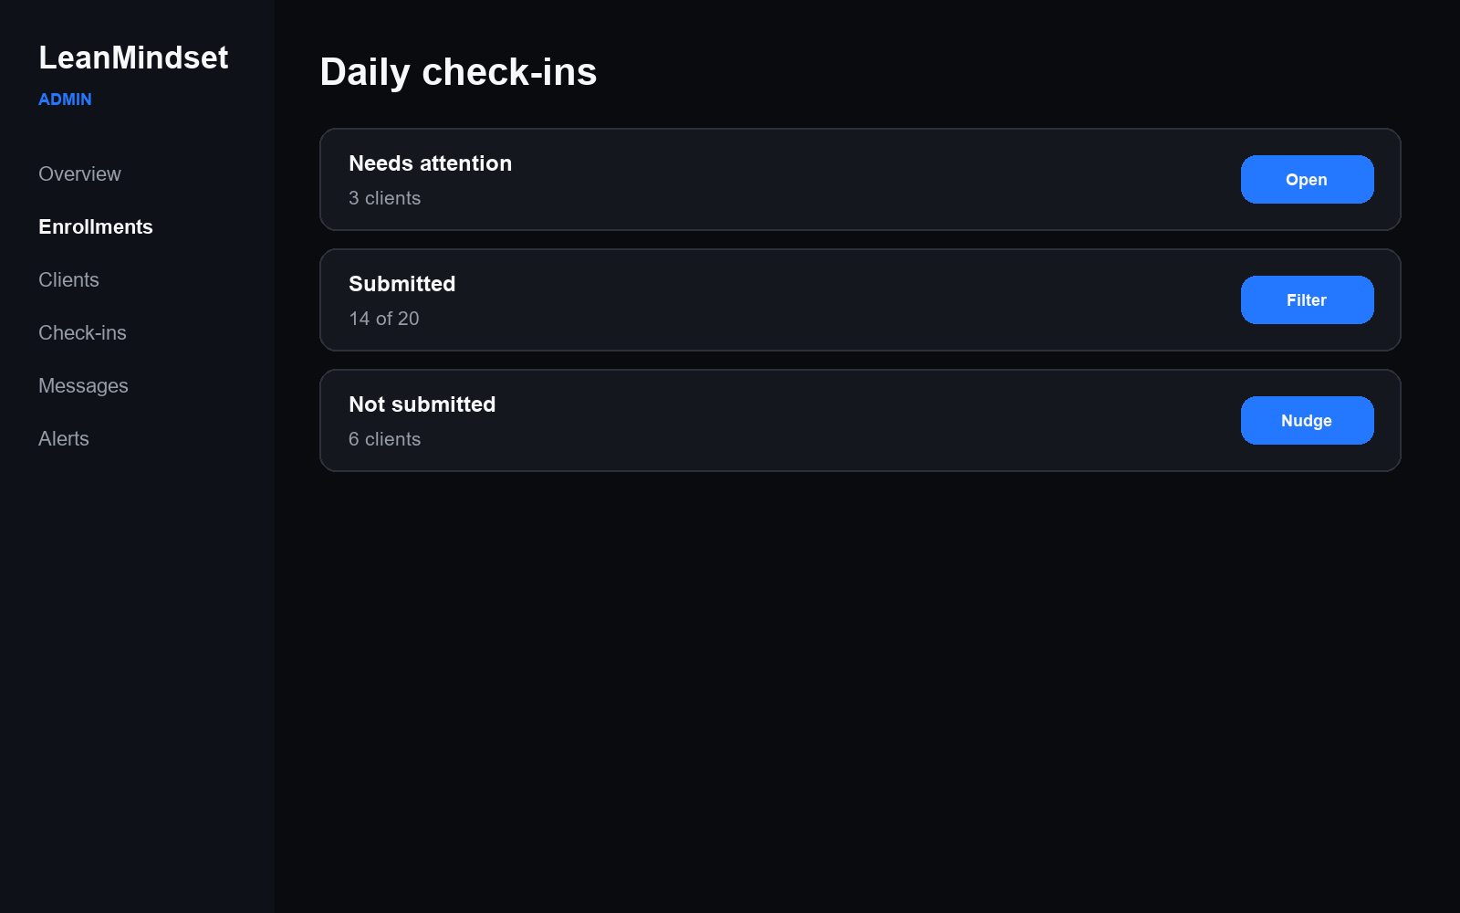

A5 Alerts
05 Admin Workflow
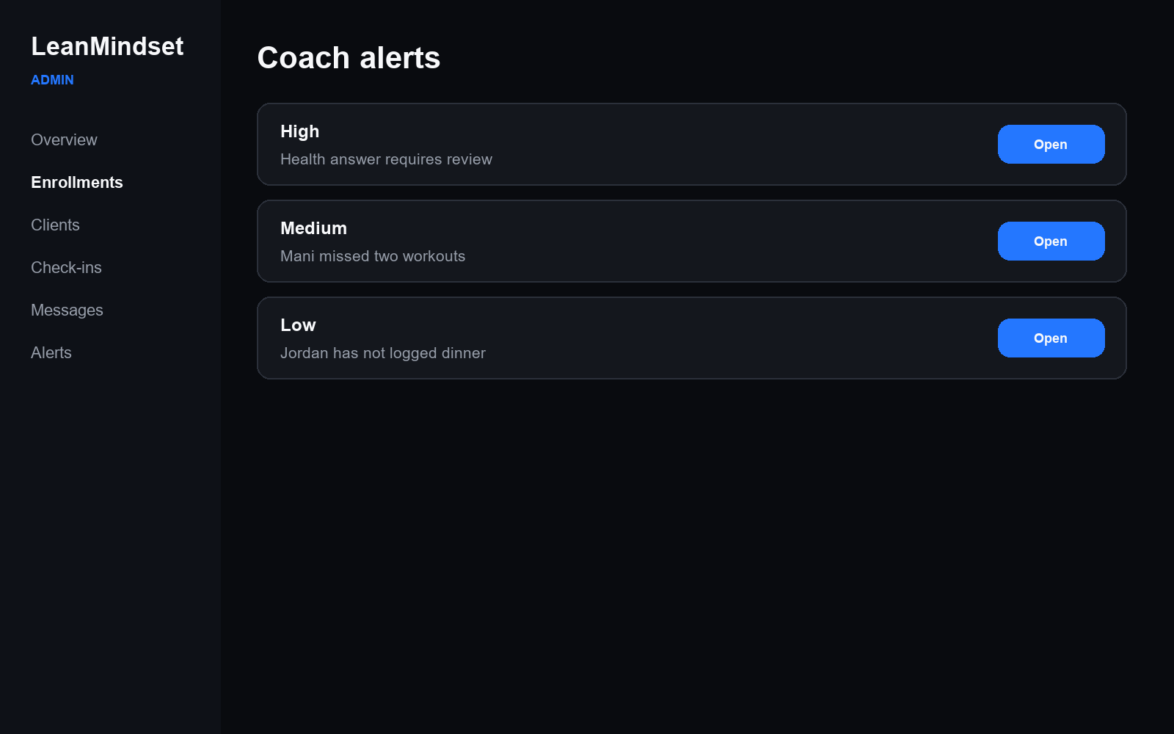

A6 Message
05 Admin Workflow
