LAB Logbook

Lab 1

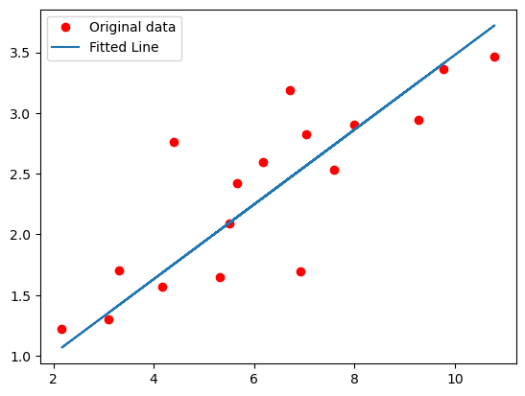

Lab 2

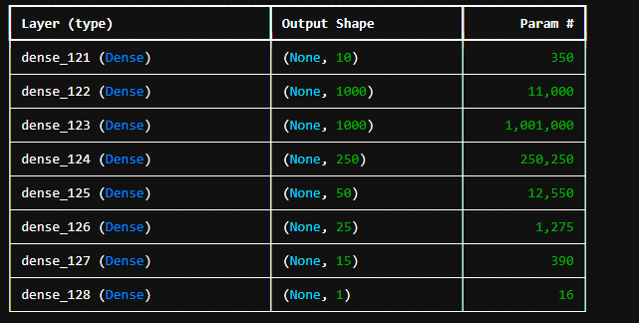93.4%

Lab 3

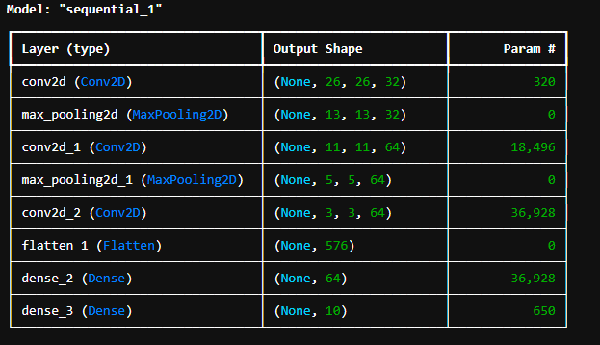

90.01%

Lab 4

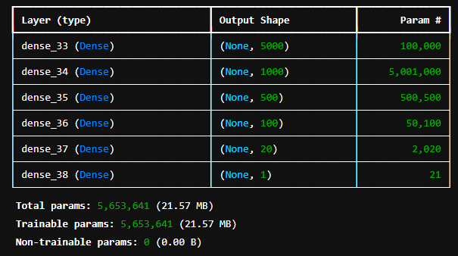

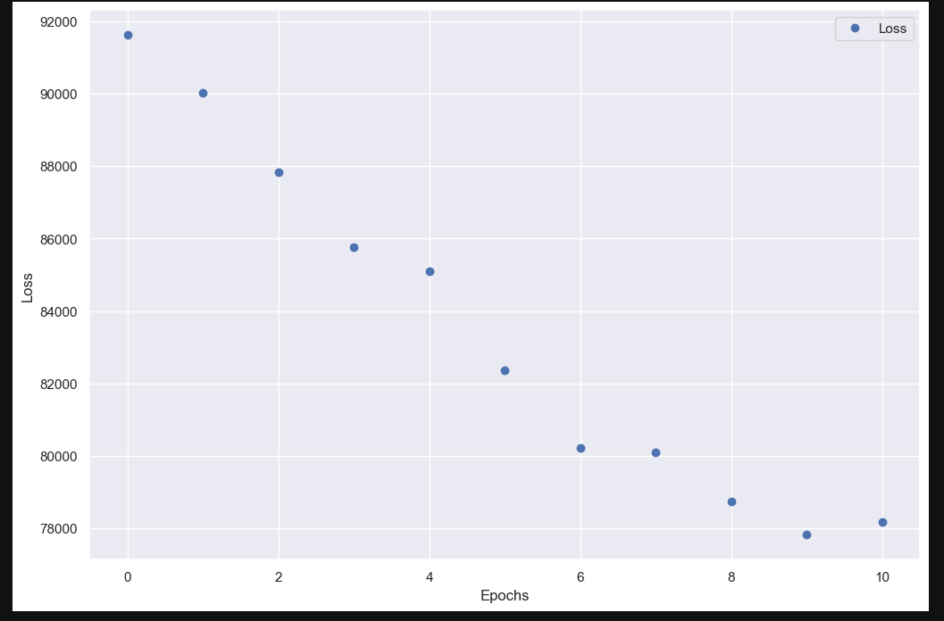

Lab 5

Lab 6

Lab 7

Lab 8

Lab 9

Lab 10

Lab 11

Lab 12